Hospital Management System (HMS)
Database Design & Implementation Report

Instructor: Nurlan Shaidullaev
01 May 4, 2026

Submitted by:
Ahmad Karim

1. Project Overview
The Hospital Management System (HMS) is a relational database designed to manage hospital operations in an efficient and structured manner. It organizes key hospital data such as patients, doctors, appointments, medical records, admissions, and billing into a centralized system.
The project is implemented using PostgreSQL and is designed to reflect real-world hospital workflows. It demonstrates how relational databases can be used to model complex systems with multiple interconnected entities.

2. Objectives
The main objective of this project is to design a normalized and scalable database system that accurately represents hospital operations.
The system focuses on:
- Designing a structured relational database
- Ensuring data integrity using constraints
- Representing real-world relationships between entities
- Automating processes using triggers and functions
- Supporting data analysis through SQL queries

3. Database Design Approach
The database is designed using an entity-based approach where each real-world object is represented as a separate table. The system follows Third Normal Form (3NF) to eliminate redundancy and improve efficiency.
This ensures that:
- Data is stored only once
- Relationships are properly managed
- The system remains scalable and maintainable
For example, patient information is stored independently, while prescriptions and billing are handled in separate tables to avoid duplication.

4. Schema Description
The system consists of multiple interconnected tables, each representing a key hospital component.
- The Departments table stores hospital units such as Cardiology and Neurology.
- The Doctors table stores medical professionals and links each doctor to their respective department.
- The Patients table contains personal and medical details of individuals receiving treatment.
- The Rooms table manages hospital infrastructure, including room types and availability status.
- The Appointments table connects doctors and patients while handling scheduling and appointment status.
- The Medical Records table stores diagnoses, symptoms, and treatment details linked to appointments.
- The Prescriptions table records medicines prescribed during each treatment session.
- The Admissions table manages inpatient records, including room allocation and duration of stay.
- The Billing system is divided into Billing and Bill Items tables to ensure detailed financial tracking and transparency.

5. Relationships Summary
The following table summarizes the relationships between entities in the database along with their foreign keys:
No. | Relationship | Type | Foreign Key (FK) | Description
1 | Department → Doctors | 1:N | doctors.department_id → departments.department_id | One department can have many doctors.
2 | Doctor → Appointments | 1:N | appointments.doctor_id → doctors.doctor_id | One doctor handles multiple appointments.
3 | Patient → Appointments | 1:N | appointments.patient_id → patients.patient_id | One patient can book multiple appointments.
4 | Appointment → Medical Record | 1:1 | medical_records.appointment_id → appointments.appointment_id | Each appointment generates one medical record.
5 | Medical Record → Prescriptions | 1:N | prescriptions.record_id → medical_records.record_id | One record can have multiple prescriptions.
6 | Patient → Admissions | 1:N | admissions.patient_id → patients.patient_id | A patient can be admitted multiple times.
7 | Room → Admissions | 1:N | admissions.room_id → rooms.room_id | A room can be used multiple times over time.
8 | Doctor → Admissions | 1:N | admissions.admitting_doctor_id → doctors.doctor_id | A doctor can manage multiple admissions.
9 | Patient → Billing | 1:N | billing.patient_id → patients.patient_id | A patient can have multiple bills.
10 | Billing → Bill Items | 1:N | bill_items.bill_id → billing.bill_id | Each bill contains multiple items.
These relationships ensure referential integrity and accurately model real-world hospital operations.

6. Advanced Features
The system includes several advanced database features to improve functionality and automation.

Views
Views are created to simplify complex queries and generate reports such as patient profiles, doctor schedules, available rooms, and pending bills.
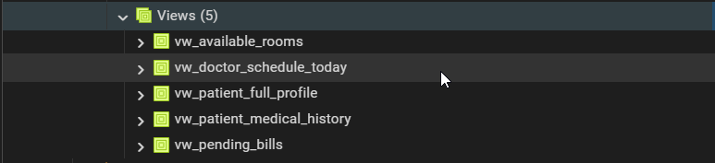
vw_patient_full_profile: displaying aggregated patient demographics, visit frequency, and overall financial balances.
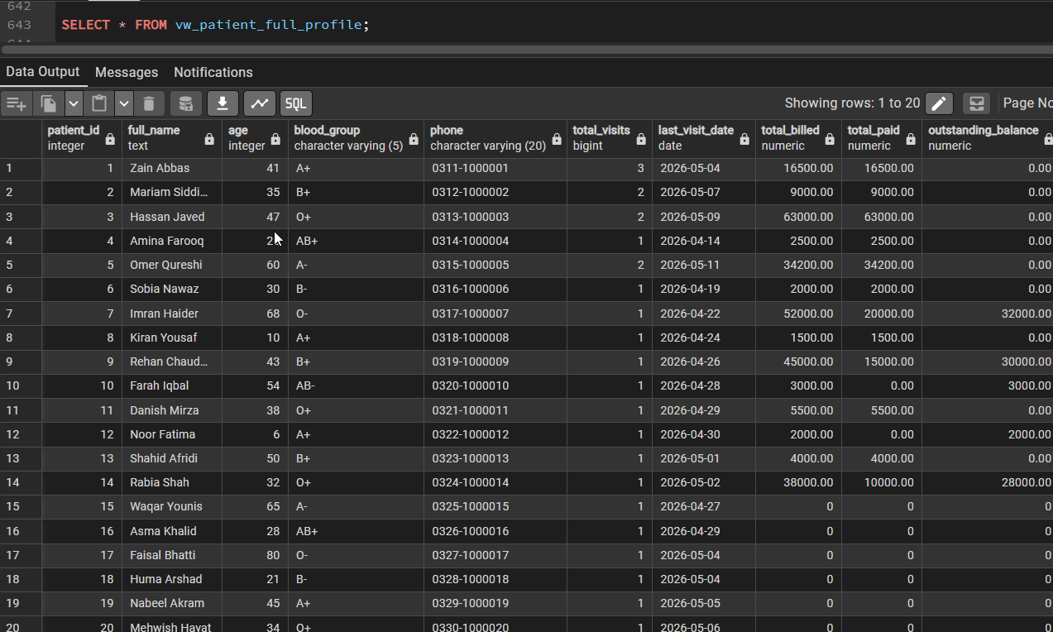

vw_doctor_schedule_today illustrating real-time daily appointment schedules for medical staff.
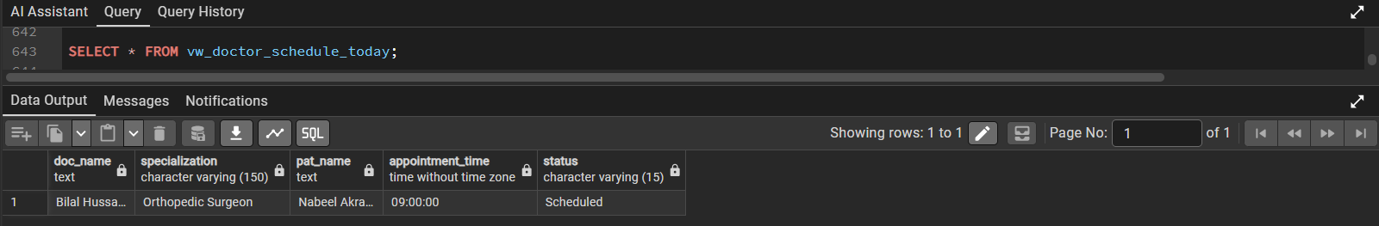

vw_available_rooms filtering hospital infrastructure to show currently unoccupied rooms and their daily rates.
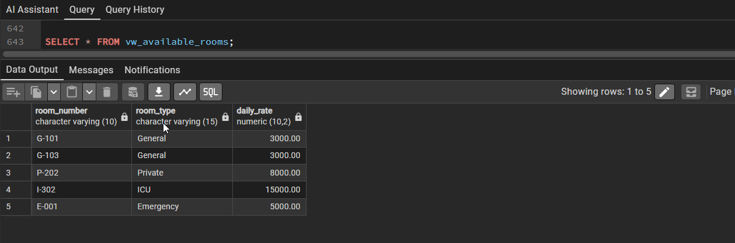
vw_pending_bills highlighting outstanding patient invoices, calculated due amounts, and days overdue for the finance department. 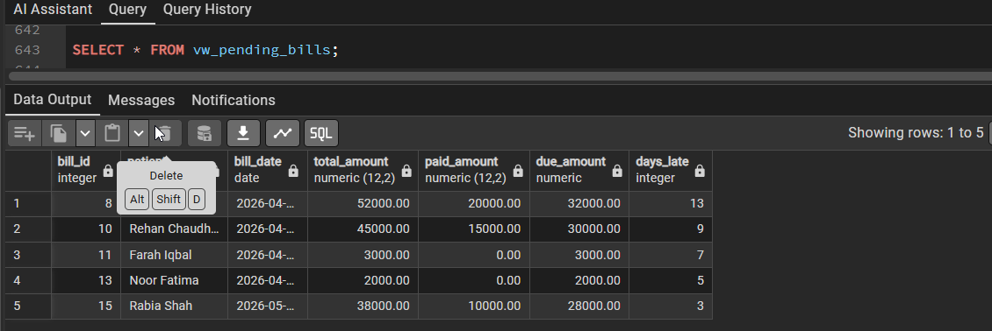
vw_patient_medical_history showing a chronological timeline of patient diagnoses and treatment plans.
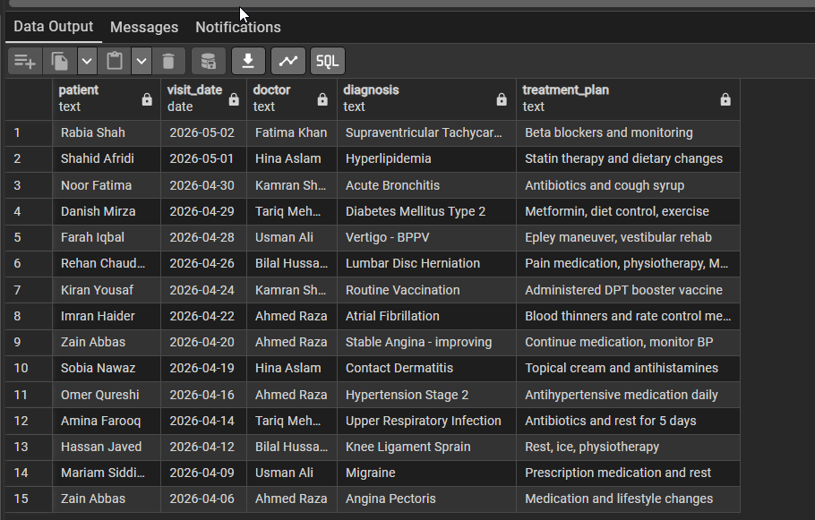

Functions
Custom functions are implemented to perform reusable operations such as calculating patient age, checking doctor availability, and retrieving outstanding balances.
the calculate_patient_age() function, accurately computing patient ages dynamically based on their stored Date of Birth.
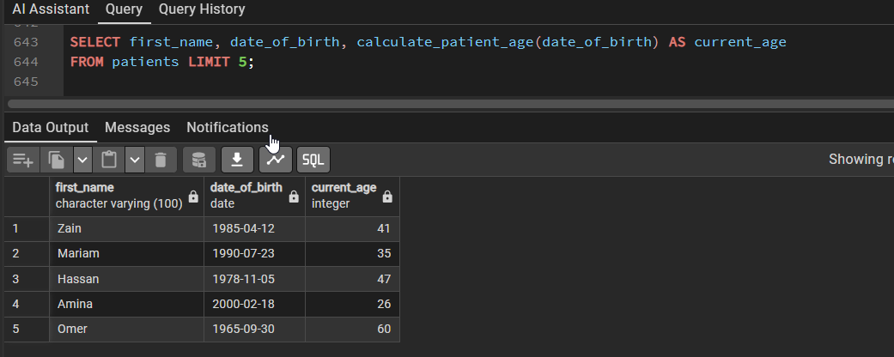
Output demonstrating the get_patient_outstanding_balance() function aggregating total unpaid billing amounts for individual patients.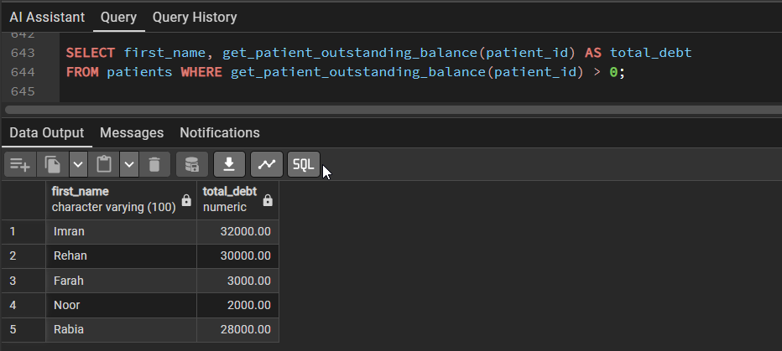
Testing the is_doctor_available() function, which acts as a safeguard against scheduling conflicts and double-booking.
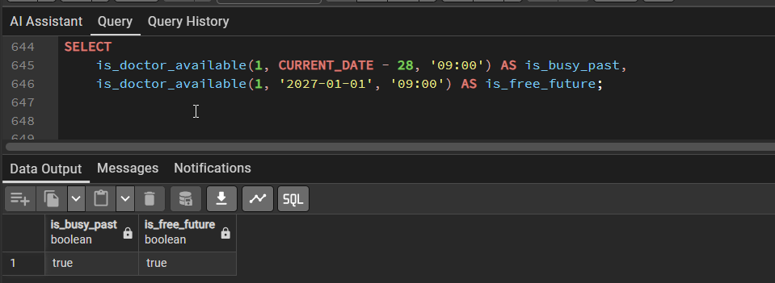

Triggers
Triggers automate important processes. For example, room status is automatically updated when a patient is admitted or discharged. Similarly, billing totals are calculated automatically based on input values.
trg_room_occupied trigger automatically updates a hospital room's status from 'Available' to 'Occupied' immediately upon patient admission.
trg_room_available trigger revertes a hospital room's status back to 'Available' upon a patient's discharge.
trg_bill_total trigger automatically calculates and inserting the final total amount based on the provided subtotal and tax percentages.

7. Sample Data
The database includes realistic sample data for testing and demonstration purposes. It contains multiple departments, doctors, patients, appointments, admissions, and billing records.
This data allows:
- Testing of SQL queries
- Validation of relationships
- Demonstration during presentations

8. Queries and Analysis
The system supports a wide range of SQL queries for analysis and reporting. These include identifying the busiest doctors, tracking patient visits, calculating revenue, and finding pending bills.
Advanced SQL concepts used include JOIN operations, aggregation functions, GROUP BY clauses, subqueries, and window functions.

9. Entity Relationship Diagram (ERD)
The ERD represents the overall structure of the database, showing how entities are connected.
It visually illustrates:
- Tables (entities)
- Attributes (columns)
- Relationships (foreign keys)
- Cardinality between entities
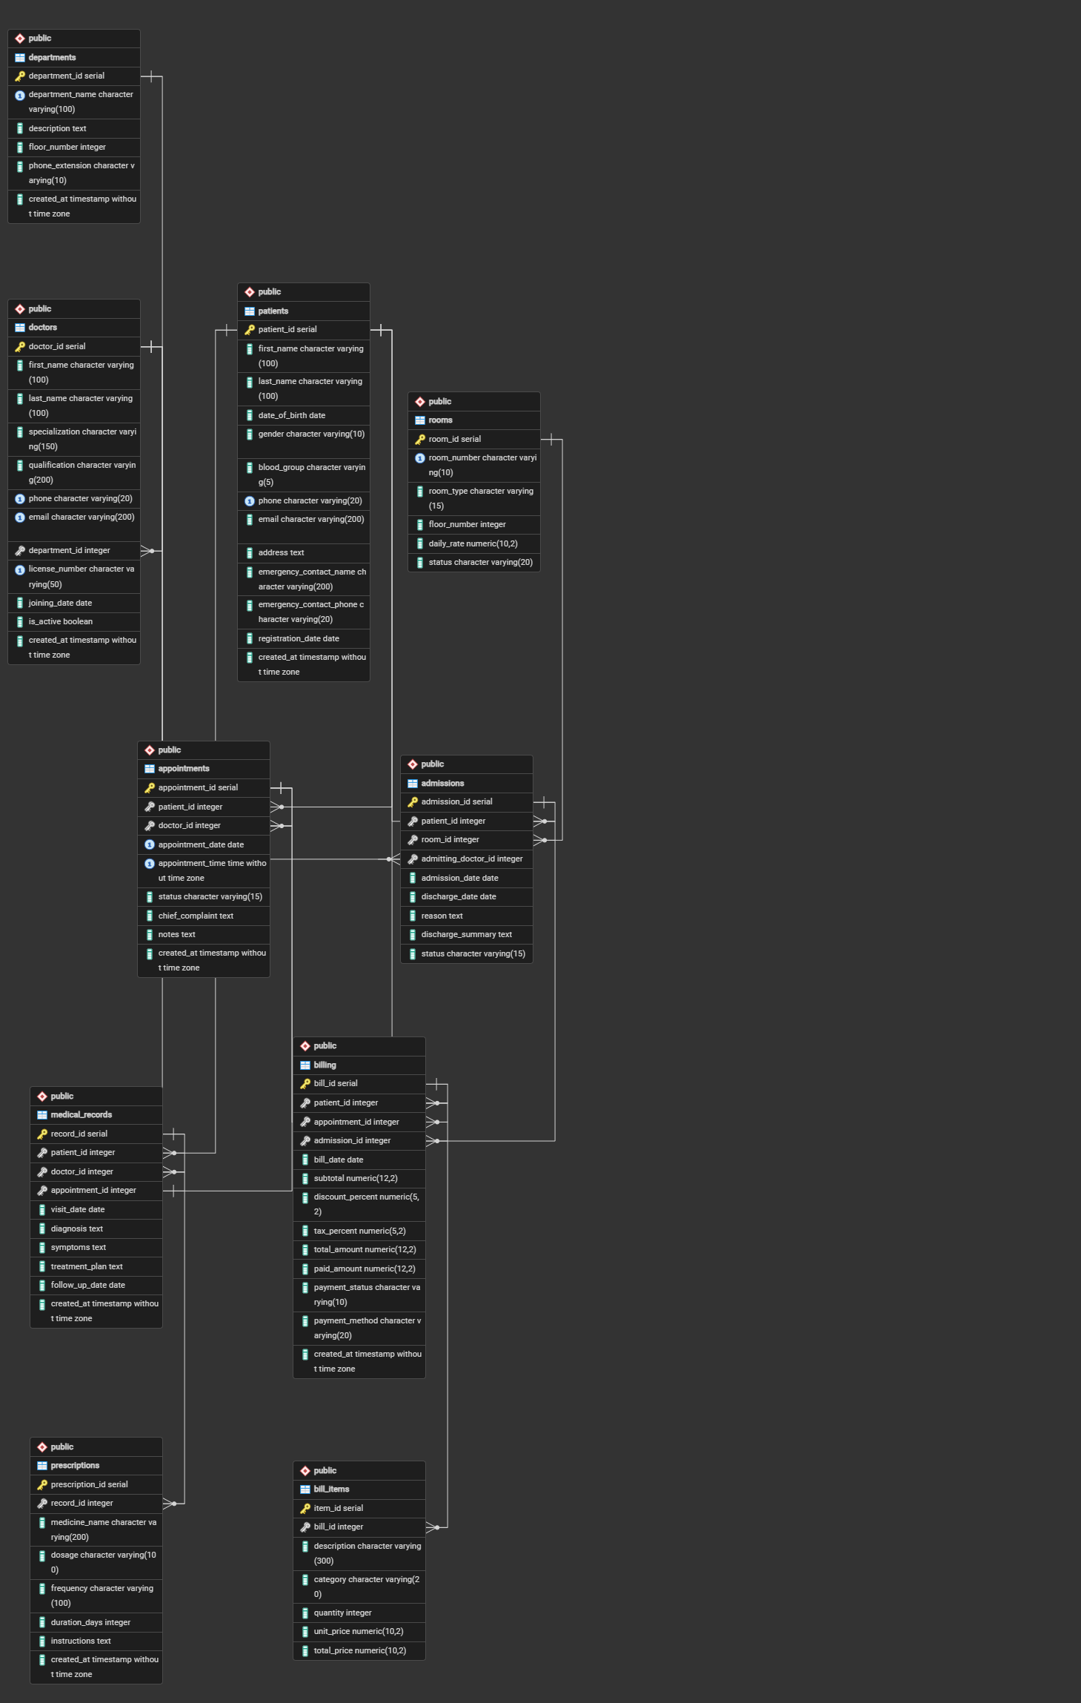

11. Real-World Simulation
The system accurately models real hospital operations, including patient registration, doctor consultations, treatment processes, hospital admissions, and billing workflows. It also manages hospital resources such as rooms and staff allocation.

12. Limitations
The system does not include a graphical user interface or user authentication system. It is also limited to a single hospital setup and does not include advanced analytics or machine learning capabilities.

13. Future Improvements
Future enhancements may include the addition of role-based authentication, a web-based interface, integration of pharmacy and inventory systems, real-time notifications, and AI-based predictive analytics for better decision-making.

14. Conclusion
The Hospital Management System demonstrates a complete and structured implementation of a relational database. It effectively models real-world hospital operations and ensures data integrity through normalization, constraints, and relationships.
The project showcases strong understanding of database design, SQL programming, and system modeling, making it suitable for academic evaluation and practical application.

