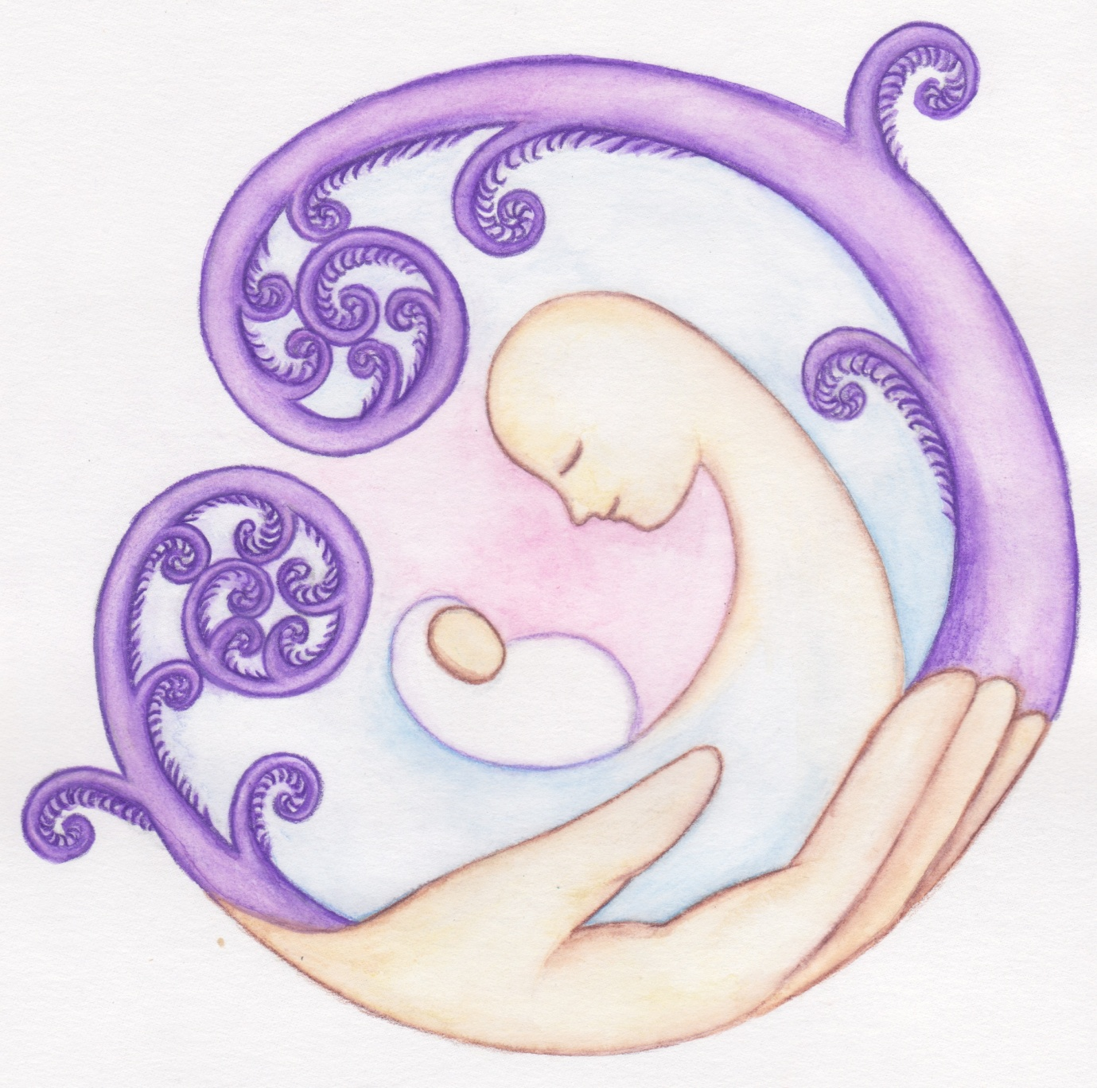 West Auckland Midwives

**Baby Movements**

Baby movements are a very important way of knowing that your baby is well.

Each baby’s movements feel different to any other baby. This can be because of size of, and where your baby is facing.

Because movements help you and us know more about how well baby is, it is important that you:

* think about how often your baby moves
* Think about whether your baby has a pattern or routine of moving
* Think about the type of movements you feel from your baby.

**It is important to get used to the normal pattern for your baby.**

Less movement (reduced) or no movements (absent) or a change in your baby’s normal movements may mean your baby is unwell.

Some reasons why your baby might not move as much as usual:

You are very busy; You are taking medicine that makes your baby less active; You are drinking alcohol/taking drugs; You are smoking; You are overweight.

**It is hard to know how many times a baby should move as they are all so different.**

If you are not sure about your baby’s movements try:

* Sit or lie down and try and relax
* Have a bath
* Eat something and drink a glass of cold water

Think about why you are concerned about your baby’s movements and consider if anything happened before the change in movements? Bleeding, Pains, Injury?

**If you are still worried, call your LMC we will take your concerns seriously.**