(1) E:\LunchBox\workspace\LunchBoxService\target>java -jar LunchBoxApp-0.1.0.jar



1. http://localhost:8080/signUpCust

{"loginusername":"suresh4","password":"admin","firstname":"Suresh","lastname":"raju","mobilenum":"9083750836","dob":"01-jul-1992","email":"suresh.raju@gmail.com"}

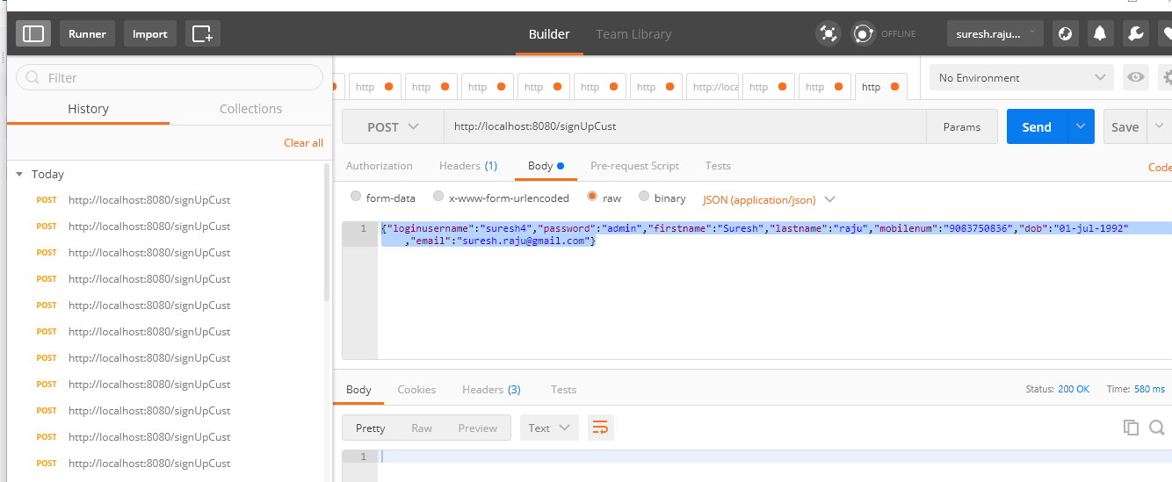

1. http://localhost:8080/loginUser

{"loginusername":"sairam1","password":"sairam"}

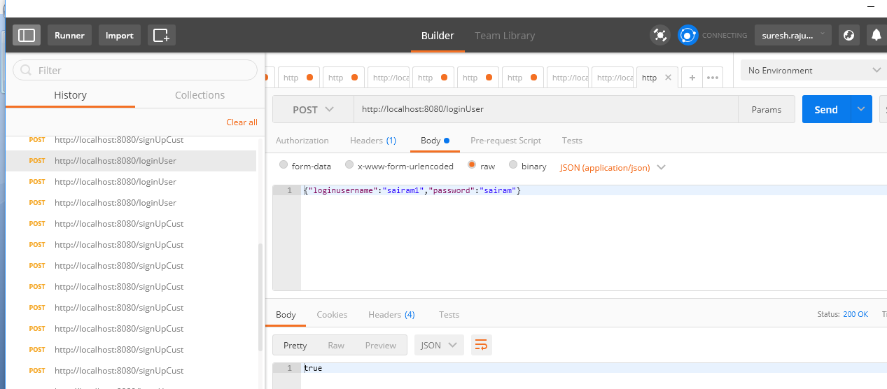

1. http://localhost:8080/menu/

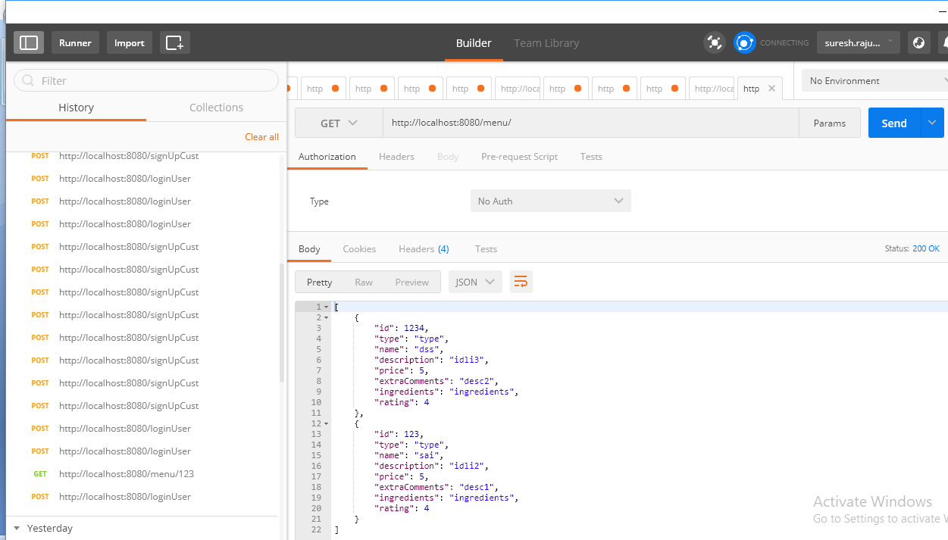

1. http://localhost:8080/menu/sai

