Assignment 4 Part 1 Diagram

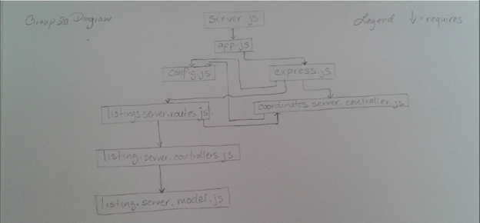

What is defined in the controllers?

‘listings.server.controller.js’ contains exports functions:

·       create()

·       read()

·       update()

·       delete()

·       list()

·       listingByID()

‘coordinates.server.controller.js’ contains an exports function that access GoogleMap’s API for mapping out coordinates.

Google API that return the coordinates to the caller function

Listings controller utilized express/middleware to define logic

  How the router makes use of the controllers to determine the flow of request handling?

The router responds to the user's HTTP request by calling the correct handler in the controller

  How middleware is used throughout the application to modularize the code?

The middleware is used to direct and redirect pages from client request

Retrieve listing and Coordinate information based off of path.