Assignment 1 – 8-bit Simple ALU Design

Deadline: 4/9

- Using conditional operator to design 8-bit ALU.
- If… else… or (2) case statement (3) assign xxx=(xxx)? xx : xx
- If the output is over 8-bit, truncate the LSB portions and output the 8-bit data from the MSB.

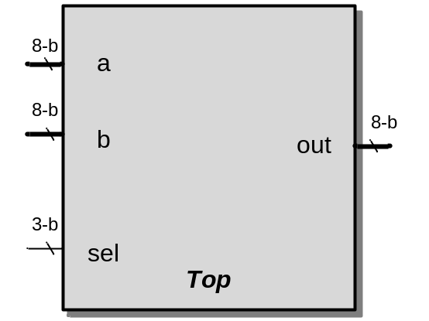

Top cell name (module name) | Top
Port | Port name | Bit-width | descriptions
Input port | a | 8 | 8-bit data (1st input)
Input port | b | 8 | 8-bit data (2nd input)
Input port | sel | 3 | Sel= 0 → a+b (9-bit)  Sel= 1 → a-b (9-bit)  Sel= 2 → a&b (8-bit)  Sel= 3 → a|b (8-bit)  Sel= 4 → a^b (8-bit)  Sel= 5 → a/2 + 4b (11-bit)  Sel= 6 → 3(a+b) (11-bit)  Sel= 7 → a*b (16-bit)
Output port | out | 8 | The output results

