Hi. Mr.Jung

Hope your business are doing so well.



Hope your face is not something like that for this project.

Throughout this app building, I think that I should report one or two things about that.

- To accomplish your requirement, I made two steps and have accomplished step by step.

1. Accomplish the algorithms. With out any UI

- SS

- DSS

- PDSS

I have 3 python files for each of them. If you needs those then just let me know.

1. From your design I have built the app something like that.

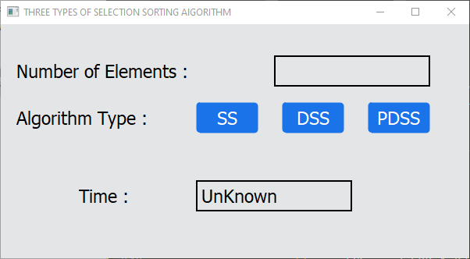

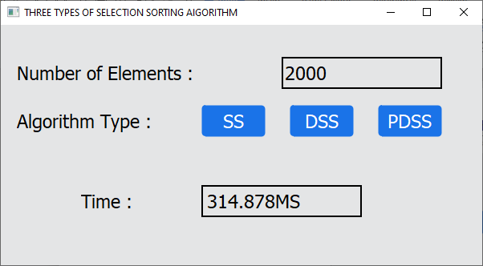

Pros and cons of this design.

Pros

- Really neat and easy to use

Cons

- It’s hard to recognize what you just chose and there is no logs about that.

- If you hope to redesign it then I will

So from there, I have spent 12 hours for building.

1. 5hours - for first step
2. 7hours - for second step

Hope to be received at least 10*12 = 120

Mr.Jung, I just assume that you are the data-scientist whose job recognize the huge size of data.

I had exp with Algo Trading and also have exp with handling tons of threading for real-time watching the change of the huge data.

If above exp is useful for you then feel free to contact me ***MeanJustin623(Skype)***.

Hope to learn more things from you. Especially AI area.

I wonder if we could talk via this Skype whether you need me or not.

One Big Note

I have seeking the accomplished DSS(PDSS) algorithm code via google but there was no code.

Almost of famous algorithms are all already accomplished by several codes.

I wonder why DSS(PDSS) are not.

Throughout building the app I found the answer.

SS is double better than DSS and PDSS is little better than SS.

I have checked the Algo and line by line. Even DSS(PDSS) already sorted the strings into the file that you sent.

Thanks for wasting your precious time.

If you have any request or questions then just let me know about those.