Student:Toktarov Nurislam

Group:Se-2302

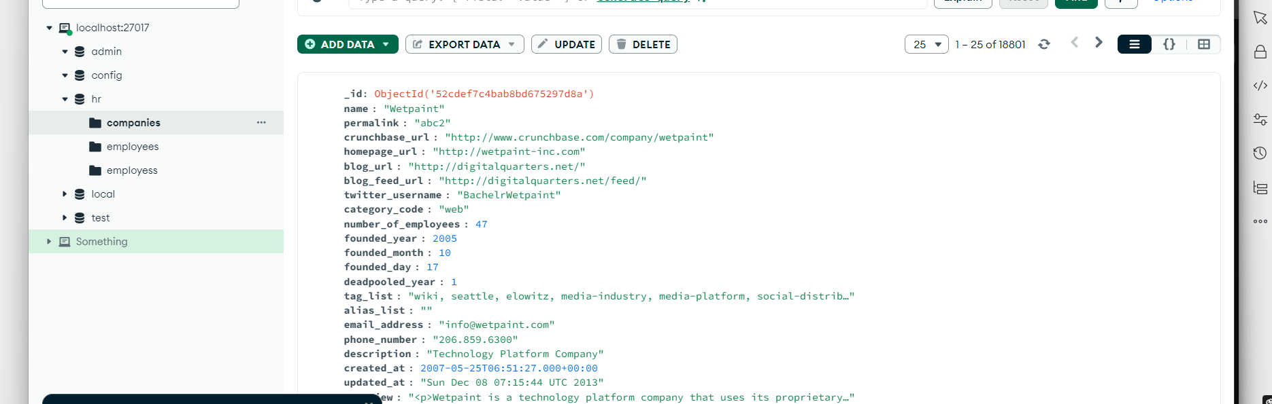

Task 1

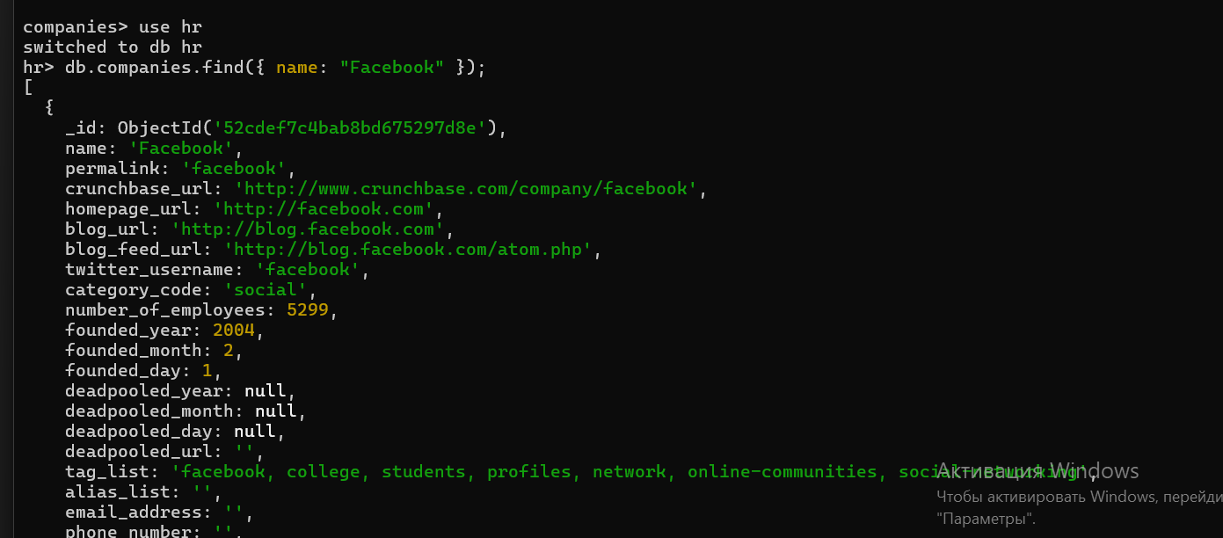

Task 2

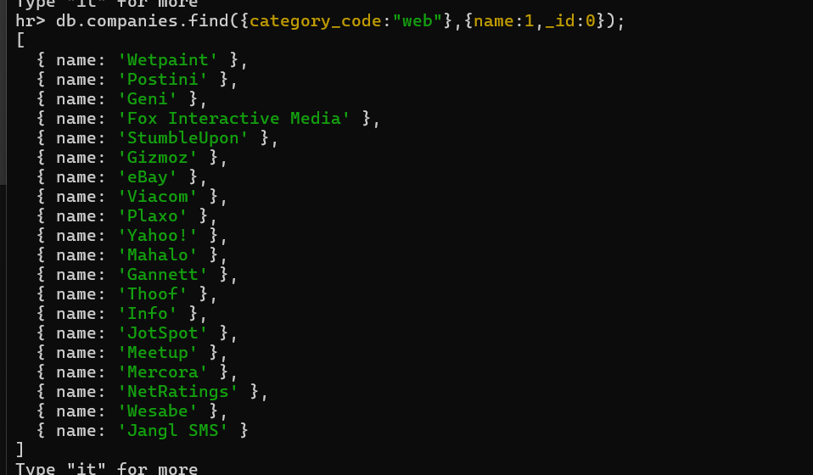

Task 3

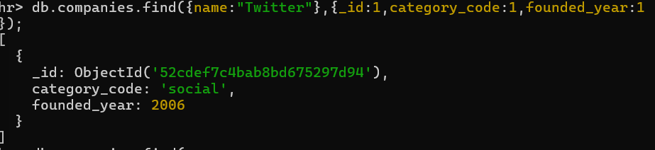

Task 4

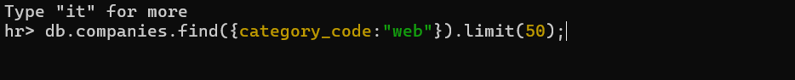

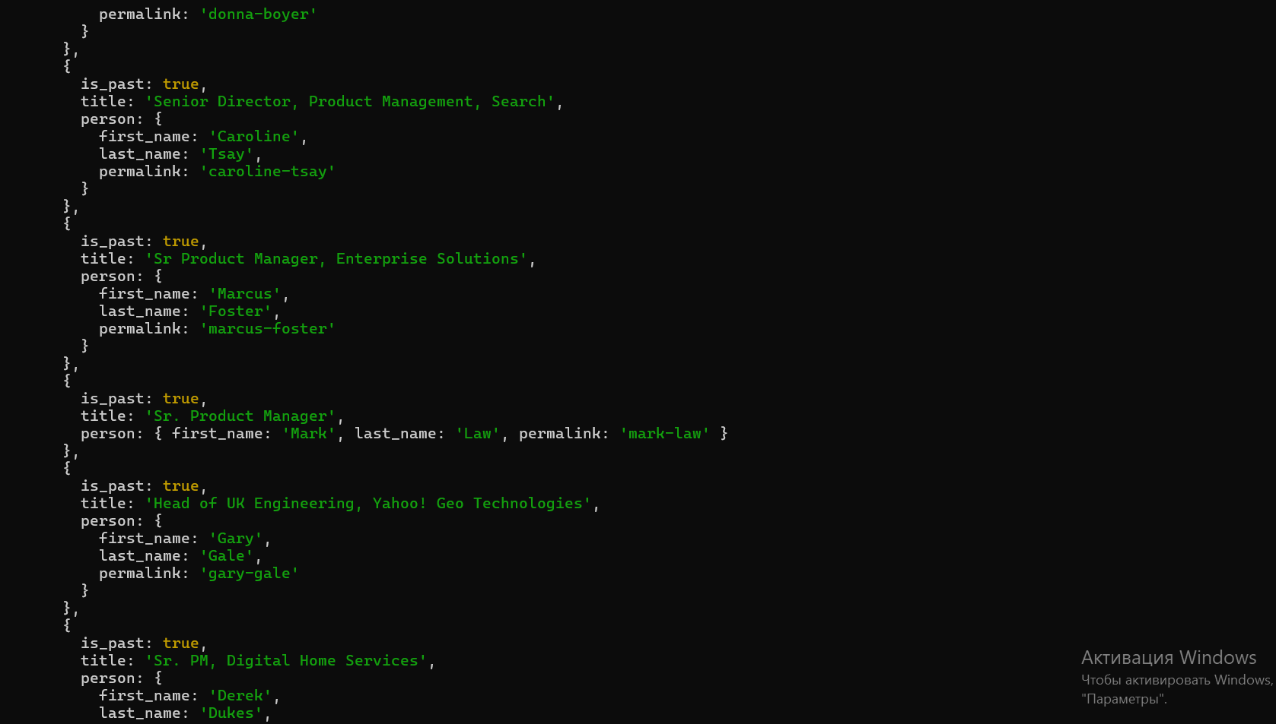

Task 5

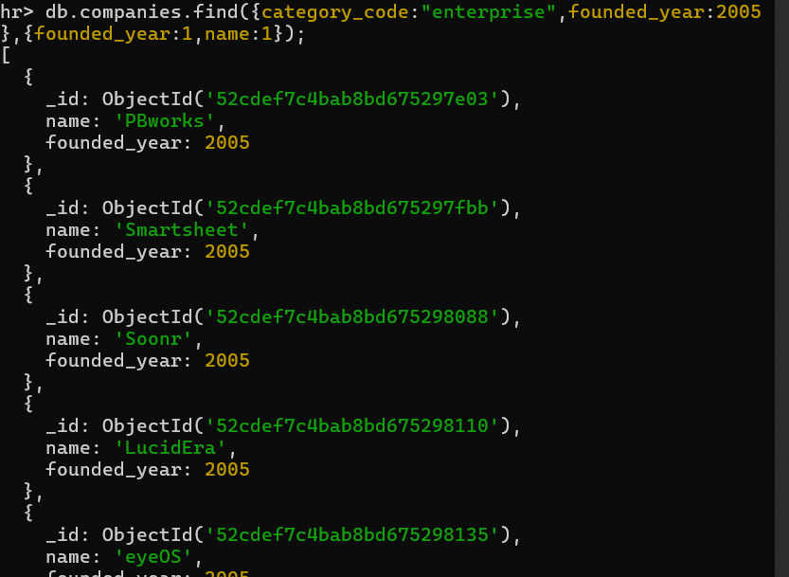

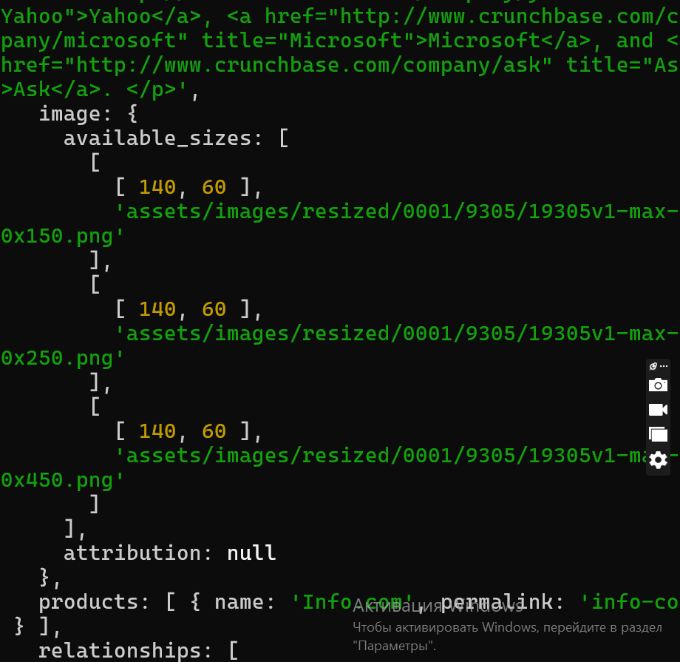

Task 6

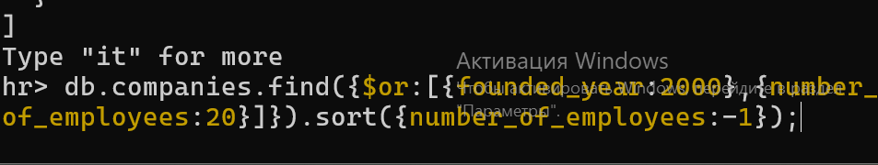

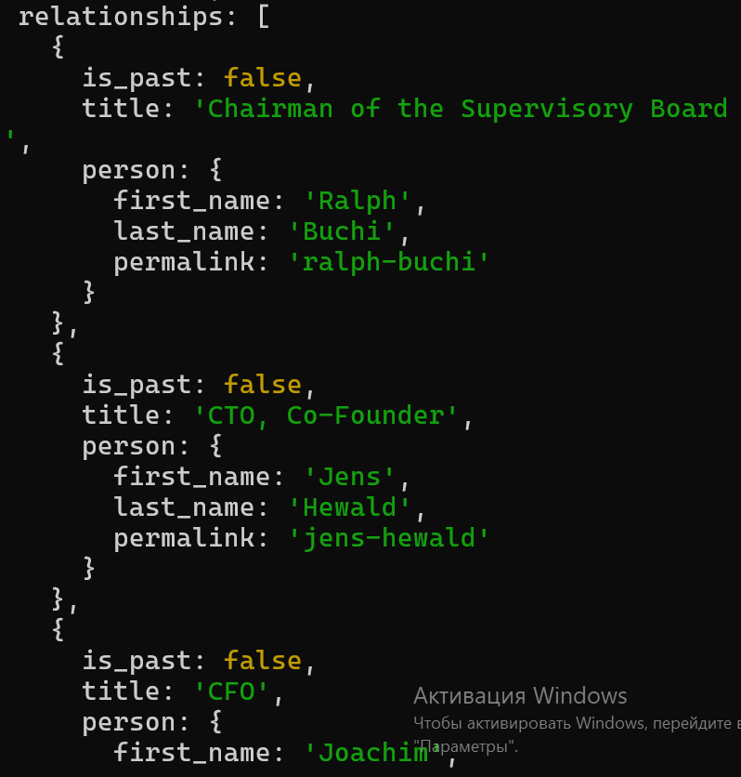

Task 7

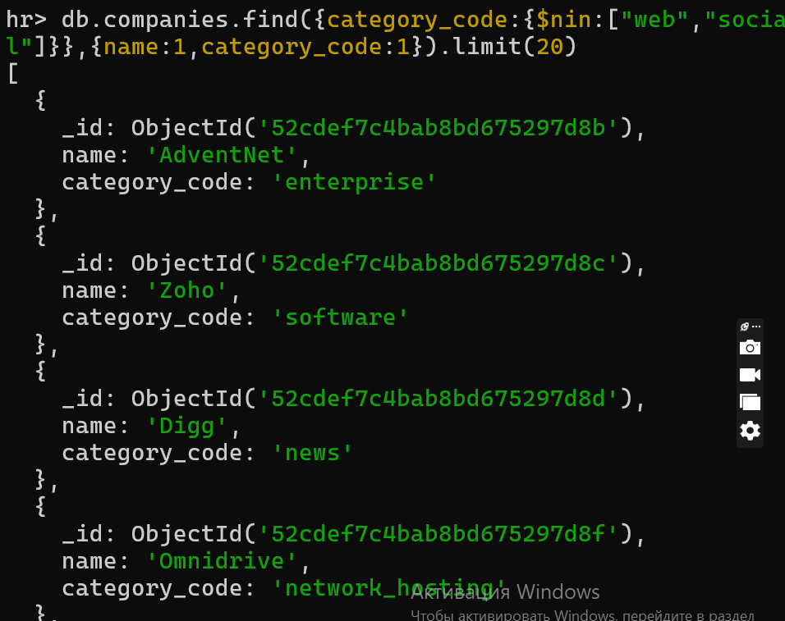

Task 8

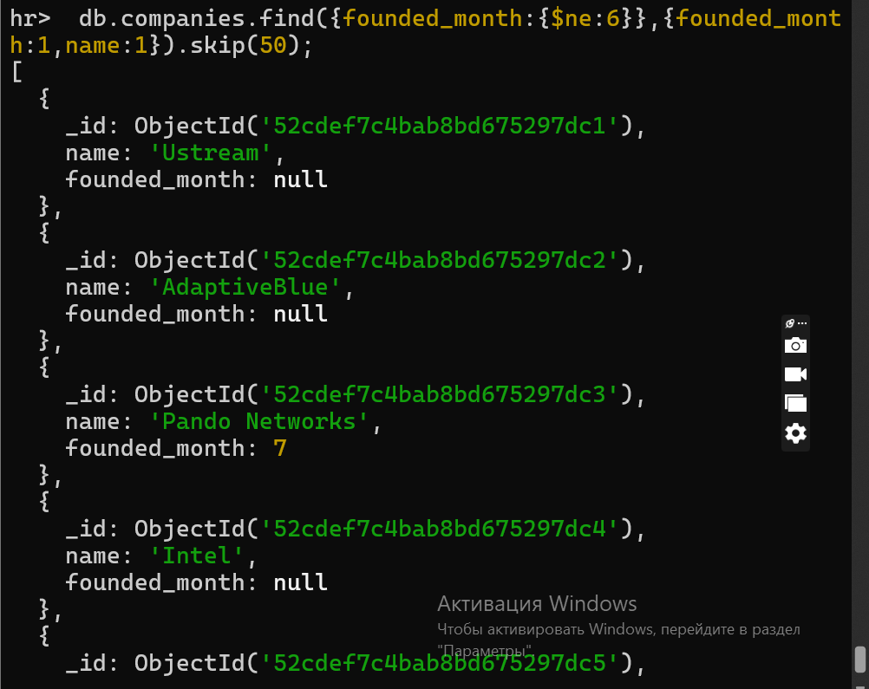

Task 9

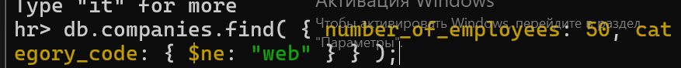

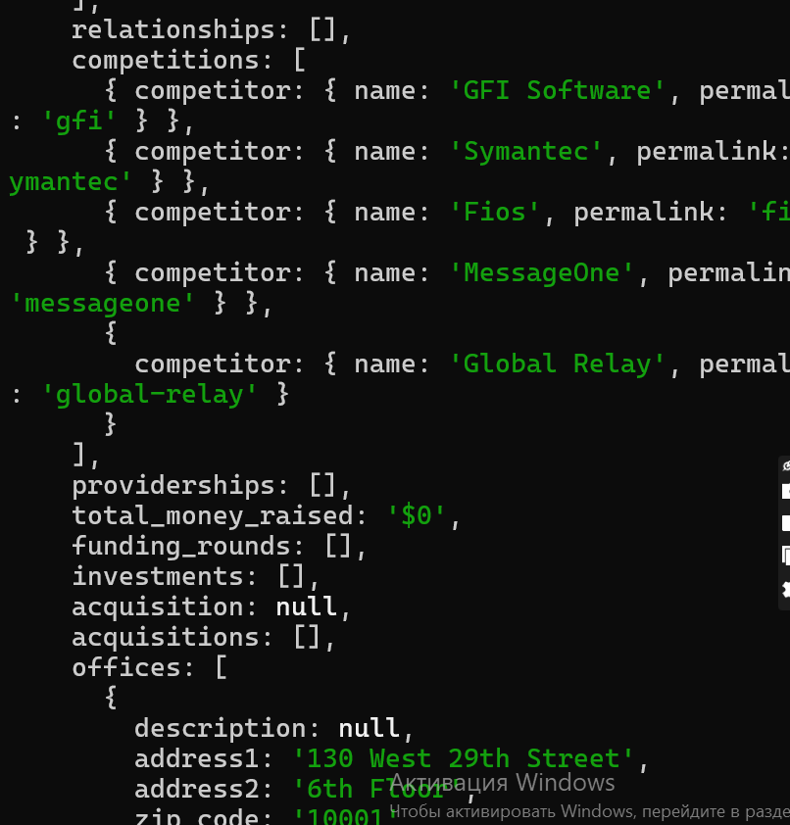

Task 10

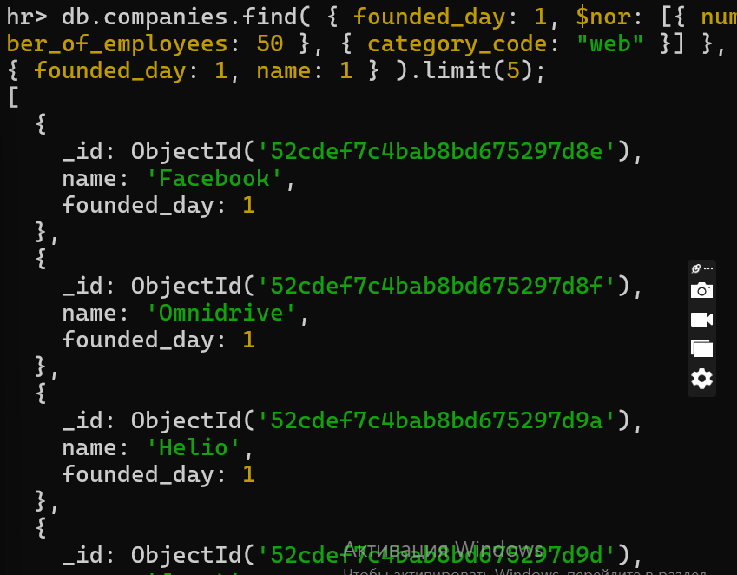

Task 11

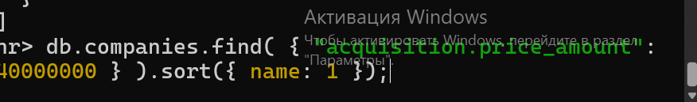

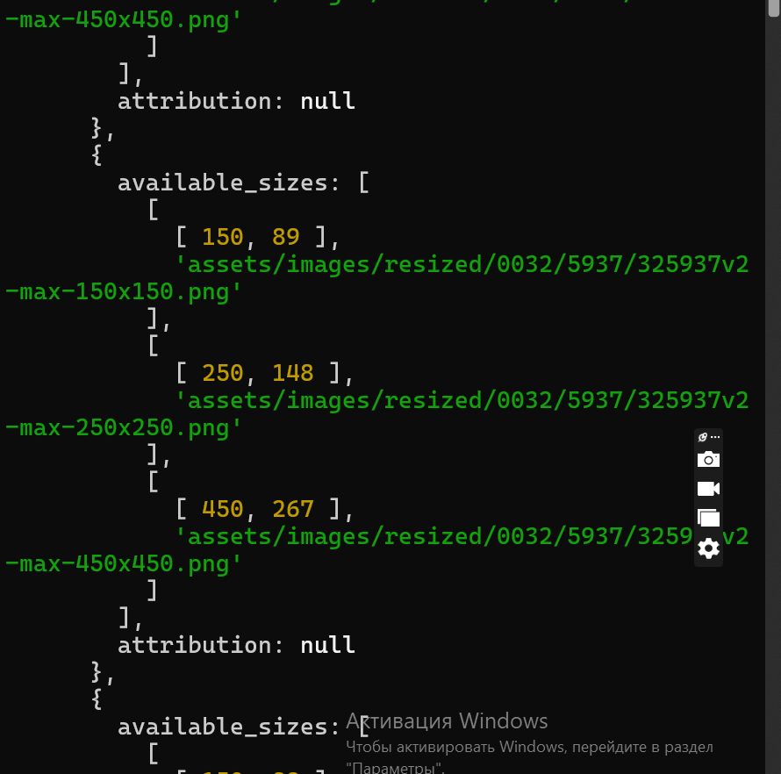

Task 12

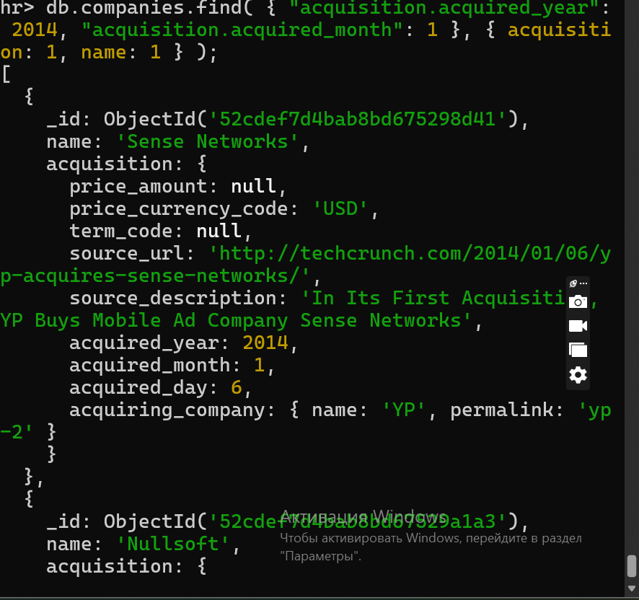

**Questions for defend**

1.What are some ways to interact with the MongoDB database?

Through the MongoDB console (mongo.exe).

Using drivers provided for various programming languages.

Using graphical interfaces like MongoDB Compass.

Through HTTP or REST APIs.

2.Is it possible to interact with the MongoDB database through the web?

Yes, using HTTP or REST interfaces.

3.

What features does MongoDB Compass have?

Full CRUD operations (Create, Read, Update, Delete).

Create and execute queries and aggregation pipelines.

Schema analysis and optimization using Explain Plans.

Real-time server stats and index management.

4.Describe the MongoDB Compass application interface.

Provides a graphical environment to manage documents, collections, and databases.

Offers tools for schema analysis, query building, and data aggregation.

Supports connections to standalone servers, replica sets, and sharded clusters

5.What is the format of command-line commands in MongoDB?

Parameters are provided in JSON format.