Sample cases for the meeting with the business experts

The roles

Introduction

ePO snippet, for context:
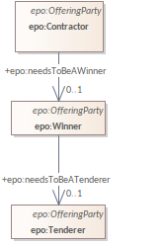
In the eProcurement domain, participants in a procurement process take on different roles over time—such as Candidate, Tenderer, Winner, and finally Contractor. These role changes are not static classifications, but process-driven transitions that are critical for ensuring transparency, legality, and integrity in public spending workflows. Modeling these role transitions temporally is essential for understanding and verifying the lifecycle of a procurement participant.

Problem
“Needs to be” in the UML associations name is not enforced in the data that is supposed to comply with ePO, because it is a label/name only. Unless an implementer manually checks and creates an undocumented ad hoc implementation rule for it.
Traditional ER or UML-based conceptual models capture only static roles. They fail to represent how and when an agent transitions from one role to another (e.g., from a Candidate to a Tenderer). This leads to loss of temporal information, weakened data integrity, and a missed opportunity to enforce key business rules such as:
- A Tenderer must exist before becoming a Winner
- A Contractor must have previously been a Winner

Questions - modelling
- Do you check for such constraints in the data now? E.g., that a winner was already in the database as a tendered, for that lot.
- Is this useful to record?
- (Answers to questions 1 and 2 determine follow-up questions, if any)

Questions - data analysis
- Do you currently analyse the procurement data?
- Would you want to analyse data across time instants? E.g.:
  - How long did it take (on average) for a winner to have become a contractor on that contract?
  - What is the percentage of candidates that eventually become contractors on a given lot/contract?
  - Did an organisation skip the tendering stage and got inserted into the database as a contractor? (is the latter now technically possible and you hope it doesn’t happen? OR not possible through an ad hoc implementation of the constraint in the database)

Contract Amendment
Relevant section of ePO v4.2

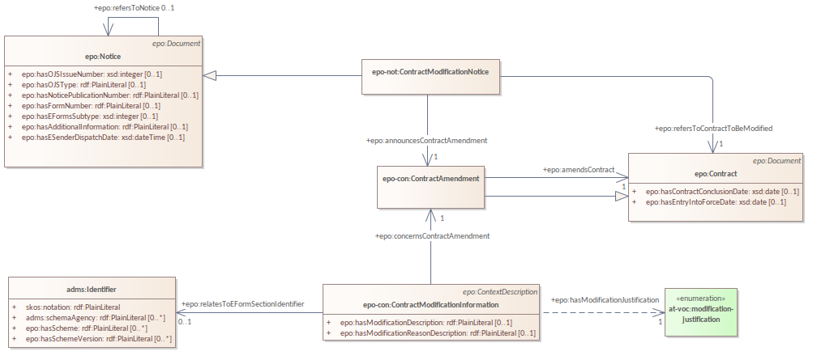

In public procurement, a contract may evolve over time through amendments. These amendments represent discrete events that modify the state of a contract.

Questions/problem
- Is the contract amendment a type of contract? yes
- During an amendment, does the contract change - yes - into a new entity ‘amended contract’ - no
- Will this amended contract contain only the changes of the contract - yes - or contract + changes - no?

Answers to these questions can resolve how to track documents and how to relate them, and possibly refine the ePO model’s current representation.

PlannedProcurementPart & Procedure/Lot
Planned Procurement Part and Procedure from ePO v4.2:
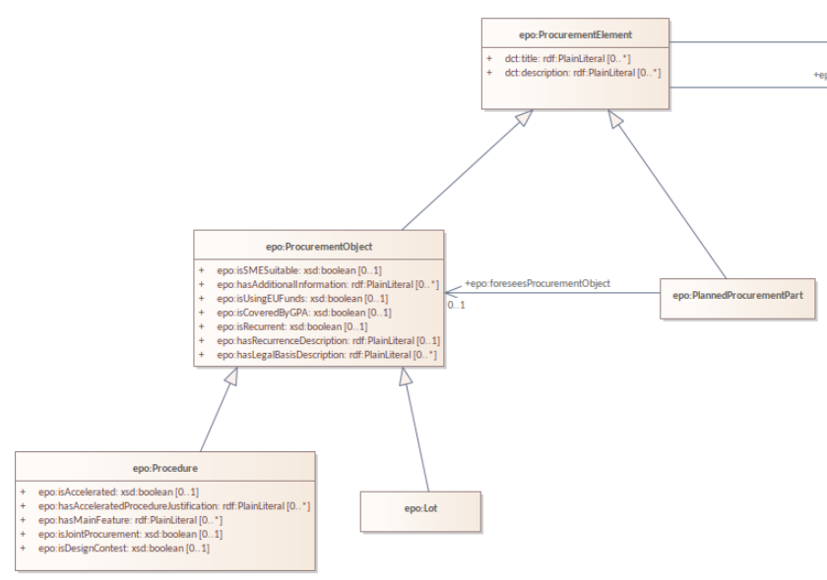

The Procedure & Planned Procurement Part exhibits two different modelling challenges that came afore when we were analysing it on what the temporal relation between the two should be, if any.

Part vs isa vd evolves into

The identity of PlannedProcurementPart and how disjoint/different it is from Procedure:
- Is PlannedProcurementPart a part of a procedure, a type of procedure, or evolves into a procedure? This was left unclear in the atemporal model, but since they are definitely temporally related, it brought up the question how, and therewith also what they really are. Some options that passed the revue in our analysis are as follows (see screenshot below), which are unlikely to be all correct:
  - The “chg” arrow says “Each Procedure was a Planned Procurement Part, but is not now.” no.
  - The “EXT” arrow: “Each Planned Procurement Part may also become a Procedure” procedure was perhaps a ppp. But not both at the same time
  - The “ext 6” arrow: “A Procedure may already be a Planned Procurement Part for 6 months.”
  - Note: other options are also possible, but not drawn; e.g., an “ext 6” arrow with a solid shaft would amount to “A Procedure was already a Planned Procurement Part for 6 months.” and adding a pin to the “chg” prevents a procedure from becoming a planned part again, i.e., “Each Procedure was a Planned Procurement Part, but is not now, and remains a Procedure indefinitely.” no!

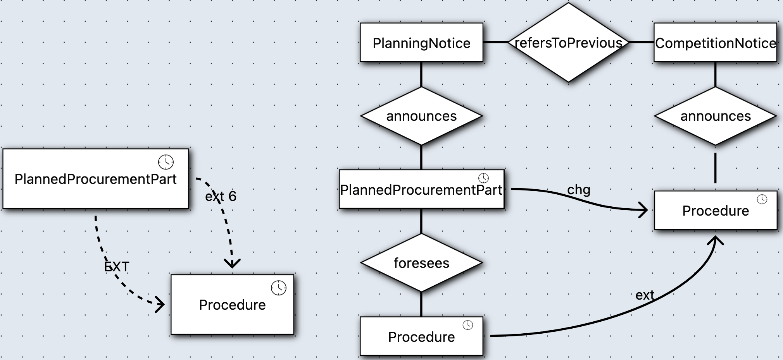

Procedure across notices

Procedure appears twice, but in different notice types, one for planning notices (foreseen by a PlannedProcurementPart) and one for competition notices (with the latter occurring after the former), which we drew in one model snippet during our analysis (in TRENDy, see above, right-hand side).
- The competition notice's Procedure is the one from the planning notice, but with a few more attributes, hence, the initial intuition for “ext”, in that the CompetitionNotice.Procedure was already a PlanningNotice.Procedure. Logically, one would not extend to itself, but to another class that is compatible in the sense of not resulting in an unsatisfiable class or association.
  - Are they the same and should therefore also have the same identifiers? (and be harmonised across models)
  - Are they different, in that the procedure of CompetitionNotice.Procedure would be a subclass of the procedure in PlanningNotice.Procedure, since it has more attributes, and so one was ‘extended’ into the other?

