# How to use provisioning script

1. Extract the zip file
2. Open the SP-PROVISIONING-SCRIPT.ps1 on a Text Editor
3. Replace the $title and $alias variable value to the name of the website you are creating

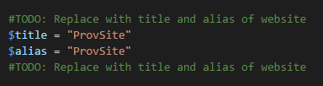

1. Set the flags to $True if you want to generate the template file.

**NOTE: if there is no template files yet, this must be set to $True**

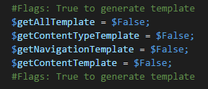

1. Go inside the Folder where the .ps1 file resides

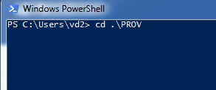

1. Execute the script

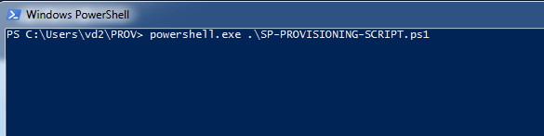

# What is being provisioned?

1. Generates the provisioning templates for future use
2. Creates the new modern site
3. Adds the executing user as the owner to the site that is being provisioned
4. Add the
   1. List and Libraries
      1. Documents
      2. Final Documents
      3. Review and Approval Tasks
      4. Team Tasks
      5. Update Document Type Workflow Tasks
      6. Workflow Tasks
   2. Workflows
      1. Update ADB Document Type
      2. Update ADB Country Document Type
      3. Update ADB Project Document Type
   3. Homepage
   4. Navigation

# NOTES:

1. Sharepoint 2010 Workflow are **NOT** provisioned.
2. Nintex Workflows are **NOT** provisioned.