Giant exterior LED screen
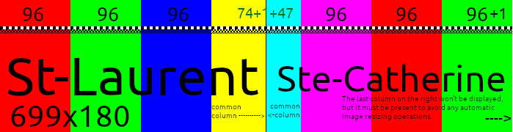

An image displayed on the giant screen must be 699 pixels wide by 180 pixels high. These are large pixels, so it’s worth refining your image down to the pixel. If the image is not exactly the right size, the display system will resize it on its own, significantly degrading the contrast and clarity.
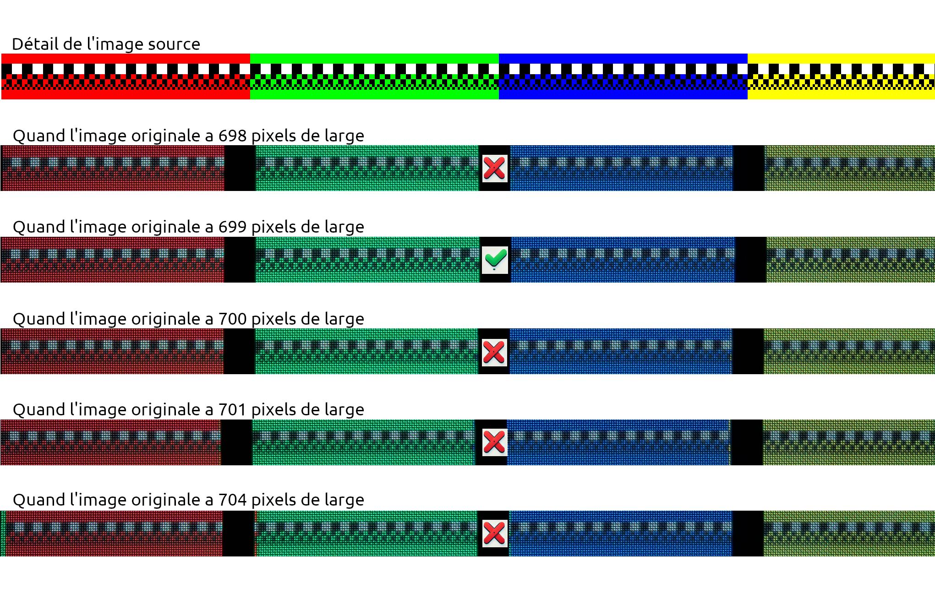
A quirk of the screen (a glitch) is that the rightmost pixel column on St-Laurent Street always has the same content as the leftmost pixel column on Ste-Catherine Street. I suspect a configuration error—a misalignment in the screen management software/firmware—which is likely the source of this annoyance.
Until a possible future fix, I suggest making this entire column of pixels black, to avoid what might look like slight image corruption. Unless you control the layout and don’t mind the duplication.

Alignment of the space for the posts between the windows.

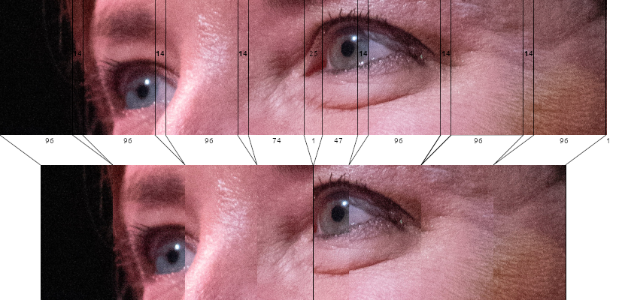
If you want to compensate for the gaps between the windows so that an image spanning multiple or all windows doesn’t look oddly stretched, you will first need to create an image of your subject at 807 pixels by 180 pixels, then cut it as follows:
So, the cutting process involves removing anything that would be hidden by the frames between the windows, all measured at an equivalent size of 14 pixels (14.1 to 14.5), except for the corner of the building, which hides *24 pixels (*25 if we count the column of pixels to darken).
The 4 windows on St-Laurent have the following numbers of pixel columns: 96, 96, 96, and *74 (*75 if we count the pixel column with the glitch).
The 4 windows on Ste-Catherine have the following numbers of pixel columns: *47 (*48 if we count the pixel column with the glitch), 96, 96, and 96.
And don’t forget the final column of pixels you must add to reach a total width of 699 pixels for the image—its content doesn’t matter, but its presence is essential.

Produce a video

To produce a video, one approach would be to first create a video at 807x180. If you’re using DaVinci Resolve, the software doesn’t allow creating a timeline smaller than 256x256, so instead produce a timeline at double size (1614x360). Then, when exporting, choose the correct size. The video export must be done as images (JPEG or another format) at 807x180.

I made a small open-source software to process the 807x180 pictures into correct 699x180 cuts, it’s available here:
https://github.com/meantux/hachoir-mem
The link above has the installation and usage instructions
Once you produced a series of pictures of 699x180 pixels you need to convert them back to a video using your preferred tool.
WARNING: some encoders (like mp4) does not let you create videos with an odd number width, we need the video to be precisely 699x180. The vp9 (webm) encoding would be able to create such an output
Denis-Carl Robidoux, ami du musée
deniscarl@gmail.com

