

CS 4210 – Assignment #5

**Maximum Points: 100 pts.**



Bronco ID: | | | | | | | | | | Last Name: First Name:

**Note 1:** Your submission header must have the format as shown in the above-enclosed rounded rectangle.

**Note 2:** Homework is to be done individually. You may discuss the homework problems with your fellow students, but you are NOT allowed to copy – either in part or in whole – anyone else’s answers.

**Note 3:** Your deliverable should be a .pdf file submitted through Gradescope until the deadline. Do not forget to assign a page to each of your answers when making a submission. In addition, source code (.py files) should be added to an online repository (e.g., github) to be downloaded and executed later.

**Note 4:** All submitted materials must be legible. Figures/diagrams must have good quality.

**Note 5:** Please use and check the Canvas discussion for further instructions, questions, answers, and hints. The bold words/sentences provide information for a complete or accurate answer.

1. [25 points] By considering the following 8 2D data points below do:
   1. [20 points] Group the points into 3 clusters by using k-means algorithm with Euclidean distance. Show the intermediate clusters (**by drawing ellipses on this 2D space**) and centroids (**by drawing marks like X on this 2D**) in each iteration until convergence. Also, **fill the solution table** below to show the distances from data points to the current centroids and the new centroids found. Consider the initial centroids as: C1 = A1, C2 = A4, and C3 = A7.

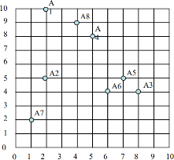

|  |  |  |  |  |  |  |  |  |
| --- | --- | --- | --- | --- | --- | --- | --- | --- |
| 1st iteration | | | | | | | | |
| Centroid: (C1, C2, C3) | | | | | | | | |
| Instance | A1 | A2 | A3 | A4 | A5 | A6 | A7 | A8 |
| C1 dist. | 0 | 5 |  |  |  |  |  |  |
| C2 dist. |  |  | 5 | 0 |  |  |  |  |
| C3 dist. |  |  |  |  |  |  | 0 |  |
| Cluster Assigned | C1 | C3 | C2 | C2 | C2 | C2 | C3 | C2 |

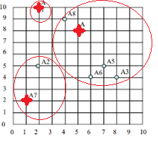

2nd iteration centroid:

C1 = (2, 10)

C2 = (6, 6)

C3 = (1.5, 3.5)

|  |  |  |  |  |  |  |  |  |
| --- | --- | --- | --- | --- | --- | --- | --- | --- |
| 2nd iteration | | | | | | | | |
| Centroid: (C1, C2, C3) | | | | | | | | |
| Instance | A1 | A2 | A3 | A4 | A5 | A6 | A7 | A8 |
| C1 dist. | 0 | 5 |  |  |  |  |  |  |
| C2 dist. |  |  |  |  |  | 2 |  |  |
| C3 dist. |  |  |  |  |  |  |  |  |
| Cluster Assigned | C1 | C3 | C2 | C2 | C2 | C2 | C3 | C1 |

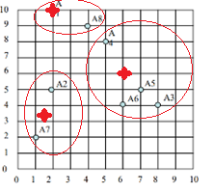

3rd iteration centroid:

C1 = (3, 9.5)

C2 = (6.5, 5.25)

C3 = (1.5, 3.5)

|  |  |  |  |  |  |  |  |  |
| --- | --- | --- | --- | --- | --- | --- | --- | --- |
| 3rd iteration | | | | | | | | |
| Centroid: (C1, C2, C3) | | | | | | | | |
| Instance | A1 | A2 | A3 | A4 | A5 | A6 | A7 | A8 |
| C1 dist. |  |  |  |  |  |  |  |  |
| C2 dist. |  |  |  |  |  |  |  |  |
| C3 dist. |  |  |  |  |  |  |  |  |
| Cluster Assigned | C1 | C3 | C2 | C1 | C2 | C2 | C3 | C1 |

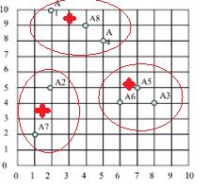

4th iteration centroid:

C1 = (3.665, 9)

C2 = (7, 4.333)

C3 = (1.5, 3.5)

|  |  |  |  |  |  |  |  |  |
| --- | --- | --- | --- | --- | --- | --- | --- | --- |
| 4th iteration | | | | | | | | |
| Centroid: (C1, C2, C3) | | | | | | | | |
| Instance | A1 | A2 | A3 | A4 | A5 | A6 | A7 | A8 |
| C1 dist. |  |  |  |  |  |  |  |  |
| C2 dist. |  |  |  |  |  |  |  |  |
| C3 dist. |  |  |  |  |  |  |  |  |
| Cluster Assigned | C1 | C3 | C2 | C1 | C2 | C2 | C3 | C1 |

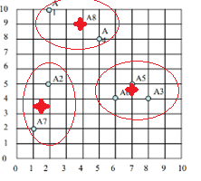

Centroids do not change! Convergence reached!

* 1. [5 points] Calculate the SSE (Sum of Square Errors) of the final clustering.

1. [15 points] Complete the Python program (clustering.py) that will read the file training_data.csv to cluster the data. Your goal is to run k-means multiple times and check which k value maximizes the Silhouette coefficient. You also need to plot the values of k and their corresponding Silhouette coefficients so that we can visualize and confirm the best k value found. Next, you will calculate and print the Homogeneity score (the formula of this evaluation metric is provided in the template) of this best k clustering task by using the testing_data.csv, which is a file that includes ground truth data (classes).
2. [20 points] The dataset below presents the user ratings on a 1-3 scale for 6 different rock bands.

|  |  |  |  |  |  |  |
| --- | --- | --- | --- | --- | --- | --- |
|  | Bon Jovi | Metallica | Scorpions | AC/DC | Kiss | Guns n’ Roses |
| Fred | 1 | 3 | - | 3 | 1 | 3 |
| Lillian | 3 | - | 2 | 2 | 3 | 1 |
| Cathy | 2 | 2 | 2 | 3 | - | 2 |
| John | 3 | 2 | 2 | 2 | ? | ? |

* 1. [10 points] Apply **user-based** collaborative filtering on the dataset to decide about recommending the bands Kiss and Guns n’ Roses to John. You should make a recommendation when the predicted rating is greater than or equal to 2.0. Use cosine similarity, a neutral value (1.5) for missing values, and the top 2 similar neighbors to build your model.
  2. [10 points] Now, apply **item-based** collaborative filtering to make the same decision. Use the same parameters defined before to build your model.

1. [25 points] Consider the following transaction dataset.

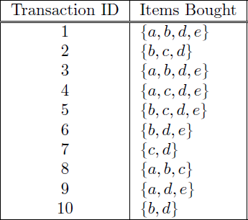

Suppose that minimum support is set to 30% (*minsup*) and minimum confidence is set to 60%.

* 1. [5 points] Rank all frequent itemsets according to their support (list their support values).
  2. [5 points] For all frequent 3-itemsets, rank all association rules - according to their confidence values - which satisfy the requirements on minimum support and minimum confidence (list their confidence values).
  3. [5 points] Show how the 3-itemsets candidates can be generated by the 𝐹𝑘−1 X 𝐹𝑘−1 method and if these candidates will be pruned or not.
  4. [10 points] Consider the lattice structure given below. Label each node with the following letter(s):

*F* if it is frequent and *I* if it is infrequent.

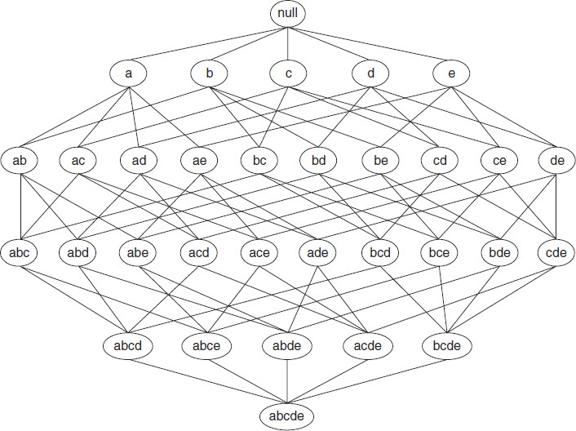

1. [15 points] Complete the Python program (association_rule_mining.py) that will read the file retail_dataset.csv to find strong rules related to supermarket products. You will need to install a python library this time. Just use your terminal to type: pip install mlxtend. Your goal is to output the rules that satisfy *minsup* = 0.2 and *minconf* = 0.6, as well as the priors and probability gains of the rule consequents when conditioned to the antecedents. The formulas for this math are given in the template.

**Important Note:** Answers to all questions should be written clearly, concisely, and unmistakably delineated. You may resubmit multiple times until the deadline (the last submission will be considered).

**NO LATE ASSIGNMENTS WILL BE ACCEPTED. ALWAYS SUBMIT WHATEVER YOU HAVE COMPLETED FOR PARTIAL CREDIT BEFORE THE DEADLINE!**