**Mubarakuly Magzhan 23B031373**

## Step 1: Identify common components of a network as represented in Packet Tracer.

**Question 1:** List the intermediary device categories.

**Answer:**

* **Routers**
* **Switches**
* **Hubs**
* **Wireless Devices**
* **Security**
* **WAN Emulation**

**Question 2:** Without entering into the internet cloud or intranet cloud, how many icons in the topology represent endpoint devices (only one connection leading to them)?

**Answer: 15.**

**Question 3:** Without counting the two clouds, how many icons in the topology represent intermediary devices (multiple connections leading to them)?

**Answer: 11**

**Question 4:** How many end devices are **not** desktop computers?

**Answer: 8**

**Question 5:** How many different types of media connections are used in this network topology?

**Answer: 4**

## Step 2: Explain the purpose of the devices.

1. In Packet Tracer, only the Server-PT device can act as a server. Desktop or Laptop PCs cannot act as a server. Based on your studies so far, explain the client-server model.

**Answer:**

The **client-server model** is a network architecture in which:

* **Clients** are devices (such as desktop PCs, laptops, or mobile devices) that send requests to access resources or services.
  + - **Servers** are dedicated devices that provide resources, services, or data to clients.

1. List at least two functions of intermediary devices.

**Answer:**

* 1. Routing **and Forwarding:**  
     Devices like routers and switches determine the best path for data to travel through the network and forward the data packets accordingly.
  2. Network **Security and Control:**  
     Firewalls and access points provide security by monitoring and controlling incoming and outgoing traffic based on security rules.

1. List at least two criteria for choosing a network media type.

**Answer:**

• **Bandwidth Requirements:**  
The amount of data the network needs to transmit. For example, fiber optic cables are suitable for high-bandwidth requirements, while twisted-pair cables are sufficient for lower bandwidths.

• **Distance:**  
The maximum distance the media can effectively transmit data. For instance, fiber optics can cover long distances without significant signal loss, whereas Ethernet cables (twisted pair) are limited to shorter distances.

## Step 3: Compare and contrast LANs and WANs.

a.     Explain the difference between a LAN and a WAN. Give examples of each.

**Answer:**

**1. LAN (Local Area Network):** Covers a small area or a geographical area like a home, office, or building. For ex: Office network with PCs connected to a switch.

**2. WAN (Wide Area Network):** Covers a large area, like cities or countries. For ex: The internet or a corporate WAN connecting multiple branch offices.

b.     In the Packet Tracer network, how many WANs do you see?

**Answer:**

There are 2 **WAN**s:

* 1. Intranet
  2. Internet

1. How many LANs do you see?

**Answer:**

There are 3 **LAN**s:

* 1. Central
  2. Home Office
  3. Branch

1. The internet in this Packet Tracer network is overly simplified and does not represent the structure and form of the real internet. Briefly describe the internet.

**Answer:**

The internet is a global network of interconnected networks that use the TCP/IP protocol for communication. It allows devices to communicate and share resources from anywhere.

1. What are some of the common ways a home user connects to the internet?

**Answer:**

DSL, Cable, satellite or mobile data.

1. What are some common methods that businesses use to connect to the internet in your area?

**Answer:**

Leased lines, Cable, Fiber Optic, DSL, Satellite.

**Challenge Questions:**

1. 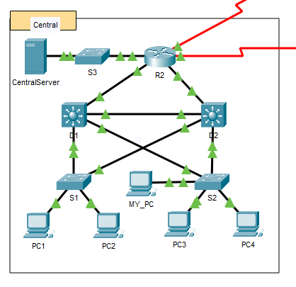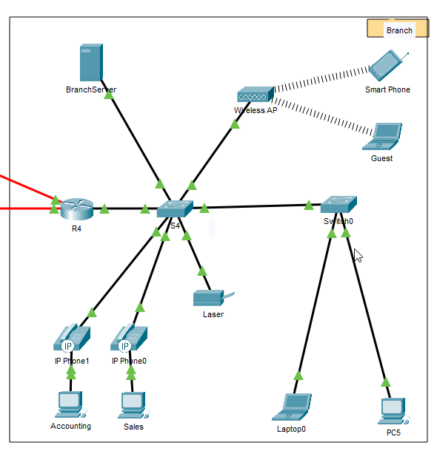
2. 