In networking, an ad hoc network is a collection of wireless mobile nodes dynamically forming a temporary network without the use of an existing infrastructure or centralized administration. Wireless nodes are free to enter and leave the network at any time causing the network topology to change rapidly and unpredictably. Ad hoc networks are generally used for peer to peer applications but can also have access to the internet through a node and can use the internet’s services. Due to the mobility, unpredictability, and size of the network make designing routing protocols challenging. In this project, we look at the network characteristics of one-hop and two-hop UDP/TCP data transmission in an ad hoc network and try to pinpoint its advantages/disadvantages.

Most ad hoc networks used commercially, for example Bluetooth, are a one-hop network. This is because they are more easily understood and are less complex. When you have a network where any 2 users can communicate with each other you must introduce routing protocols. Since the nodes can vary in processing capabilities you want the routing protocols to be efficient while still being done in a timely manner. There are many different design choices involved in creating a routing protocol such as proactive (keeping an updated list of reachable nodes) or reactive (getting a distance vector to a node upon request). The best routing protocol for an ad hoc network is yet to be found and is an active area for research.

Another challenge in ad hoc networks is security. Because the routing is done at the node level it Is easy for a malicious user to sabotage the routing of packets. Since there is no centralized authority, authentication to join a network can be hard to implement. Since the network can sometimes consist of very unsecure nodes users are able to hack into less secure nodes to easily gain access to the network. Once a malicious user is in the network it can be very hard for the network to identify this user. This creates security challenges at multiple network layers and is shown nicely in a table taken from the book: *A Hoc Mobile Wireless Networks by Subir Kumar Sarkar T.G. Basavaraju C. Puttamadappa*:

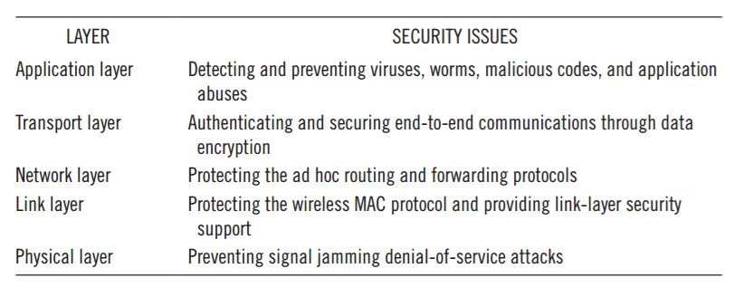

While ad hoc networks have a lot of challenges involved in its implementation it can be a useful solution in certain situations. For example, in a natural disaster where the local infrastructure gets destroyed an ad hoc network would be able to be set up in a matter of hours to be able to contact people in need of help. Another implementation is in sensor networks. Sensors could be put in various environments and communicate with each other without having to be in a location that has access to the internet. This could be used to track the conditions of an ecosystem in a remote area. There is also a nice list in the same book of potential applications of an ad hoc network:

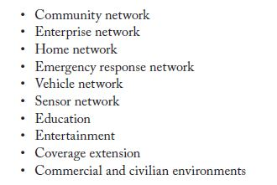

For this project, we were tasked with observing the network characteristics of an ad hoc network. We looked at the data transmission via UDP/TCP in 1/2 hops by measuring the jitter, packet loss, and speed as well as other factors to try to get a better understanding of how an ad hoc network functions in the real world.

**TALK ABOUT HOW WE WENT ABOUT THE PROJECT**

One thing to note is that when we were taking our measurements for the 2-hop data transmission we noticed that sometimes the source would bypass the relay and try to directly connect to the destination. While we do not know the exact routing protocol in Linux’s ad hoc mode we think that it the source requestor will broadcast an IP that they wish to receive from, then any node that hears this request will try to find that IP. If a node hears this request and is the IP that the request is looking for then the node will respond saying to connect through me. If a node hears this request and doesn’t have the IP the request it is looking for then it tries to flood its network with a request for the IP to see if it is within reach. Then if one of the nodes in its network responds then it will respond back to the original requestor saying that it can reach the IP and go through me.

We think that sometimes the destination would hear the IP request and respond to the source faster than the relay would be able to contact the destination and respond. This would bypass the router and even though the destination responded to the request quicker than the relay it is a much spottier connection due to the distance between the source and destination. The complete data transmission would have been smoother to go through the relay because between each individual node there is a shorter distance and there would be less packet loss.

This poses a problem when constructing an ad hoc network, how does a node choose the best path? Since distance creates a much larger packet loss than speed loss, how do you make a network that can pick up on this and choose the best path?

A proposed solution is using GPS to get the location of a node and then use that in the request/accept message so a node can factor distance into the routing equation. Exhaustive testing would need to be done to have a good understanding of the packet loss at different distances, then what you could do is have a cost based routing function and assign a weight to whatever distance the node is from one another. Combine that with the pinged throughput to have a more accurate routing equation that would produce less packet loss. GPS technology may have to improve because the distances between nodes in ad hoc networks are relatively small. Also, this adds overhead and would require the nodes to be more power hungry by using GPS. Maybe there will be a new technology that would be able to track relative distances instead of using GPS coordinates.