Modeling the evolution of ai language

  - A Single-Firm Case Study

  - Marco Siliezar ^{1, 2,}†
  - 1 Northwestern University
2 https://meatloaf02.github.io
† marco.siliezar@gmail.com

Abstract
With the popularity and fast evolution of artificial intelligence (AI) over the last several years, enterprise software firms have increasingly redistributed internal resources toward the development and integration of AI technologies (McKinsey & Company 2025). As noted in the McKinsey article, executives view AI as likely to drive “potentially higher margins and earnings” from AI-powered solutions and from internal development efficiencies, which translate to increases in shareholder value. This research paper attempts to answer the question, has shareholder value been recognized as a result?
This research aims to review the evolution of AI related language, product capabilities, market positioning, and risk disclosures from 2015 to present for Workday, Inc., a business-to-business enterprise software company. Information about this company will be extracted from various online sources including regulatory filings, official company press releases, and events, ingested and stored in a knowledge graph (KG) database. The KG will power a predictive model for predicting the next month return direction for this company’s stock as a proxy for shareholder value. The KG is the facility by which basic answers can be obtained about the company, mentions, disclosures, announcements included in its SEC filings, and it’s the mechanism by which timeseries analyses can be conducted by investors, researchers, and management.
Table of Contents
Abstract i
Introduction and Problem Statement 1
Literature Review 1
Textual Analysis of SEC Filings as Financial Signal 1
Corporate Disclosures and Knowledge Graphs 2
AI-Related Language in Disclosures and Risks 2
Research Gap and Contribution 2
Data 2
Methods 4
Results 9
Conclusions 10
References 11
Code Availability 13
Appendix 14

Introduction and Problem Statement
Core enterprise software-as-a-service enterprise platform companies sell to other businesses products that aim to increase productivity. Workday is a publicly traded company that builds these products for managing human resources, finances, payroll, and other core aspects of corporate and government operations. These aspects are essential to corporate operations thus there is an inherent efficiency maximization problem that is to be solved. Therefore, Workday is an interesting single-company case study to research whether its use of AI addresses this efficiency problem for its customers.
This research aims to compare the increase in AI-related language over time against the stock price. A predictive model will be powered by a knowledge graph containing information about this company. The predictive model will attempt to predict next month’s stock direction. The model will not answer whether the stock should be bought or sold, rather it will output the probability the direction next month is up based on signals and measures derived from the knowledge base.
Likely users of this application will be analysts, investors, and management conducting research who will be looking for support for a trading-style direction rule using this firm’s AI strategy as input. The application will not be for users who want to answer the question, “should I buy or sell WDAY?”

Literature Review

Textual Analysis of SEC Filings as Financial Signal
Finance researchers have previously studied the link between financial tone of text in 10-K filings to financial performance and outcomes. By creating finance-domain specific word lists, Loughran and McDonald (2011) showed that these lists provide a better understanding of the impact of filing text on stock returns more than generic nonbusiness word lists. The text in filings is an important aspect but more so is its readability. When analyzing the relationship between annual report readability and company performance, Li (2008) found that firms with poor performance have more difficult to read annual reports. Thus, financial tone and readability are signals and are features worth comparing against embeddings.

Corporate Disclosures and Knowledge Graphs
Financial narrative researchers have previously explored how to process unstructured corporate disclosure documents using natural language processing techniques to store them in knowledge graphs to discover underlying networks. An approach by Cavar (2018) creates a pipeline to process 10-K filings, analyze their semantics using publicly available Python packages for NLP processing, creates a uniform data structure, and implements a knowledge graph for storing raw text as tuples. This demonstrates the feasibility of domain-specific knowledge graphs for storing and analyzing corporate disclosure data.

AI-Related Language in Disclosures and Risks
The rise of AI-related language has been quantified by industry analysis. In a report by Arize (2024), an AI observability and LLM evaluation company, quantified how often companies mention AI and how often this language is associated with risk. Their report shows that in 2024 the Fortune 500 companies mention AI 250.1% more than in 2022. These companies cited AI as a risk factor more than 473.5% more in 2024 than in 2022. This analysis supports the hypothesis about AI as an opportunity versus a risk.

Research Gap and Contribution
Prior work demonstrates that language in 10-K filings is informative, provides signals, and representing their information in a knowledge graph, provides relationships that would otherwise be nonobvious. However, there is limited work integrating longitudinal NLP, knowledge graph modeling, and firm-specific context within a single framework. This research contributes by modeling Workday, Inc. as a longitudinal single-firm case study, constructing a knowledge graph that captures the evolution of AI-related language from 2015 to present. This approach enables exploratory signals relevant to investment decision-making.

Data
To build a strong dataset for the predictive model, data from 2015 to 2026 was obtained about this single company from its official SEC filings, official corporate webpages, earnings prepared remarks, and public news coverage. Table 2 in the Appendix summarizes the data. Most of the data originates from SEC filings, however. All data was obtained from public and free sources. Data available only from paid subscriptions was not obtained. However, the public data contains adequate context about the activity of this company including acquisitions, product capabilities, risk topics mentioned by leadership, and announcements over time. For example, the earnings prepared remarks dated November 25, 2025, obtained through web scraping provided the CEO’s announcement about a recent acquisition of an AI platform company: “Last week, we announced the intent to acquire Pipedream, a low-code integration platform for AI agents…” (Workday, Inc., 2025). This document is an example contribution to high-signal product detail. This can be fed into the knowledge graph that becomes the generator of features whose provenance can be traced back to this specific document.
The MVP scope of this research is to ingest 300 – 500 documents to balance comprehensive coverage with project feasibility. Ideally, these documents are distributed across the analysis period (2015 to present) with the priority of documents sourced from SEC filings. The success criteria in as far as document ingestion is that MVP is achieved when at least one document is ingested for every quarter in the analysis period, all SEC filings are included, and there are at least 30 AI-relevant documents per year at least starting in 2020.
A methodological approach was taken to reach a document corpus that was of minimum noise and was appropriate for a longitudinal AI-language analysis. The raw corpus consisted of 785 documents. However, some of these documents were filing components such as exhibits, index pages, and attachments that are included with SEC filings. These documents are not useful for this study and including them artificially inflate document counts and distort longitudinal measures. Thus, to preserve the original raw corpus and define a set of documents to be used for analysis, a canonical analysis layer was defined for the purpose of filtering. Accession numbers (unique document identifier) was used for deduplication. For future proofing, the analysis layer is versioned. The first version of the analysis layer was defined as annual reports (10-K filings), quarterly reports (10-Q’s), earnings releases (8-K’s) and proxy statements (DEF 14A). These are primary narrative filings only. Documents needed to contain at least 100 characters (this filters out XBRL shells.) To filter All documents that fit these criteria in the processed JSON files have this field set to true. To maintain canonical analysis layer versioning, an additional field was created, and each eligible document is tagged with this field set to ‘canonical_v1’ to version the analysis corpus definition.
The reasoning for the canonical analysis layer approach is described next. First, this approach ensures temporal comparability and eliminate duplication of documents, which is inherent in SEC EDGAR filings. The first version of the canonical filing corpus represents one primary narrative document per SEC filing event. Second, this approach ensures there are comparable document counts across years. This will help keep stable the denominator for language normalization. Third, downstream consumers, such as KG-backed features, filter on versioned analysis layer for AI-study scope.
The temporal scope of the canonical corpus (Figure 1) is as follows. For each fiscal year spanning 2013 – 2025, the corpus contains:
- One Form 10-K
- Three Form 10-Q filings
- One Form DEF 14A
- A variable number of Form 8-K filings
The second version of the analysis layer excluded DEF 14A proxy statements. The problem with proxy statements is that they have a distinct narrative focus such as executive compensation and governance discussions. These documents are inappropriate for the AI-language evolution study. Of the 118 documents included in the first canonical analysis layer, 104 documents remained in this second iteration.

Figure 1: Temporal scope of the canonical corpus

Methods
To arrive at utilizing the predictive model for predicting the next month’s return direction of this company’s stock, a five-stage pipeline was created. This pipeline aims to provide the predictive model with an aggregation of quarterly signals along with entities extracted from a knowledge graph created in a prior step. The benefits of creating a knowledge graph at this stage is for identifying, exploring relationships (nodes/edges) that otherwise wouldn’t be obvious in a relational database, and easy query the ingested data. The data for knowledge graph ingestion is processed through its own pipeline to extract text, dates, split sentences, and store the processed documents in a JSON format. To summarize the architecture, the first stage ingests data from the mentioned sources and stores the raw documents in a PostgreSQL database. Table 4 in the Appendix provides a summary of the pipeline stages.

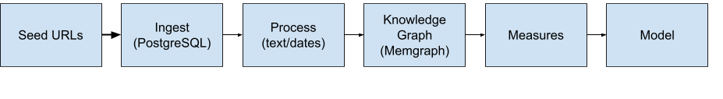
Figure 2. Architecture Overview
The ingest and process steps are as follows. Prior to ingesting data, seed URLs were hand curated. The goal of this approach is to obtain high coverage of company information and minimize noise. In this stage, sitemaps were also pulled with the purpose of enabling the web crawler to obtain documents deeper in these websites in a focused manner. The seed URLs were from a mix of content sources as seen in Table 3 in the Appendix. The focused web crawler takes the seed URL as an allowed and focused website list to crawl and fetches documents while maintaining compliance to robots.txt and implements rate limiting for polite crawling. Additionally, the data was normalized and deduped since duplicate data is surely to exist as information is sourced from various web locations. This web information extraction implementation uses the Beautiful Soup (Richardson, 2025) Python package to extract data from HTML files ingested from the internet, for example, for SEC filing documents. The ingested data is stored in a PostgreSQL table using the SQL Alchemy package (SQLAlchemy, 2026) to handle document metadata storage for hand-off to the knowledge graph.
One manual intermediate step was taken to define seed data for entities. The goal was to simplify the information extraction and to accurately populate the knowledge graph without noise. Seed data for entities included company products, capabilities and risk topics. Of course, a seed company was defined. However, the knowledge graph is abstracted enough and isn’t one-company specific. It can be applied to any similar company. Table 1 in the Appendix provides examples.
The knowledge base was constructed using a curated approach. The curated method (Nickel et al., 2015) was chosen to leverage the author’s expert knowledge of this company (and its subsector) to create an accurate representation. With this approach, a simple but effective set of triples was created to construct the knowledge graph. The KG was created using Memgraph software running inside a Docker container. The Memgraph software provides a user interface for interacting with the KG by running Cypher queries and visualizing the KG model itself. A visual representation of the KG schema (created in Memgraph software) is in Figure 2.
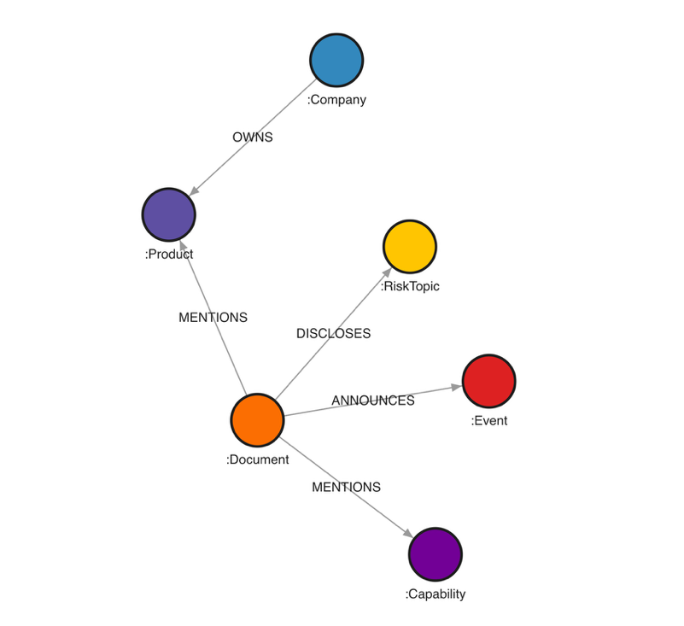
Figure 3. Knowledge Graph Schema (Memgraph)
The knowledge base schema includes entities and relationships that are Resource Description Framework (RDF) compatible. As the goal for this KG is to deliver buy/sell signal features which originate from information in documents created at a point in time, the database is designed to store documents which contain excerpts about mentions and claims. These mentions will become the evidence for the signal. Events will also become important. Events include filings, earnings calls, acquisition announcements, among other activity. These events will be time anchors. If analyst reports become obtainable such that they can be stored in the database, they are also documents and measures. Additionally, because Cypher (Neo4j, 2026) is used as the language to query the knowledge database, properties were declared for relationships to leverage this Cypher capability, particularly for maintaining timestamps. The complete knowledge graph schema is summarized in the Appendix: the entities in Table 3 and the relationships and their properties in Table 4.
An important ontological choice was the definition of an event for the purposes of the knowledge graph. A concrete definition was created to minimize scope and not introduce additional complexity from such techniques as named entity recognition. An event is either an earnings call, product launch, acquisition, partnership, leadership change, conference, or regulatory filing.
Database queries can be run in two ways in this repository. The first way is via the Memgraph connection module that uses a Neo4J Python driver (Neo4J, 2026). Because Memgraph is also compatible with the Bolt protocol (Memgraph, 2020), a Python connection module using this driver establishes a connection by which Cypher queries can be run against the database directly using Python (see connection.py in this paper’s Github repository.) The second way is to query the database using Memgraph software. This second approach is more user friendly, particularly for the target users of this KG. The power of KG querying using Cypher is its ability to run logically complex queries with just a few lines of code. The figure below shows the simplicity of running a query that finds all the capabilities and product mentions for every document published November 11, 2019. Note that the field ‘doc_sub_type’ in this database are details about a document. In this example, the 8.01 item in an 8-K filing was used by this company to disclose artificial intelligence and machine learning capabilities in their 8-K filing.
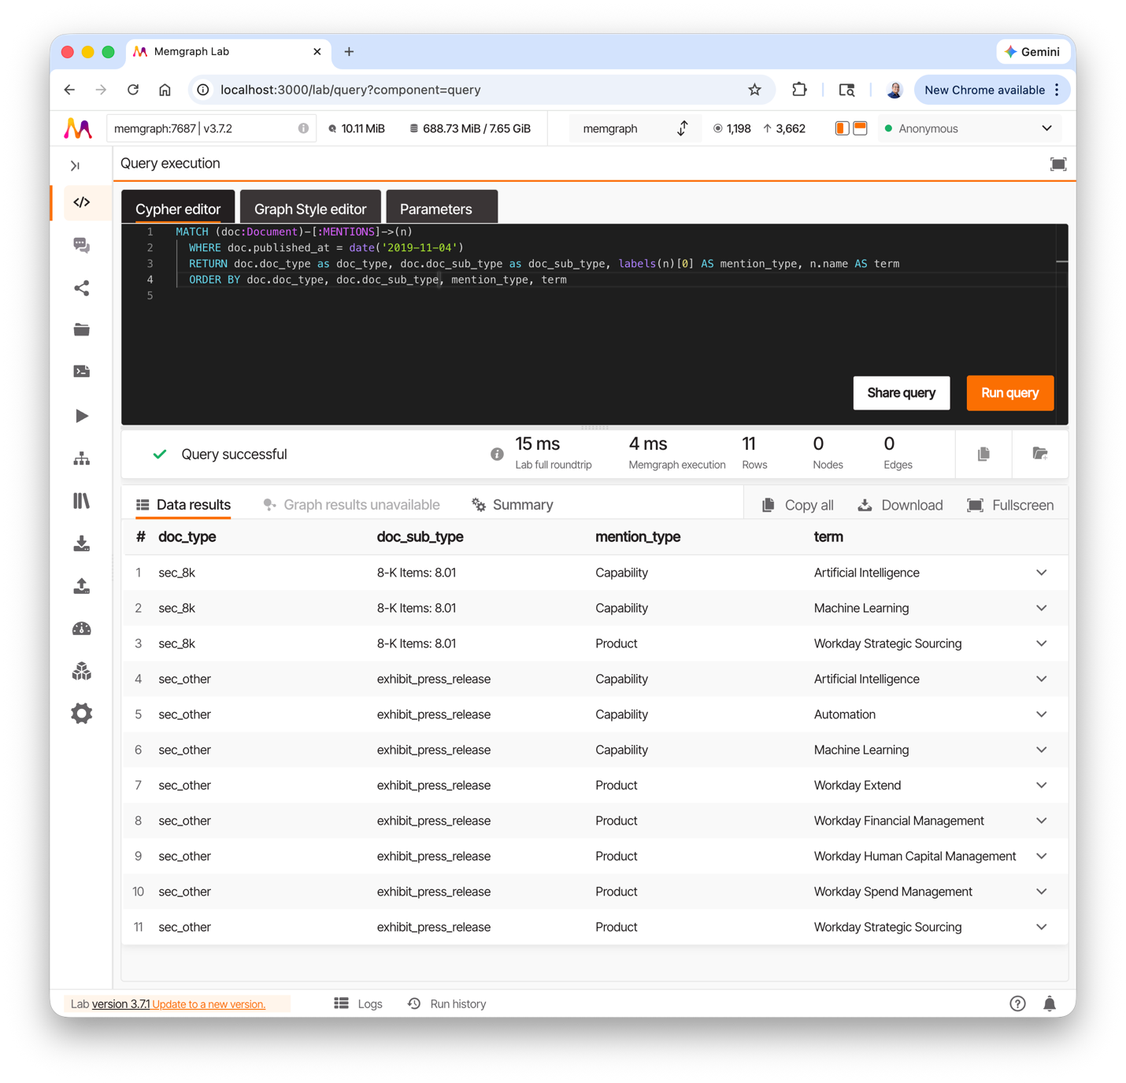
Figure 4. Example Cypher query in Memgraph
The example above demonstrates the usefulness of this graph database implementation in addressing questions. In the example, artificial intelligence and machine learnings were product capability terms that appeared in this 8-K filing, in addition to mentions about the company’s existing products. To further emphasize the simplicity for users of this KG in answering management questions, the figure below shows that a simple 4-line query returns the top 10 mentioned products (including their mention counts) across the corpus of this company’s filings from 2013 to 2025. Thus, using Memgraph software is the method used to query the KG for this research.
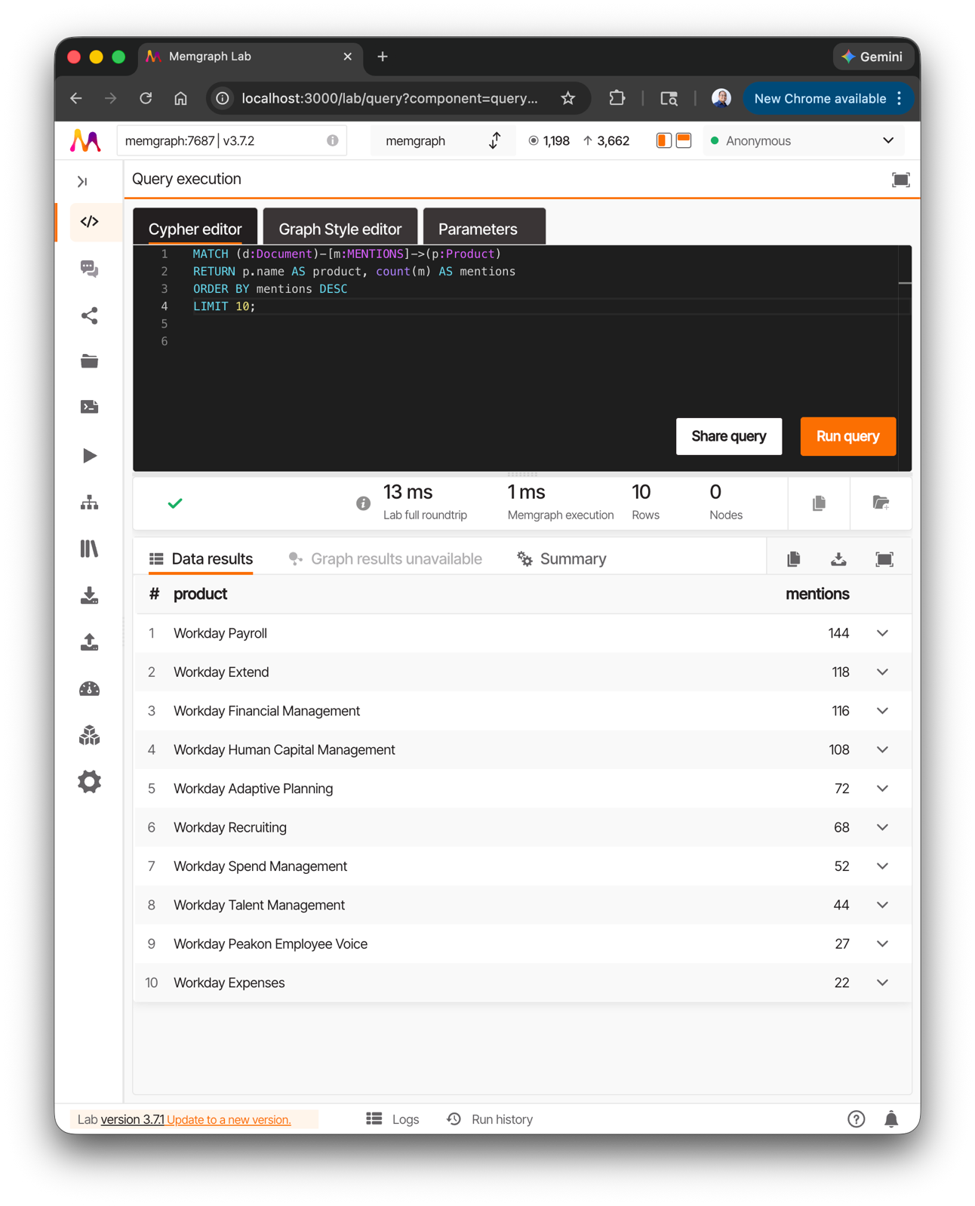
Figure 5. Top 10 product mentions
To facilitate timeseries questions and analysis by management, a disclosure-based artificial intelligence index (AII) was created constructed from company-authored filings. The purpose of this calculation is to identify how strongly Workday’s public narrative is shifting towards artificial intelligence. This index, measured in quarters, is computed as follows:
- Numerator: weighted count of AI-related mentions
- Denominator: total document length (in tokens) to normalize
Token counts were estimated as a document’s character count divided by four. Each document type is weighted in the following way:
- 10-K = 1.5x
- 10-Q = 1.2x
- 8-K = 1.0x
The rationale behind document weights is as follows. Each filing type carries different signaling credibility. The 10-K filings are strategic documents and thus should carry the most weight. The 10-Q filings provide updates to the annual 10-K filing, so these should carry slightly less weight than a 10-K. Lastly, 8-K filings provide announcements of events that could impact a company’s financial condition. Thus, these should carry the least weight due to their event-driven nature. The purpose is to provide a hierarchy of document importance. Using equal weights would assume that informational content across documents is homogenous which is inconsistent with the intent of the SEC. This index will be calculated for all documents in the second version of the analysis layer (layer that excluded DEF 14A proxy statements.) Once calculated across quarters, this index becomes a timeseries.

Results

Conclusions
The knowledge base that will be built for this research is designed to power a predictive model for the analyst and investor with the ability to answer questions such as: “What AI capabilities does Workday claim, where, and how often?”, “Which products are emphasized over time?”, “What risk topics are emerging?”. Additionally, it will power buy and sell signal features from media measures, impacts of events, and shifts in the language of filings over time. This depends on the quality and quantity of data which can be gathered from public sources. At the same time, the timespan of 2015 to present should provide sufficient data for the model. Lastly, this application will not claim certainty for a buy or sell position of a stock in the company, and it will not claim it has solved stock prediction. The success of this application in production for its users paves the way to implement future applications to additional B2B SaaS companies in the information technology sector.

References
Arize AI, Inc. 2024. “The Rise of Generative AI in SEC Filings”. https://arize.com/wp-content/uploads/2024/07/The-Rise-of-Generative-AI-In-SEC-Filings-Arize-AI-Report-2024.pdf
Bayer, Michael. 2026. “SQLAlchemy”. Accessed Feb 2, 2026. https://www.sqlalchemy.org/
Cavar, Damir and Matthew Josefy. 2018. “Mapping Deep NLP to Knowledge Graphs: An Enhanced Approach to Analyzing Corporate Filings with Regulators.” Proceedings of The first financial narrative processing workshop (FNP 2018).
Kejriwal, Mayank, Craig A. Knoblock, and Pedro Szekely. 2021. Knowledge Graphs: Fundamentals, Techniques, and Applications. Cambridge, MA: MIT Press.
Li, Feng. 2008. “Annual report readability, current earnings, and earnings persistence”. Journal of Accounting & Economics 45, no. 2 – 3 (August 2008): 221 – 247. https://doi.org/10.1016/j.jacceco.2008.02.003
Loughran, Tim and Bill McDonald. 2011. “When is a Liability Not a Liability? Textual Analysis, Dictionaries, and 10-Ks”. The Journal of Finance 66, no. 1 (February 2011): 35 – 65. https://doi.org/10.1111/j.1540-6261.2010.01625.
Memgraph, Ltd. 2020. “Memgraph 1.2 Release – Implementing The Bolt Protocol v4”. October 29, 2020. https://memgraph.com/blog/memgraph-1-2-release-implementing-the-bolt-protocol-v4
McKinsey & Company. 2025. “The AI-centric imperative: Navigating the next software frontier. October 16, 2025. https://www.mckinsey.com/industries/technology-media-and-telecommunications/our-insights/the-ai-centric-imperative-navigating-the-next-software-frontier
Neo4J. 2026. “Cypher Manual”, version 25. https://neo4j.com/docs/cypher-manual/current/introduction/
Nickel, Maximillian, Kevin Murphy, Volker Tresp, and Evgeniy Gabrilovich. 2015. “A Review of Relational Machine Learning for Knowledge Graphs.” Proceedings of the IEEE, 104(1): 11-33. https://arxiv.org/abs/1503.00759
Richardson, Leonard. 2015. “Beautiful Soup”. Accessed Feb 2, 2026. https://www.crummy.com/software/BeautifulSoup/
Workday. 2025. “Third Quarter Fiscal 2026 Prepared Remarks”. November 25, 2025. https://investor.workday.com/files/doc_financials/2026/q3/workday-fiscal-2026-third-quarter-prepared-remarks.pdf

Code Availability
The essential code to reproduce this research are available at https://github.com/meatloaf02/KG.git. The repository includes a comprehensive README file.

Appendix
URL | Content | Document Count
https://blog.workday.com/ | Corporate blog posts | 7
https://investor.workday.com/ | Investor Relations official website | 8
https://techcrunch.com/tag/workday/ | Public news coverage | 1
https://www.prnewswire.com/ | Press releases | 2
https://sec.gov | 10-k, 10-Q, 8-K filings, proxy statements | 784
Table 1. Data Manifest
Entity | Seed Data Examples
Company | Workday
Product | Workday-HCM, Workday-Financials, Workday-Payroll
Capability | AI, ML, Predictive Analytics, Automation, LLM
Risk Topic | Cybersecurity-Risk, Data-Breach, Regulatory-Compliance, AI-Ethics
Table 2. Seed Examples
Entity | Field | Notes
Document
 | Content Hash
 | URL Hash
 | Doc Type | 10-K, 10-Q, Press Release, etc.
 | Source Type | SEC Filing, Investor Relations, etc.
 | Publish Date
 | Published At | Converted to native Memgraph Date
 | Source URL
 | Created At
 | Updated At
Company
 | ID
 | Name
 | Ticker
 | SEC CIK
 | Created At
Product
 | ID
 | Name
 | Description
 | First Seen
 | Created At
 | Updated At
Capability
 | ID
 | Name
 | Category | AI, ML, Analytics, Automation, etc.
 | First Seen
 | Created At
 | Updated At
Risk Topic
 | ID
 | Name
 | Category
 | First Seen
 | Created At
 | Updated At
Event | ID
 | Name
 | Event Type | Earnings Call, Product Launch, etc.
 | Event Date
 | Description
 | Created At
 | Updated At
Table 3. KG Entities

Relationship | Property | Notes
Mentions; Discloses; Announces
 | Evidence Text | Text Span
 | Sentence ID | Sentence Identifier
 | End Char | End Offset
 | Confidence | 0 - 1
 | Extracted At | Date Time
Has_Capability
 | First Seen
 | Created At | Timestamp
Owns
 | Created At | Timestamp
Table 4. KG Relationships

