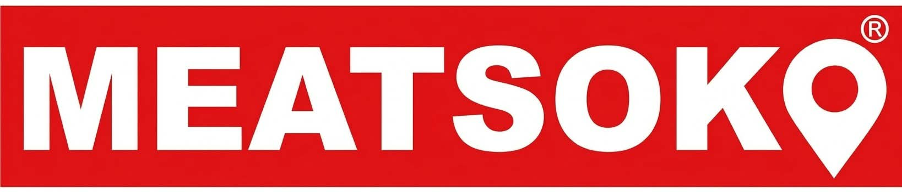  CONCEPT NOTE  NYAMA  FEST  Building the Next Generation of Kenya’s Red-Meat Economy  A strategic initiative of MEATsoko Group  CONCEPT DEVELOPED BY  Aaron Greene  Advisor to the Board, MEATsoko Group | 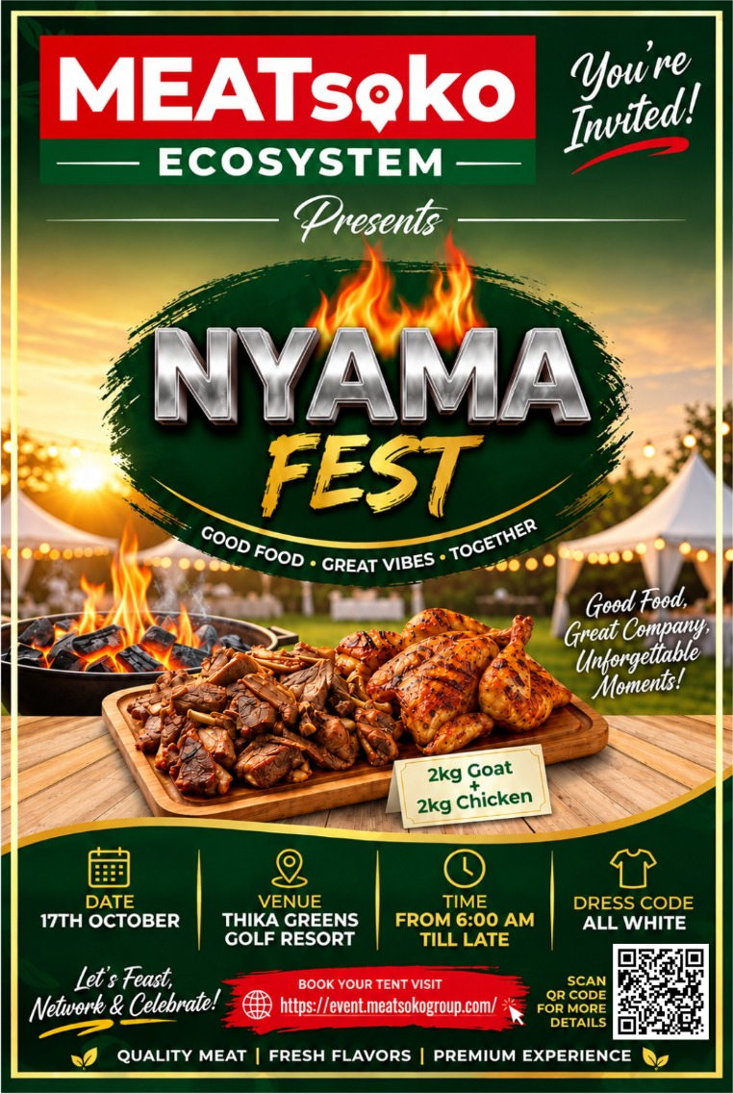

Event at a Glance
Detail | Information
Event | Nyama Fest
Date | 17 October 2026
Venue | Thika Greens Golf Resort
Time | From 6:00 AM till late
Dress code | All white
Host | MEATsoko Group
Information and bookings | event.meatsokogroup.com

About the Concept Developer
 | Aaron Greene  Climate Justice Advocate | Resilience Coach | Writer | Climate Geopolitics & Conflict Observer  Advisor to the Board, MEATsoko Group, on climate change, circularity, circular economy, informal workers’ rights and red-meat value-chain transformation.  With over 16 years of professional experience across climate justice, sustainable development, community resilience, circular economy, informal workers’ rights, advocacy, partnerships and frontline community engagement.

1 Background and Executive Summary
Kenya’s red-meat economy is deeply connected to livelihoods, culture, food systems, pastoralist communities, trade and enterprise. For decades, much of this economy has grown through informal networks, intergenerational knowledge, relationships and entrepreneurial activity.
Nyama Fest is a strategic initiative of MEATsoko Group, designed to help shape the next generation of this economy. MEATsoko represents a new generation of youth and adult entrepreneurs, many with roots and lived experience in Kenya’s ASAL regions, who are building a more formalised, connected, technology-enabled and resilient red-meat value chain.
This is not about abandoning the systems built by earlier generations. It is about building on their knowledge, relationships and entrepreneurial foundations while addressing the limits of informality, fragmentation, inadequate infrastructure, limited financing, climate vulnerability, weak traceability, resource leakage and insufficient value addition.
The concept draws on the strategic perspective of Aaron Greene, Advisor to the Board of MEATsoko Group, whose work over more than 16 years has focused on the intersections of climate justice, sustainable development, community resilience, circular economy, informal workers’ rights, advocacy and partnerships.
Nyama Fest is therefore positioned beyond a conventional food festival. It is a value-chain ecosystem platform where celebration becomes the entry point for collaboration, networking, investment, innovation, policy dialogue, technology exchange, partnerships and deal-making. It brings together farmers, pastoralists, traders, abattoirs, processors, retailers, consumers, informal workers, youth enterprises, technology companies, financial institutions, investors, government, researchers, development partners and regional actors.
THE CORE PROPOSITION
Nyama Fest is where the traditional red-meat economy meets the next generation.

It is where culture meets enterprise, experience meets technology, informality meets formalisation, waste meets value, climate risk meets resilience, energy transition meets opportunity, youth meets investment, and Kenya’s meat economy connects with the region and the world.

2 Project Overview
Nyama Fest is a strategic event of MEATsoko Group and a platform for building relationships across the red-meat ecosystem. MEATsoko is part of an emerging generation of meat-sector enterprises that seek to formalise, modernise and connect actors across the value chain while keeping the community knowledge and lived experience that underpin Kenya’s livestock economy.
The initiative deliberately embraces formalisation, technology and digitalisation, circularity, climate resilience, clean and renewable energy, value addition, youth entrepreneurship, decent work and workers’ rights, investment and finance, and regional and global connectivity.

Six interconnected pillars
Pillar | What it means
CELEBRATE | Good food, culture, quality, hospitality and shared experience.
CONNECT | Bringing together actors who traditionally operate in fragmented parts of the value chain.
COLLABORATE | Creating partnerships around innovation, circularity, sustainability, technology and enterprise.
NETWORK | Building relationships between businesses, professionals, communities, investors and institutions.
INVEST | Connecting viable opportunities with finance, technology, expertise and markets.
DEAL-MAKE | Moving beyond conversation towards MoUs, partnerships, investment commitments, market linkages and joint initiatives.

3 Problem Statement
The red-meat value chain faces a combination of structural and emerging challenges:
Market and enterprise | Value addition and environment | People and policy
- Persistent informality and fragmentation  - Limited access to finance and investment  - Weak traceability and digital integration  - Limited youth ownership and access to capital  - Limited regional market integration  - Weak links between research, technology and enterprise | - Limited processing and value addition  - Poor use of slaughter and processing by-products  - Pollution from unmanaged abattoir waste  - Loss of valuable organic resources  - Limited integration of renewable energy  - Climate shocks affecting livestock and livelihoods | - Occupational health and safety risks  - Inadequate recognition and inclusion of informal workers  - Gaps between policy and implementation

Experience in circular economy, climate resilience and informal workers’ rights adds an important dimension to this challenge. The question is not simply:
How do we produce and sell more meat?
It is:
How do we build a red-meat economy in which more of the value generated by livestock, labour, technology, knowledge and resources remains within communities and businesses, while reducing environmental harm and strengthening climate resilience?
That is the transformation Nyama Fest seeks to catalyse.

4 Rationale
Transforming Kenya’s red-meat economy requires an ecosystem approach. Production cannot be separated from markets. Markets cannot be separated from logistics. Processing cannot be separated from energy. Slaughter cannot be separated from waste management. Waste cannot be separated from circularity. Circularity cannot be separated from climate resilience. And enterprise development cannot be separated from workers’ rights and inclusive participation.
MEATsoko’s advisory perspective, built on 16+ years of professional experience, provides a strategic lens for connecting these dimensions:
ONE CONNECTED AGENDA
Climate action + circularity + enterprise + workers’ rights + technology + investment + value-chain transformation

Nyama Fest is conceived as a practical meeting point where these normally separate conversations can interact.

5 Goal
GOAL
To accelerate the transformation of Kenya’s red-meat value chain into a formalised, inclusive, technology-enabled, climate-resilient and circular economy ecosystem that creates dignified livelihoods, enterprise opportunities, investment and sustainable value across generations.

6 Objectives
Nyama Fest will seek to:
1 | Strengthen connectivity across the red-meat value chain.
2 | Support the generational transition from predominantly informal systems towards more formal and technology-enabled enterprise.
3 | Promote circularity and resource efficiency.
4 | Advance climate-resilient business models.
5 | Promote a just transition towards cleaner and renewable energy.
6 | Position youth as entrepreneurs, investors, innovators and owners.
7 | Promote decent work and recognition of informal workers.
8 | Create investment and commercial partnership opportunities.
9 | Strengthen regional and global connectivity.
10 | Turn dialogue into practical commitments, partnerships and deals.

7 Methodology
Nyama Fest combines celebration with strategic ecosystem building through six approaches:
Approach | Description
7.1 Convening | Bringing diverse actors together in one physical and strategic space.
7.2 Showcasing | Demonstrating technologies, enterprises, products, innovations and circular solutions.
7.3 Knowledge exchange | Sharing practical experience between traditional actors, emerging entrepreneurs, researchers, policymakers and technology providers.
7.4 Investment matchmaking | Connecting viable opportunities with investors, financial institutions and development finance.
7.5 Policy dialogue | Creating space for government and private-sector actors to identify regulatory and implementation opportunities.
7.6 Deal-making | Supporting concrete outcomes including MoUs, investment commitments, technology partnerships, market linkages and joint programmes.

8 Expected Outcomes
Nyama Fest is expected to generate:
- A more connected red-meat ecosystem
- Increased visibility of circular-economy opportunities
- Stronger youth enterprises
- New investment pipelines
- Technology partnerships
- Circularity and waste-valorisation opportunities
- Renewable-energy opportunities
- Stronger climate-resilience strategies
- Greater recognition of informal workers
- New regional and international relationships
- Concrete commercial agreements and partnerships

MEASURE OF SUCCESS
The central measure of success is not how many people attend, but: what relationships were created, what opportunities were unlocked, what investments were mobilised and what deals were signed.

9 Monitoring, Evaluation and Learning
A Nyama Fest Action and Investment Tracker will record commitments made at the event. For every commitment it should answer:
Who committed to what? | By when? | With what resources? | For which communities or businesses? | With what expected results?

Key indicators
- Number of participants  - Youth participation  - Women’s participation  - Informal-worker participation  - Businesses represented  - Investors engaged  - Technology providers engaged | - Partnerships established  - MoUs signed  - Investment value mobilised  - Circular-economy initiatives identified  - Renewable-energy opportunities developed  - Market linkages established  - Regional partners engaged  - Follow-up actions completed at 3, 6 and 12 months

10 Call to Action
Who | What we invite you to do
Government | Create enabling policies, standards, infrastructure and investment conditions.
Investors | Invest in infrastructure, technology, value addition, youth enterprise and circular business models.
Technology providers | Develop affordable, practical and scalable technologies for the meat ecosystem.
Financial institutions | Create financing mechanisms suited to youth enterprises, SMEs and circular businesses.
Youth | Move from being seen mainly as beneficiaries to becoming entrepreneurs, investors, innovators, owners and decision-makers.
Informal workers | Demand recognition, dignity, safety, fair participation and pathways into formal value chains.
Farmers and pastoralists | Remain central actors in the transformation of the value chain.
Development partners | Support systems change rather than isolated interventions.
Regional and global partners | Connect Kenya’s emerging meat economy to markets, technology, knowledge and investment.
MEATsoko | Continue building the bridge between traditional knowledge and modern, formal, digital, circular and climate-resilient enterprise.

11 Sustainability
Nyama Fest will build sustainability across five dimensions:
Dimension | What it means
Commercial | Viable businesses and revenue-generating partnerships.
Enterprise | Stronger youth-led businesses and value-chain enterprises.
Knowledge | Continued learning and knowledge exchange.
Partnership | Relationships that continue beyond the event.
Environmental | Resource efficiency, waste reduction, renewable energy and circularity.

The event itself should model the principles it promotes through responsible sourcing, waste reduction, recycling, resource efficiency and appropriate energy solutions.

12 Partner With Nyama Fest
Whether you are an investor, technology provider, financial institution, government agency, development partner or enterprise, there are practical ways to take part:
- Showcase technologies, products or circular solutions.
- Take part in investment matchmaking and partnership conversations.
- Join policy and knowledge-exchange sessions.
- Explore MoUs, market linkages and joint programmes.

Contact | Details
Name | [Insert contact person]
Email | [Insert email]
Phone / WhatsApp | [Insert phone]
Event information | event.meatsokogroup.com

13 Conclusion
Nyama Fest is an opportunity to do something larger than host a successful festival. It can become a strategic platform for the generational transformation of Kenya’s red-meat economy.
The knowledge, relationships and entrepreneurial spirit built by earlier generations are not obstacles to this transition. They are its foundation. The next generation can build on that foundation with technology, digital markets, formalisation, circular economy models, climate resilience, renewable energy, data, investment and regional and global connectivity.
With MEATsoko providing an emerging platform for this transition, and with Aaron Greene contributing more than 16 years of experience across climate justice, circularity, sustainable development, community resilience and informal workers’ rights in his advisory role to the Board, Nyama Fest can become an important space for connecting these agendas.

THE NYAMA FEST PROPOSITION
Nyama Fest is where the traditional red-meat economy meets the next generation.
Culture meets enterprise.  Experience meets technology.  Informality meets formalisation.  Waste meets value. | Climate risk meets resilience.  Energy transition meets opportunity.  Youth meets investment.  Kenya meets the region and the world.

OUR COMMITMENT
Nyama Fest should not only showcase what is possible. It should create the space where the people who can make it possible meet, collaborate, invest and sign the deals.

