Brett Lange, Metthew Austin, Jacob Mueller, and Kenneth Bevineau

**Project Deliverable 2**

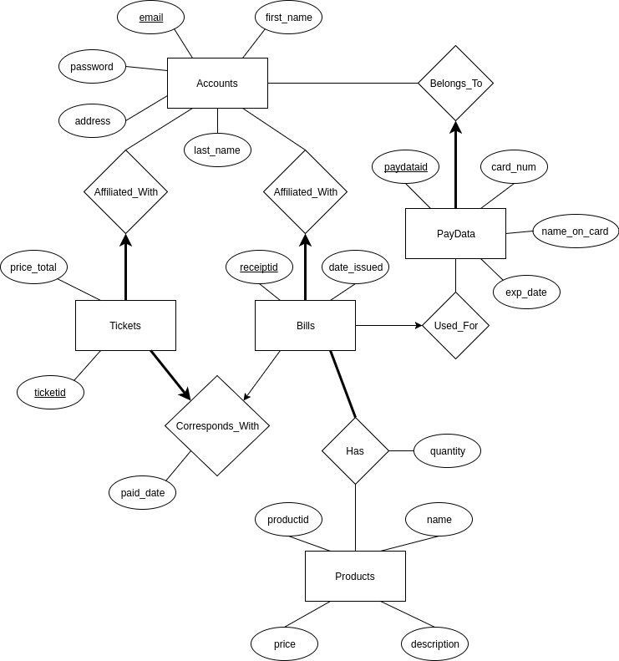

**1.)**

**Reasoning for our relationship types:**

Accounts and PayData – a user can have multiple credit/debit cards, but a credit/debit card can only belong to one user.

Accounts and Tickets – a user can have multiple tickets, but a ticket can only belong to one user.

Accounts and Bills – a user can have multiple bills, but a bill can only belong to one user.

Bills and PayDate – a bill can only be paid by one credit/debit card, but a credit/debit card can be used to pay many bills.

Bills and Tickets – A bill can be associated with only one ticket, and a ticket can be associated with only one bill. The ticket exists to show that a bill has been paid.

Bills and Products – A bill can have multiple products, and a product can be included in multiple bills.

**Primary key choices:**

The Accounts table will have its email as a primary key to make sure that multiple users can’t have the same email as emails will be used for authentication and invoicing. Every other key is an auto-incrementing integer. This is for simplicity.

**2.)**

**Does data already exist?:**

Not yet, as Brett’s clients are so far paying by check.

**How we plan to curate our data:**

The data will be curated from the information being entered into a form on a PHP website. The data will then be inserted into the database so that the customers can easily retrieve information like their bills, tickets, and credit/debit card information for later use.

**Who is in charge of this?:**

At the moment Brett is in charge of collecting and curating the data as he is working with his clients directly.