**Assignment 4**

**CIS355** – Spring Term 2018

**Point Value**: 100 points

**Assignment Due Date**: **In class Thursday, April 12, 2018**

**Submission Instruction**

The name of the file should be HW4_YourLastname_YourFirstname.docx. Please submit the file .docx on Schoology by 11:59pm and a hard copy of the .docx file to the instructor in class.

**Short answers**

1. What is logical address **(4 points)?** What is Physical address **(4 points)?**
2. What is internal fragmentation **(5 points)?** What is external fragmentation **(5 points)?** Please use your own words to describe them. You can draw figures/diagrams to illustrate them.
3. Compare the memory organization schemes of *contiguous memory allocation*, *pure segmentation*, and *pure paging* with respect to the following issues:
   1. External fragmentation **(6 points)**
   2. Internal fragmentation **(6 points)**
   3. Ability to share code across processes **(6 points)**
4. **Consider the following segment table:**

**Segment Base Length/Limit**

0 219 600

1 2300 14

2 90 100

3 1327 580

4 1952 96

What are the physical addresses for the following logical addresses?

**Segment# offset**

1. 0, 430 **(5 points)**
2. 1, 10 **(5 points)**
3. 2, 200 **(5 points)**
4. 3, 400 **(5 points)**
5. Please explain what is swapping **(5 points)?** What are the advantages and disadvantages of swapping? **(5 points)**
6. Explain why mobile operating systems such as iOS and Android do not support swapping**? (6 points)**
7. Assuming a 512 bytes memory and the page size is 32 bytes, CPU can address 1 byte. What are the page numbers and offsets for the following logical address references:
   1. 24 (**5 points**)
   2. 128 **(5 points)**
   3. 267 **(5 points)**
   4. 500 **(5 points)**

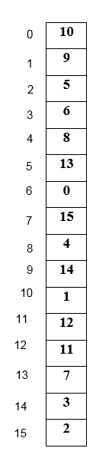

1. Assuming a 512 bytes memory and the page size is 32 bytes, CPU can address 1 word (4 bytes):
   1. How many bit for the physical address? (**4 points**)
   2. How many bit for the logical address? (**4 points**)