Material and methods

Database construction

To simulate plasmidome sequencing, we need reference sequences from plasmids and from chromosomes to simulate contamination.
Accessions of plasmids and contaminants used in this study can be found at https://github.com/meb-team/plasmidome_scripts/tree/master/PlasSimul/simulation_ref/plasmids_accession.txt and https://github.com/meb-team/plasmidome_scripts/blob/master/PlasSimul/simulation_ref/contaminants_accession.txt. There are 1828 plasmid sequences and 506 chromosome sequences
To construct the plasmid database, all the plasmid sequences from RefSeq are used, and 1 sequence per species is kept. To construct the contaminant database, prokaryote chromosome sequences from RefSeq are used, 1 genome per database is kept and 500 genomes are randomly selected.

Sequencing simulation

Illumina and PacBio sequencing are simulated with Grinder v0.5.4. For Illumina sequencing, 150 bp paired-end reads with an insert size of 350 bp are generated. For PacBio sequencing, 6000 bp single-end reads are generated. To simulate contamination, contaminant reads are generated and added to the plasmid reads. For example, for what we will call "20% contamination", 20% of the plasmid reads number will be added as contamination reads. If there are 100 000 plasmid reads, 20 000 contaminant reads will be added to the simulated dataset.
Several sequencing coverage are simulated : 1X, 2X, 5X, 10X and 20X for Illumina. 0.5X,1X and 5X for PacBio. Several contamination rates are also simulated : 0%, 5%, 10% and 20%.

Assembly
6 tools are tested for assembly. Short-reads only assemblies are tested with Megahit v1.0.5 (with parameter –12 to give interleaved fastq paired-end file, other parameters by default), SPAdes v3.9.0 and MetaSPAdes v3.9.0 (parameter –12 to give interleaved fastq paired-end file and –only-assembler to skip correction step by Hammer. Parameter –meta is used to launch MetaSPAdes. Other parameters by default.) . Hybrid assemblies are tested with HybridSPAdes v3.9.0 (same parameters as SPAdes, with –pacbio to launch hybrid assembly), Unicycler v0.4.4, and a "super-assembly" of short-reads assemblies (both Megahit, MetaSPAdes and SPAdes) and long reads with CAP3 (date of the version : 12/21/2017).
Assemblies done for each tool are given in
List of assemblies done for each tool :
* Megahit, MetaSPAdes and SPAdes : All Illumina coverages (1X, 2X, 5X, 10X, 20X) for 0% contamination. Illumina coverage of 10X for other contamination rates.
* HybridSPAdes and Unicycler : an Illumina coverage of 10X, all PacBio coverage for 0% contamination. An Illumina coverage of 10X and PacBio coverage of 1X for other contamination rates.
* CAP3 : Used with Megahit, MetaSPAdes and SPAdes short assemblies (10X) and with PacBio long reads for coverage 1X.
After assembly, only contigs over 1kb are conserved.

Assembly evaluation

Assembly evaluation is done with MetaQuast and the treatment of its output files. Evaluation parameters are :
* N50 : N50 is a classical assembly evaluation parameters. It means that 50% of the bases in the assembly are in contigs with N50 length or more.
* Number of misassembled contigs : misassembled contigs represent contigs that can be chimeric (different part of the contig maps against different plasmids), inverted (maps in two directions against same plasmid) or relocalized (the left and right parts of the contig map against the same plasmid with a gap or an overlap over 1 kb)
* Longest contig : The longest contig produced by the assembly.
* Reference coverage : The reference coverage is the percentage of bases in the reference sequences (plasmids used to simulate sequencing) covered by good contigs (correct or ambiguous, misassembled are discarded).
* Complete plasmids : A plasmid is complete when at least 90% of its length is covered by only one contig.
* Contaminated contigs : Contaminated contigs are contigs that don’t map with any reference plasmid and map against reference contaminants.
Plasmid prediction / Decontamination

Plasmid prediction or decontamination is done for two assemblies : Megahit and MetaSPAdes short-reads assemblies, defined as the best with the assembly evaluation. Several methods for separate plasmid contigs and contaminants contigs have been evaluated. Two tools designed for this purpose are first tested :
* PlasFlow : PlasFlow is a tool that trains on reference sequences to create models for plasmid prediction. Each contig will have a probability to be plasmidic or chromosomal. A Probability threshold can be defined, if a contig has a probability greater than this threshold to be a plasmid or a chromosome, it will be assigned to the corresponding category. If not, it will be defined as "unclassified". PlasFlow has been tested with all probability thresholds from 10 to 90, with steps of 10.
* cBar : cBar is another tool that classify contigs as plasmids or chromosomes with machine learning. There's no adjustable threshold and contigs can just be classify as plasmids or chromosomes, not unclassified.
* cBar + PlasFlow : A combination of cBar and PlasFlow tools is tested. First, cBar is used and sequences identified as plasmids are kept. Then, PlasFlow is used on sequences predicted as chromosomes by cBar. Sequences now predicted as plasmids by PlasFlow are added to cBar plasmids to constitute all predicted plasmids. PlasFlow threshold of 70, 80 and 90 are tested.
2 others methods are tested :
* Chromosome alignment : The purpose is to align against known prokaryotic chromosomes to eliminate chromosomal contigs. The database of chromosomes is RefSeq prokaryotic chromosomes, the same used for select contaminant genomes in the database construction part. Contaminant genomes are discarded. Contigs are aligned against this new database. Contigs that map are considered as chromosomes and others as plasmids. Several clustering are then done to estimate if we can decontaminate samples when contaminants sequences are distant from database used.
Clustering is done using contaminant chromosomes as seed and we delete chromosomes from the prokaryotic chromosomes database which are closer than 90, 95, 97 and 99% identity.
* Plasmid markers searching : The purpose is to search plasmid markers in contigs. When a plasmid marker is found, the contig is classified as plasmid. The markers used are markers from the mob_suite tool. It contains replicase dna, oriT dna, mobilization proteins and mate-pair formation proteins. For proteins, the search is done with blastp against contig predicted genes (with Prokka v) translated to proteins. For DNA sequences, the search is done with blastn against the contigs. The same treatment parameters as mob_suite are applied. If markers map with contigs or predicted genes with at least 80% identity and on at least 80% of its length (90 and 90% for oriT dna), it's considered as found.

Plasmid prediction evaluation

To evaluate plasmid prediction, we compare real affectation (if a contig represents a plasmid or a chromosome, determined by alignment against the reference done for assembly evaluation) and predicted affectation (contigs classified as plasmids or chromosomes by plasmid prediction methods).
Based on this comparison, we can define true positive, true negative, false positive and false negative contigs.
* True positives (TP) : contigs classified as plasmids that are actual plasmids
* True negatives (TN) : contigs classified as chromosomes that are actual chromosomes
* False positives (FP) : contigs classified as plasmids but are actually chromosomes
* False negatives (FN) : contigs classified as chromosomes are actually plasmids.
With those parameters, we can compute the following metrics :
* Recall : TP / (TP + FP). Number of correctly predicted plasmids among all plasmids. It reflects how many real plasmids are correctly predicted.
* Precision : TP / (TP + TN). Number of correctly predicted plasmids among all contigs predicted as plasmids. Reflects how many predicted plasmids are real plasmids.
* Accuracy : (TP+TN) / (TP+TN+FN+FP). Number of correctly predicted contigs, plasmidic or chromosomal among all contigs. It reflects how many sequences are correctly predicted.
* F1-Score and F0.5-Score : Summarize recall and precision (harmonic average of recall and precision for F1-Score).
Results
Assemblies
Short-reads assemblies
Assemblies are first done with only Illumina simulated sequencing for several sequencing coverages. Megahit, SPAdes and MetaSPAdes are being tested. To evaluate assembly quality, we focus on the following statistics : N50, largest contig, reference coverage and misassembled contigs.
N50 increases with sequencing depth, from an average of 1410 bp for 1X to an average of 69369 bp with 20X. For low sequencing depth (1X and 2X), N50 are similar among the different assemblers. For high sequencing depth, Megahit produces the worst N50 and SPAdes or MetaSPAdes the best (35107 bp for Megahit and 48638 bp for SPAdes with 10X depth and 50875 bp for Megahit and 82150 bp for MetaSPAdes with 20X depth) (Figure 1)
For the largest contig, similar observations can be done. The size of largest contig increases with depth, from 18545 bp for 1X to 935693 bp for 20X for the worst results (Megahit). The best results are produced by SPAdes, with same length as MetaSPAdes for 20X depth.
The reference coverage increases with depth and reaches a threshold of around 85% from 10X.
The misassembled contig rate decreases from sequencing depth of 1X to 10X for Megahit (from 7.1% for 1X to 0.8% for 10X). SPAdes gives high misassembly rates for low depth (1X and 2X), up to 34.7% for 1X. With the same depth, MetaSPAdes gives the best results with 2.9% of misassembled contigs with 2X. For higher depth, Megahit gives best results (0.8 for the best value, with 10X sequencing depth).
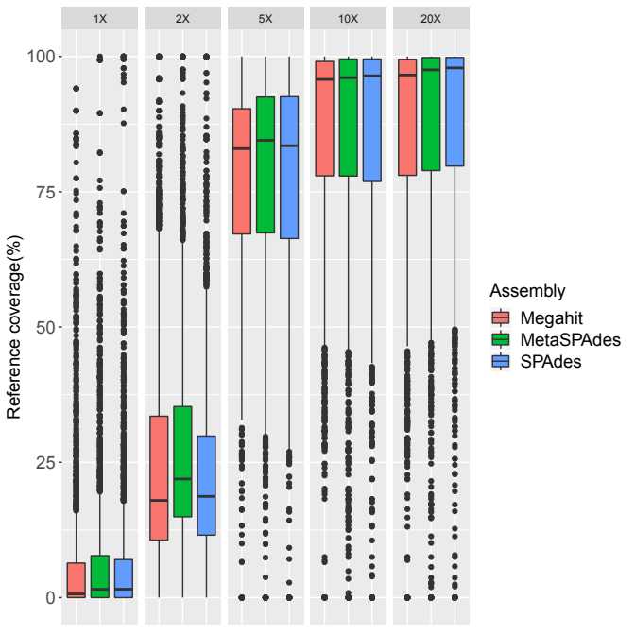Figure 1: Reference coverage for short-read assemblies with sequencing coverage between 1X and 20X

SPAdes isn't a good choice because misassemblies are too high for low depth sequencing. This is discriminant for our type of data. We don't have informations about plasmidomes species, so we have to minimize assemblies that create chimeras. Megahit and MetaSPAdes are two performant assemblers, based on different criterias. Megahit minimizes a lot chimeras if sequencing depth is sufficient but it leads to a more fragmented assembly. MetaSPAdes gives better results for low sequencing depth, and a less fragmented assembly (but with more misassemblies) than Megahit.

Hybrid assemblies
Hybrid assemblies have been tested with Illumina sequencing depth of 10X (optimal value for recovery and misassemblies rate on short read assemblies), and PacBio sequencing depth from 0.5X to 5X.
Unicycler gives the best N50 for PacBio depth of 5X (148453 bp). But the N50 with PacBio depth of 1X is similar to the best short-read assembly (82519 bp for Unicycler and 82150 bp for MetaSPAdes with 20X Illumina depth). The CAP3 approach gives a lower N50 than the associated short reads assemblies. (33227 bp for Megahit + CAP3 against 35107 bp for just Megahit with the same Illumina depth of 10X).
Unicycler produces longer contigs than HybridSPAdes, up to X bp for PacBio depth of XX. The largest contigs for the CAP3 approach are the same than the associated short-reads assemblies (X bp for Megahit, X bp for MetaSPAdes and X bp for SPAdes). The largest contigs from short-reads assembly have not been improved by CAP3 hybrid assembly.
Misassemblies rate increase with PacBio depth, from X% to X% for Unicycler and from X% to X% for HybridSPAdes. The best rate between those two assemblers (X% for X with XX depth) remains above the worst short-reads assemblies rate for the same Illumina depth (X% for X). The CAP3 approach gives best results than HybridSPAdes and Unicycler but the rate remains above the associated short-reads assemblies. (X% for Megahit + CAP3 against X% for just Megahit). Even with more stringent parameters for overlapping (98% identity on at least 60 bp), misassembled contigs rate is still only above Megahit (X%).
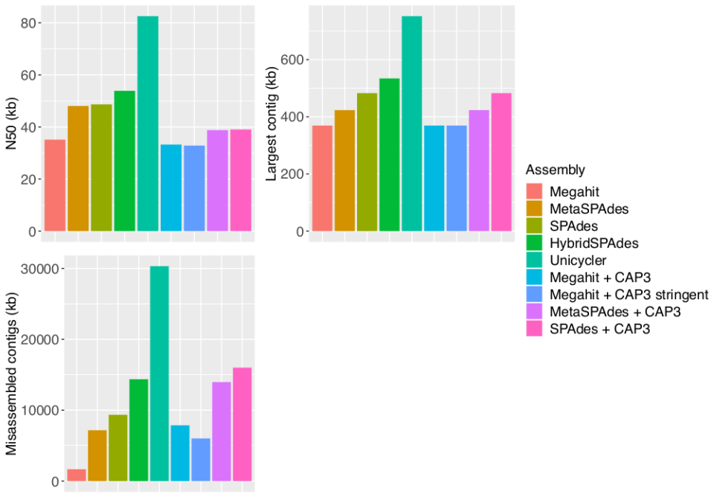Figure 2: N50, largest contigs and misassembled contigs for assembly with Illumina sequencing depth of 10X and PacBio sequencing depth of 1X

The only advantage of hybrid assembly is to produce less fragmented assemblies if PacBio depth is sufficient. 1X depth is not enough to have less fragmented assembly than a short reads assembly with high sequencing depth. Moreover, this approach increases misassemblies, mostly with high PacBio depth. Minimizing misassemblies is an important criteria when we assemble plasmidomes. With the current available tools, it seems preferable to focus on short reads assemblies with high sequencing depth than hybrid assemblies.

Decontamination
cBar + PlasFlow and cBar are discarded, we consider that precision is too low and recall too high, leading to an unsufficient contamination rate decrease regarding to the number of missed plasmids (reference coverage).
An Increase in PlasFlow’s threshold leads to better precision but lower recall, reflected by better contamination rate and lower reference coverage rate. Plasmids are better predicted but we lost a lot of them. There is a gap between the 50 and 60% thresholds. Contamination rate is too high and precision too low for threshold of 50% and less. For our purpose, precision is a little more important than recall as we prefer losing true plasmids but be sure of the correctness of the ones we get. So we chose to use PlasFlow with high thresholds.
For the chromosome alignment method, when we take chromosomes databases distant from the chromosomes present in the assembly (with clustering between 90% and 99%), the method is useless ( we obtain the same values than no decontamination for contamination and reference coverage rate). When chromosomes in the database are closed to the contaminants chromosomes (no clustering), it allows to decrease contamination rate with almost no loss in reference coverage.
The search plasmid markers method has had the best precision, so we had very few actual chromosomes in the predicted plasmids, probably partly due to the very low number of conserved sequences among plasmids. Recall and reference coverage rates are low, so a lot of plasmids are not predicted.

Plasflow methods are a good compromise between precision and recall.
To treat real sequencing data, we can combine previous methods. Researching plasmid markers misses many plasmids, but it can be used as a first approach for detecting some of them. The approach can be completed with PlasFlow (high threshold) to detect some other plasmids, with less insurance. Chromosomes alignment still decreases decontamination rates without missing too many plasmids, so it can also be used as first approach to eliminate known chromosomes before predicting plasmids.

