**ASSIGNMENT 01**

**Submitted by:**

**Haseebullah Shaikh (2303.KHI.DEG.015)**

and

**Mehboob Ali (2303.KHI.DEG.018)**

**Task 01: On a linux server setup a cron job for copying example data with *rsync* periodically. Ensure the copying is handled in the background and independently of the user session.**

**Solution:**

**Step 01:** The “source” folder is created in documents folder in which we have 20 programs files, that are created using **touch** command and the “designation” folder is created in downloads to synchronize and backup or copy the files.

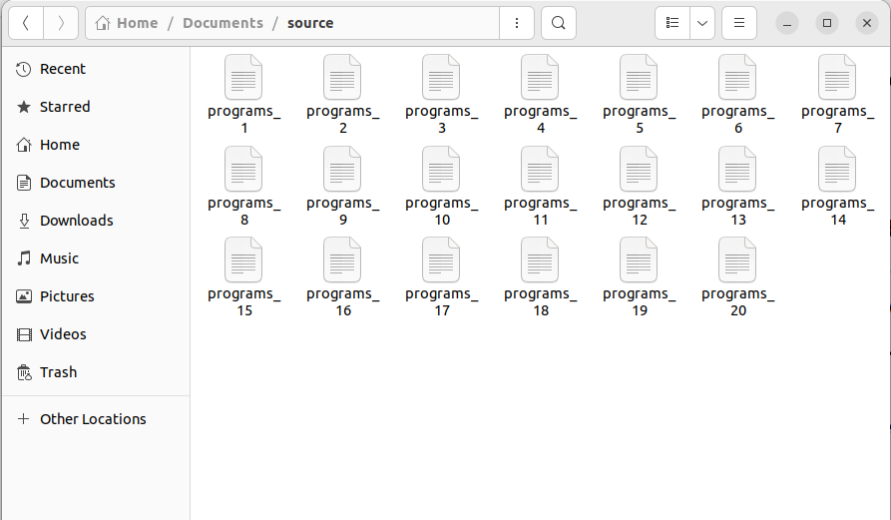

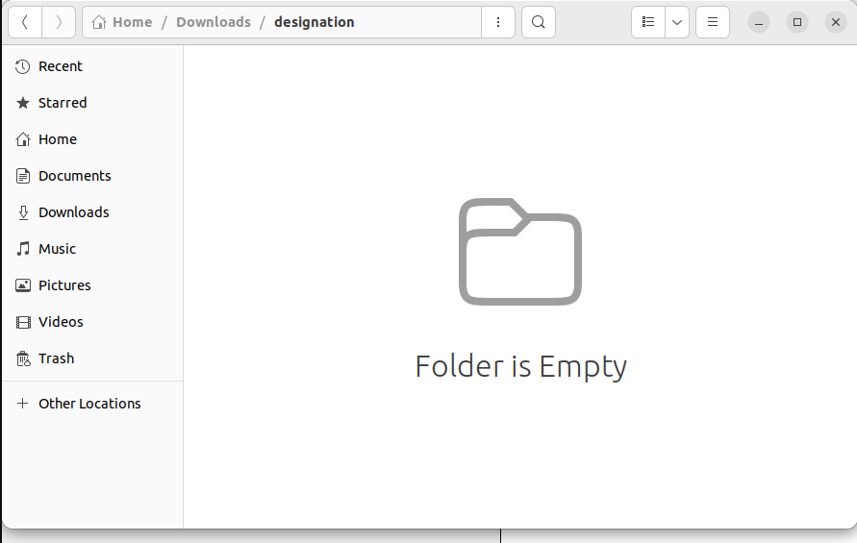

**Step 02:** The crontab –e command is used to open the scheduler file where we can schedule our task. The backup and synchronizing of the files from **source** to **designation** folder where –e refers to the start with editing in crontab file.

**Explanation of complete command:**

* * * * * *: These stars refer simultaneously to the following. Minute, hour, day of the month, month, day of the week. Here it means it will copy and synchronize after every minute, it also can be written as 1 * * * *.
* Rest represents the command that is to be scheduled where,
  + rsync: it refers to the remote sync which means synchronizing and copying or backup the files.
  + -a: It refers to the archive mode, and copy or backup all files recursively.
  + Source
  + Designation.

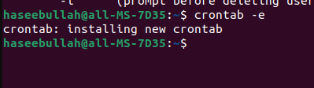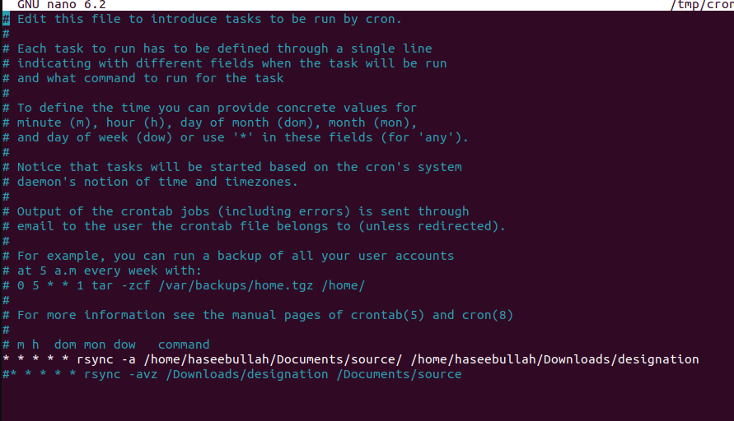

**Step 03:** To verify files are being synchronized and copied recursively.

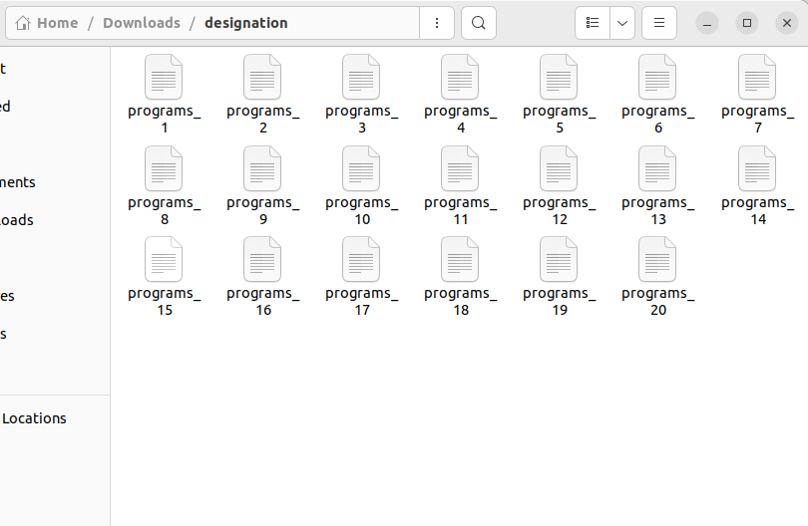

New 10 programs are added in source folder.

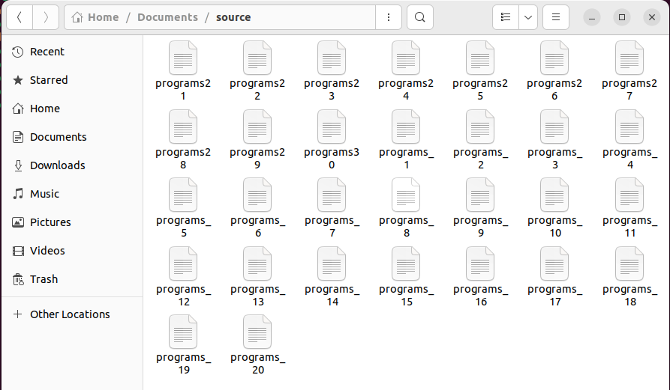

New 10 programs are recursively copied and synchronized after one minute in designation folder.

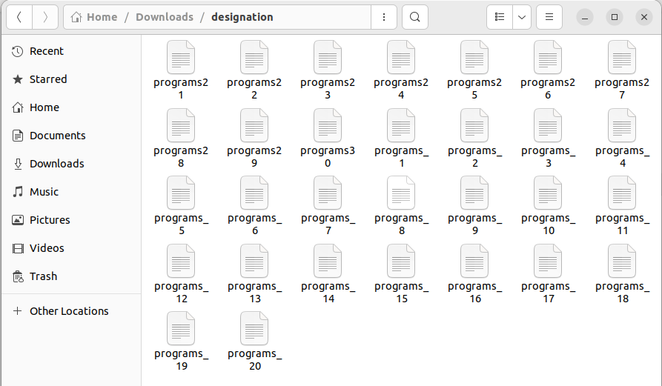

**References**

Cron Tab  
<https://phoenixnap.com/kb/set-up-cron-job-linux>

rsync  
<https://www.digitalocean.com/community/tutorials/how-to-use-rsync-to-sync-local-and-remote-directories>