**ASSIGNMENT 02**

**on**

**SQL Fiddle**

**Submitted by:**

**Haseebullah Shaikh (2303.KHI.DEG.015)**

and

**Mehboob Ali (2303.KHI.DEG.018)**

**Task 01: Create a new SQLFiddle and then add the database from db.sql (provided in tasks/1_introduction/day_2_basic_tooling/hands_on_sql) to be able to perform queries.**  
  
**Your task then is to do two things:**  
**1. Insert two articles written by Joe (id 3) into articles table (choosing the titles is up to you).**

**Solution:**

INSERT INTO articles(author_id, title) VALUES

(3,'Once upon a time'),

(3,'There was piece');

**Complete Schema and Insertion**

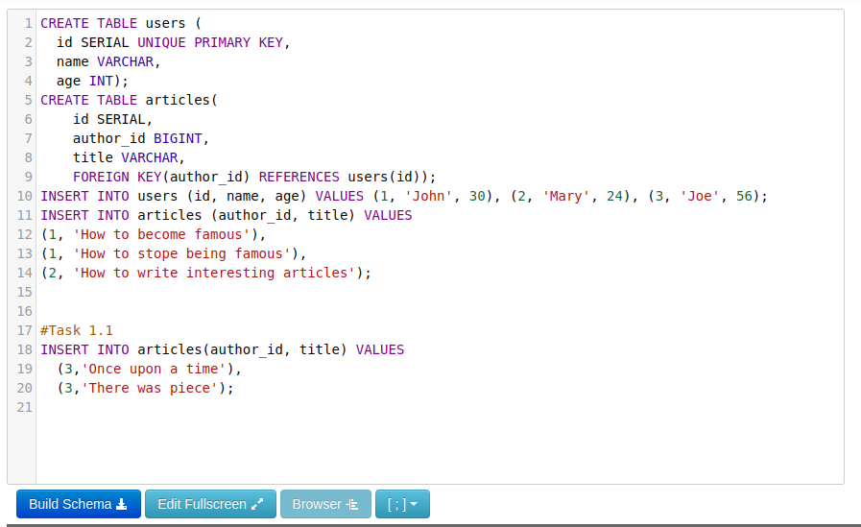

**2. Write a query that will return you a list of articles written by authors who are at least 25 years old.**

Solution:

SELECT a.author_id, a.title, u.age FROM articles as a, users as u

WHERE a.author_id = u.id AND u.age >= 25;

**Input**

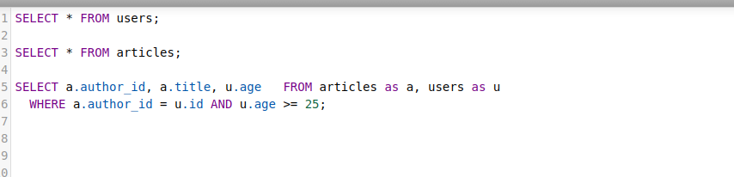

**Output**

