Aim
To customize a switch by adding network modules in Cisco Packet Tracer and
verify extended connectivity options.

Algorithm
→Start Packet Tracer and place a Router 2811 on the workspace.
→Power off the router (Physical tab).
→Remove cover plates from empty module slots.
→Insert network modules (e.g., NM-1T, NM-1E) into empty slots.
→Power on the router
→Check new interfaces appear (FastEthernet, Serial, Ethernet).
→Place PCs (PC0, PC1) near the router.
→Connect PCs to router interfaces using Copper Straight-Through cables.
→Configure router interfaces:
*Assign IP address
*Enable interface (no shutdown)
→Configure PCs:
*Assign IP address in same subnet
*Set default gateway as router interface IP
→Test connectivity:
*Ping router from PCs
*Ping PC1 from PC0 and vice versa

Topology
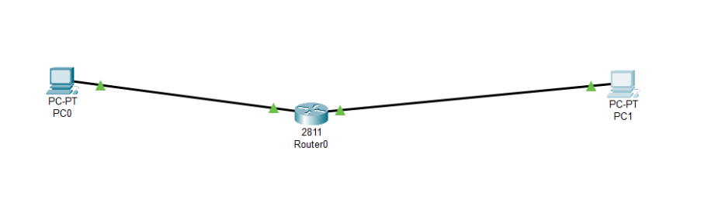

Output
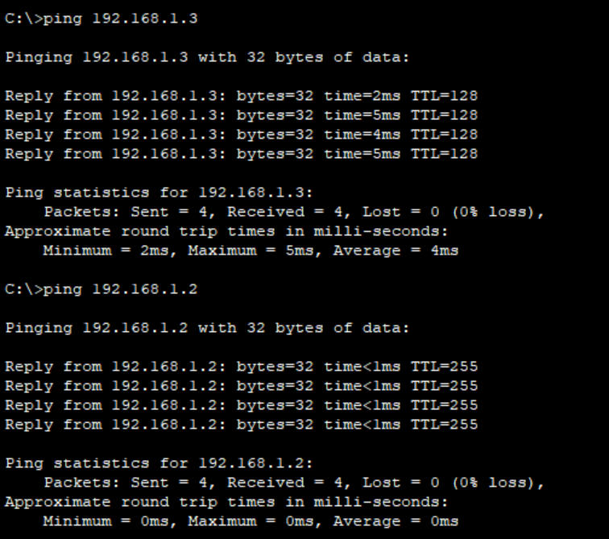

Result
The switch was successfully customized by adding a network module, and the
newly added ports functioned correctly for connecting PCs in Cisco Packet
Tracer.

