Aim
To study and analyze different network protocol packets such as TCP, UDP,
IP, HTTP, ARP, DHCP, ICMP, and DNS by capturing live network traffic
using Wireshark tool.

Algorithm
→Open Wireshark application on the system.
→Select the active network interface (Wi-Fi or Ethernet) to capture packets.
→Click on Start Capturing Packets.
→Open Command Prompt in Windows and execute the commands to generate various types of traffic
→After running the commands, return to Wireshark and click Stop Capture.
→Save the captured packets as a .pcap file.
→Observe packet details such as Source & Destination IP, MAC addresses, ports, and payload.

Output
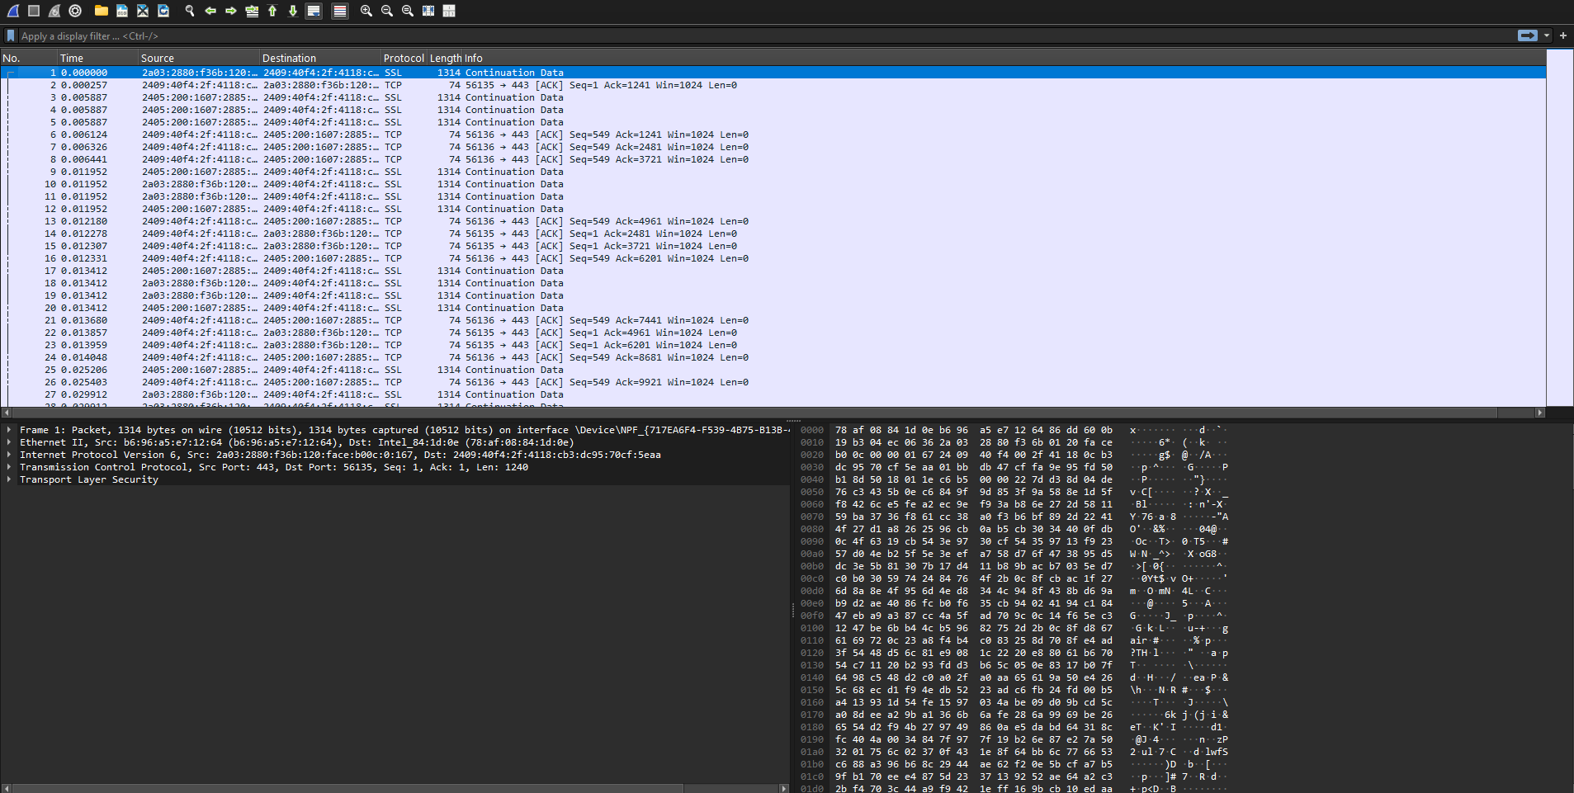

Result
The experiment to capture and analyse network traffic using Wireshark was successfully performed.
Packets for TCP, UDP, IP (IPv6), HTTP, ARP, ICMP, and DNS were captured and analysed.
Hence, the objective of the experiment is achieved successfully.

