Request Packet

Physical Layer
This layer is the actual transmission medium. It determines the data transfer rate between the server and the end device.
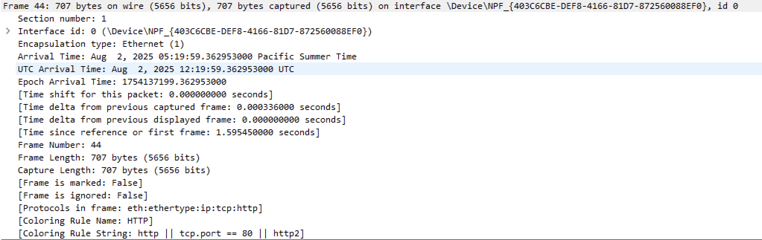

Datalink Layer
This layer is responsible for hop to hop delivery. It defines the mac address of the source and the destination and mac address changes in each hop.
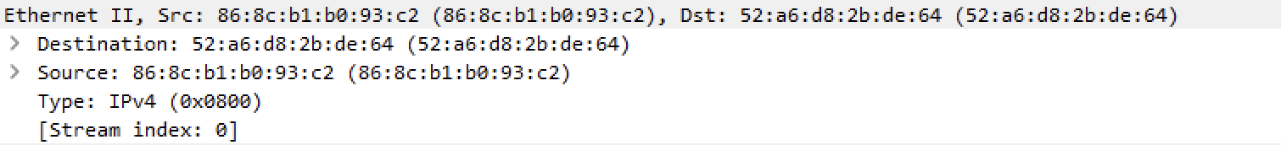

Network Layer
This layer is responsible for host to host delivery. It defines the logical/IP address of the source and the destination, IP address remains constant from source to destination. For example, here source IP: 192.168.64.4 and destination IP: 150.171.27.11
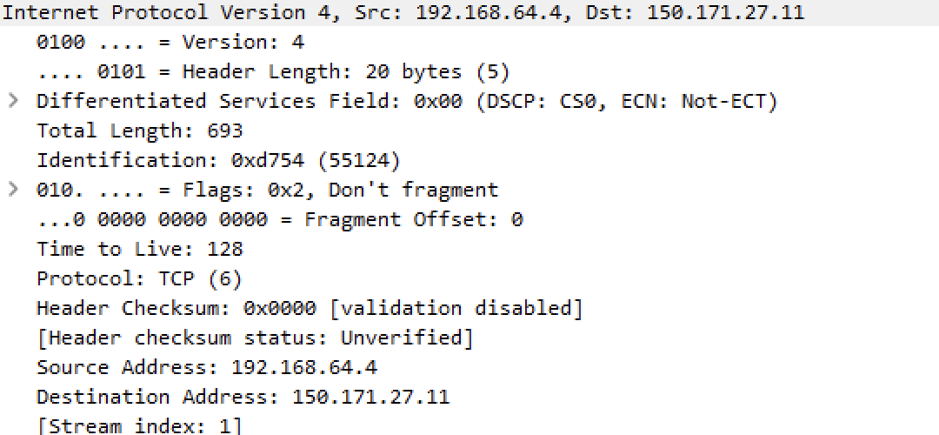

Transport Layer
This layer is responsible for process to process delivery. It adds the port address no of the source and the destination, port address also remains same from source to destination. Here, source port 49798 (dynamic port) and destination port 80 (well known port).
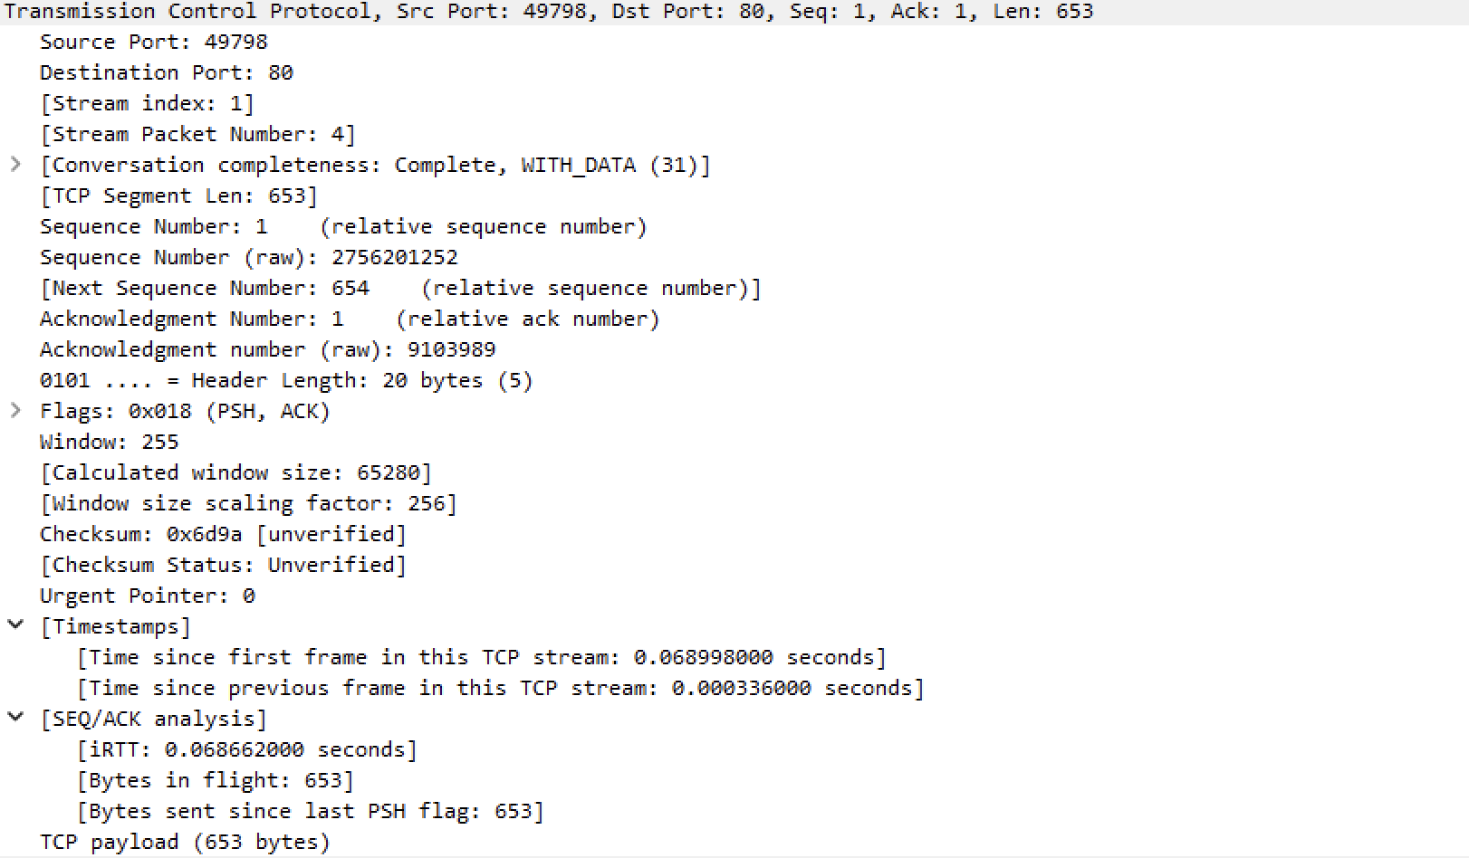

Application Layer
This layer is responsible for providing user services. It mentions the http request message with its header.
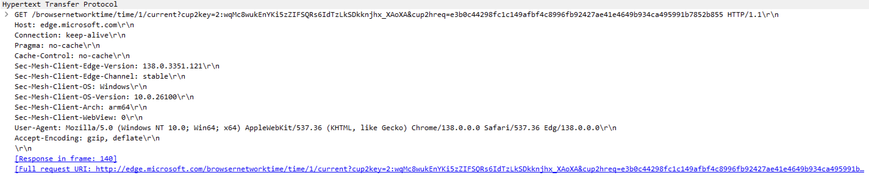

Response Packet

Physical Layer
Same as request packet physical layer
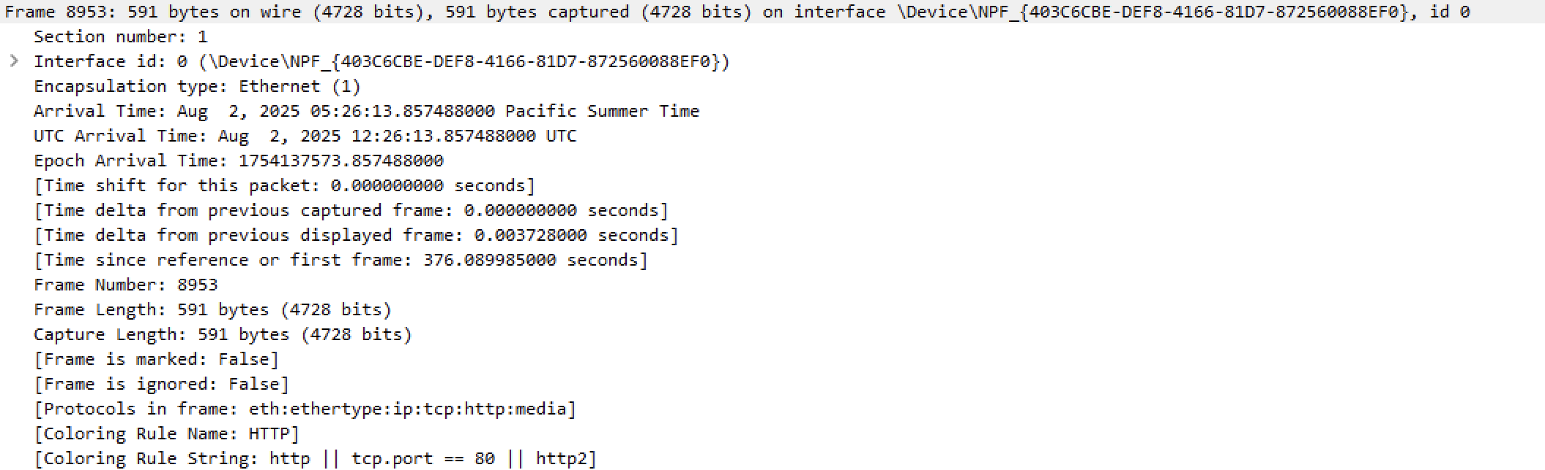

Datalink Layer
Same as request packet datalink layer
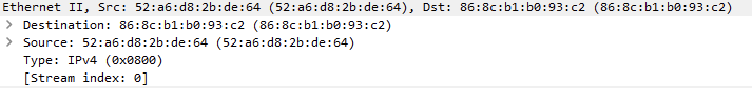

Network Layer
Same as request packet network layer
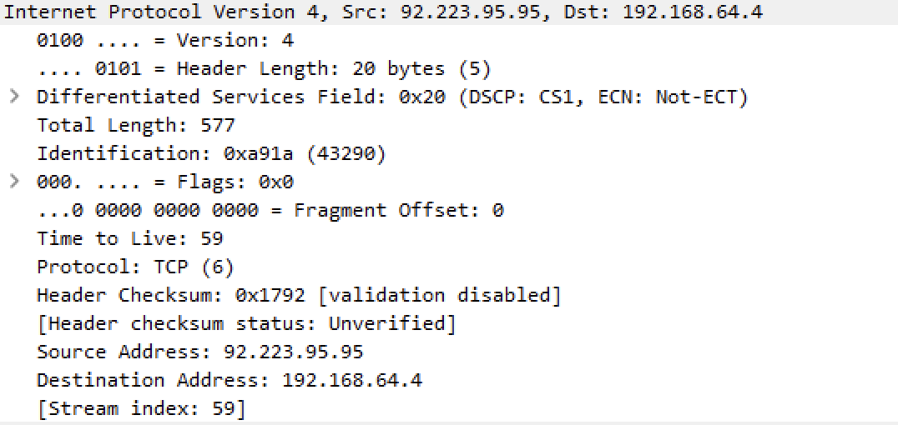

Transport Layer
Here, source port 80 (http) and destination port 49907 (dynamic), data transmission is happening.
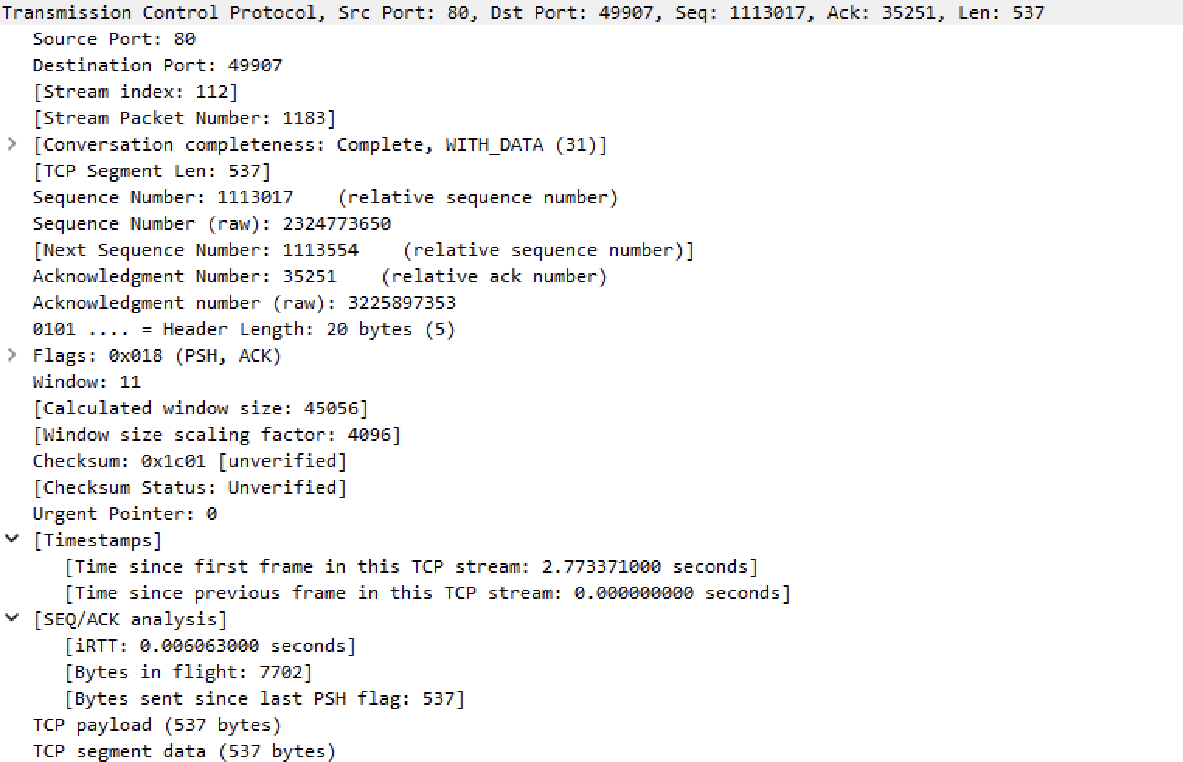

Application Layer
It mentions http response message with status code 200 OK, with other http header information.
