COMP 282 - Advanced Data Structures
Summer 2020
Instructor: Mahdi Ebrahimi (mahdi.ebrahimi@csun.edu)
Office: Online via Zoom
Office Hours: Online by appointment

Section | Class Title | Dates & Times | Room | Class Dates
COMP 282-01  (10500) | ADV DATA STRUCT (Lecture) | MoTuWeTh  1:00PM - 2:35PM | Online Class  via Zoom | Jul 8, 2020-  Aug 18, 2020

Zoom Lecture Policy:
In the event the course is held online, students will be required to appear on webcam during lectures and exams. For students who feel this is a violation of their privacy, they can take steps to create a neutral background, either physically or electronically. For any student who still objects, the instructor may be able to grant exceptions if the student provides the instructor with a reasonable justification for why the policy is not acceptable. Requests for exceptions will be considered on a per student basis.

Communication:
Please use email rather than telephone voice mail for messages. Please keep emails short and focused, and use a clear subject line beginning with “COMP 282 Question”. Many technical questions are better handled in person during lecture rather than email since the class as a whole might benefit from the discussion.
You may email me (mahdi.ebrahimi@csun.edu) at any time; I will generally respond within 24 hours (during the academic days). Always include your name, course, and CSUN email address in your messages to me; an email address like meqwik@love.com leaves me clueless about who you are!

Course Description (from the catalog)
Introduction to advanced data structures (particularly persistent structures) using object-oriented design. Main memory structures: hash tables, trees. Architectural foundations for files. Large-scale sorting. Hash-based persistent structures. Indexed files. Introduction to databases.

Objectives
Throughout this course, the student will become familiar with data structures and algorithms used to efficiently manage large volumes of information. In particular, the student will become comfortable implementing and using hash tables and trees. Sorting and searching of large volumes of information will also be discussed, as well as their representation in persistent memory structures, such as indexed files. Finally, the student will be introduced to formalized systems for data storage: databases.

Course Material:
Course material is available on Canvas ( https://canvas.csun.edu ). Assignments/Projects, Exams, and grades will be posted on canvas ( https://canvas.csun.edu ). Any questions about a assignment/exam grade should be addressed within two days of posting. After two days, all grades are final.

Textbook
No textbook is required. If you’d like a textbook for further study, one decent supplemental textbook is:
- Data Abstraction and Problem Solving with Java (J. Prichard & F. Carrano)

Assignment/Project:
Note: All assignments/Projects submitted in “digital file” format (.zip, .rar, .pdf, .docx, etc.) must be submitted using Canvas. An “Assignment” area will be created for each assignment/project.
Assignments submitted via email will not be accepted unless explicitly approved by the instructor prior to email submission.
Assignments/Projects will be assigned with due dates. Students are expected to:
a) Complete the assignments/projects on time to the best of their ability.
Students are expected to submit their own original work.
b) ASK QUESTIONS if problems are encountered or if more information is required (BEFORE the due date!).
In the event that there is a problem with Canvas, you may email your assignments/projects to me (mahdi.ebrahimi@csun.edu), though this should be considered a last resort.

Grading

Assignments/Projects (~3) | 30%
Midterm Exam 1 | 15%
Midterm Exam 2 | 15%
Final Exam (Comprehensive) | 40%

Midterms are not comprehensive; however, the final will be comprehensive. It should be noted, however, that the final will place more emphasis on material covered since the last midterm. Sometime during lecture prior to each exam will be devoted to a review of material covered on the exam. In the case of the final, the entire lecture period will be devoted to a comprehensive review of the course material. The student is expected to come to these review sessions with any questions they would like covered, there will be no structured review material.

Plus/minus grading is used, according to the scale below. The left column shows the minimal score necessary to receive the grade in the right column. The highest letter grade possible given the score is chosen; e.g., if you receive an 88.2, you’d receive a ‘B+’ for the course, which corresponds to being >= 86.5.
If your score is >=... | ...you will receive...
96.5 | A+
92.5 | A
89.5 | A-
86.5 | B+
82.5 | B
79.5 | B-
76.5 | C+
72.5 | C
69.5 | C-
66.5 | D+
62.5 | D
59.5 | D-
0 | F

- NOTE: Failure to take the Final Exam will result in a grade of “WU” which is equivalent to a grade of “F”
- An important part of this course is the operating system terminology, concepts, and definitions; therefore, I do not answer questions during examinations.
- In fairness to all, I don't give make-up for any missed projects, assignments, or exams.
- An incomplete (I) grade is given for genuine medical and other certified emergencies only; it is never given to catch up with missed assignments. Furthermore, to receive an Incomplete grade, you must have successfully completed at least two-thirds of the semester with a passing grade.

Late Policy:

Late assignments will be accepted without penalty if prior arrangements have been made or there is some sort of legitimate emergency (at my discretion). If an assignment is otherwise submitted late, it will be penalized according to the following scale:
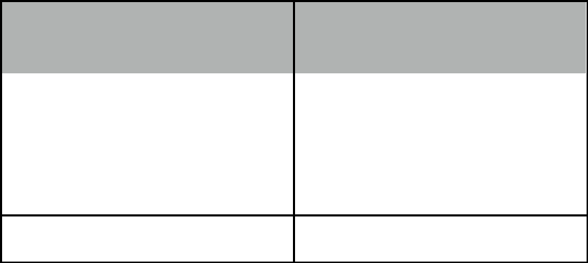
If your assignment is late | ...it will be deducted by...
by <= this many days...
1 | 10%
2 | 30%
3 | 60%

4+ 100%

To be clear, assignments that are submitted four or more days beyond the deadline will not receive credit.

Plagiarism and Academic Honesty
While collaboration is allowed on assignments, you are responsible for all of your own work. You may not take code from online sources and submit it as your own. No discussion whatsoever is allowed during exams, except with the instructor. Any violations can result in a failing grade for the assignment, or potentially failing the course for egregious cases. A report will also be made to the Dean of Academic Affairs.
Students who repeatedly violate this policy across multiple courses may be suspended or even expelled.

Disabled Students
"If you have a disability and need accommodations, please register with the Disability Resources and Educational Services (DRES) office or the National Center on Deafness (NCOD). The DRES office is located in Bayramian Hall, room 110 and can be reached at (818) 677-2684. NCOD is located on Bertrand Street in Jeanne Chisholm Hall and can be reached at (818) 677-2611. If you would like to discuss your need for accommodations with me, please contact me to set up an appointment."

Changes to Syllabus
Changes may be needed to this syllabus and to the course plan. All such changes will be announced in class and will be announced via email. Students are responsible for this information.

Class Schedule and List of Topics (Subject to Change)

Schedule
Weeks | Topics | Note
Week 1 – 2 | Class Introduction, Data Structures Review (Linked List, Stack and Queue)
Week 2 – 1 | Algorithm Complexity, Introduction to Trees
Week 2 – 2 | Introduction to Specialized Binary Trees
Week 3 – 1 | Binary Trees, Balance, Rotation
Week 3 – 2 | AVL Trees, Red Black Trees
Week 4 – 1 | B-Trees, B⁺-Tree, and Review | Midterm Exam 1  Project 1 deadline
Week 4 – 2 | Introduction to Graphs, Searching Graphs (BFS and DFS)
Week 5 – 1 | Shortest Path, and MST
Week 5 – 2 | Hashing Functions, Hash Tables, and Collisions, External Sort | Project 2 deadline
Week 6 – 1 | Files, Data Access, and Review | Midterm Exam 2
Week 6 – 2 | Introduction to Databases and SQL  Data Design, Keys, and Normal Forms
Week 7 – 1 | Comprehensive Review | Final Exam  Project 3 deadline

