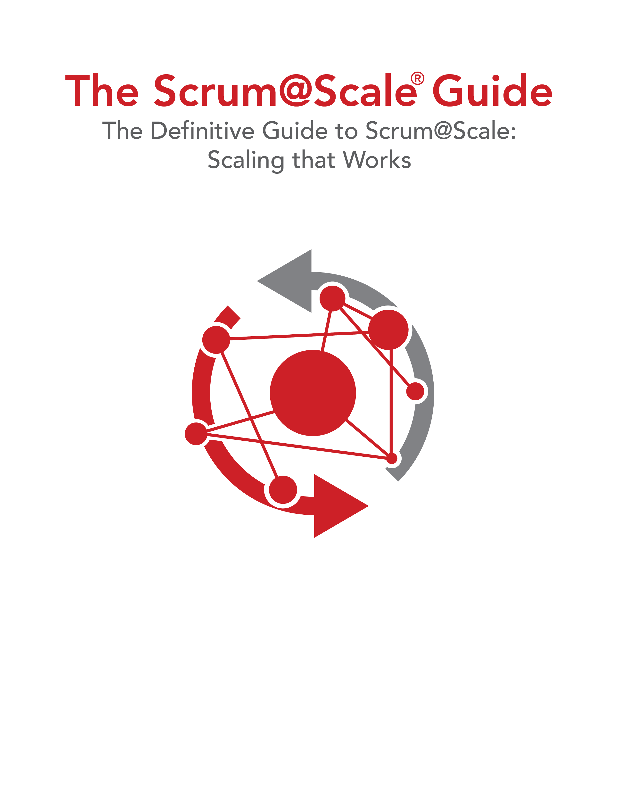

**スクラムをスケールする**

**Scrum@Scale の決定版ガイド**

**Scrum@Scale®ガイド**

Version 1.02 — 2018/08/21

©2006-2018 Jeff Sutherland and Scrum Inc., All Rights Reserved   
Scrum@Scale is a registered trademark of Scrum Inc.   
Released under Creative Commons 4.0 Attribution-Sharealike License