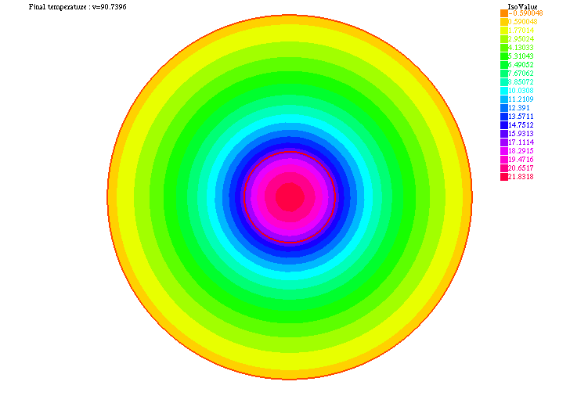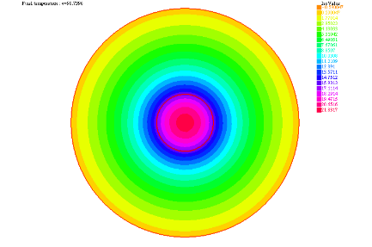

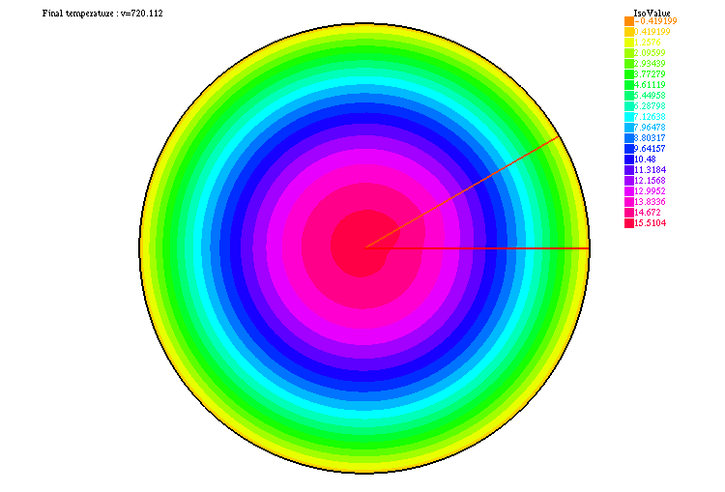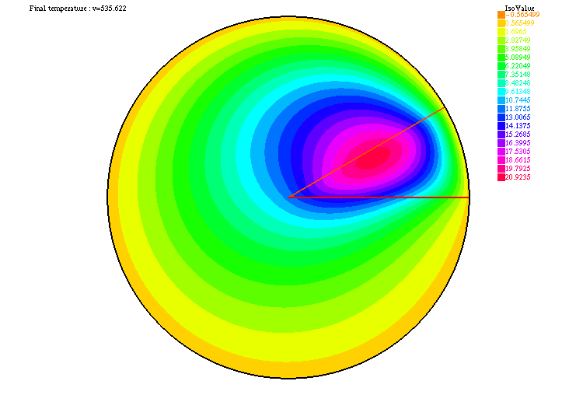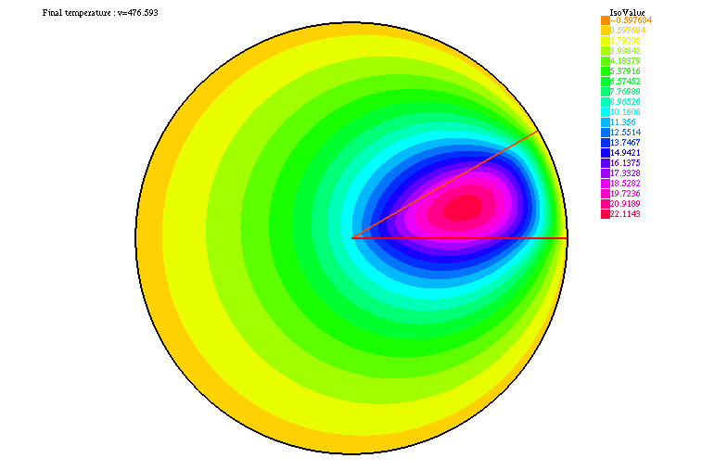In the first case when $Ω$ and $ω$ are both circles, and when the convection $u=[-y,x]$ is central symmetric, there is no difference for the distribution of the temperature whether the convection exists or not.

When $ω$ is a slice of $π/6$:

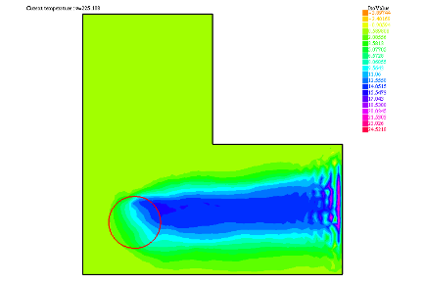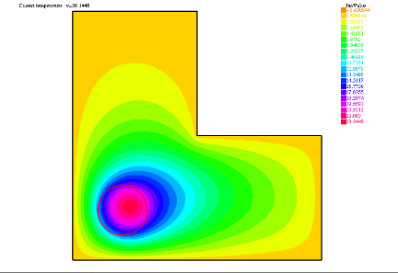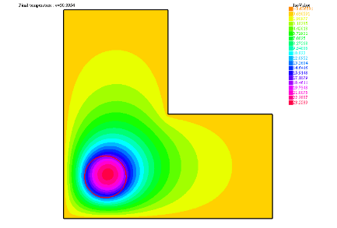Without the convection, the distribution of the temperature looks like a combination of the form of $Ω$ and the form of $ω$, and it has the same symmetry as region $ω$. If we add the convection to this system, which can transport the heat, there appears a displacement of the distribution of the temperature according to the direction of the convection. And when the convection is strong enough, the distribution of the temperature depends more on the convection, so we can find a more homogeneous distribution and the maximum of the temperature in this domain is lower than before while the temperature of the source in the optimal case is much higher. That means, thanks to a strong convection, the source can offer more heat to the $Ω$ domain without worry about a too high central temperature.

As for the L-beam, we meet a problem of non-convergence, then we choose a larger tolerance and limit the number of iterations less than 100 to get a convergent solution. Finally, we get these solutions above. Without the convection, the heat will diffuse according to the form of the $Ω$ domain. Then if we add the convection to this system, we can also see the displacement of the heat in the direction of the convection. And when the convection is strong enough, the heat will go out of this domain at the right side, so the optimal solution of the temperature can be really large.