Meeting content

Date: 10/24/2025
Group Member: Haocheng, Mary
Content:
Discussed about the UI design and color palette.
Outcome:
AI designed UI: https://www.figma.com/make/dg1kxBP3l6cAlsIuKOib5Y/Data-Dashboard-UI-Pattern-Library?node-id=0-1&t=Gno28ymgATEBSoCH-1

Color palette options:
(Currently both Haocheng and Mary prefer option3)

Font:
Montserrat: bold 700 is close to the logo font
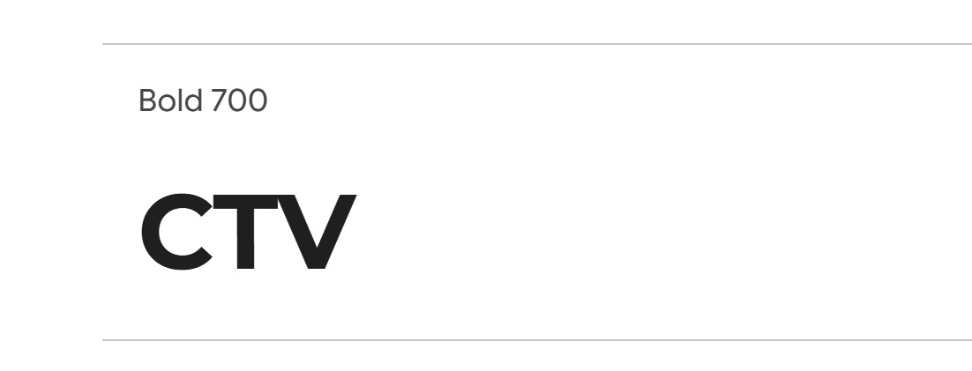

Next meeting date: 11pm,10/28/2025

