The Pennsylvania State University

The Graduate School

**DESIGN AND IMPLEMENTATION OF KALMAN FILTER-BASED**

**MPC-MPPT ALGORITHM FOR PV DC-DC CONVERTER SYSTEMS**

A Thesis in

Electrical Engineering

by

Matthew Capuano

© 2021 Matthew Capuano

Submitted in Partial Fulfillment

of the Requirements

for the Degree of

Master of Science

August 2021

The thesis of Matthew Capuano was reviewed and approved by the following:

Xinwei Niu

Assistant Professor of Electrical Engineering

Thesis Advisor

Javad Khazaei

Assistant Professor of Electrical Engineering

Kiana Karami

Assistant Professor of Electrical Engineering

Nashwa Elaraby

Associate Teaching Professor of Electrical Engineering

Rafic A. Backnak

Professor of Electrical Engineering

Program Head/Chair of Electrical Engineering Graduate Program

**ABSTRACT**

DC-DC converters and their respective control systems are commonly used in photovoltaic (PV) energy systems in order to maximize the power that can be extracted from a PV source and supply a steady DC signal to a load while providing a desired amount of gain. Since PV cells have low power efficiency and contain variable I-V and P-V characteristics, a maximum power point tracking-based (MPPT) control system for the converter must be designed and implemented in order for the converter to consistently draw maximum possible power from the PV source and thus apply maximum possible power to a load. In this thesis, a Kalman Filter is combined with the Incremental Conductance algorithm in order to track maximum PV power and control a custom topology DC-DC boost converter in an optimal control scheme comparable to that of Model Predictive Control. The Kalman Filter functions to estimate system states, filter noise from existing sensors, and predict future states of the system given a change in duty cycle, thus allowing for a reduction in sensor count and an increase in algorithm accuracy and efficiency. The Incremental Conductance algorithm generates a desired reference signal that is compared to the predicted signals generated from the Kalman Filter and control of the converter’s duty cycle is applied as needed. Given that an averaged state space model can be derived for the controlled DC-DC converter, this design can be implemented across any non-isolated circuit topology, and functions to improve upon existing designs by reducing sensor count, filtering noise, and providing the processor system with access to complete state information of the circuit it is controlling. This thesis explains the design, implementation, experimentation, and results of the proposed system both in software simulation and hardware experimentation.

**TABLE OF CONTENTS**

List of Figures…………………………………………………………………………………………….X

List of Tables……………………………………………………………………………………………..X

Chapter 1: Introduction…………………………………………………………………………………...X

1.1 Overview…………………………………..………………………….……………………...X

1.2 Motivation…………………………………………………………………………………….X

1.3 Thesis Structure……………………………………………………………………………….X

Chapter 2: Background……………………………………………………………….……………………X

2.1 Overview………………………………………………………………………………………X

2.2 Photovoltaics…………………………………………………………………………………..X

2.3 DC-DC Converter Topologies………………………………………………………………...X

2.4 MPPT Algorithms and Controllers……………………………………………………………X

2.5 Model Predictive Control……………………………………………………………………...X

2.6 Kalman Filters…………………………………………………………………………………X

Chapter 3: Methodology…………………………………………………………………………………...X

3.1 Circuit Model……………………………………………………………..…………………..X

3.2 Kalman Filter Design……………………………………………………..…………………..X

3.3 MPC-Incremental Conductance Design…………………………………..…………………..X

Chapter 4: Experiment……………………………………………………………………………………..X

4.1 System Setup……………………………………………………………..…………………...X

4.2 MATLAB Simulation…………………………………………………..…………………….X

4.3 FPGA Hardware-in-the-Loop…………………………………………..…………………….X

Chapter 5: Results………………………………………………………………………………………….X

5.1 MATLAB Simulation…………………………………………………...…………………….X

5.2 FPGA Hardware in-the-Loop………………………………………………………………….X

Chapter 6: Conclusion…………………………………………………………….………………………..X

6.1 Discussion and Conclusion …………………………………………………………………..X

6.2 Future Work…………………………………………………………….……………………..X

References…………………………………………………………………………..……………………..X

Appendix A………………………………………………………………………………………………..X

**LIST OF FIGURES**

1.1 Example Figure 1…………………………………………………………………………………….X

1.2 Example Figure 2…………………………………………………………………………………….X

**LIST OF TABLES**

1.1 Example Table 1………………………………………………………………………………………X

1.2 Example Table 2………………………………………………………………………………………X

**Chapter 1**

**Introduction**

**1.1 Overview**

Driven by both increases in population growth and energy-consuming technologies, the energy requirements of both developed and developing countries is consistently increasing every year [1][2]. However, conventional energy resources such as fossil fuels are reducing in availability and come with the cost of having a harmful impact on the environment [3]. The world is therefore undergoing a transitional period where its focus on energy extraction is switching from fossil fuels to renewables. Of the types of renewable energy resources available, solar energy extraction through the use of photovoltaic (PV) cells, modules, and arrays have gained a large amount of attention. This is primarily due to solar energy being readily available and capable of being extracted anywhere with sunlight, as well as because PV systems have minimal operational and maintenance costs. Additionally, the overall cost of development and implementation of PV systems is continuing to decrease [4][5][6].

However, PV power efficiency is still considerably low, and the maximum power point that exists within a PV system at any given time is dependent on many variables, which include environmental temperature, solar irradiance, shadowing effects, PV surface cleanliness, PV cell and array arrangement, as well as other internal characteristics of the PV cell itself [7]. This causes complexity in determining the optimal design of a DC-DC converter system that must function as a link between a PV array and a load. Due to constant changes in the previously stated variables, the maximum power point is constantly changing with time, and continuous adjustments to the circuit that functions to extract power must be made. Therefore, designing a maximum power-point tracking (MPPT) controlled converter system that both provides a steady output voltage while also tracking and maintaining maximum power efficiency is of high importance, and is considered to be a major focus of solar energy research [8].**1.2 Motivation**

A large amount of research has been conducted for the development and testing of various MPPT algorithms [9]. These models have been designed and implemented in order to transfer energy at its optimum efficiency through the use of controllers with high tracking accuracy, as well as provide fast and stable transient and steady-state responses, capable of driving a steady output voltage containing minimum oscillations. The overall effectiveness of these designs can be determined through analysis of power efficiency, cost, hardware complexity, number of sensors, steady state tracking efficiency, algorithm complexity, transient response, and degree of steady state oscillations [9] [10]. More specifically in reference to tracking efficiency, many popular tracking algorithms that perform efficiently in ideal conditions begin to reduce in efficiency or lose tracking completely when noise is introduced via the nonideal, real-world environmental conditions present in the combination of PV sources, embedded microcontrollers, and voltage and current sensors [A-1].

Through the analysis of existing designs, it can be seen that many proposed systems have excessive levels of complexity and cost, do not perform efficiently, or come with other significant design tradeoffs [10][11]. As an example of tradeoffs, a simple circuit design topology could have few components and simple algorithms, but will typically track MPP poorly and have low power efficiency. In contrast, a complex design topology and algorithm could track MPP efficiently and have high boost efficiency, but also contain many hardware components and complex algorithms.

With specifics to how noise affects the ability of a system to track and perform efficiently, existing research in this area offers little in terms of hardware implementation and experimentation, and often comes to conclusions based on software simulation alone, where noise is not present. Because of this, ideal system conditions are typically simulated, and real-world disturbances such as noise from sensors and the circuit are ignored, and problem criteria such as how noise and other disturbances could affect the control algorithm and PV system as a whole are typically not considered [A-5]. However, of the research that does exist for monitoring how noise affects system performance, considerable limiting effects on algorithm performance have been discovered for many of the most popular and common tracking algorithms [A-5] [A-2] [A-3] [A-4]. Additionally, many of the standard and common MPPT algorithms typically require at least two sensors, one for voltage and one for current[A-6], and some of the more complex MPPT algorithms contain sensor counts greater than this [11]. More specifically, the process of current measurement has the capacity to directly correlate to noisy data from measurement, power loss, and increased expenses [A-6].

Therefore, the ability to design a MPPT algorithm that has strong tracking performance comparable to that of more complex systems while also being able to maintain its performance in the presence of noise and keep sensor count low, especially through the removal of the current sensor, can be considered desirable for low-cost applications that are subject to noisy environments.

As a result of this, the objective of this thesis is to model a Kalman filter-based MPC-MPPT algorithm in order to control the duty cycle on a DC-DC converter, which thus controls its output load voltage-to-current ratio. The Kalman filter will estimate states of the system in order to reduce sensor count and filter any system and output noise that would be present in real applications. It also functions to predict future states of the system given an incremental decrease or increase in duty cycle. It then passes this information to an Incremental Conductance algorithm which finds the maximum power point from the provided state information and creates a reference photovoltaic current signal that will be compared to the predicted states from the Kalman filter and, through choosing the predicted state that most closely resembles the reference signal, a change in duty cycle will occur. This process of state prediction and reference comparison is structurally similar to a Model Predictive Control System. This design attempts to offset the multiple sensors needed for Incremental Conductance and MPC-Increment Conductance algorithms, and further optimizes the efficiency of the system through noise removal and accurate future state prediction, all while maintaining the high efficiency levels seen in high-complexity MPPT algorithms.

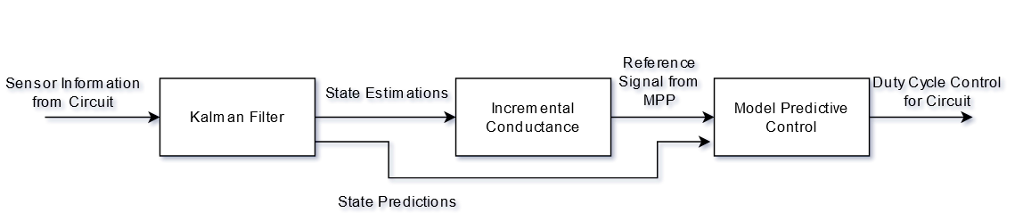

Figure X: Proposed Control Scheme

The Kalman filter utilizes an averaged state space model of the DC-DC converter being controlled and, given that an averaged state space model can be derived, this methodology can be used for any non-isolated circuit topology. The algorithm is developed and implemented in MATLAB and Simulink, and is further developed on FPGA hardware for further testing and analysis.

**1.3 Thesis Structure**

This thesis functions to review existing literature surrounding PV DC-DC converter systems and MPPT algorithms, perform mathematical modeling of the proposed systems, implement the models in simulation software and hardware, and analyze and discuss acquired results. Chapter 2 provides a literary background regarding photovoltaics, converter topologies, MPPT Algorithms, Model Predictive Control, and Kalman Filters, as well as literature review of existing research regarding this specific topic. Chapter 3 discusses the methodologies used to derive the mathematical models of the proposed system to be designed and tested. Chapter 4 discusses the experimentation process. Chapter 5 discusses the results obtained from the experiment. Chapter 6 discusses concluding remarks and future work.

**Chapter 2**

**Background**

**2.1 Overview**

Existing research explores the various circuit topologies, MPPT algorithms, control algorithms, and other design criteria for designing the best possible PV DC-DC converter given specific constraints. There is no single system design that is considered best since certain design specifications could be considered more favorable in a specific application when compared to others. For example, a certain PV system design that is considered optimal for satellite applications could also be considered suboptimal for residential applications [12]. Likewise, a PV system designed to regulate charge to a low-voltage battery pack will benefit from very specific design criteria while a PV system designed to be directly fed into a high-voltage utility grid will not benefit from the same criteria [13].

Since the goal of this thesis is to design a MPPT algorithm that filters noise and reduces sensor count while maintain a high level of accuracy, the analysis of literature focuses on research regarding existing high accuracy, high complexity MPPT and control algorithms, high resource cost system designs, and systems that underperform or fail under noisy conditions. With MPPT algorithms, A review of power efficiency, MPPT tracking speed, and controller efficiency with and without the presence of noise is conducted to review overall system performance, and analysis of circuit resource utilization, algorithm complexity, and sensor count is performed in order to gauge overall system complexity. Additionally, fundamental yet necessary concepts such as the functionality of photovoltaics, DC-DC converter topologies, and Kalman filter functionality is discussed.

**2.2 Photovoltaics**

Photovoltaic energy systems convert solar irradiation to electricity through the use of two-layer PN junctions. Photons that reach the junction increase charge carriers and thus create a potential difference which results in current flow through a respective circuit [14]. The equivalent circuit of a solar cell can be represented using equation X and figure X:

(X)

Where is solar-generated current, is diode saturation current, thermal array voltage, is number of cells in series, is diode ideality constant, is series resistance representing physical contact and semiconductor resistances, and is a parallel, parasitic resistance [15].

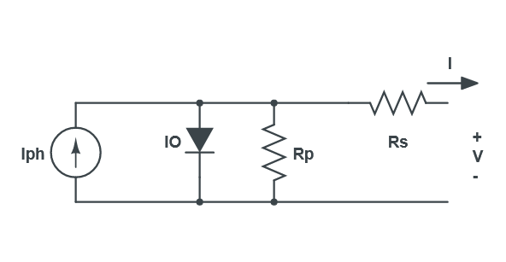

Figure X. Equivalent circuit model of a solar cell

The value of is dependent on both solar irradiance and temperature, as seen in the following equation:

$I=I_{ph}I_{0}\left(e^{\frac{V+R_{s}I}{V_{t}a}}-1\right)-\left(\frac{V+R_{S}I}{R_{p}}\right)$ (X)

Where $I_{ph}$ is solar current generated at nominal conditions, $G$ is irradiance, $G_{n}$ is nominal irradiance, $T$ is cell temperature, $T_{n}$ is nominal cell temperature, and $K_{i}$ is short-circuit current/temperature coefficient [15]. Furthermore, the value of the diode saturation current, $I_{o}$ is dependent on temperature as well, with the following:

$I_{o}=I_{on}{\left(\frac{T}{T_{n}}\right)}^{3}e^{\frac{qE_{g}}{ak}\left(\frac{1}{T_{n}}-\frac{1}{T}\right)}$ (X)

Where $I_{on}$ is nominal diode saturation current, $q$ is electron charge, $k$ is Boltzmann’s constant, and $E_{g}$ is bandgap energy [15]. $I_{on}$ can further be expressed as follows:

$I_{on}=\frac{I_{scn}}{e^{\frac{V_{ocn}}{aV_{tn}}}-1}$ (X)

Where $V_{ocn}$ is open circuit voltage, $V_{tn}$ is nominal cell thermal voltage, and $I_{scn}$ is short circuit nominal current.

From the previous equations, the relationship of the solar cell’s output current and voltage can be analyzed graphically through its I-V relationship curve.



Figure X. I-V and P-V characteristics of Kyocera Solar KC200GT solar cell with a fixed temperature of 25 deg. C and specified irradiances of 600, 800, 1000, and 1200 $\frac{W}{m^{2}}$ with the cell’s maximum power point dotted

From figure X, it can be seen that irradiance changes cause changes in the characteristics of the PV cell’s I-V and P-V relationship when other factors are held constant, with an increase in irradiance causing vertical shift upwards in the I-V curve.



Figure X. I-V and P-V characteristics of Kyocera Solar KC200GT solar cell with a fixed irradiance of 1000 $\frac{W}{m^{2}}$ and specified temperatures of 25, 50, 75, and 100 deg. C, with the cell’s maximum power point dotted

Furthermore, from figure X it can be seen that temperature changes cause changes in the solar cell’s I-V and P-V characteristics when other factors are held constant, with a horizontal shift left with an increase in temperature.

For any set of operational conditions, there is a specific voltage value and current value that results in maximum power output, known as the maximum power point [16]. This maximum power value can be obtained through the process of impedance matching a load that will allow for the desired voltage and current values to exist. From the previous figures, it can be concluded that the maximum power point is constantly changing given constantly changing atmospheric temperature and irradiance values, and therefore the point must be regularly tracked, and the resulting load’s impedance must be regularly controlled.

**2.3 DC-DC Converter Topologies**

The load applied to the PV cell is typically of the form of a DC-DC converter system. Non-isolated boost converters are typically used in order to boost low PV voltages to a higher value so that an inverter can successfully apply the signal to the AC grid [17]. Likewise, buck converter topologies can be utilized for battery charging and universal power supply applications [18]. Non-isolated converters have the advantage of reducing system cost and improving system efficiency when compared to their isolated counterparts [19].

Research generally used in the design of PV DC-DC converter systems involve the use of custom topology boost, buck, buck-boost, SEPIC, cuk, flyback, dual-active bridge, and push-pull converters [13][20], as well as many other topologies that capitalize on achieving high gain, reduce switch voltage stress, or reduce the need for high duty cycles [19]. The overall classification for PV converter topologies can be ordered into isolated and non-isolated systems, where isolated systems are multi-staged in order to have complete separation of inputs and outputs, typically through the use of a transformer. Specialized, high voltage applications typically benefit most from isolated systems [20]. In general, the non-isolated topology of the boost converter is considered most favorable for general applications, due to its low number of components, simple drive circuit, and non-pulsating input current (the input pulsates in correlation to the switching rate) [21]. At the same time, the main drawback of the boost converter is its limited gain capabilities, as well as the need for high voltage rating diodes, and the presence of copper and core losses in the inductor. Many custom designed boost converter topologies attempt to perform voltage multiplying in order to address problems with gain. However, this typically comes with the cost of increased components, increased voltage stress, and variable efficiency ratios given the condition of the system (i.e., input voltage, switching frequency) [21].

The sample topology explored in this experiment involves a custom, high gain boost converter designed by the authors of [11]. However, additional example application topologies that could be interchanged with the boost converter, with examples including the bidirectional SEPIC converter presented by the authors of [22], as well as the synchronous buck converter presented by the authors of [18].

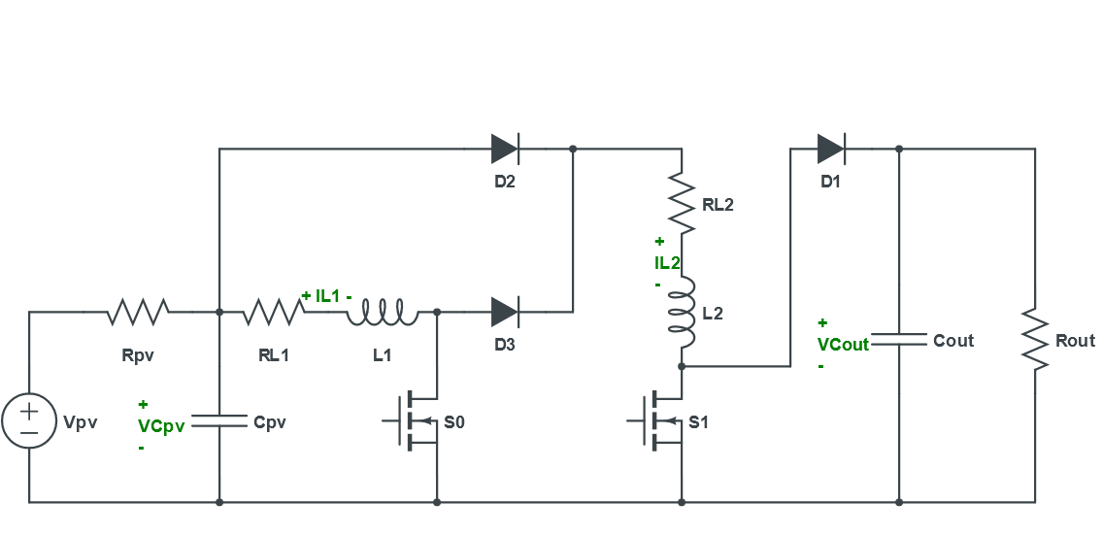

Figure X: Custom Topology High Gain Boost Converter

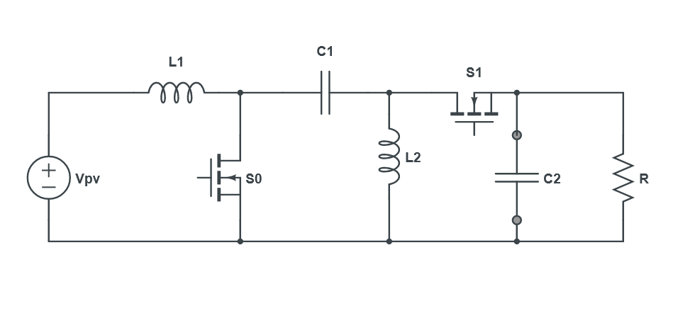

Figure X: Bidirectional SEPIC Converter

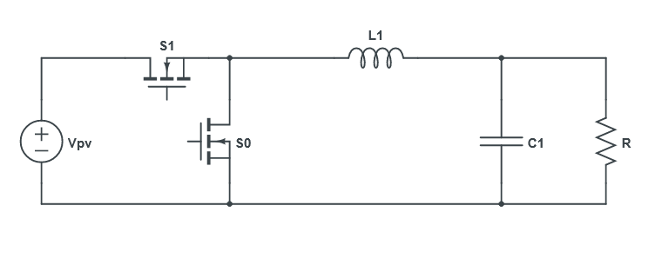

Figure X: Synchronous Buck Converter

Boost converters typically have higher efficiency compared to SEPIC converters [21]. However, SEPIC converters are typically favored over traditional buck-boost converters for higher efficiency rates and continuous input current [21]. Boost converters suffer from the need of high switching conduction rates, causing sharp current spikes and high current stress, a problem the authors of [11] attempt to address through the custom designed topology [11][21]. The synchronous buck converter functions to reduce diode conduction losses seen in the traditional buck converter topology [18].

**2.4 MPPT Algorithms and Controllers**

There are a wide variety of MPPT algorithms in existence today, with newer, more complex algorithms being researched more recently. Some of the most common and modern MPPT algorithms throughout literature involve the Incremental Conductance, Perturb and Observe, Fuzzy Logic Controller, Neural Network, and $\frac{dP}{dV}$ or $\frac{dP}{dI}$ feedback control algorithms [12]. MPPT algorithms can be categorized into three classes: Direct, Indirect, and Soft Computing. Direct MPPT applies control signals to the converter and observes how those signals affect the MPP through observation. Indirect MPPT exploits characteristics of the PV panel in order to determine MPP. Soft computing MPPT uses computing methods that are applied to approximation and predictive models [23]. The most popular forms of MPPT fall within the Direct class and most commonly involve variations on the Perturb and Observer algorithm, as well the Incremental Conductance algorithm [23]. The P&O algorithm is considered a simple algorithm but has drawbacks due to the system never achieving steady state, errors occurring when irradiance drops below 400 $\frac{W}{m^{2}}$ as well as rapid changes in atmospheric conditions causing tracking failures [24]. P&O functions by applying a perturbation of $ΔD$ to the duty cycle of the converter with a perturbation frequency of $f_{MPPT}$. It is then observed if the resultant change in PV power is positive or negative. If positive, the perturbation continues in the same direction. If negative, the perturbation is applied in the opposite direction [25].

The Incremental Conductance algorithm has a higher level of algorithmic complexity which results in the need for high sampling rates, digital implementation, and high levels of speed control. However, it is capable of reducing output oscillations by reaching a steady state. It can also track faster than P&O, and has a very high degree of accuracy [12][24]. Incremental Conductance functions by assuming that the rate of change of PV power with respect to voltage is equal to zero at maximum power point, as follows [26]:

$\frac{dP}{dV}=\frac{d\left(VI\right)}{dV}=I+V\frac{dI}{dV}=0$ (X)

Which assumes current is a function of voltage, and which then can be rearranged as follows:

$-\frac{I}{V}=\frac{dI}{dV}$ (X)

From these equations, the following inequalities can be derived to determine where the system is with respect to the maximum power point [26]:

(X)

Therefore, the algorithm identifies where on the photovoltaic P-V curve it is located by calculating the relation between the rate of change of conductance and instantaneous conductance.

The MPPT algorithms function to track maximum power points, and therefore either aid in the control of what is typically the voltage or current parameters of the circuit, or directly control the system on its own. The MPPT algorithms that only identify what voltage or current values are needed for MPP require a controller to implement control (Current/Voltage MPPT Control). This occurs through the design of a control system that can interpret the desired reference MPPT signal, compare it to the existing MPPT signal, apply control as needed. This contrasts to MPPT algorithms that directly control the duty cycle of the circuit switches (Direct Duty Cycle MPPT Control), where the control system is built into the algorithm and an additional controller is not needed [23].

**2.5 Model Predictive Control**

With the advent of high-speed microprocessor technology, applications of model predictive control in power electronics have become increasingly popular [27]. The main principal of model predictive control involves predicting future behavior of desired control variables over a predetermined time horizon [28]. The MPC system typically does this by having information about the system it is controlling, typically through the use of a discrete state space model, as seen below:

$x\left(k+1\right)=Ax\left(k\right)+Bu\left(k\right)$ (X)

$$y\left(k\right)=Cx\left(k\right)+Du\left(k\right)$$

A cost function is then compared with the predicted values at the end of the time horizon, as seen below:

$g=f\left(x\left(k\right),u\left(k\right), …,u\left(k+N\right)\right)$ (X)

Where N is time horizon. The predicted value that minimizes the cost function at time N is chosen, and the control actuation associated with the value is applied only for time k+1. The sample time then moves up one step and the entire process is repeated over again [28].

With DC-DC converters, the MPC algorithm functions to predict future switching states of the system through the mathematical model of the converter, define a cost function that represents the desired behavior of the system (typically correlated to maximum power point), and applying control to the switching state associated to the input that minimizes the cost function. This form of control is considered useful when PV systems undergo rapid atmospheric condition changes. The cost function is typically represented as a PV current or PV voltage reference signal generated from the P&O or Incremental Conductance MPPT algorithms [29].

MPC techniques typically provide fast dynamic responses with high stability when compared to classic control techniques [30]. Furthermore, robust control, higher convergence speeds, and less steady state oscillation is seen in simulation of MPC-MPPT systems [31][32][33]. However, hardware implementation has shown for these results to be inconclusive [29].

**2.6 Kalman Filters**

The Kalman filter is an algorithm that uses a series of data samples observed over time to estimate unknown system states with as much accuracy as possible. The Kalman filter further assumes that the data being observed contains both noise and disturbances [34]. The states estimated are based on linear dynamical systems presented in a state space format. The process model then defines how a state develops per unit timestep as follows:

$x_{k}=Fx_{k-1}+Bu_{k-1}+w_{k-1}$ (X)

Where $F$ is the state transition matrix, which is applied to the previous state vector $x_{k-1}$, $B$ is the control-input matrix, which is applied to the previous control vector $U_{k-1}$, and $w_{k-1}$ is the process noise vector, assumed to be a zero-mean Gaussian distributed white noise with a covariance matrix defined as [35]. The covariance matrix functions to determine uncertainty of a prediction, with larger covariance values (or weights) correlating to higher amounts of uncertainty. The states of the process model are correlated to the measurements (or observations) of the system through the following equation:

$z_{k}=Hx_{k}+v_{k}$ (X)

Where $z_{k}$ is the measurement vector, $H$ is the measurement matrix, and $V_{k}$ is the measurement noise vector, assumed to be a zero-mean Gaussian distributed white noise with a covariance matrix defined as $R$ [35]. The goal of the Kalman filter is to estimate the state vector $x_{k}$ through consistent analysis and comparison to the measured output, $z_{k}$, provided that the other system information ($F,B,H,Q,R)$ is provided.

The information from the previously mentioned models is then used in the following two-stage mathematical algorithm to form the structure of the Kalman Filter, where $x_{a|b}$ is the value of $x$ at time $a$, given observations up to and including at time $b$:

Predict:

${\hat{x}}_{k|k-1}=F_{k}{\hat{x}}_{k-1|k-1}+B_{k}u_{k}$ (X)

$$P_{k|k-1}=F_{k}P_{k-1|k-1}F_{k}^{T}+Q_{k}$$

Update:

$y_{k}=z_{k}-H_{k}{\hat{x}}_{k|k-1}$ (X)

$$S_{k}=H_{k}P_{k|k-1}H_{k}^{T}+R_{k}$$

$$K_{k}=P_{k|k-1}H_{k}^{T}S_{k}^{-1}$$

$${\hat{x}}_{k|k}= {\hat{x}}_{k|k-1}+K_{k}y_{k}$$

$$P_{k|k}=\left(I-K_{k}H_{k}\right)P_{k|k-1}$$

Where equation XA is the predicted state estimate, equation XB is the predicted error covariance, equation XC is the measurement residual, equation XD is the Innovation covariance, equation XE is the Optimal Kalman gain, equation XF is the updated state estimate, and equation XG is the updated error covariance.

The prediction stage uses the existing input value to estimate the states of the system and the error covariance using previously estimated state estimates and error covariances. The update stage uses the existing output to determine the error in the prediction, create a gain that minimizes the error covariance, and applies said gain in order to correct or ‘update’ the existing state and error estimations. Furthermore, a future time-step prediction can be made by feeding the corrected state estimation back into the first equation of the prediction stage.

This two-step algorithm is executed in its entirety for each discrete timestep k, with previously estimated values being recursively fed back into the algorithm at the next time step. This can be seen as a form of feedback control, in that the filter estimates the process state at time k, and then obtains feedback in the form of noisy measurements. It can also further be considered a form of optimal control; in that it minimizes the estimated error covariance [36].

**2.6 Analysis of Existing Research**

In reference to hill climbing MPPT algorithms (includes the Perturb and Observe and Incremental Conductance algorithms) the authors from [A-4] concluded that erroneous measurement of solar array voltage and current sensors affects MPPT performance, primarily from the nonideal conditions of sensors, amplifiers, and ADCs, causing a measurement bias that causes the MPPT algorithm to settle or track away from the MPP. The authors also stated that these systems are subject to large amounts of noise due to the use of switching power converters that control operating points of solar arrays [A-4]. Since these algorithms are highly nonlinear and work with mathematical derivatives in their formulation, noise present in the voltage and current sensors cause significant effects on the decisions made by these algorithms [A-4]. These authors concluded that low pass filtering of sensors has a high probability of suppressing useful information, sacrificing algorithm speed, and destabilizing the MPPT loop [A-4]. Through experimentation, the authors from [A-4] found that positive DC-bias (resultant from noise) causes the settling point to side with lower incremental conductance (settling to the left of MPP), while a negative DC-bias causes higher incremental conductance (settling to the right of MPP). This is particularly noticeable for biased current values since its value directly depends on solar irradiation values, and lower current values cause more extreme shifts away from MPP [A-4]. These erroneous values are also present in smaller degrees with voltage measurement.

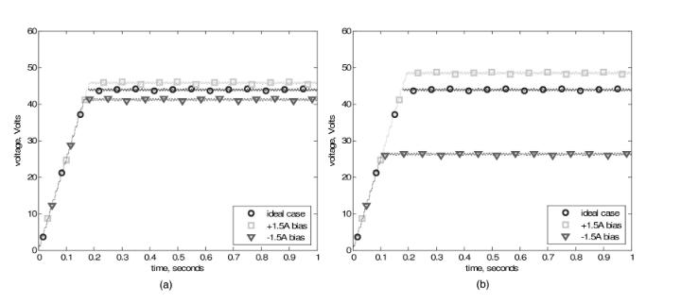

Figure X: P&O performance with current DC bias, high (left) and low (right) current [A-4]

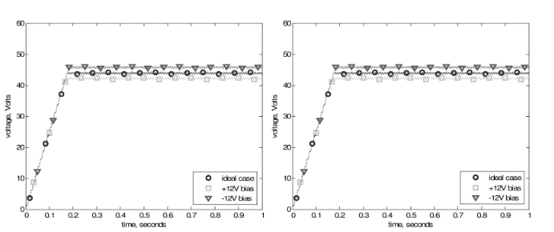

Figure X: P&O performance with voltage DC bias, high (left) and low (right) current [A-4]

Additionally, the authors from [A-4] found that the frequency of erroneous decisions was directly correlated to noise severity and the location of the operating point, with noise in voltage measurements causing a shift of settling point to the right-hand side of the MPP, with noise in current measurements reducing tracking speed. Additionally, they found that variable step-size algorithms lost their ability to optimally change their increment and decrement rates. These authors experimented with a P&O algorithm and concluded that large step sizes and extensive filtering can help with tracking, but only under specific noise conditions.

The authors from [A-5] emphasized how existing current measurement methods are particularly noisy, with Hall Effect transducers being capable or generating considerable amounts of noise, and sense resistors entailing a tradeoff between signal-to-noise ratio and measurement and power loss through the resistor. They also emphasized that the presence of noise had a considerable effect on steady state efficiency, which is defined as the ratio of average output power to the power at the maximum power point. These authors found that specific parameters, including the sampling frequency and change in duty cycle rate affect how well the algorithm responds to noise, with decreases in sampling rate causing improvements due to removing higher frequency noise, and decreases in duty cycle steps reducing oscillatory problems that are exacerbated with the presence of noise. The authors from [A-5] experimented with optimizing algorithms parameters with the P&O method in order to enhance tracking accuracy and reaction rate.

The authors from [A-8] assessed potential drawbacks of the incremental conductance algorithm, and emphasized how only holds true when noise and system dynamics are negligible, weather conditions are stationary, quantize error with digital control is negligible, and change in array voltage tends to zero. They also emphasized how the presence of noise combined with small step sizes could cause a measurement recording to repeat, causing the system to settle away from the MPP, until a needed change in irradiance levels interrupts this erroneous process. Low step sizes in general cause major issues in that system response to noise begins to become comparable to that of the MPPT perturbations. These authors proposed that the delay associated with filter implementation may influence the decision making of the algorithm. In application of the filter, it was concluded that the measured system waveforms oscillated between three different levels, with further swings to additional levels when lower step sizes were introduced. Higher perturbation frequencies caused to system to respond faster at the cost of faster deviations of from MPP and high chances of system instability. If a PI controller is used, higher perturbation rates correlated to loss in PI stability. Loss of stability was also correlated with the addition of low-pass filters.

The authors from [11] proposed a Model-Predictive-Control Incremental Conductance algorithm that adds a Model Predictive Control scheme to the Incremental Conductance in order to improve on speed, accuracy, and robustness in tracking MPP under various conditions. It used 3 sensors that could be reduced down to 2 if using the gain equation with an associated circuit topology. The algorithm was considered to improve up the traditional Inc. Cond. with increased efficiency, tracking capability, reliability, and response to variations, as well as lowered steady state oscillations, at the cost of increased system complexity.

The authors from [A-9] analyzed how the presence of noise affects the P&O and Incremental Conductance algorithms. Their results concluded that considerable levels of ripple and oscillations are seen in fixed and adaptive step size Incremental Conductance.

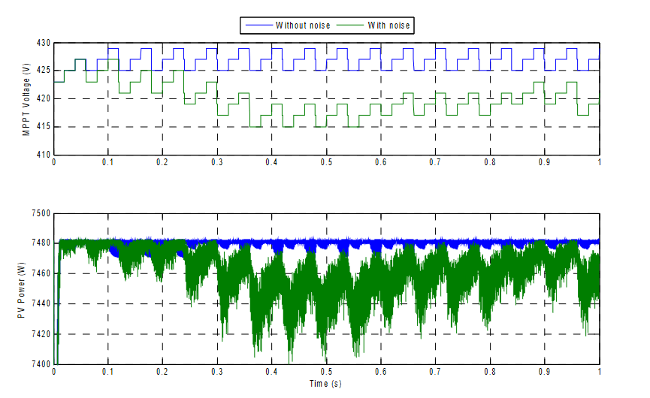

Figure X: 3-Point P&O in the presence of noise [A-9]

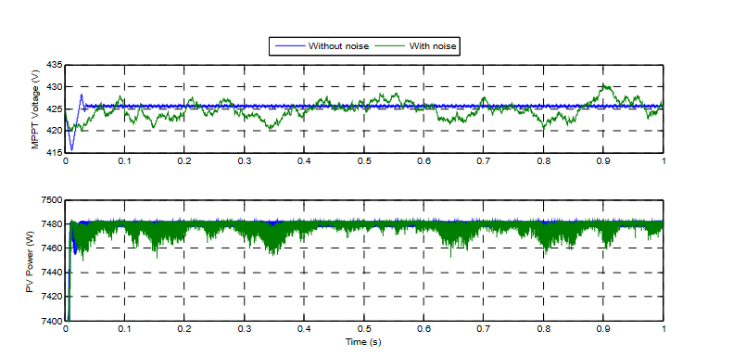

Figure X: Fixed Step Inc. Cond. in the Presence of Noise [A-9]

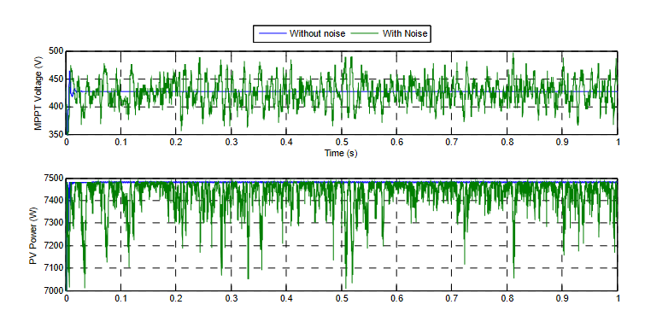

Figure X: Variable Step Inc. Cond. in the Presence of Noise [A-9]

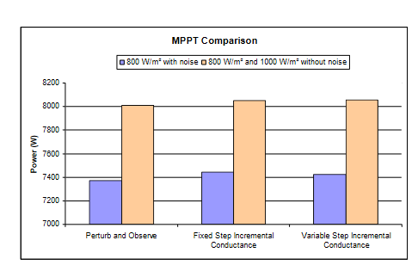

Figure X: Power Comparison of Algorithms with and without Noise [A-9]

These authors concluded that even low levels of noise present in real systems have a significant effect on algorithm performance when compared to ideal simulations.

**2.7 Problems and Gaps in Existing Research**

The authors from [A-4] concluded that noise has a significant effect on a hill-climbing algorithm’s ability to track MPP efficiently, and explained how very little research exists in terms of mitigation efforts needed to correct this problem. Their only solution to the problem was to introduce low pass filters at the cost of information loss, speed, destabilization. They also did no experimentation and provided no solution or insight for the incremental conductance algorithm.

The authors from [A-5] found that the P&O method could be optimized using specific system parameters, but did not provide any information on optimizing the Incremental Conductance algorithm, which is subject to the same set of problems with regard to noise.

The authors from [A-2] analyzed the effect of noise on the direct duty cycle Incremental Conductance algorithm and its correlation to parameter step sizes and sampling/perturbation rates and concluded that high sampling/perturbation rates and low step sizes allow for high rates of tracking error when noise is introduced. However, increasing step size to offset this problem results in increases in steady state oscillations, reduction in overall system stability, and lower overall efficiency.

The authors from [A-8] analyzed how the integration of low pass filters assisted in the filtering of noise for the Incremental Conductance algorithm, and concluded that it correlated with loss of system stability with PI control, and slow transient response and poor performance with rapidly changing irradiance values with direct duty cycle control. They also emphasized that system parameters such as step size and perturbation frequency changed how well the algorithm responded to noise, normally with specific parameters needed in order to handle noise efficiently.

While the authors of [11] were able to create an MPC-Incremental Conductance algorithm that outperformed the regular Incremental Conductance algorithm, it come with additional costs of moderate system complexity and increased sensor count. Additionally, no information regarding how this system operates under the presence of noise is indicated. Furthermore, while it is suggested to reduced sensor count from 3 to 2 by using the circuit topology gain equation, no proof of how well this stands when considering noise. Additionally, this algorithm heavy requires the use of current sensing, which, from previously state literature [A-5] is naturally subject to noise.

The authors from [A-9] concluded that noise has a significant effect on algorithm performance for P&O and Incremental Conductance, but gave no proposals or possible solutions for solving the problem.

There is some research involved with using the Kalman filter and MPPT algorithms. However, some of this research involves creating an independent MPPT algorithm that uses the PV characteristic curve as a state space model for the Kalman filter [A-10][A-14][A-15], as opposed to optimizing an existing MPPT algorithm to account for noise or complexity. Additionally, other authors have used the Kalman filter for approximating parameters such as settling time for step size optimization through the use of Dual-Kalman Filters [A-11][A-12] or speed rotation for MPPT algorithms in wind turbines[A-16]. Furthermore, some authors used the Kalman filter to improve tangentially related systems, such as the authors from [A-13] using Kalman filter to optimize P&O for thermoelectric generator systems.

**2.8 Proposed Solution**

With existing evidence of MPPT tracking problems relating to noise combined with the increasing complexity involved with newer MPPT algorithms, (in particular sensor count), combined with little literature on how to address this problem, a Kalman filter based MPC-Incremental Conductance algorithm is proposed. This algorithm will aid in optimizing the overall MPPT performance in the presence of noise, as well as reduce sensor count through state estimation, both of which are problems seen in existing literature. Additionally, it will function to maintain the high level of tracking performance seen in more complex algorithms by also allow for high levels of tracking performance seen in more complex algorithm designs. The design centers around deriving an averaged state space model of the DC-DC converter under consideration, using that state space model in the Kalman filter algorithm, and estimating and predicting system states in the presence of noise and without the need for additional sensor for each state. It will also modulate the state space model for slight increases in duty cycle and slight decreases in duty cycle, and then predict future states based on these modifications. This data will then be fed through the traditional incremental conductance algorithm, where a reference signal will be generated and compared to the future state predictions for direct duty cycle control of the circuit.

**//REDO/REMOVE 2.6 Similar Designs**

Research that closely resembles the design and implementation goals of this project involve the use of high gain boost converter topologies, Incremental Conductance or Perturb and Observe MPPT systems, and some form of controller and/or observer designs for driving the circuit to its desired voltage and current values. The authors from [11] used the same circuit topology (2 capacitor, 2 inductor) and the same MPPT algorithm (Incremental Conductance) and controller (MPC), but did not integrate any state estimator, resulting in a system that required 2-3 sensors. They concluded that there were power efficiency problems at certain input voltage levels. The authors from [37] used a 2 capacitor, 1 inductor boost topology that utilized an MPC P&O algorithm. The MPC model improved slow transient behavior and ripple of the P&O algorithm, and an Extended Kalman Filter (EKF) was added to the system to reduce sensors. However, only MATLAB simulations were used, which simplified the experiment to ideal conditions only. The authors from [38] used a buck-boost topology with an incremental conductance algorithm. They were able to conclude that the incremental conductance algorithm outperforms the P&O algorithm, but the boosting ratios on the buck-boost converter were considered low.

In exploring more broadly similar literature, the authors from [39] used a cuk converter with an ANN algorithm, but concluded that the cuk converter’s increased complexity does not outweigh its ability to perform better than the boost converter at lower irradiance levels. The authors only performed software simulation under ideal conditions. The authors from [40] used reinforcement learning on a 2 capacitor, 1 inductor boost converter, and concluded that there were small ripples present in the output, and MPPT control accuracy was weakened when an additional neural network was not used to approximate the states of the system.

**Chapter 3**

**Methodology**

**3.1 Circuit Model**

The first step in the system design involves creating a mathematical state space model of the circuit being controlled. The following shows the derivation of the bilinear switching and small signal averaged state space model for the high gain boost converter of [11] when resistors are added in series with the inductors. These two models are then modified to create a linearized state space model that depends on the duty cycle $D$ and the PV voltage $V_{pv}$ that is more accurate than the averaged small signal model while still being linearized.



Figure X: Overall Circuit

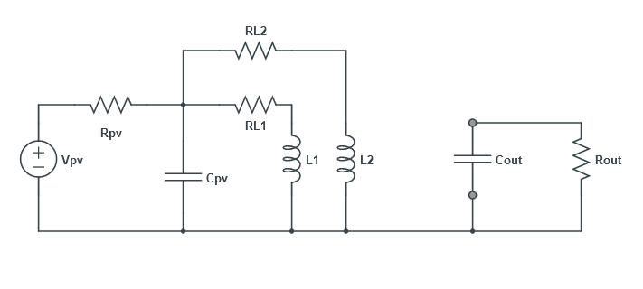

Figure X: circuit when switch is on

The KVL and KCL equations of the circuit when the switch is on are as follows:

$C_{pv}*\frac{dVC_{pv}}{dt}+IL_{1}+IL_{2}=\frac{V_{pv}-VC_{pv}}{R_{pv}}$ (X)

$$IL_{1}*RL_{1}+L_{1}*\frac{dIL_{1}}{dt}=VC_{pv}$$

$$IL_{2}*RL_{2}+L_{2}*\frac{dIL_{2}}{dt}=VC_{pv}$$

$$C_{out}*\frac{dVC_{out}}{dt}= -\frac{VC_{out}}{R_{out}}$$

The equations can be rearranged in terms of state variables as follows:

$\dot{VC_{pv}}=\frac{V_{pv}}{C_{pv}*R_{pv}}-\frac{VC_{pv}}{C_{pv}*R_{pv}}-\frac{IL_{1}}{C_{pv}}-\frac{IL_{2}}{C_{pv}}$ (X)

$$\dot{IL_{1}}=\frac{VC_{pv}}{L_{1}}-\frac{IL_{1}*RL_{1}}{L_{1}}$$

$$\dot{IL_{2}}=\frac{VC_{pv}}{L_{2}}-\frac{IL_{2}*RL_{2}}{L_{2}}$$

$$\dot{VC_{out}}= -\frac{VC_{out}}{R_{out}*C_{out}}$$

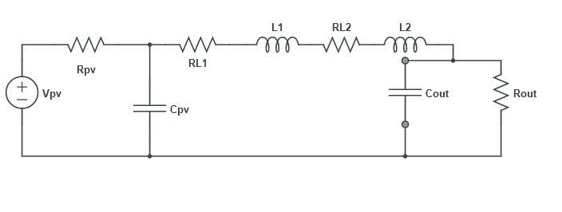

Figure X: circuit when switch is off

The KVL and KCL equations of the circuit when the switch is on are as follows:

$C_{pv}*\frac{dVC_{pv}}{dt }+IL_{1}=\frac{V_{pv}-VC_{pv}}{R_{pv}}$ (X)

$$VC_{pv}=IL_{1}*RL_{1}+L_{1}*\frac{dIL_{1}}{dt}+IL_{2}*RL_{2}+L_{2}\frac{dIL_{1}}{dt}+VC_{out}$$

$$VC_{pv}=IL_{1}*RL_{1}+L_{1}*\frac{dIL_{2}}{dt}+IL_{2}*RL_{2}+L_{2}*\frac{dIL_{2}}{dt}+VC_{out}$$

$$IL_{2}=C_{out}*\frac{dVC_{out}}{dt}+\frac{VC_{out}}{R_{out}}$$

The equations can be rearranged in terms of state variables as follows:

$\dot{VC_{pv}}=\frac{V_{pv}}{C_{pv}*R_{pv}}-\frac{VC_{pv}}{C_{pv}*R_{pv}}-\frac{IL_{1}}{C_{pv}}$ (X)

$$\dot{IL_{1}}=\frac{VC_{pv}}{L_{1}+L_{2}}-\frac{IL_{1}*RL_{1}}{L_{1}+L_{2}}-\frac{IL_{2}*RL_{2}}{L_{1}+L_{2}}-\frac{VC_{out}}{L_{1}+L_{2}}$$

$$\dot{IL_{2}}=\frac{VC_{pv}}{L_{1}+L_{2}}-\frac{IL_{1}*RL_{1}}{L_{1}+L_{2}}-\frac{IL_{2}*RL_{2}}{L_{1}+L_{2}}-\frac{VC_{out}}{L_{1}+L_{2}}$$

$$\dot{VC_{out}}=\frac{IL_{2}}{C_{out}}-\frac{VC_{out}}{R_{out}*C_{out}}$$

The two sets of equations can be combined into a single set of equations, incorporating both when the switch is on by distributing the variable U (representing the switch on) through the first set of equations, and when the switch is off by distributing (1-U) through the second set of equations. The following shows the results after combining equations, distributing values, and cancelling terms:

$\dot{VC_{pv}}=-\frac{IL_{2}}{C_{pv}}*U+\frac{V_{pv}}{C_{pv}*R_{pv}}-\frac{VC_{pv}}{C_{pv}*R_{pv}}-\frac{IL_{1}}{C_{pv}}$ (X)

$$\dot{IL_{1}}=\frac{L_{1}+L_{2}-L_{1}}{L_{1}\left(L_{1}+L_{2}\right)}*VC_{pv}*U+\frac{RL_{1}*L_{1}-RL_{1}\left(L_{1}+L_{2}\right)}{L_{1}\left(L_{1}+L_{2}\right)}*IL_{1}*U+\frac{VC_{pv}}{L_{1}+L_{2}}-\frac{IL_{1}*RL_{1}}{L_{1}+L_{2}}-\frac{IL_{2}*RL_{2}}{L_{1}+L_{2}}-\frac{VC_{out}}{L_{1}+L_{2}}+\frac{RL_{2}}{L_{1}+L_{2}}*IL_{2}*U+\frac{VC_{out}}{L_{1}+L_{2}}*U$$

$$\dot{IL_{2}}=\frac{L_{1}+L_{2}-L_{2}}{L_{2}(L_{1}+L_{2})}*VC_{pv}*U+\frac{RL_{2}*L_{2}-RL_{2}\left(L_{1}+L_{2}\right)}{L_{2}\left(L_{1}+L_{2}\right)}*IL_{2}*U+\frac{VC_{pv}}{L_{1}+L_{2}}-\frac{IL_{1}*RL_{1}}{L_{1}+L_{2}}-\frac{IL_{2}*RL_{2}}{L_{1}+L_{2}}-\frac{VC_{out}}{L_{1}+L_{2}}+\frac{IL_{1}*RL_{1}}{L_{1}+L_{2}}*U+\frac{VC_{out}}{L_{1}+L_{2}}*U$$

$$\dot{VC_{out}}=\frac{IL_{2}}{C_{out}}-\frac{VC_{out}}{R_{out}*C_{out}}-\frac{IL_{2}}{C_{out}}*U$$

The bilinear switching model follows the format of $\dot{x}=Ax+\left(Bx+b\right)u+d$, and the previous set of equations can be incorporated into the model as follows:

$\left[\begin{aligned}\dot{VC_{pv}} \\ \dot{IL_{1}} \\ {\dot{IL}}_{2} \\ \dot{{VC}_{out}}\end{aligned}\right]=\left[\begin{matrix}-\frac{1}{C_{pv}*R_{pv}} & -\frac{1}{C_{pv}} & 0 & 0 \\ \frac{1}{L_{1}+L_{2}} & -\frac{R_{L1}}{L_{1}+L_{2}} & -\frac{R_{L2}}{L_{1}+L_{2}} & -\frac{1}{L_{1}+L_{2}} \\ \frac{1}{L_{1}+L_{2}} & -\frac{R_{L1}}{L_{1}+L_{2}} & -\frac{R_{L2}}{L_{1}+L_{2}} & -\frac{1}{L_{1}+L_{2}} \\ 0 & 0 & \frac{1}{C_{out}} & -\frac{1}{R_{out}*C_{out}}\end{matrix}\right]\left[\begin{aligned}\begin{aligned}\begin{matrix}VC_{pv} \\ IL_{1}\end{matrix} \\ IL_{2}\end{aligned} \\ VC_{out}\end{aligned}\right]$ (X)

$+\left[\begin{matrix}0 & 0 & -\frac{1}{C_{pv}} & 0 \\ \frac{L_{2}}{L_{1}(L_{1}+L_{2})} & -\frac{R_{L1}*L_{2}}{L_{1}(L_{1}+L_{2})} & \frac{R_{L2}}{L_{1}+L_{2}} & \frac{1}{L_{1}+L_{2}} \\ \frac{L_{1}}{L_{2}\left(L_{1}+L_{2}\right)} & \frac{R_{L1}}{L_{1}+L_{2}} & -\frac{R_{L2}*L_{1}}{L_{2}(L_{1}+L_{2})} & \frac{1}{L_{1}+L_{2}} \\ 0 & 0 & -\frac{1}{C_{out}} & 0\end{matrix}\right]\left[\begin{aligned}\begin{aligned}\begin{matrix}VC_{pv} \\ IL_{1}\end{matrix} \\ IL_{2}\end{aligned} \\ VC_{out}\end{aligned}\right]*u+\left[\begin{matrix}0 \\ 0 \\ 0 \\ 0\end{matrix}\right]*u+\left[\begin{matrix}\frac{V_{pv}}{C_{pv}*R_{pv}} \\ 0 \\ 0 \\ 0\end{matrix}\right]$

However, this model is not linear, nor is it in the typical state space form needed for the Kalman Filter. Therefore, the small signal averaged model, which is in the form of $\dot{x}=Ax+Bu$ is developed by combining the A and B matrices of the switching model in terms of the averaged switching value, denoted as $U_{e}.$ The B matrix is determined by determining the rate of change of the switch U after setting the rate of change of the state variables equal to zero and solving for the value of the unknown state variables.

$\left[\begin{aligned}\dot{\tilde{{VC}_{pv}}} \\ \tilde{IL_{1}} \\ \tilde{{IL}_{2}} \\ \dot{\tilde{VC_{out}}}\end{aligned}\right]=\left[\begin{matrix}-\frac{1}{C_{pv}*R_{pv}} & -\frac{1}{C_{pv}} & -\frac{1}{C_{pv}}*U_{e} & 0 \\ \left(\frac{1}{L_{1}+L_{2}}+\frac{L_{2}*U_{e}}{L_{1}\left(L_{1}+L_{2}\right)}\right) & \left(-\frac{R_{L1}}{L_{1}+L_{2}}-\frac{R_{L1}*L_{2}*U_{e}}{L_{1}\left(L_{1}+L_{2}\right)}\right) & \left(-\frac{R_{L2}}{L_{1}+L_{2}}+\frac{R_{L2}*U_{e}}{L_{1}+L_{2}}\right) & \left(-\frac{1}{L_{1}+L_{2}}+\frac{U_{e}}{L_{1}+L_{2}}\right) \\ \left(\frac{1}{L_{1}+L_{2}}+\frac{L_{1}+U_{e}}{L_{2}\left(L_{1}+L_{2}\right)}\right) & \left(-\frac{R_{L1}}{L_{1}+L_{2}}+\frac{R_{L1}*U_{e}}{L_{1}+L_{2}}\right) & \left(-\frac{R_{L2}}{L_{1}+L_{2}}-\frac{R_{L2}*L_{1}*U_{e}}{L_{2}\left(L_{1}+L_{2}\right)}\right) & \left(-\frac{1}{L_{1}+L_{2}}+\frac{U_{e}}{L_{1}+L_{2}}\right) \\ 0 & 0 & \left(\frac{1}{C_{out}}-\frac{U_{e}}{C_{out}}\right) & -\frac{1}{R_{out}*C_{out}}\end{matrix}\right]\left[\begin{aligned}\begin{aligned}\begin{matrix}\tilde{VC_{pv}} \\ \tilde{IL_{1}}\end{matrix} \\ {\tilde{IL}}_{2}\end{aligned} \\ \tilde{VC_{out}}\end{aligned}\right]$ (X)

$$+\left[\begin{matrix}-\frac{IL_{2}}{C_{pv}} \\ \frac{L_{2}*VC_{pv}}{L_{1}(L_{1}+L_{2})}-\frac{R_{L1}*L_{2}*{IL}_{1}}{L_{1}\left(L_{1}+L_{2}\right)}+\frac{R_{L2}*IL_{2}}{L_{1}+L_{2}}+\frac{VC_{out}}{L_{1}+L_{2}} \\ \frac{L_{1}*VC_{pv}}{L_{2}(L_{1}+L_{2})}+\frac{R_{L1}*I_{L1}}{L_{1}+L_{2}}-\frac{R_{L2}*L_{1}*IL_{2}}{L_{2}\left(L_{1}+L_{2}\right)}+\frac{VC_{out}}{L_{1}+L_{2}} \\ -\frac{IL_{2}}{C_{out}}\end{matrix}\right]*\left[\tilde{U}\right]$$

However, the small signal averaged model proves to have problems with accuracy, which will be seen later in experimentation and therefore the model is modified so that $U_{e}$ of the A matrix is replaced with the actual value of the switching duty cycle D for a given time t, and the B matrix is modified so that it incorporates the d matrix of the bilinear switching model, with the input, U replaced by $V_{pv}$. This is modified to the following state space model:

$\left[\begin{aligned}\dot{\tilde{{VC}_{pv}}} \\ \tilde{IL_{1}} \\ \tilde{{IL}_{2}} \\ \dot{\tilde{VC_{out}}}\end{aligned}\right]=\left[\begin{matrix}-\frac{1}{C_{pv}*R_{pv}} & -\frac{1}{C_{pv}} & -\frac{1}{C_{pv}}*D & 0 \\ \left(\frac{1}{L_{1}+L_{2}}+\frac{L_{2}*D}{L_{1}\left(L_{1}+L_{2}\right)}\right) & \left(-\frac{R_{L1}}{L_{1}+L_{2}}-\frac{R_{L1}*L_{2}*D}{L_{1}\left(L_{1}+L_{2}\right)}\right) & \left(-\frac{R_{L2}}{L_{1}+L_{2}}+\frac{R_{L2}*D}{L_{1}+L_{2}}\right) & \left(-\frac{1}{L_{1}+L_{2}}+\frac{D}{L_{1}+L_{2}}\right) \\ \left(\frac{1}{L_{1}+L_{2}}+\frac{L_{1}+D}{L_{2}\left(L_{1}+L_{2}\right)}\right) & \left(-\frac{R_{L1}}{L_{1}+L_{2}}+\frac{R_{L1}*D}{L_{1}+L_{2}}\right) & \left(-\frac{R_{L2}}{L_{1}+L_{2}}-\frac{R_{L2}*L_{1}*D}{L_{2}\left(L_{1}+L_{2}\right)}\right) & \left(-\frac{1}{L_{1}+L_{2}}+\frac{D}{L_{1}+L_{2}}\right) \\ 0 & 0 & \left(\frac{1}{C_{out}}-\frac{D}{C_{out}}\right) & -\frac{1}{R_{out}*C_{out}}\end{matrix}\right]\left[\begin{aligned}\begin{aligned}\begin{matrix}\tilde{VC_{pv}} \\ \tilde{IL_{1}}\end{matrix} \\ {\tilde{IL}}_{2}\end{aligned} \\ \tilde{VC_{out}}\end{aligned}\right]$ (X)

$$+\left[\begin{matrix}\frac{1}{C_{pv}*R_{pv}} \\ 0 \\ 0 \\ 0\end{matrix}\right]*\left[V_{pv}\right]$$

Given that the exact value of the duty cycle can be determined and access to the value of $V_{pv}$ is possible, this model proves to have high accuracy in terms of representing the functionality of the circuit under consideration in a state space form.

**3.2 Kalman Filter Design**

The Kalam filter used in this system assumes availability of $V_{pv}$, $VC_{out}$, and the existing duty cycle rate, $D$ at the existing time of sampling $(t=k)$. That said, the need for access to $V_{pv}$ can be removed by estimating its value either by working backwards using KVL and KCL equations given state values, or by using the gain equation associated with the corresponding DC-DC converter.

The Filter also requires a discretized state space model of the system it is observing. The previously stated state space model from equation X is discretized using the forward Euler method of approximation:

$x\left[k+1\right]≅\left(I+AT_{s}\right)x\left[k\right]+T_{s}Bu[k]$ (X)

Where I is the identity matrix, and $T_{s}$ is the chosen sampling rate of the system. C and D matrices remain unchanged. The A and B matrices of the discretized state space model is then used as the F and B matrices of the Kalman filter algorithm seen in equation X, respectively. A C matrix is chosen as

$\left[\begin{matrix}0 & 0 & 0 & 1\end{matrix}\right]\left[\begin{matrix}VC_{pv} \\ IL_{1} \\ IL_{2} \\ {VC}_{out}\end{matrix}\right]$ (X)

Since $VC_{out}$ is considered the output of the system. Q and R matrix coefficient values are chosen to scale with the amount of noise added to the simulation states and simulation output, respectively.

Given this system setup, the algorithm will compute the set of equations corresponding to predict and update, as seen in equations X through X. After predicting and correcting for the states of the system for time $t=k$, the Kalman filter algorithm with then make future state predictions. It performs these predictions by slightly increasing the existing duty cycle D value by a small amount, recomputing the discrete state space system with this new value, and iterating through the prediction process again. It then slightly decreases the existing duty cycle D and again recomputes state space and prediction states. At this point, there is an estimation of states for time t=k given the existing duty cycle, as well as an estimation of future states for time $t=k+1$ given a slightly increased D, and slightly decreased D. These values will then be used in the MPC-Incremental Conductance algorithm.

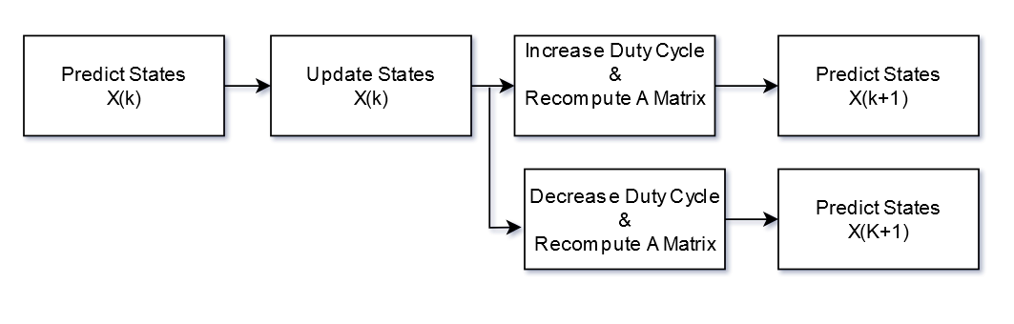

Figure X. Flow Chart describing simplified Kalman filter process

**3.3 MPC-Incremental Conductance Design**

On every discrete timestep, the MPC-Incremental Conductance algorithm will receive the existing and future state estimates of the circuit from the Kalman filter. It will then use these values to calculate $I_{pv}$ using the following equation:

$I_{pv}=\frac{V_{pv}-VC_{pv}}{R_{pv}}$ (X)

Which is derived through circuit analysis of the converter both when the switch is on and off, as seen in figures X and X. As an alternative method to solve for that allows for the removal of the resistor , the averaged value of the sum of and the Inductor currents and when the switch is on and and or should yield similar results. Access to all off these values should be available from estimations of the Kalman filter. The incremental conductance algorithm then uses $V_{pv}$ and $I_{pv}$ in the following flow chart in order to derive a desired reference current, $I_{ref}$.

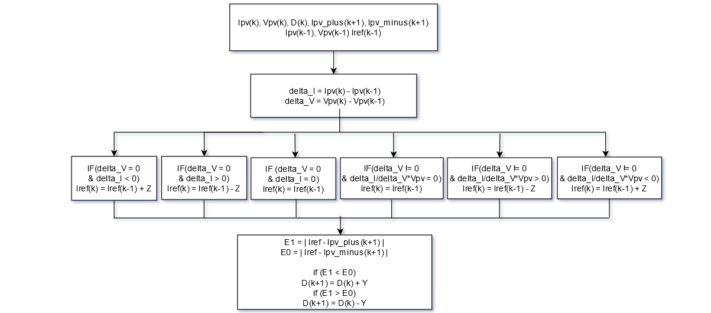

Figure X: MPC-Incremental Conductance Algorithm Flowchart

Where Z and Y are predetermined step values for incrementing or decrementing and respectively. On each discrete timestep, the variables from the Kalman filter ( , , , ) are received and the change in current and voltage is computed ( and ). The Incremental Conductance algorithm from the set of equations from X is then computed and a reference signal is computed accordingly. The predicted values of and are compared to and the duty cycle D is increased or decreased with the respect to the predicted duty cycle that produces the least error with respect to the reference. This duty cycle is applied to a PWM signal controlling the switches of the DC-DC converter.

**Chapter 4**

**Experiment**

**4.1 System Setup**

The following figure shows the high-level system model that must be implemented in simulation.

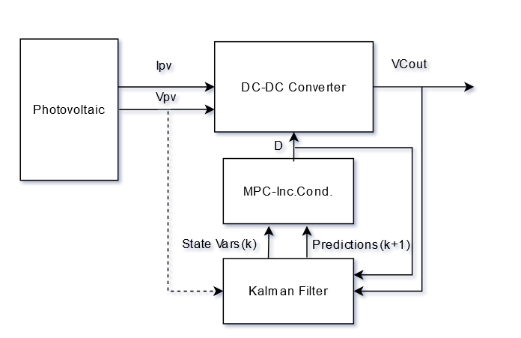

Figure X: Block Diagram of how each part the design interacts

has a dotted line due to its capability of being estimated. However, the gain equation is only useful during ideal circuit conditions, and the added resistors used in this simulation prevent it from being accurate. Using circuit analysis techniques for estimation requires modifying initial condition parameters of the Kalman filter to make sure the system converges during the initial stages of estimation.

**4.2 MATLAB Simulation**

In Simulink, the PV simulation model chosen is the Kyocera Solar KC200GT, with typical I-V and P-V responses to irradiance and temperature seen in figures X and X. The array is modeled as a single parallel string with a single series connected module, with inputs of temperate and irradiance that are functions of time.

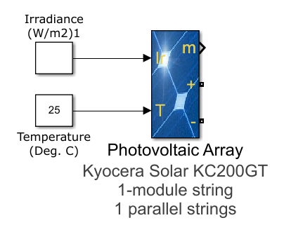

Figure X: PV Array Module in Simulink

The following table shows the specific PV characteristics of the model:

Table X: Parameters of Simulated Kyocera Solar KC200GT

|  |  |
| --- | --- |
| Maximum Power (W) | 200.143 |
| Cells Per Module | 54 |
| Open Circuit Voltage, VOC (V) | 32.9 |
| Short Circuit Current, ISC (A) | 8.21 |
| Voltage at MPP, VMP (V) | 26.3 |
| Current at MPP, IMP (A) | 7.61 |
| Temp. Coefficient of VOC | -.355 |
| Temp. Coefficient of ISC | .06 |

The irradiance temperature inputs are configured so that they have the following values over the course of 2 seconds of simulation time, with the necessary values of voltage, current and power needed for maximum power extraction given those values:

Table X: PV Input Parameters and Expected V, I, and P Values at Maximum Power Point

|  |  |  |  |  |  |
| --- | --- | --- | --- | --- | --- |
| Simulation Time (seconds) | PV Input Irradiance (W/m^2) | PV Input Temperature (deg. C) | Voltage at MPP (V) | Current at MPP (I) | Power at MPP (W) |
| 0 | 800 | 25 | 26.5 | 6.1 | 161.5 |
| .5 | 1000 | 25 | 26.3 | 7.6 | 200.2 |
| 1 | 1000 | 35 | 25.1 | 7.6 | 191.5 |
| 1.5 | 1000 | 45 | 24.0 | 7.6 | 182.8 |

For initial testing, the high gain boost converter modelled in chapter 3 is implemented as a circuit in Simulink. Table X shows the circuit parameters chosen for simulation.

Table X: Circuit Parameters of Simulated High Gain Boost Converter

|  |  |  |  |
| --- | --- | --- | --- |
|  | 260 |  | 1 |
|  | 260 |  | 1 |
|  | 3 mH |  | 1 |
|  | 3 mH |  | 100 |

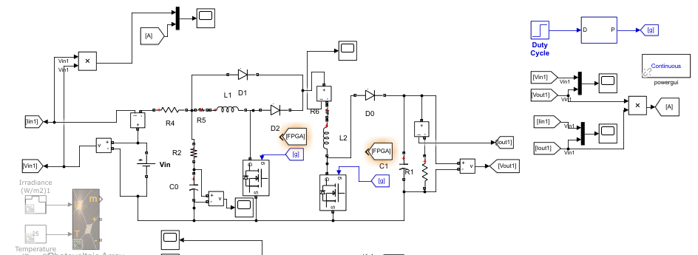

Figure X: Simulink Model of High Gain Boost Converter

Before implementing and testing the algorithms with the circuit, the averaged state space model of equation X is implemented in MATLAB and its response to arbitrary duty cycles (50% seen in the following) switching at 66.67kHz with a fixed input voltage of 30V is tested and compared to that of the circuit model with the same input parameters to verify accuracy. The simulation setups and state responses are seen below:

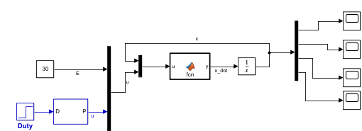

Figure X: MATLAB Function block containing the state space model of the circuit



Figure X:



Figure X:



Figure X:

Additionally, the small signal averaged model of equation X is also tested and compared to that of equation X to show inaccuracies in that model. The code for these function blocks can be found in appendix A. The standalone Kalman filter was also evaluated with the previously mentioned test data to ensure it was estimating states properly.

After verifying the state space model, the proposed Kalman Filter MCP-Incremental Conductance algorithm is written as a MATLAB function block within Simulink, with specific parameters seen below:

Table X: Kalman Filter and MPC-Incremental Conductance Algorithm Parameters

|  |  |  |  |
| --- | --- | --- | --- |
| KF Matrix Coefficients | .000001 (without noise)  . 000001 (with noise) | Algorithm Sampling Rate, | 15 |
| KF Matrix Coefficients | .000001 (without noise)  10 (with noise) | Step Size, Z | .001 |
| KF Predicted D Increment/Decrement | .0001 | Duty Cycle D Control Increment/Decrement | .0001 |

The algorithm is implemented as a single MATLAB function blocks, with inputs of and , and with a constant value output that determines the duty cycle of the circuit switches. The code can be found in appendix A.

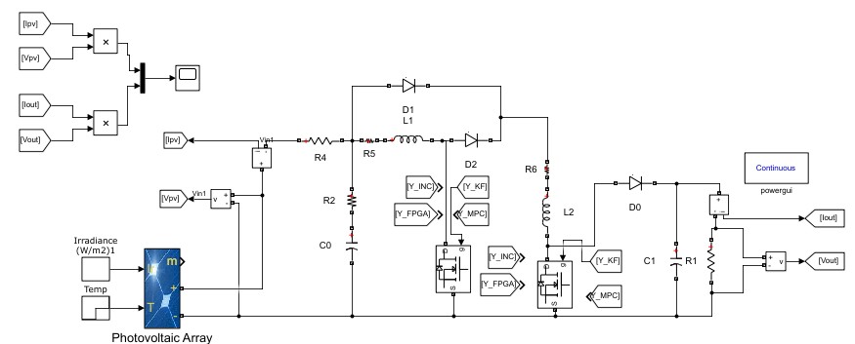

Figure X: Simulink circuit simulation showing various possible ‘from’ tags controlling the switches

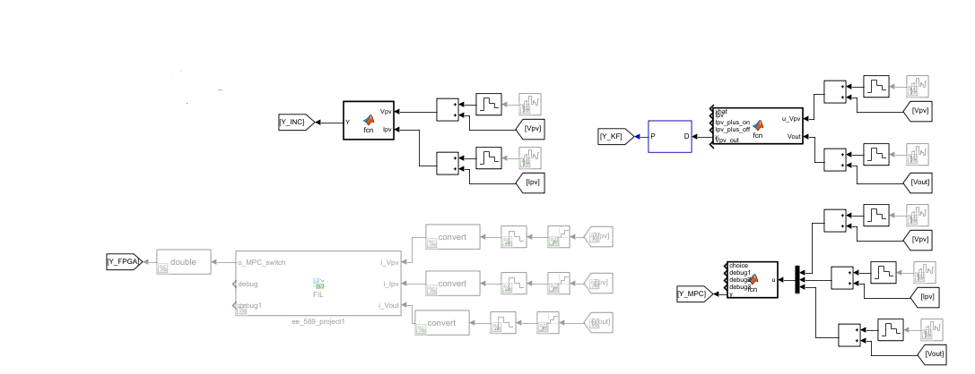

Figure X: MATLAB Function blocks of various algorithms under test, with ‘from’ tags routing from the circuit model, and ‘go to’ tags routing to the switch of the circuit

Aside from the proposed algorithm, two other algorithms will be used for functionality comparison. These algorithms are the traditional, direct duty cycle controlled Incremental Conductance algorithm and the MPC-Incremental Conductance algorithm from [11]. The code for these modules can be found in appendix A. The results of the algorithms will be compared to the proposed algorithm under conditions without noise, with noise, without estimating , and with estimating .

Table X: Simulation Criteria

|  |  |  |
| --- | --- | --- |
| High Gain Boost Converter | No Noise | Noise |
| MMPT/Power Efficiency | Results A | Results B |
| Transient Response | Results A | Results B |
| Steady State Oscillations | Results A | Results B |

**4.3 FPGA Hardware-in-the-Loop**

Hardware in the loop (HIL) simulation is a process where an FPGA development board can be integrated via JTAG or Ethernet to a MATLAB/Simulink project so that a hardware/software co-simulation can occur. This method allows for an engineer to implement the designed control algorithm in an FPGA, and then test the FPGA design with the simulation plant it is controlling in MATLAB/Simulink. HIL creates a virtual real-time environment for testing algorithms without the need of prototypes. For this specific experiment, this allows for testing the FPGA with the circuit model, without actually having to design and implement a circuit model prototype.

The Kalman Filter MPC-Incremental Conductance Algorithm is written in Verilog HDL, and ported to the DE1-SOC Development Board, which contains an Intel/Altera Cyclone V FPGA-SOC. The board is then used in HIL simulation in Simulink with the remaining simulation system (PV module, DC-DC converter circuit) staying in simulation software.

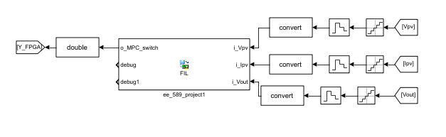

Figure X: FPGA block in Simulink that routes simulation data to and from the FPGA development board

The samples entering the FPGA must be quantized at a discrete interval, then sampled using a zero-order-hold method. In this experiment, the quantize rate is set to the sampling period of the algorithm, and the zero-order-hold rate is set to the clock frequency of the FPGA. This is done because Simulink will send input data on every clock cycle of the FPGA clock (correlated to ZOH sampling rate), and of the data being sent to the FPGA on every clock cycle, it must be updated once every algorithm sampling period (correlated to quantize rate). In this manner, the FPGA can effectively count clock cycles and determine that, after a number of clock cycles equal to the sampling period, new data has arrived.

For FPGA development, how a system is designed in digital hardware depends on both hardware requirements and timing requirements. The Cyclone V FPGA used in this simulation contains 32070 logic elements, 87 DSP blocks, 5MB of block RAM, and 457 pins. The sampling rate for this design is set at 66.67kHz, which means there is 15 worth of time for the system to compute an output given a new input. How many clock cycles this equates to scales with the chosen clock frequency of the system, and the chosen clock frequency either chosen based on hardware component requirements (max oscillator frequency) or on how the FPGA logic is designed (meeting sample and hold requirements that account for propagation delay).

The design for this algorithm is broken down into three modules: a top module for controlling the external IO, performing the sampling of data, and handling of dataflow between all other modules, a Kalman filter module for executing the full Kalman Filter algorithm, and an Incremental Conductance-MPC module for executing the MPPT and control algorithm.

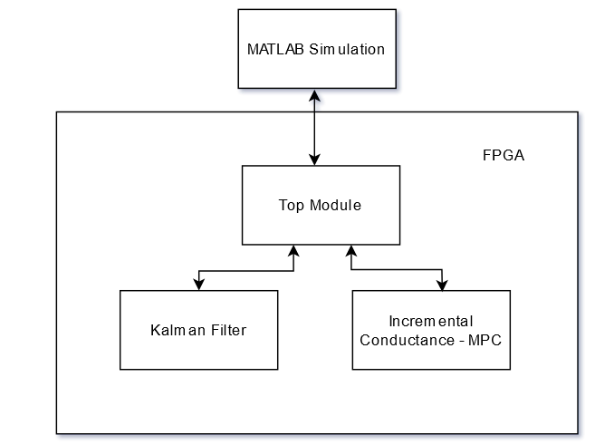

Figure X: System hierarchy for the FPGA modules

As stated, the Hardware in the Loop Simulation sends data on each clock cycle that updates with respect to the zero-order-hold discretization/sampling rate chosen in the corresponding function block that feeds in the FPGA block. Because of this, the top module utilizes a counter that counts each clock cycle until the value of the sampling rate is achieved. Once that value is achieved, it registers the input data at the given clock cycle, and sends a data-valid to the Kalman Filter, thus beginning the computation process.

The data format chosen is 32-bit signed fixed point with 16 fractional bits. The bit width and fraction length are chosen arbitrarily for simple testing purposes, and increased computational accuracy can be achieved by increasing both the bit width and the amount of fractional bits at the cost of increased risk of expending hardware resources and causing an overflow error.

From a computational perspective, the Kalman Filter algorithm can be considered a long chain of multiplications and accumulations. However, the need to take an inverse arises when computing the Kalman gain. That said, given the number of state variables and subsequent state space matrix dimensions for this specific application, what would otherwise be a matrix inverse simplifies into taking the inverse of a single value , as . The synthesis tools used by Quartus implement 3 IP cores when a division operator is written in Verilog. These cores attempt the perform a division within a single clock cycle at the cost of considerable amounts of logic and maximum possible clock frequency. There is a broad amount of literature regarding approaches to division and inverse operations in FPGA logic, but, as will be later discussed, this specific design is able to work around the increase in logic utilization and decrease in maximum possible clock frequency.

The largest computation within the algorithm (in terms of number of multiplies and adds needed to get a result when computing a value) is a 4x4 matrix multiplied by another 4x4 matrix to get a 4x4 result. This result requires 64 multiplies and adds. Since there are a limited number of DSP blocks, a multiply-accumulate section (MAC) is created and the subsequent state machine running the algorithm routes various signals to the MAC given the specific state of the state machine. The chosen number of multiply blocks was 16, which allows for a full 4x4 matrix to be multiplied with a 1x4 vector within a single clock cycle, as seen in of the state space model when there are 4 states. Thus, when a 4x4 must be multiplied with a 4x4, the columns of the second matrix must be passed in column by column over four clock cycles. This design tradeoff is intended to create a balance between DSP block utilization and number of clock cycles needed for a computation.

The Incremental Conductance-MPC module can be written so that only a single multiply and single divide is needed.

After each module was written, it was tested separately with a testbench that contained input data mirroring an equivalent MATLAB function with equivalent input data in order to check for accuracy and error. Individual module resource utilization and timing analysis was also conducted. After ensuring the accuracy of the Verilog modules through testbenches, the system was integrated into the Simulink Hardware in the Loop simulation for full system testing to ensure it functioned in the same manner as its simulation equivalent. Code for the algorithms can be found in appendix A.

**Chapter 5**

**Results**

**5.1 MATLAB Simulation**

The simulation was conducted across the three algorithms under the different conditions listed below. Under noisy conditions, white Gaussian noise was added to for the Kalman filter, as well as and for the MPC-Inc.Cond. algorithm, and and for the Inc.Cond. algorithm ( is estimated using estimated state variables for the Kalman Filter and has no sensor, the Inc.Cond. Algorithm does not ). The noise power was incremented from 0 towards 1 until the algorithms began losing their ability to track.

MPPT/Power Efficiency was calculated by taking the actual PV power over the MPP power during each irradiance/temperature cycle change once steady state was reached, and averaging the value across the 4 changes.

Transient response was calculated by recording the amount of time taken for steady state to be reached during each irradiance/temperature change, and averaging the value across the 3 changes, thus excluding the first since it relies on chosen initial condition values.

Steady state oscillation records the peak-peak value of the signal oscillations at steady state, where the first value is the oscillation of the signal overall, and the second value is the oscillation from switching rate. How these values are extracted are further seen in figure X - X.

The following images show example output power values for the three algorithms when no noise occurring. Analysis of these responses are used for conducting the data seen in table X.



Figure X: The value of the blue line when compared to the value of power in table X during steady state to determine efficiency



Figure X: The peak-peak value of oscillations on left image is the first oscillation value, the peak-peak value of the right image is the second oscillation value



Figure X. Transient time is found by analyzing time from a transition to steady state

Table X: Recorded Power Results Across Varying Values of Noise

|  |  |  |  |  |  |  |  |  |  |
| --- | --- | --- | --- | --- | --- | --- | --- | --- | --- |
| High Gain Boost Converter | No Noise | | | Sensor Noise  Power of | | | Sensor Noise  Power of to .0001 | | |
|  | KF | MPC | Inc.Con | KF | MPC | Inc.Con | KF | MPC | Inc.Con |
| MPPT/Power Efficiency | 99.91% | 99.78% | 98.70% | 99.90% | 99.78% | Tracking error | 99.89% | No tracking | No tracking |
| Transient Response | .060s | .063s | .067s | .062s | .063s | Tracking error | .073s | No tracking | No tracking |
| Steady State Oscillations | .212W  .076W | 0W  .470W | .8W  .075W | .210W  .076W | 0W  .470W | Tracking Error | .210W  .077W | No Tracking | No Tracking |



Figure X: Power Response of Kalman Filter algorithm with increasing noise power moving left to right



Figure X: Power response of Incremental-Conductance-MPC algorithm with increasing noise power moving left to right



Figure X: Power response of Incremental Conductance algorithm with increasing noise power moving left to right

The noise was further increased to .99, and with the coefficients of the R covariance matrix moved up from 10 to 100, the Kalman Filter continued to track, although after a slow initial transient.



Figure X: Kalman filter power tracking with noise power increased to 100, an amount of noise that would be considered beyond typical



Figure X: Detailed view of Kalman filter power tracking at 100 noise power

**5.2 FPGA Hardware in-the-Loop**

After confirming through testbench simulation that each module and the system as a whole is functioning accurately, analysis of the resource utilization and maximum possible clock frequency is performed. The results of each individual module and the module as a whole is listed below. Since the 3 IP core instantiation of the division block has a considerably large effect on these parameters, how the system performs with and without this division block is shown as well.

|  |  |  |  |  |  |
| --- | --- | --- | --- | --- | --- |
| Module | Logic Utilization | Logic Utilization W/o Division IP Core | Max Clock Freq. | Max Clock Freq. W/o Division IP Core | Clock Cycles Needed for Computing One Sample (latency) |
| Kalman Filter | 4025 ALMs | 2616 ALMs | 7.79 MHz | 47.54 MHz | 42 |
| MPC-INC | 1685 ALMs | 295 ALMs | 8.30 MHz | 107.34 MHz | 11 |
| Full System | 5685 ALMs | 2866 ALMs | 7.79 MHz | 47.54 MHz | 53 |

Table X: Logic Utilization and Maximum Clock Frequency of HDL Design ported to Cyclone V FPGA

The full HDL design also utilizes 51 of Cyclone V’s 87 DSP blocks. While the division operator appears heavily detrimental for this design, the Cyclone V has enough additional logic blocks to handle the increase in logic utilization, and the design also performs in enough clock cycles to be moved down to a clock frequency of around 5 MHz. This is because, at this clock frequency, the total number of clock cycles, X need to compute one sample correlates to using X seconds of time, which fits within the needed sampling period of 15.

PUT RESULTS OF HIL HERE

**Chapter 6**

**Conclusion**

**6.1 Discussion and Conclusion**

In analysis of the results from Chapter 5, it can be seen that, without presence of noise, the Kalman Filter MPPT algorithm is comparable in terms of efficiency, transient response, and oscillations when compared to the MPC-Incremental Conductance and regular incremental conductance algorithm. In analysis of efficiency, it is seen that the Kalman Filter algorithm has slightly higher efficiency than the traditional Incremental Conductance algorithm, but slightly lower efficiency than the MPC-Inc.Cond. This is most likely due to the MPC-Inc.Cond. algorithm having complete control of the switching state per sampling rate, as opposed to a duty cycle value that has to be incremented of decremented. This reason also explains why there is also no steady state oscillation with the MPC-Inc.Cond. as well. However, decrementing the duty cycle increment/decrement step size and value step size could yield lower steady oscillation values for the KF algorithm, however with the possible cost of increased transient values. Transient times were all about the same for the three algorithms, which is expected because each algorithm’s associated step size parameter was set to similar values.

It should be noted that the Kalman Filter MPPT algorithm has multiple additional parameters when compared to the other algorithms that will provide varying output results when modified in terms of oscillations, transient times, etc. This includes predicted duty cycle increment/decrements, duty cycle control increment/decrements, and reference current step size. This is in contrast to the single parameter step size with the MPC-Inc.Cond. and the single parameter of duty cycle increment/decrement step size of the Inc.Cond. Further research could possibly allow for a proper calibration that maximizes efficiency and minimizes oscillations and transients for the KF algorithm. That said, the algorithm operating at an efficiency comparable to the other algorithms is significant considering it is also capable of being reduced to a single sensor system when is estimated, while the other two algorithms are only capable of being reduced to a two-sensor system. It is also proven to filtering noise, which the other two algorithms fail to do once a certain threshold is met.

With noise added to the DC-DC converter, the Kalman Filter MPPT algorithm was still capable of estimating system states, and thus tracking MMPT through continued increments of noise, while the other two algorithms lost their ability to track when noise power was increased above . Therefore, with applications with noisy environments, the Kalman Filtered based MPPT algorithm could be considered a favorable application. Additionally, it can be considered favorable when there is a need to reduce sensor count.

**6.2 Future Work**

This thesis serves as a good starting point for the development, simulation, and hardware testing of both algorithms that build out of the Incremental Conductance Algorithm as well as general MPPT algorithms. With a full circuit model, mathematical model, control blocks, and tested FPGA design implemented, future researchers in this area can utilize this framework for building and testing various circuits, algorithms, and FPGA implementations by modifying each model as needed.

For the success of the proposed algorithm, future work regarding the successful calibration of parameters and initial conditions should allow for the Kalman filter algorithm to reduce down to a single sensor system. Additionally, the testing of this model across various circuit topologies and various noise environments, with further analysis how circuit parameters effect overall efficiency and speed could aid in more critical analysis of algorithm performance, and aid to correct for systems that fail given specific parameters (example being adaptive or small step sizes). This method used a direct duty cycle control method in combination with a Model Predictive Control scheme. Further experimentation with replacing direct duty cycle control with PI control may yield alternative results.

Additionally, this Kalman filter structure can be combined and experimented with algorithms other than the MPC-Inc. Cond., including the Perturb and Observe algorithm, which has higher correlation to tracking error in the presence of noise [A-8].

For the FPGA design, improvements can be made by replacing the IP core division block with a custom designed division system that meets the criteria for this specific type of division, that is also capable of expanding the process over multiple clock cycles. This will allow for high clock frequencies and less logic resources to be used. Additionally, more research can be conducted in terms of finding optimal bit widths and fractional bit values for the signed fixed-point notation, which will allow for the smallest amount of error with the fixed-point data conversion that is possible. This will allow for lower values of system parameters such as step size and initial conditions to be possible, and also lead to higher amounts of tracking accuracy and efficiency.

**REFERENCES**

[1] Rezk, Hegazy & AL-Oran, Mazen & Gomaa, Mohamed R. & Tolba, Mohamed A. & Fathy, Ahmed & Abdelkareem, Mohammad Ali & Olabi, A.G. & El-Sayed, Abou Hashema M., 2019. "A novel statistical performance evaluation of most modern optimization-based global MPPT techniques for partially shaded PV system," Renewable and Sustainable Energy Reviews, Elsevier, vol. 115.

[2] Al-Najideen, Mohammad I., and Saad S. Alrwashdeh. 2017. “Design of a Solar Photovoltaic System to Cover the Electricity Demand for the Faculty of Engineering- Mu’tah University in Jordan.” *Resource-Efficient Technologies* 3 (4). National Research Tomsk Polytechnic University: 440–45. doi:10.1016/j.reffit.2017.04.005.

[3] A. Kokare, S. Patil and L. Bacchav, "Implementation of a highly efficient MPPT technique for a PV system using sepic converter," 2017 International Conference on Information, Communication, Instrumentation and Control (ICICIC), 2017, pp. 1-5, doi: 10.1109/ICOMICON.2017.8279029.

[4] B. Subudhi and R. Pradhan, "A Comparative Study on Maximum Power Point Tracking Techniques for Photovoltaic Power Systems," in IEEE Transactions on Sustainable Energy, vol. 4, no. 1, pp. 89-98, Jan. 2013, doi: 10.1109/TSTE.2012.2202294.

[5] A. Harrag, S. Messalti and Y. Daili, "Innovative Single Sensor Neural Network PV MPPT," 2019 6th International Conference on Control, Decision and Information Technologies (CoDIT), 2019, pp. 1895-1899, doi: 10.1109/CoDIT.2019.8820335.

[6] Yılmaz, Unal, A. Kircay and S. Borekci. “PV system fuzzy logic MPPT method and PI control as a charge controller.” Renewable & Sustainable Energy Reviews 81 (2018): 994-1001.

[7] S. Motahhir, A. El Ghzizal, S. Sebti, and A. Derouich, “Modeling of Photovoltaic System with Modified Incremental Conductance Algorithm for Fast Changes of Irradiance,” International Journal of Photoenergy, 13-Mar-2018. [Online]. Available: https://www.hindawi.com/journals/ijp/2018/3286479/. [Accessed: 19-Feb-2021].

[8] J. Prasanth Ram, T. Sudhakar Babu, N. Rajasekar, “A comprehensive review on solar PV maximum power point tracking techniques, Renewable and Sustainable Energy Reviews”, Volume 67,2017. Pages 826-847. ISSN 1364-0321.

[9] D. Singh and H. Singh, "Technical Survey and review on MPPT techniques to attain Maximum Power of Photovoltaic system," *2019 5th International Conference on Signal Processing, Computing and Control (ISPCC)*, 2019, pp. 265-268, doi: 10.1109/ISPCC48220.2019.8988382.

[10] M. L. Azad, P. K. Sadhu and S. Das, "Comparative Study Between P&O and Incremental Conduction MPPT Techniques- A Review," *2020 International Conference on Intelligent Engineering and Management (ICIEM)*, 2020, pp. 217-222, doi: 10.1109/ICIEM48762.2020.9160316.

[11] O. Abdel-Rahim and H. Wang, "A new high gain DC-DC converter with model-predictive-control based MPPT technique for photovoltaic systems," in CPSS Transactions on Power Electronics and Applications, vol. 5, no. 2, pp. 191-200, June 2020, doi: 10.24295/CPSSTPEA.2020.00016.

[12] El-Khozondar, H.J., El-Khozondar, R.J., Matter, K. et al. A review study of photovoltaic array maximum power tracking algorithms. Renewables 3, 3 (2016). https://doi.org/10.1186/s40807-016-0022-8

[13] Baharudin, Nor Hanisah, T. M. N. T. Mansur, Fairuz Abdul Hamid, Rosnazri Ali, and Muhammad Irwanto Misrun. "Topologies of DC-DC converter in solar PV applications." Indonesian Journal of Electrical Engineering and Computer Science 8, no. 2 (2017): 368-374.

[14] H. Patel, M. Gupta and A. K. Bohre, "Mathematical modeling and performance analysis of MPPT based solar PV system," *2016 International Conference on Electrical Power and Energy Systems (ICEPES)*, 2016, pp. 157-162, doi: 10.1109/ICEPES.2016.7915923.

[15] A. H. M. Nordin and A. M. Omar, "Modeling and simulation of Photovoltaic (PV) array and maximum power point tracker (MPPT) for grid-connected PV system," 2011 3rd International Symposium & Exhibition in Sustainable Energy & Environment (ISESEE), 2011, pp. 114-119, doi: 10.1109/ISESEE.2011.5977080.

[16] Seyedmahmoudian, Mohammadmehdi; Mekhilef, Saad; Rahmani, Rasoul; Yusof, Rubiyah; Shojaei, Ali Asghar (2014-03-01). "Maximum power point tracking of partial shaded photovoltaic array using an evolutionary algorithm: A particle swarm optimization technique". Journal of Renewable and Sustainable Energy. 6 (2): 023102.

[17] W. Li and X. He, "Review of Nonisolated High-Step-Up DC/DC Converters in Photovoltaic Grid-Connected Applications," in IEEE Transactions on Industrial Electronics, vol. 58, no. 4, pp. 1239-1250, April 2011, doi: 10.1109/TIE.2010.2049715.

[18] K. Pal and M. Pattnaik, "Performance of a Synchronous Buck Converter for a Standalone PV System: an Experimental Study," 2019 IEEE 1st International Conference on Energy, Systems and Information Processing (ICESIP), 2019, pp. 1-6, doi: 10.1109/ICESIP46348.2019.8938345.

[19] R. J. Wai, W. H. Wang and C. Y. Lin, "High-performance stand-alone photovoltaic generation system", IEEE Trans. Ind. Electron., vol. 55, no. 1, pp. 240-250, Jan. 2008.

[20] Raghavendra, Kummara V.G.; Zeb, Kamran; Muthusamy, Anand; Krishna, T. N.V.; Kumar, S. V.S.V P.; Kim, Do-Hyun; Kim, Min-Soo; Cho, Hwan-Gyu; Kim, Hee-Je. 2020. "A Comprehensive Review of DC–DC Converter Topologies and Modulation Strategies with Recent Advances in Solar Photovoltaic Systems" Electronics 9, no. 1: 31. https://doi.org/10.3390/electronics9010031

[21] A. Amir, A. Amir, H. S. Che, A. Elkhateb, and N. A. Rahim, “Comparative analysis of high voltage gain DC-DC converter topologies for photovoltaic systems,” Renewable Energy, vol. 136, pp. 1147–1163, 2019.

[22] J. Meher and A. Gosh, "Comparative Study of DC/DC Bidirectional SEPIC Converter with Different Controllers," 2018 IEEE 8th Power India International Conference (PIICON), 2018, pp. 1-6, doi: 10.1109/POWERI.2018.8704363.

[23] S. Motahhir, A. El Hammoumi, and A. El Ghzizal, “The most used MPPT algorithms: Review and the suitable low-cost embedded board for each algorithm,” Journal of Cleaner Production, vol. 246, p. 118983, 2020.

[24] T. Jayakumaran et al., "A Comprehensive Review on Maximum Power Point Tracking Algorithms for Photovoltaic Cells," 2018 International Conference on Computation of Power, Energy, Information and Communication (ICCPEIC), Chennai, India, 2018, pp. 343-349, doi: 10.1109/ICCPEIC.2018.8525191.

[25] J. M. Riquelme-Dominguez and S. Martinez, "Comparison of Different Photovoltaic Perturb and Observe Algorithms for Drift Avoidance in Fluctuating Irradiance Conditions," 2020 IEEE International Conference on Environment and Electrical Engineering and 2020 IEEE Industrial and Commercial Power Systems Europe (EEEIC / I&CPS Europe), 2020, pp. 1-5, doi: 10.1109/EEEIC/ICPSEurope49358.2020.9160791.

[26] T. M. Chung, H. Daniyal, M. H. Sulaiman and M. S. Bakar, "Comparative study of P&O and modified incremental conductance algorithm in solar maximum power point tracking," 4th IET Clean Energy and Technology Conference (CEAT 2016), 2016, pp. 1-6, doi: 10.1049/cp.2016.1300.

[27] M. B. Shadmand, R. S. Balog and H. Abu-Rub, "Model Predictive Control of PV Sources in a Smart DC Distribution System: Maximum Power Point Tracking and Droop Control," in IEEE Transactions on Energy Conversion, vol. 29, no. 4, pp. 913-921, Dec. 2014, doi: 10.1109/TEC.2014.2362934.

[28] J. Rodriguez, M. P. Kazmierkowski, J. R. Espinoza, P. Zanchetta, H. Abu-Rub, H. A. Young, et al., "State of the art of finite control set model predictive control in power electronics", IEEE Trans. Ind. Informat., vol. 9, no. 2, pp. 1003-1016, Jan. 2013.

[29] A. Lashab, D. Sera, J. M. Guerrero, L. Mathe and A. Bouzid, "Discrete Model-Predictive-Control-Based Maximum Power Point Tracking for PV Systems: Overview and Evaluation," in IEEE Transactions on Power Electronics, vol. 33, no. 8, pp. 7273-7287, Aug. 2018, doi: 10.1109/TPEL.2017.2764321.

[30] S. Sajadian and R. Ahmadi, "Distributed maximum power point tracking using model predictive control for solar photovoltaic applications", Proc. IEEE Appl. Power Electron. Conf. Expo., pp. 1319-1325, 2017.

[31] M. Metry, S. Bayhan, R. S. Balog and H. Abu Rub, "Model predictive control for PV maximum power point tracking of single-phase sub multilevel inverter", Proc. Power Energy Conf. Illinois, pp. 1-8, Feb. 2016.  
[32] M. B. Shadmand, R. S. Balog and H. Abu-Rub, "Model predictive control of PV sources in a smart DC distribution system: Maximum power point tracking and droop control", IEEE Trans. Energy Convers., vol. 29, no. 4, pp. 913-921, Dec. 2014.

[33] P. E. Kakosimos, A. G. Kladas and S. N. Manias, "Fast photovoltaic-system voltage- or current-oriented MPPT employing a predictive digital current-controlled converter", IEEE Trans. Ind. Electron., vol. 60, no. 12, pp. 5673-5685, Dec. 2013.

[34] Q. Li, R. Li, K. Ji and W. Dai, "Kalman Filter and Its Application," 2015 8th International Conference on Intelligent Networks and Intelligent Systems (ICINIS), 2015, pp. 74-77, doi: 10.1109/ICINIS.2015.35.

[35] Kim, Youngjoo, and Hyochoong Bang. "Introduction to Kalman filter and its applications." *Introduction and Implementations of the Kalman Filter* 1 (2018): 1-16.

[36] Bishop, Gary, and Greg Welch. "An introduction to the kalman filter." *Proc of SIGGRAPH, Course* 8, no. 27599-23175 (2001): 41.

[37] M. Ahmed, M. Abdelrahem, R. Kennel and C. M. Hackl, "Maximum Power Point Tracking Based Model Predictive Control and Extended Kalman Filter Using Single Voltage Sensor for PV Systems," 2020 IEEE 29th International Symposium on Industrial Electronics (ISIE), Delft, Netherlands, 2020, pp. 1039-1044, doi: 10.1109/ISIE45063.2020.9152256.

[38] R. I. Putri, S. Wibowo, and M. Rifa’i, “Maximum Power Point Tracking for Photovoltaic Using Incremental Conductance Method,” Energy Procedia, vol. 68, pp. 22–30, 2015.

[39] R. Divyasharon, R. Narmatha Banu and D. Devaraj, "Artificial Neural Network based MPPT with CUK Converter Topology for PV Systems Under Varying Climatic Conditions," 2019 IEEE International Conference on Intelligent Techniques in Control, Optimization and Signal Processing (INCOS), 2019, pp. 1-6, doi: 10.1109/INCOS45849.2019.8951321.

[40] K. Chou, S. Yang, C. Yang and Y. Chen, "Maximum Power Point Tracking of Photovoltaic System Based on Reinforcement Learning," 2019 IEEE International Conference on Consumer Electronics - Taiwan (ICCE-TW), Yilan, Taiwan, 2019, pp. 1-2, doi: 10.1109/ICCE-TW46550.2019.8991860.

[A-1] M. A. A. Mohd Zainuri, M. A. Mohd Radzi, A. C. Soh and N. A. Rahim, "Adaptive P&O-fuzzy control MPPT for PV boost dc-dc converter," 2012 IEEE International Conference on Power and Energy (PECon), 2012, pp. 524-529, doi: 10.1109/PECon.2012.6450270.

[A-2] M.A. Elgengy, D.J. Atkinson, B. Zahawi, “Experimental Investigation of the Incremental Conductance Maximum Power Point Tracking Algorithm at High Perturbation Rates”, Institute of Engineering and Technology Renewable Power Generation, Volume 10, Issue 2, February 2016, p. 133 – 139

[A-3] Al-Atrash, H. & Batarseh, Issa & Rustom, K. “Statistical modeling of DSP-based Hill-climbing MPPT algorithms in noisy environments”, 2005 Conference Proceedings - IEEE Applied Power Electronics Conference and Exposition - APEC. 3. 1773 - 1777 Vol. 3. 10.1109/APEC.2005.1453286.

[A-4] H. Al-Atrash, I. Batarseh and K. Rustom, "Effect of Measurement Noise and Bias on Hill-Climbing MPPT Algorithms," in IEEE Transactions on Aerospace and Electronic Systems, vol. 46, no. 2, pp. 745-760, April 2010, doi: 10.1109/TAES.2010.5461654.

[A-5] A. M. Latham, R. Pilawa-Podgurski, K. M. Odame and C. R. Sullivan, "Analysis and Optimization of Maximum Power Point Tracking Algorithms in the Presence of Noise," in IEEE Transactions on Power Electronics, vol. 28, no. 7, pp. 3479-3494, July 2013, doi: 10.1109/TPEL.2012.2211038.

[A-6] M. Killi and S. Samanta, "Voltage-Sensor-Based MPPT for Stand-Alone PV Systems Through Voltage Reference Control," in IEEE Journal of Emerging and Selected Topics in Power Electronics, vol. 7, no. 2, pp. 1399-1407, June 2019, doi: 10.1109/JESTPE.2018.2864096.

[A-7] Z. M. Dalala and O. S. Saadeh, "A Novel Reduced Voltage Sensor-Count Control of a DC/DC Converter," 2018 IEEE Energy Conversion Congress and Exposition (ECCE), 2018, pp. 1449-1452, doi: 10.1109/ECCE.2018.8557770.

[A-8] M. A. Elgendy, B. Zahawi and D. J. Atkinson, "Assessment of the Incremental Conductance Maximum Power Point Tracking Algorithm," in IEEE Transactions on Sustainable Energy, vol. 4, no. 1, pp. 108-117, Jan. 2013, doi: 10.1109/TSTE.2012.2202698.

[A-9] Calavia, M., J. M. Perié, J. F. Sanz, and J. Sallán. "Comparison of MPPT strategies for solar modules." In *Proc. Int. Conf. Renewable Energies Power Quality*, pp. 22-25. 2010.

[A-10] B. O. Kang and J. H. Park, "Kalman filter MPPT method for a solar inverter," 2011 IEEE Power and Energy Conference at Illinois, 2011, pp. 1-5, doi: 10.1109/PECI.2011.5740490.

[A-11] M. Ricco, P. Manganiello, E. Monmasson, G. Petrone and G. Spagnuolo, "FPGA-Based Implementation of Dual Kalman Filter for PV MPPT Applications," in IEEE Transactions on Industrial Informatics, vol. 13, no. 1, pp. 176-185, Feb. 2017, doi: 10.1109/TII.2015.2462313.

[A-12] P. Manganiello, M. Ricco, G. Petrone, E. Monmasson and G. Spagnuolo, "Dual-Kalman-Filter-Based Identification and Real-Time Optimization of PV Systems," in IEEE Transactions on Industrial Electronics, vol. 62, no. 11, pp. 7266-7275, Nov. 2015, doi: 10.1109/TIE.2015.2475240.

[A-13] K. Yahya, M. Z. Bilgin, T. Erfidan and B. Çakir, "Improving the performance of the MPPT for thermoelectric generator system by using Kalman filter," 2018 5th International Conference on Electrical and Electronic Engineering (ICEEE), 2018, pp. 129-132, doi: 10.1109/ICEEE2.2018.8391315.

[A-14] Motahhir, Saad, Ayoub Aoune, Abdelaziz El Ghzizal, Souad Sebti, and Aziz Derouich. "Comparison between Kalman filter and incremental conductance algorithm for optimizing photovoltaic energy." *Renewables: Wind, Water, and Solar* 4, no. 1 (2017): 1-10.

[A-15] Ramchandani, Varun, Kranthi Pamarthi, and Shubhajit Roy Chowdhury. "COMPARATIVE STUDY OF MAXIMUM POWER POINT TRACKING USING LINEAR KALMAN FILTER & UNSCENTED KALMAN FILTER FOR SOLAR PHOTOVOLTAIC ARRAY ON FIELD

PROGRAMMABLE GATE ARRAY." *International Journal on Smart Sensing & Intelligent Systems* 5, no. 3 (2012).

[A-16] A. Echchaachouai, S. El Hani, A. Hammouch and S. Guedira, "Extended Kalman filter used to estimate speed rotation for sensorless MPPT of wind conversion chain based on a PMSG," 2015 International Conference on Electrical and Information Technologies (ICEIT), 2015, pp. 172-177, doi: 10.1109/EITech.2015.7162989.

**APPENDIX A**