Wearable-Free Fall Detection System
User Guide

ESP32-based sensor fusion for privacy-preserving fall detection

Contents
1. Goals 3
2. Overview of Design 3
Hardware Overview 3
Software Overview 3
3. Components Required 4
4. Hardware Setup 4
Connection Diagram 5
DEVKIT V1 Pinout 5
Example Breadboard Implementation 5
Example Final Implementation 6
5. Software Setup 6
Dependencies 6
Building & Flashing 6
Operating Modes 7
6. Tuning 7
Microphone Tuning 7
CSI Tuning 8
Vibration Tuning 9
7. Final Product 11
Operating the Device 11
8. Resources 12
GitHub Repository 12
Component Purchases 12
Espressif / ESP-IDF Documentation 12
CSI Sensing Background 12

1. Goals
This project creates an inexpensive, camera-free fall detection system that does not require wearables. Because the elderly often forget or choose not to wear health devices, a system installable in a home or assisted living facility can be more reliable. By avoiding cameras, the design also preserves resident privacy. Additionally, by using simple Wi-Fi hardware rather than expensive radar hardware, the system can be made inexpensively.

2. Overview of Design

Hardware Overview
This system uses three sensing modalities to detect a fall:
- Piezoelectric vibration sensor: detects impact with the floor
- Microphone: detects the thump of a fall or presence in the room
- Wi-Fi CSI (Channel State Information): detects motion-induced changes in signal propagation

An ESP32 serves as the central processing hub, and a speaker plays an audible alert on fall detection.

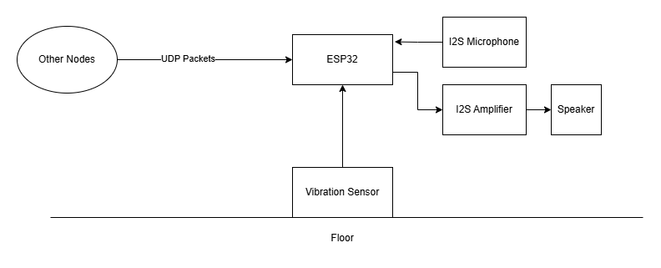

💡 For more background on CSI sensing technology, see the Resources section.

Software Overview
ESP32 Firmware (C) (folder in repo: code/node_final)
Handles all on-device processing:
- Interfacing with the microphone and speaker
- Reading and processing vibration data
- Sending and receiving UDP packets
- Processing CSI data
- Development modes: streaming raw sensor data for tuning
- Normal operation mode: transmitting only detection results to preserve privacy

Python Scripts (folder in repo: code/data_proc)
Run on a computer connected to the ESP32 via USB:
- Dashboard showing sensor activity and detection status (normal mode)
- Visualization tools for CSI, microphone, and vibration data (development modes)

3. Components Required
The following components are needed. Purchase links are in the Resources section.

Component | Details
ESP32 DEVKIT V1 | ×2 Main microcontroller boards
INMP441 Board | I2S MEMS Microphone
Piezoelectric Ceramic Disc | Vibration / impact sensor
MAX98357 Amplifier Board | I2S audio amplifier
Speaker | 1 W, 8 Ohm

4. Hardware Setup
Connect components as shown in the diagrams below. A breadboard is recommended for initial testing before creating a permanent implementation. Optional 3D-printable enclosure CAD files are available in the project repository.

💡 Only the receiver ESP32 needs sensors connected. The second ESP32 acts solely as a Wi-Fi packet transmitter.

Connection Diagram
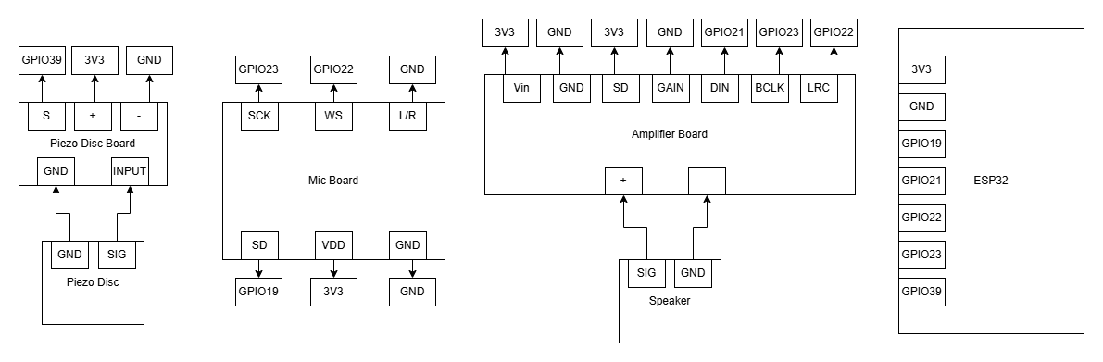

DEVKIT V1 Pinout
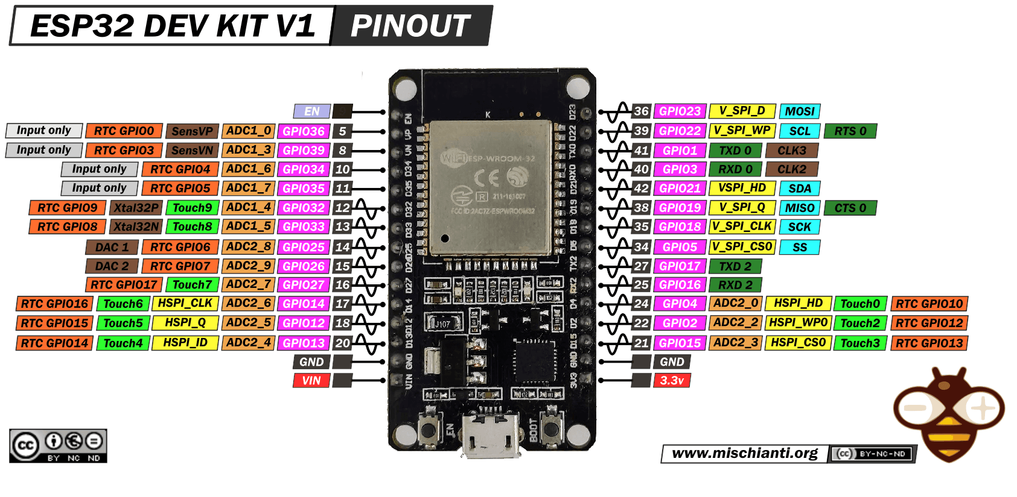

Example Breadboard Implementation
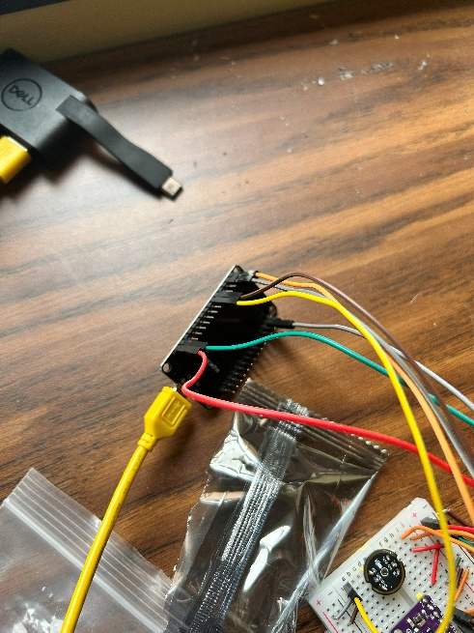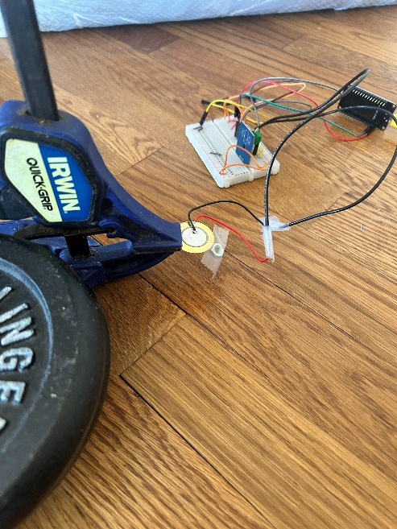

Example Final Implementation
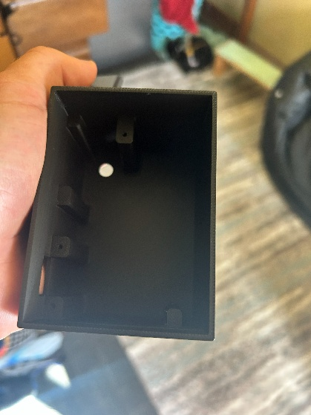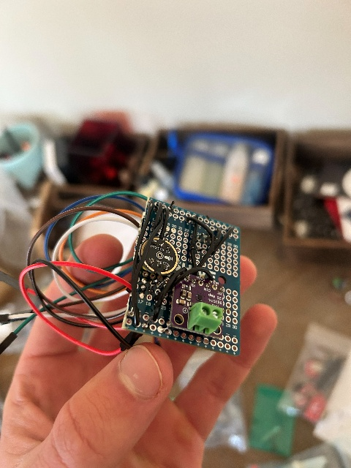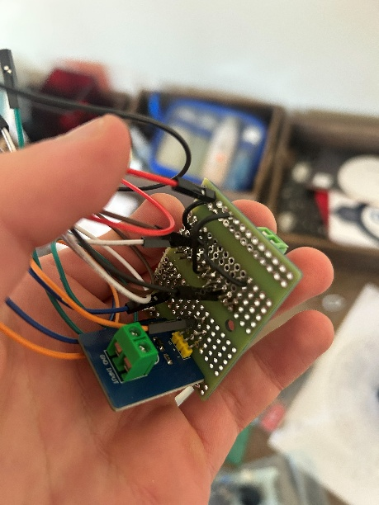
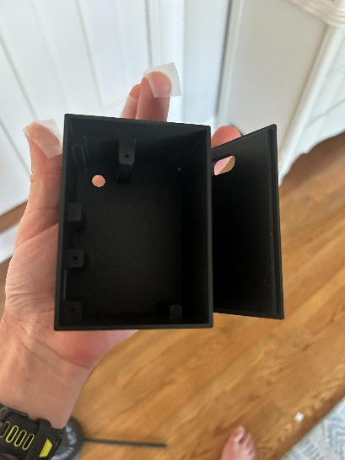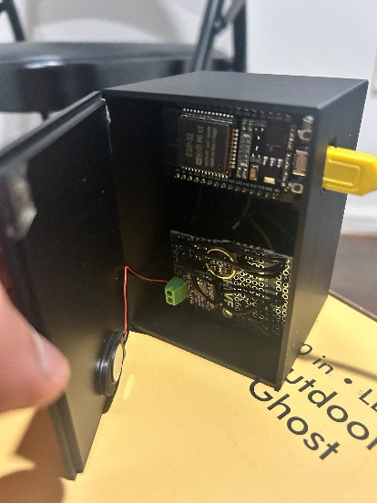

5. Software Setup

Dependencies
- Install ESP-IDF using the official Espressif getting started guide (link in Resources). If the installer fails, clone the esp-idf repository manually and run:
install.ps1
- Clone the thread_proj repository from the project GitHub (link in Resources).

Building & Flashing
💡 If using the ESP-IDF GUI rather than CLI, refer to Espressif’s IDE documentation.

Run the following commands from the code/node_final directory. The export script must be run once per terminal session (add esp-idf directory to PATH for convenience):

export.ps1 # Run once per terminal session
idf.py set-target esp32
idf.py menuconfig # Component Config > Wi-Fi > Enable CSI
idf.py build
idf.py flash

💡 Flash this firmware onto both ESP32s. Each board will automatically negotiate its role (transmitter or receiver) at power-on.

Operating Modes
Before building, set the mode variable in node_final.c to one of the following options:

Mode | Description
NORMAL | Normal operation: transmits detection results only
DEV_CSI | Streams raw CSI data for development/tuning
DEV_VIB | Streams raw vibration data for development/tuning
DEV_MIC | Streams raw microphone data for development/tuning

6. Tuning
Sensor thresholds depend on room layout, sensor placement, and floor type. Use the DEV modes with the provided Python scripts to stream and visualize sensor data before finalizing values.

Microphone Tuning
💡 The microphone is not sensitive to physical setup and may not require tuning.

Steps to tune:
- Build and flash in DEV_MIC mode
- Activate the data_proc_venv Python environment
- Run mic_reader.py (adjust COM port if not on Windows/COM5), make some test sounds, then press Ctrl+C
- Run mic_processor.py (update file paths to your collected data)
- A graph such as this one will be produced:

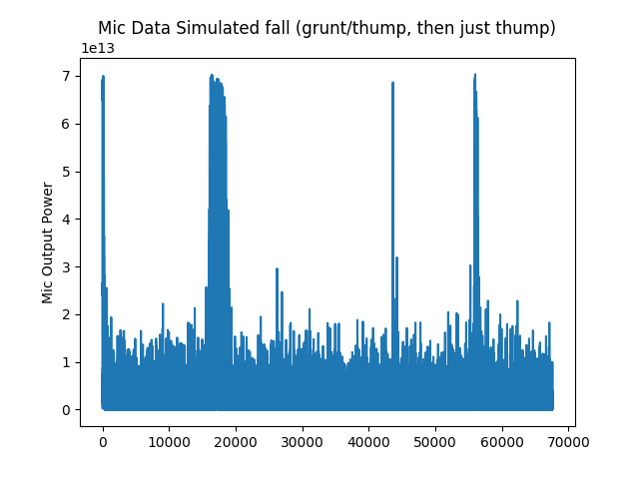

Select a threshold from the graph. Take the square root (convert power to amplitude) and set the macro in sound.c:
// Example: threshold = 3e13, sqrt(3e13) ≈ 5477225
#define MIC_THRESHOLD 5477225

CSI Tuning
Because it depends on antenna patterns and multipath reflections, CSI is sensitive to room layout and antenna orientation. CSI data is processed using a moving average and rolling variance over two subcarrier groups. The plots below show example raw magnitudes and smoothed data.
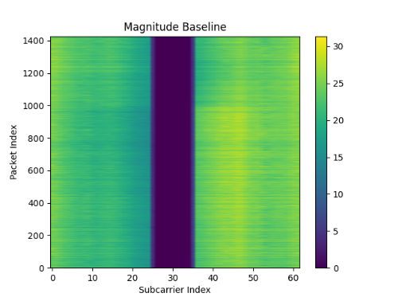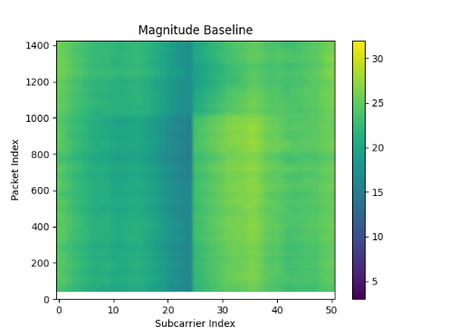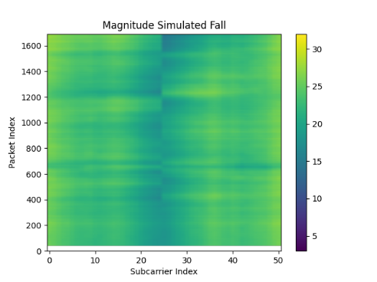

Steps to tune:
- Build and flash in DEV_CSI mode
- Run csi_reader.py and csi_processor.py
- A graph such as this one will be produced:

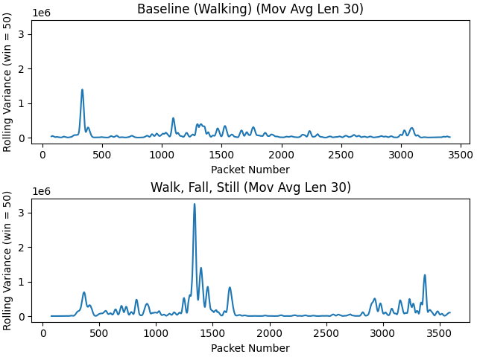

Select two thresholds: one for walking, one for large motion. Both should be above the noise floor. Set the macros in csi_rx.c:
#define CSI_THRESHOLD_LOW 100000 // e.g. 0.1e6 for walking
#define CSI_THRESHOLD_HIGH 650000 // e.g. 0.65e6 for large motion

Vibration Tuning
The piezo disc is highly sensitive to its physical setup. One possible configuration uses clamps to cantilever the disc with a weight on the end, plus weights to couple it to the floor. Wood floors work best.

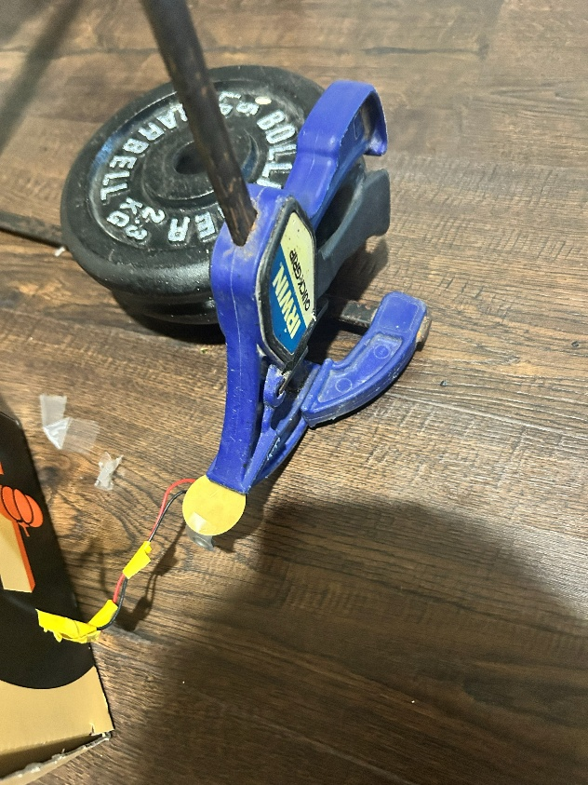

💡 Avoid pulldown resistors and biasing on the ADC pin. These attenuate the signal (as shown in image below). An adaptive threshold compensates for the floating pin.

Steps to tune:
- Build and flash in DEV_VIB mode
- Run vib_reader.py and vib_processor.py
- A graph such as this one will be produced:

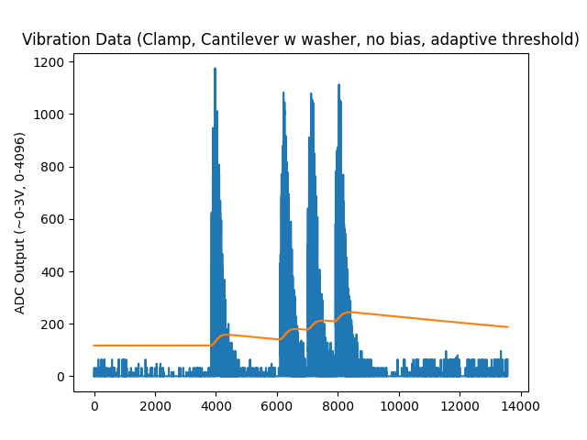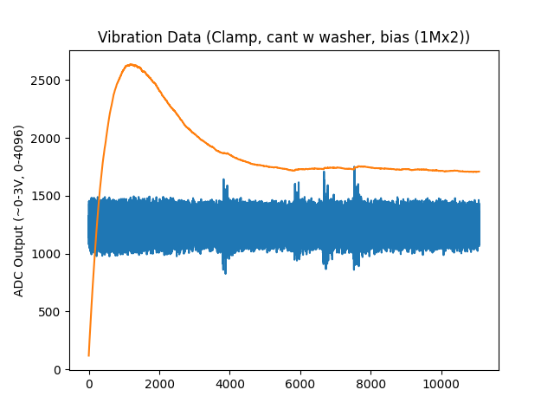

Adjust thresh_factor until the adaptive threshold (orange line) sits above the noise floor, then set the macro in vib.c:
#define VIB_THRESH_FACTOR <your_value>

💡 Collect data at different times and with different physical configurations to find the most robust setup.

7. Final Product
With the 3D-printed enclosure, the assembled device looks like this:

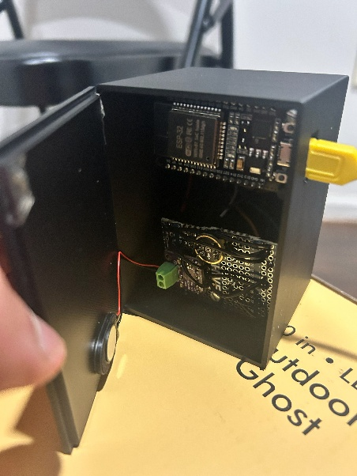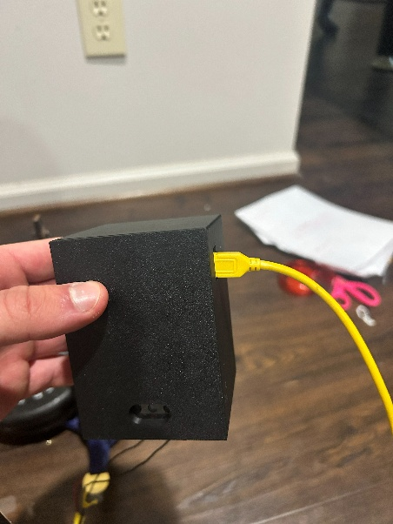

The program ui.py opens the monitoring dashboard when device is in NORMAL mode:

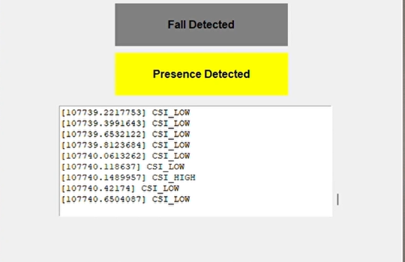

Operating the Device
- Ensure both ESP32s are flashed in NORMAL mode.
2. Power on the transmitter ESP32 first. It will automatically detect no other transmitter and claim that role.
- Power on the receiver ESP32 (with sensors attached). It will find the transmitter and take the receiver role.
- Connect the receiver to a computer via USB and run ui.py to launch the dashboard.

When a fall is detected, the device beeps and the fall indicator on the dashboard lights up red. Presence detection is indicated by the yellow box. A scrolling log shows the events that triggered each detection.

8. Resources

GitHub Repository
github.com/mecargill/thread_proj

Component Purchases
ESP32 DEVKIT V1 boards
INMP441 Microphone Board
MAX98357 Amplifier Board
Speaker (1W, 8 Ohm)
Piezoelectric Disc

Espressif / ESP-IDF Documentation
ESP-IDF Getting Started Guide
ESP-IDF GitHub Repository
ESP-IDF API Reference
DOIT ESP32 DEVKIT V1 Pinout

CSI Sensing Background
How CSI Sensing Works (Digital Intelligence)
CSI Sensing Encyclopedia (Huawei)

