Wearable-Free Fall Detection User Guide

Goals
The goal of this project is to use sensors to create an inexpensive fall detection system without wearables. The elderly often forget or choose not to put on health wearables, so a fall detection system that could be installed in a home or assisted living facility rather than worn could be more reliable. To preserve privacy, this project aims to avoid using cameras.

Overview of Design

Hardware Overview
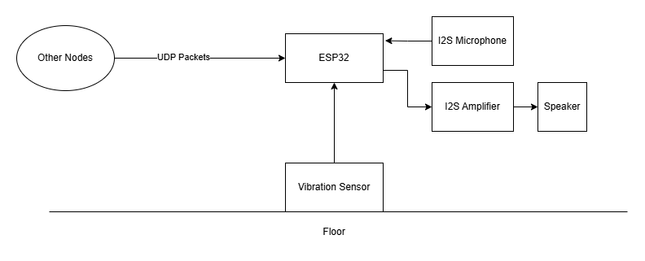
This system uses 3 types of sensing to detect a fall: a piezoelectric vibration sensor, a microphone, and Wi-Fi Channel State Information (CSI) sensing. The vibration sensor detects someone hitting the floor. The microphone detects the thump of a fall or presence in the room. The CSI data is used to detect changes in Wi-Fi signal propagation at different frequencies caused by motion (more information is in the resources section or here). An ESP32 will serve as the central hub where most of the processing will happen. Additionally, the speaker is used to play an alert when a fall is detected.

Software Overview
There are 2 main sets of software in this project (repositories in resources section). The first is the C program (in repo node_final) running on the ESP32 which handles the following:
- Interfacing with microphone and speaker
- Reading and processing vibration data
- Sending and/or receiving packets
- Processing CSI data
- Depending on the mode, either streaming data for development/tuning purposes (development modes) or communicating only the results of processing to preserve privacy (normal operation mode)
The second set of software is written in Python and is run on a computer connected to the ESP32 development board’s UART to USB chip (in repo data_proc). There are multiple programs, which have the following functions:
- With ESP32 software in normal operation mode, act as a dashboard showing sensor activity and detection status
- Read/visualize streamed CSI data for development purposes
- Read/visualize streamed microphone data for development purposes
- Read/visualize streamed vibration data for development purposes

Components Required
The following components were used in this project:
- 2 ESP32 DEVKIT V1 boards
- INMP 441 Board (microphone)
- Piezoelectric Ceramic Disc
- MAX 98357 Amplifier Board
- 1 W, 8 Ohm speaker
The exact purchases are in the resources section.

Hardware Setup
Once the hardware is obtained, the connections shown below should be implemented. It is best to use a breadboard first for testing, then potentially create a more permanent implementation if desired. The provided CAD files can be used to 3D print an enclosure as well.
This setup only needs to be done on one of the ESP32s – the one which will be receiving the UDP packets and calculating the CSI.

Connection Diagram
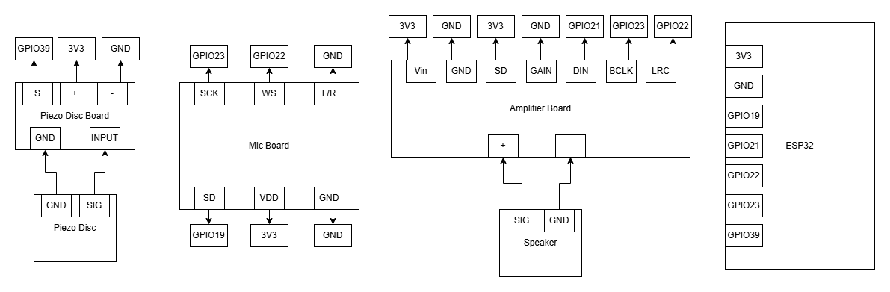

DEVKIT V1 Pinout
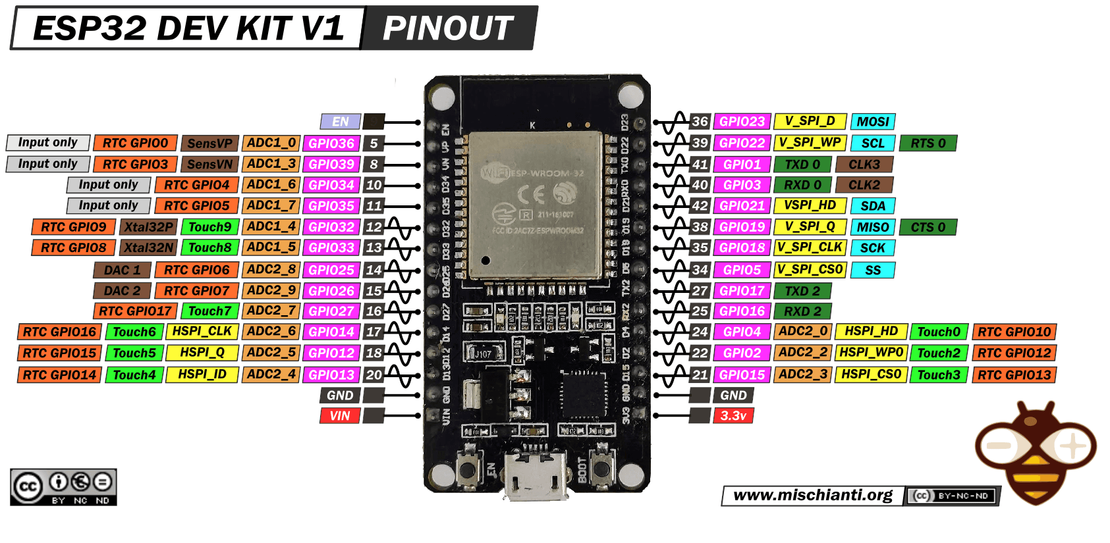

Example Breadboard Implementation
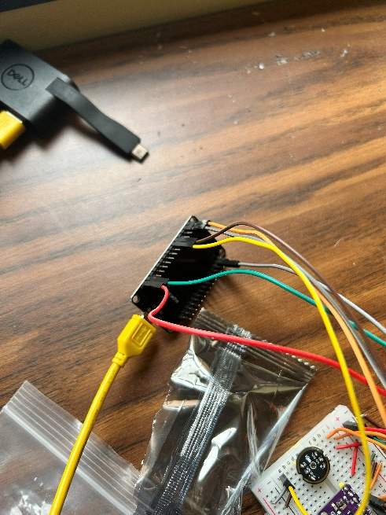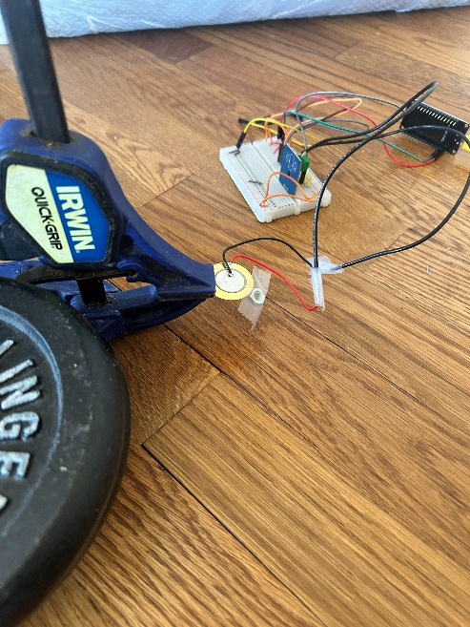

Example Final Implementation
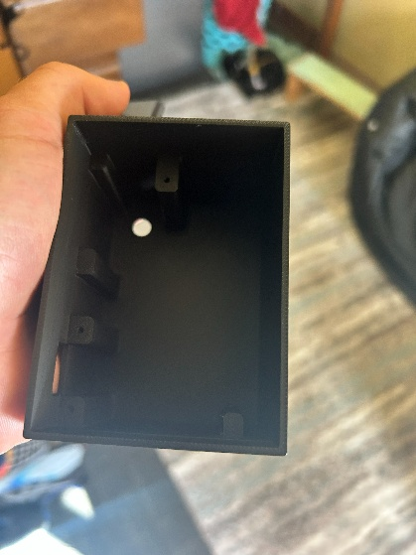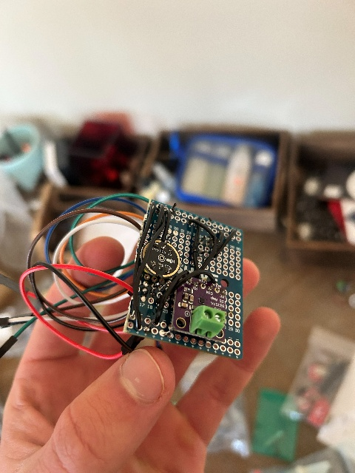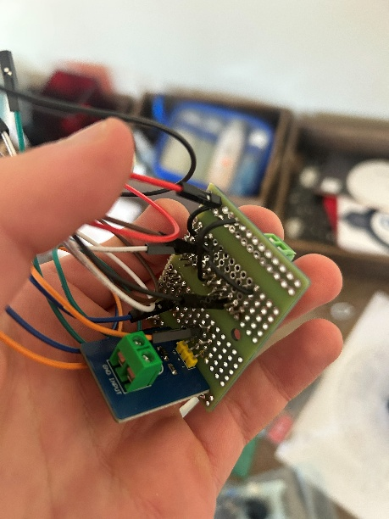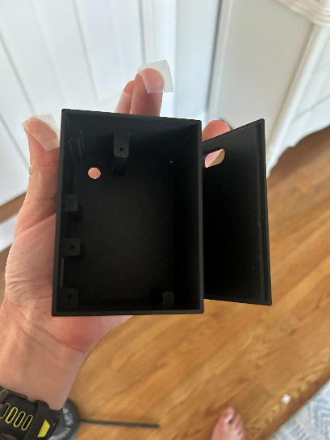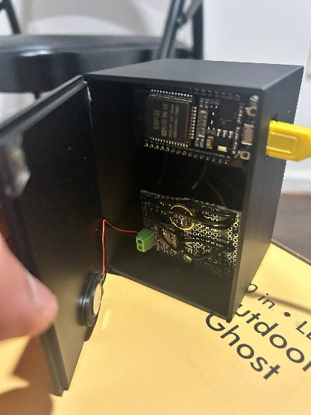

Software Setup

Dependencies
This project uses the ESP-IDF framework. In addition to cloning the repository, the ESP-IDF libraries/tools need to be installed to build the code. The Espressif documentation on this process is available here. In my case, the installer did not work and I had to clone this repository and use the command line interface. Once the esp-idf repository is cloned, run the “install.ps1” script.
Additionally, clone the repository “node_final” from the project GitHub.

Building
(if using the gui, refer to Espressif documentation)
In the node_final folder, run the “export.ps1” script provided by the esp-idf repository – This must be done once per terminal session in which you want to use idf.py.
To build and flash, run the following commands:
idf.py set-target esp32
idf.py menuconfig (Use this GUI to go to component config -> Wi-Fi -> enable CSI)
idf.py build
idf.py flash
You should flash this software onto 2 ESP32s – one to transmit and one to receive.

Setting the Mode
There is a variable in the file “node_final.c” called mode. There are 4 options for the mode: NORMAL, DEV_CSI, DEV_VIB, and DEV_MIC. It must be set before building. NORMAL is for normal operation, and the others are used for data collection and tuning.

Tuning

Test Setup
In this prototype setup, the sensor data are sensitive to the exact layout of the room, orientation of the sensors, and setup of the piezo disc. Using the DEV modes, along with some provided Python scripts, the sensor data can be streamed and visualized on a laptop to help tune threshold values.

Microphone Tuning
(microphone is not sensitive to setup and likely doesn’t need tuning)
To stream mic data and tune, follow these steps:
- Build/flash the node_final project in DEV_MIC mode
- Activate data_proc_venv
- Run “mic_reader.py” (The port name may need to be adjusted from COM5 on different systems)
- After you test via making sound, hit ctrl + c
- Run “mic_processor.py” (The file paths will need to be adjusted to include your data)
- A graph such as this will be produced:
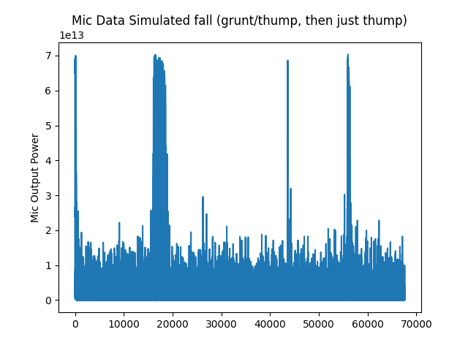
- Simple thresholding is used in this prototype system - a threshold of 3*10^13 would be good based on this graph
- Take the square root (ie. sqrt(3*10^13) = 5477225) and set the macro MIC_THRESHOLD to that value (in sound.c)

CSI Tuning
The CSI data is processed with a moving average and rolling variance over 2 groups of subcarriers that were found to be sensitive to motion. Example captures of full CSI magnitudes are shown here first with no processing, then with smoothing and removal of nulled subcarriers. The variance (times window length) of the smoothed data is what is thresholded.
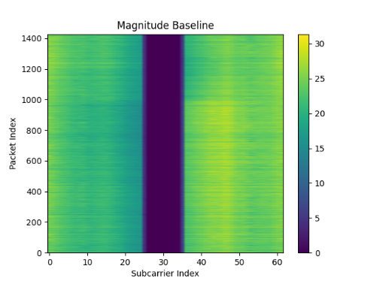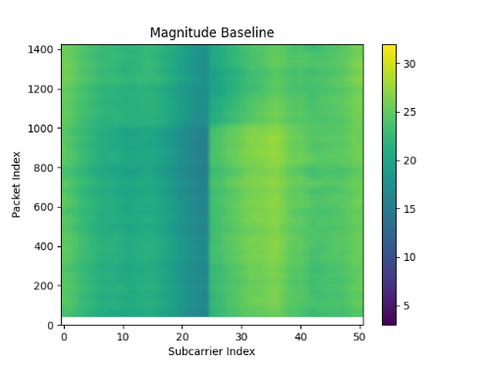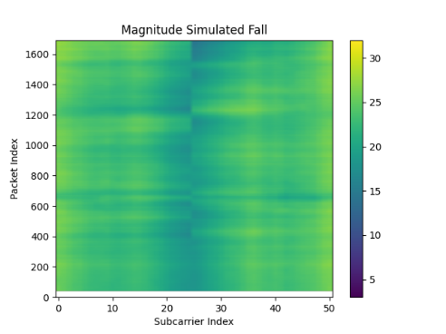
To stream/tune CSI data, follow these steps:
- Build/flash in DEV_CSI mode
- Run “csi_reader.py” and “csi_processor.py” similarly to the mic
- A graph like this will be produced:
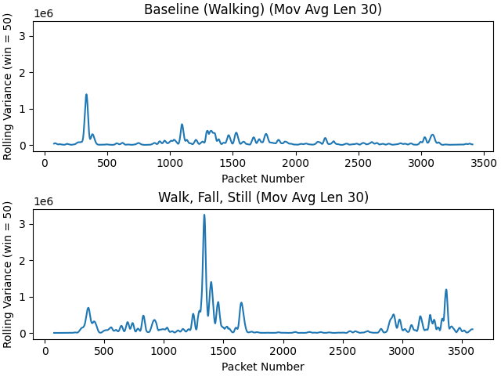
- Pick 2 thresholds – one for just walking, and one for large amounts of motion, both above the noise floor (ex. Here, 0.1e6 and 0.65e6 would work)
- Set the macros CSI_THRESHOLD_LOW and HIGH (in csi_rx.c)

Vibration Tuning
The piezo disc is very sensitive to the setup. Multiple configurations may need to be tested. An example configuration is shown here:
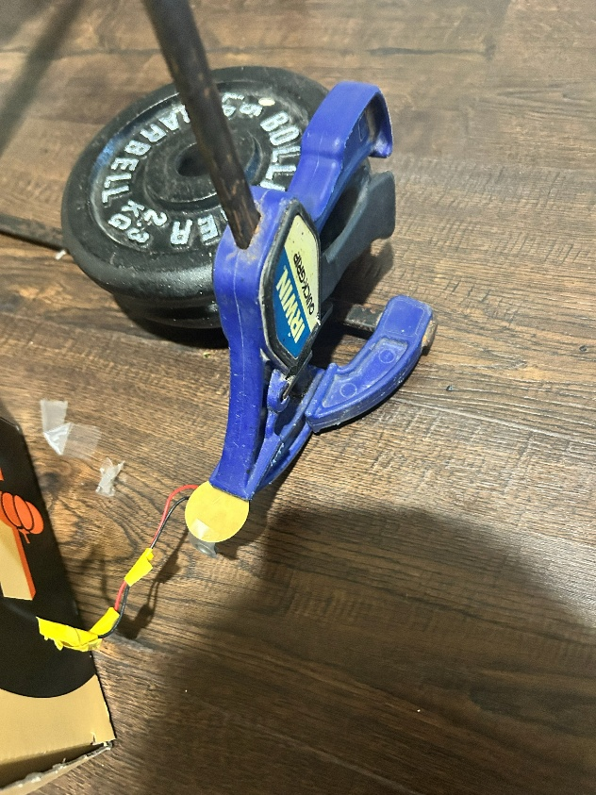
I found the most success by using clamps to cantilever, a weight on the end, and weights to couple the setup to the floor (ideally wood). To keep maximum sensitivity, I avoided pins with pulldown resistors and avoided biasing (as shown below, these attenuate the signal). Because of this, the ADC pin is mostly floating and drifts somewhat. For that reason, the vibration data has an adaptive threshold (shown in the orange line below).
To stream/tune vibration data follow these steps:
- Build in DEV_VIB mode
- Run “vib_reader.py” and “vib_processor.py” similarly to the mic
- A graph like these will be produced:
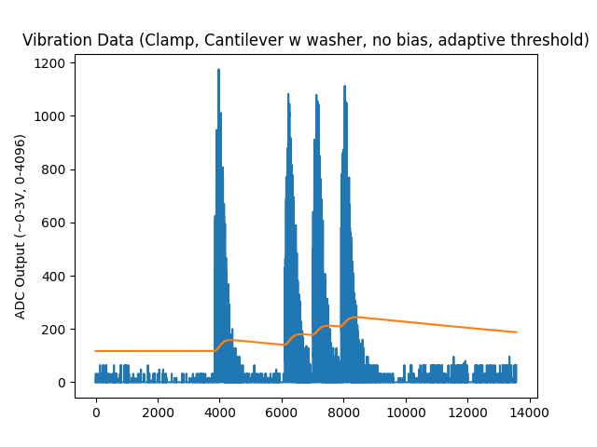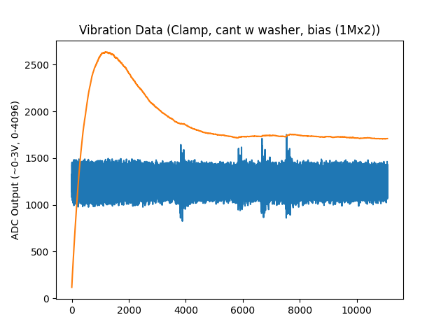
- The orange line shows what the threshold would have been. Adjust thresh_factor until it falls above the noise level and set the macro VIB_THRESH_FACTOR (in vib.c)
- It is recommended to take several data collects over time and test different setups

Final Product
If the CAD files are used to 3D print an enclosure (optional), the final product looks like this:
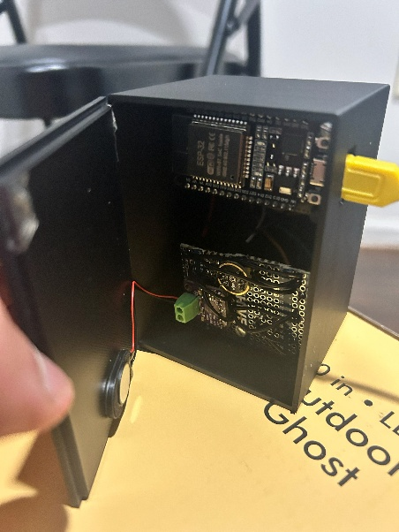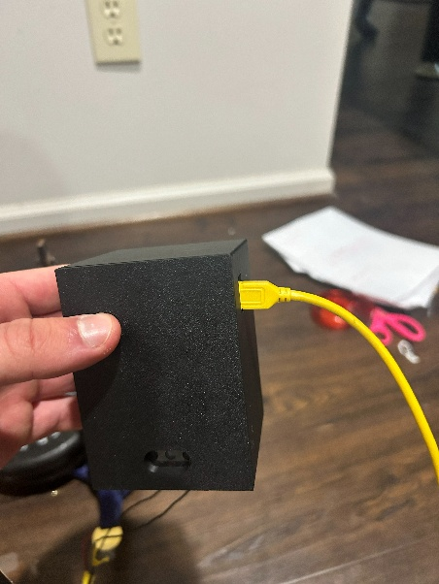
After setting mode to NORMAL, the program “ui.py” can be used to produce a dashboard that looks like this:
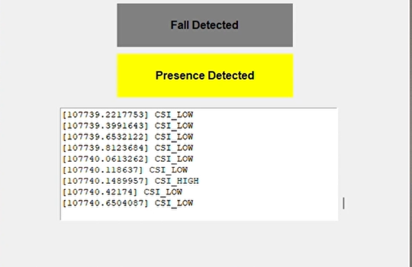
To use the final product, follow these steps:
- Make sure both ESP32s are flashed in NORMAL mode
- Power the ESP32 used for the transmit role first – it will detect that no transmitters exist and take that role automatically
- Then, power the ESP32 (hooked up to sensors) used for the receive role – it will find the transmitter and take the receive role automatically
- With the receive ESP32 connected to a computer via the UART to USB chip on the DEVKIT, run “ui.py”
When a fall is detected, the device will beep and the fall detected icon in the dashboard will light up red. It also detects presence. The events causing the detections are printed via the scrolling textual log.

Resources

GitHub Project

Components
https://www.amazon.com/dp/B0FHWB5VFW?ref=ppx_yo2ov_dt_b_fed_asin_title
https://www.amazon.com/dp/B0B18FW97Z?ref=ppx_yo2ov_dt_b_fed_asin_title
https://www.amazon.com/dp/B0B18FW97Z?ref=ppx_yo2ov_dt_b_fed_asin_title
https://www.amazon.com/dp/B0C7C2HQ7P?ref=ppx_yo2ov_dt_b_fed_asin_title
https://www.amazon.com/dp/B0FC5YJD3S?ref=ppx_yo2ov_dt_b_fed_asin_title

Espressif Docs
https://docs.espressif.com/projects/esp-idf/en/stable/esp32/get-started/index.html
https://github.com/espressif/esp-idf
https://docs.espressif.com/projects/esp-idf/en/stable/esp32/api-reference/index.html
https://mischianti.org/doit-esp32-dev-kit-v1-high-resolution-pinout-and-specs/

CSI Sensing Information
https://www.digitalintelligence.at/wifi-signals-can-see-you-how-csi-sensing-works/
https://info.support.huawei.com/info-finder/encyclopedia/en/CSI+Sensing.html

