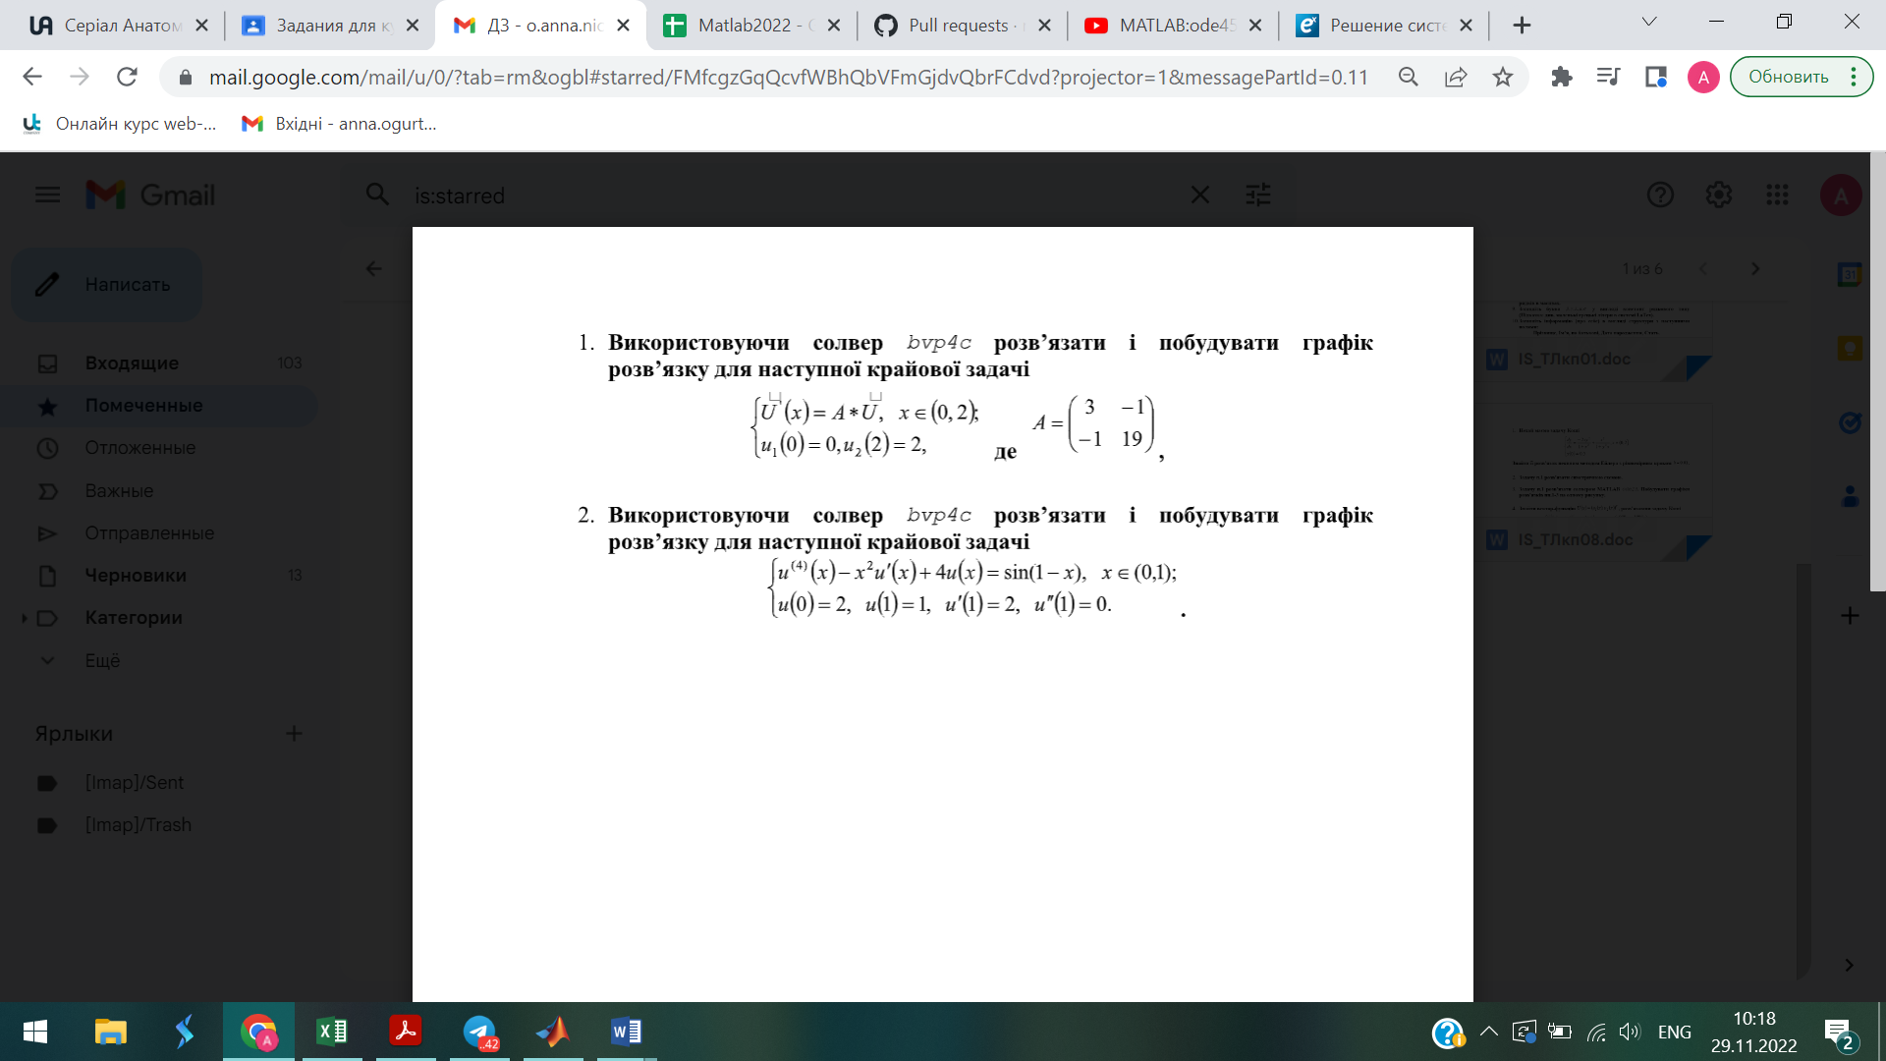
clear, clc
T=1;
x=0:0.1:T;
io=bvpinit(x,[0,0,0,0]);
u=bvp4c(@myfun,@myfun2,io);
U=deval(u,x);
plot(x,U,'gD-','MarkerSize',7)

function du=myfun(x,u)
du=[u(2)
u(3)
u(4)
sin(1-x)+x^2*u(2)+4*u(1)];
end
function bc=myfun2(ua,ub)

bc=[ua(1)-2,ub(1)-1,ub(2)-2,ub(3)];
end

function lect9
clear; clc
a = 0; b = 2;
g(1)=0; g(2)=2;
f = @(x) A.*U`
x = [a b];
u_init = [3 -1, -1 19];
solinit = bvpinit(x,u_init);

sol = bvp4c(F,G,solinit);

x = linspace(a,b,21);
u = deval(sol,x);

plot(x,u(1,:),'b-','ro ','LineWidth',1.5,'MarkerFaceColor','y')

