**Homeowners vs Renters**

Mecahel Demissie

CTEC 128

3/12/21

**Introduction**

This project will explain the difference in owning a home vs renting one. In the time of researching, articles were found arguing over which option would fit people more, but they were influenced solely on personal stories and experiences. By the end of this project, the data collected from the Census Bureau will be transformed into information for analysis on trends. A quick synopsis of the differences, when owning a home, you pay a monthly mortgage for a house you own, you can personalize/decorate the house, and if you want, you can sell the house, where the value may increase or decrease. If you rent a home, you must pay monthly rent to live inside a home someone else owns, you cannot personalize living space, and you can move in/out easier as you do not have to sell or close down the place.

The problem surrounding this topic is that everybody has their own circumstances when it comes to deciding between two options. Whether the place is close to your job, how much the person makes, or more, people cannot decide for themselves if they want to rent or buy a home.

The concept map gives a brief understanding that lists things people should be aware of when deciding. Starting with the topic owning or renting a home, and key points that surround which play a factor in the decision. First is age: where if a person is old enough to settle down for a home, or do they want to experience moving place to place with no hassle by renting, income: does the person have enough money to put down payment on mortgage or rent, education: does the person have a high enough education to rent or own a home, and race: can it play a part on gaining a home to stay in.

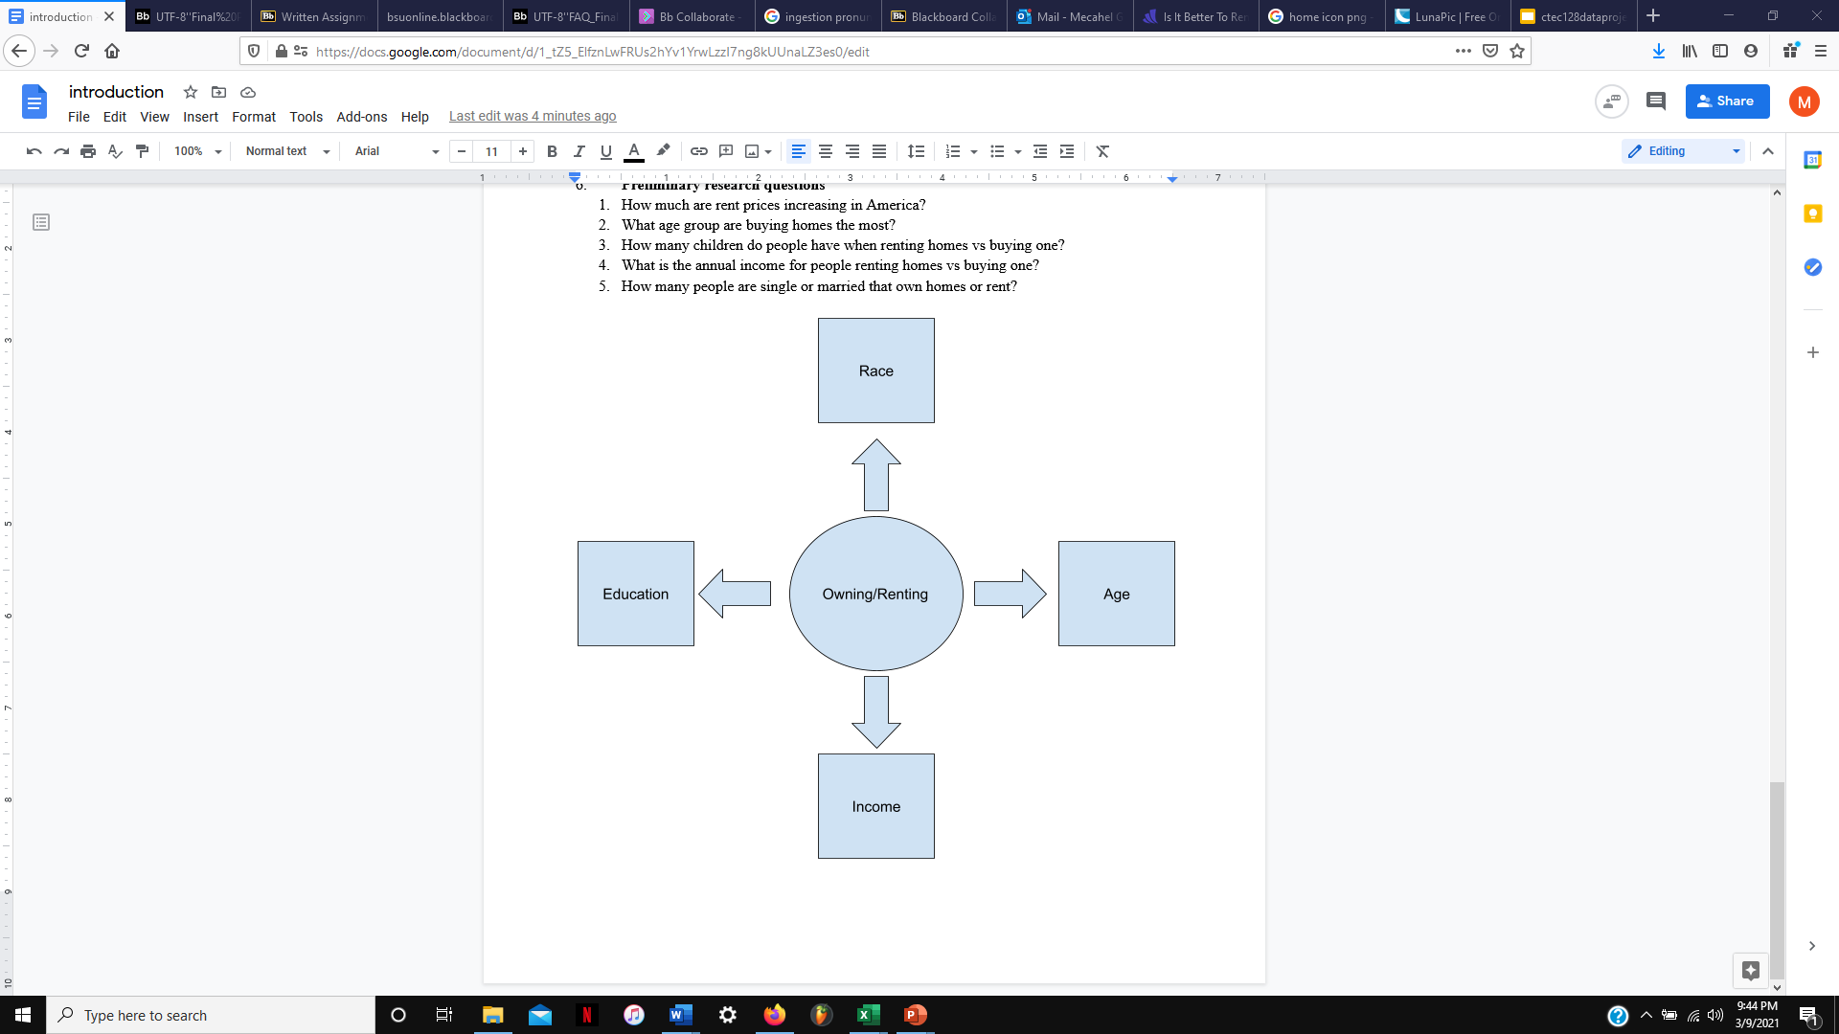

**Figure 1.**

The purpose of this project is to examine the demographic, economic, and social differences between homeowners and renters. Some objectives centered on the project include:

* Understanding the difference of trends between people buying/renting a house
* Providing the reader with data on the demographics of who owns/rents a house
* Finding out average income for homeowners and renters

When researching the topic, question asked were:

* What is the difference between genders being homeowners or renters?
* Are people who graduate college more likely to own a home than people who did not graduate high school?
* What is the average income for people renting homes vs buying one?
* Which race of colored people are renting or owning homes the most?
* What age group are buying homes the most?

**Data Science Pipeline**

1. **Ingestion**

Starting off the data science pipeline with ingestion, the data source used for the project is ACS 1-Year Estimates – Public Use Microdata Sample and the year used is 2019. The United States Census Bureau collects this data and uses it to find changes within the communities and states from housing to demographics of people, and finances. This dataset is collected yearly with the most recent being 2019, dating to 2004. The data files included housing and person files which were split into parts A and B because of how large they were. The number of instances were about 3,645,000 but the variables needed were race, age, income, tenure, gender, and school attainment. The variables were separated from the data files using data wrangling.

1. **Wrangling**

After separating the variables, the data was still a little bit too much than what we needed, so feature engineering was implemented. Starting with marital status, people that were never married were only put on the sheet, the reason behind this is because the plan for the project is to use people that are living by themselves, with no relationship with others.

Age is another variable used that is filtered by removing everything from less than 22 to more 82, the reason behind this is 22 is about the time people graduate college and get a job, while 82 is where some people may go into a group home, or unfortunately pass.

Next is race, where blacks, whites, Indians, and Asians have their own column. The person data file had a Hispanic column but there were many types of Hispanics, so a function was created so that regardless, if they were categorized Hispanic, they received a 1 for true and 0 for false if they were not. All the other races were categorized into a variable named “Other Races” for whenever someone does not qualify for the other races.

The next variable wrangled was school attainment where everything under 9th grade were removed and kept everything above, the project intend to group by people who did not graduate HS, who got their GEDS or equivalent, who did not graduate college, and who got their associates, bachelor’s, or anything above a bachelor’s.

Income was also wrangled to remove any blanks, 0s, and negative numbers. The blanks meant they were under 15 years old, 0 meant they had no income, and negative meant they lost income which was unnecessary for the project. Everything after $150k was removed because this is where the middle-class average income ends, and everything above is high class.

The final variable wrangled was tenure, where blanks were removed because they were people in group homes, which was not related to the project. Another function created was if someone owns with mortgage or loan, or owns free and clear, they are considered homeowners, but if someone is marked as rented, or occupied without payment of rent, they are considered renters.

1. **Exploratory Data Analysis**

After wrangling, visualizations were created. The first graph created was based on age, where ages ranged from 22-82. The age groups were grouped by 10 for fairness and categorized the ages of the people by homeowner or renter. From the chart, renters dominated age groups 22-31 and 32-41 with 36% and 22% as the average for renters in the set are 42 years old. But as the age groups get older, homeowners start to rise from 42 all the way to 82 as the average of homeowners are 52 years old with percentages totaling to 16%, 23%, 22%, and 10%.

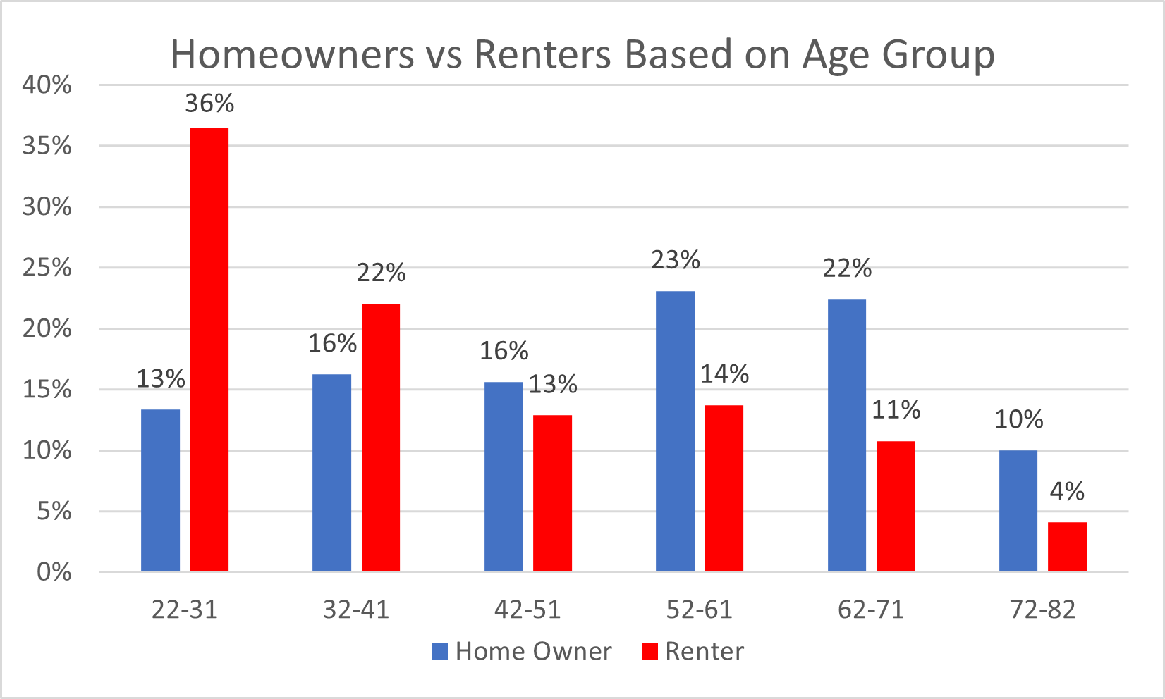

Figure 2.

The next demographic looked at is gender, where there are more homeowners and renters who are male than female. The difference between homeowners and rents for both genders is only 1% which is not far off.

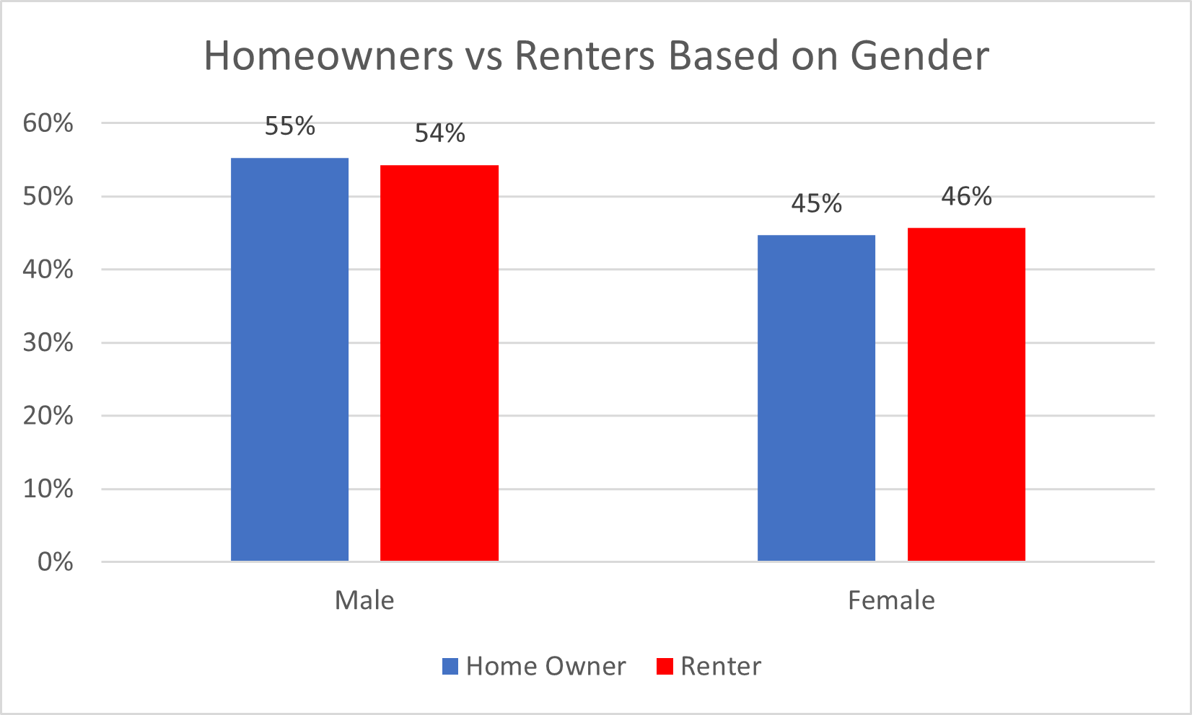

Figure 3.

The third variable is income whereas the income gets higher, there were less instances, but more people were homeowners if they had low income, but as the income starts getting higher, renters gradually become more populated than homeowners.

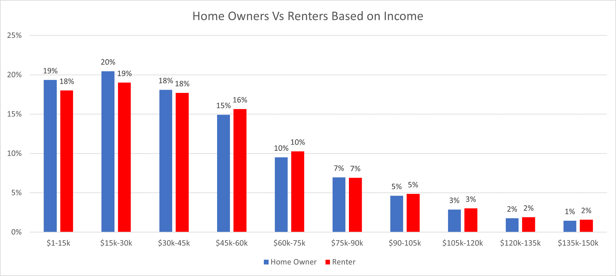

Figure 4.

Race is another variable which showed trends with owning homes and renting. As white people make up about 60% of the United States, they have more instances in the dataset, which influences the chart. Aside from that, white people were more likely to own homes than rent, while every other race in the dataset were more likely to rent a home than own one.

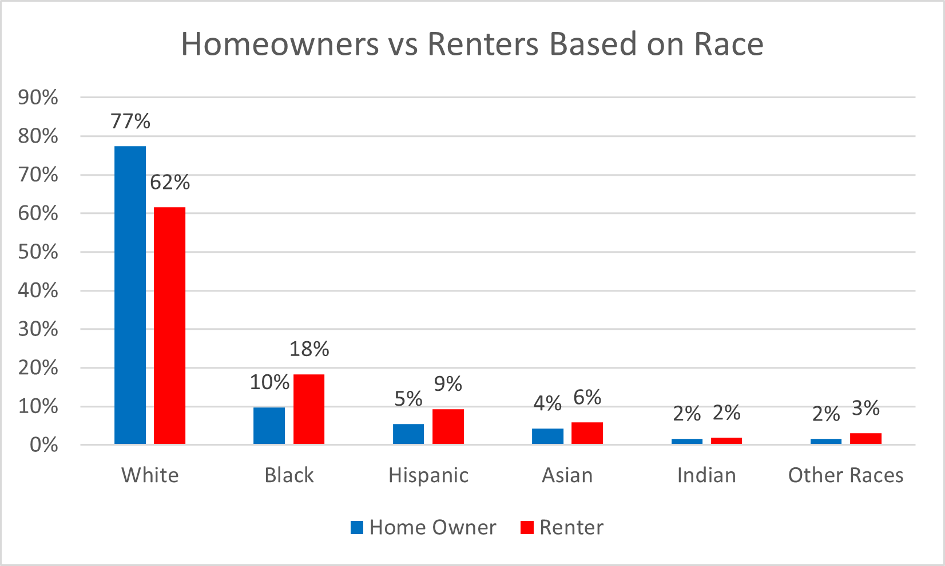

Figure 5.

The last variable analyzed was school attainment and how it can play a factor with owning a home vs renting one. With the first group being people who did not graduate high school, there were not a lot of instances of this group as they were unlikely to do both, but it showed that they were more likely to rent a home than own one. The next group is obtaining a HS diploma or equivalent where 19% of them were homeowners and 21% were renters, the instances lowered in the next group with people who did not graduate college as 18% owned homes and 20% rented them. The instances lowered even more with people who obtained their associate’s with 10% being renters. But the instances of people who obtained their bachelor’s made up most of the data with 31% being homeowners, and 30% being renters. Degrees above bachelor’s still had more homeowners than renters but were only at 19% and 16%.

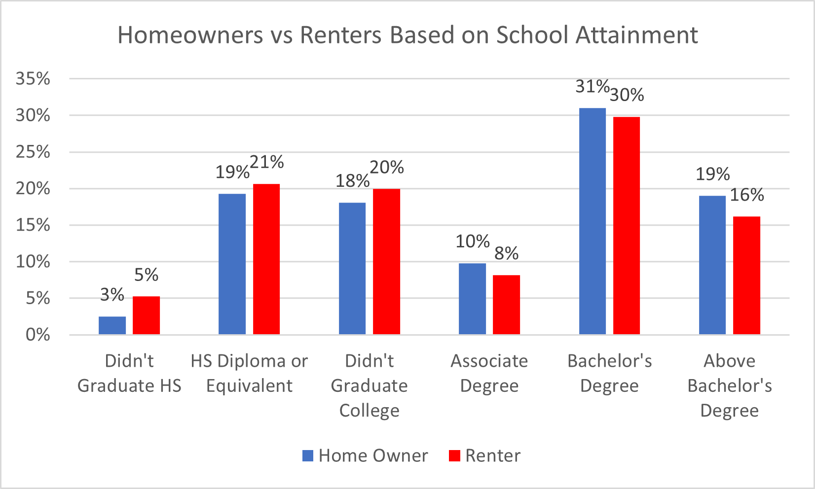

Figure 6.

**Insights**

The visualizations help conclude parts of the project. With the bias found in white people that they make up 70% of the data, the rest of the races only made up 30% which does not help the data at all. With no way to fix this there is no to be sure about the trends as it is not 100% accurate, although there seems to be a factor where if you graduated college with an associate’s or higher, you were more likely to own a house, than rent.

Another trend noticed was the people in the age groups of 22-31 and 32-41 seemed to have more renters than homeowners. But as people get older, they seem to settle down to own a house.

The final trend noticed was that males were more likely to own homes than rent, while females were more likely to rent than own but this is only a 1% difference.

**Recommendations/Future Projects**

Recommendations in the future include to research thoroughly on comparisons between the two options and how they differentiate. Also, to take the time and learn programming languages such as Python, C++, or Java to use commands and wrangle data much faster. Finally, take time to read previous reports of data science and take note of what to do/not to do and read more about the PUMS dictionary.

For future projects we would like to look at why most smart watch devices do not capture accurate data on darker skin tones. Also look at the trend of decrease/increase of homeowners and renters over the years.

**References**

Holdsworth, L. (2011). *Sole voices:* *Experiences of non-home-owning sole mother renters.* Retrieved February 26, 2021, from https://researchportal.scu.edu.au/view/delivery/61SCU_INST/1266772600002368/1367449620002368

Green RK. (2001). *Homeowning, social outcomes, tenure choice, and US housing policy.* Retrieved February 28, 2021, from http://citeseerx.ist.psu.edu/viewdoc/download?doi=10.1.1.623.1421&rep=rep1&type=pdf

Charles, KK. Hurst, E. (2002). *The transition to home ownership and the black-white wealth gap.* Retrieved February 28, 2021 from https://scholar.google.com/scholar?start=20&q=home+ownership+renting&hl=en&as_sdt=0,21&as_ylo=2000&as_yhi=2021

Deng Y. Ross, SL. Wachter, SM. (July 2002) *Racial differences in homeownership: the effect of residential location*. Retrieved March 2, 2021 from https://opencommons.uconn.edu/cgi/viewcontent.cgi?article=1261&context=econ_wpapers