Robert Lloyd

A01014318

June 4, 2016

**Project 2: Two-dimensional Heat Conduction In a Plate**

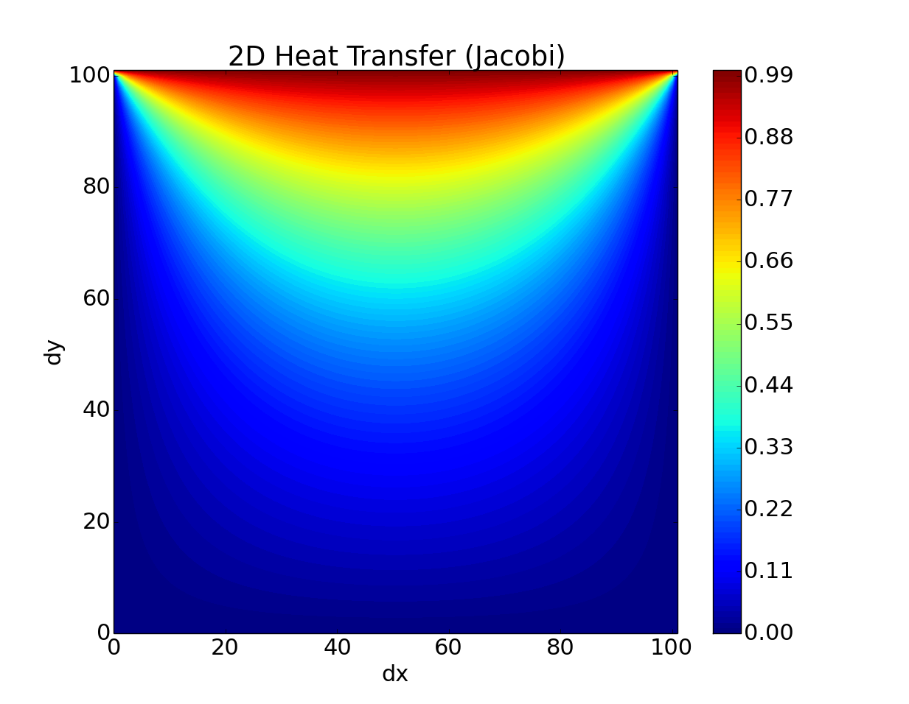

**Figure 1: Solution**

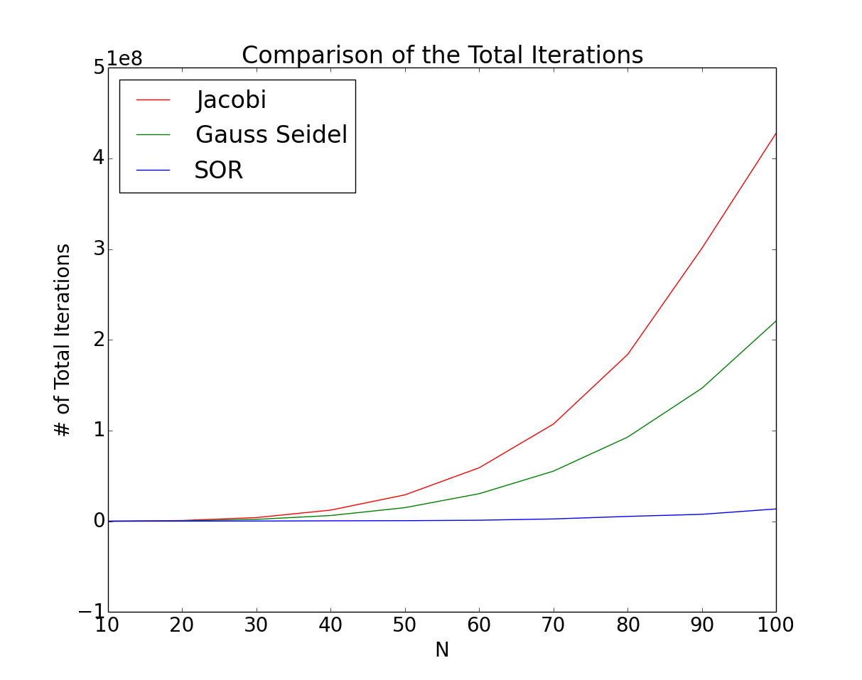

**Figure 2: Total Iterations**

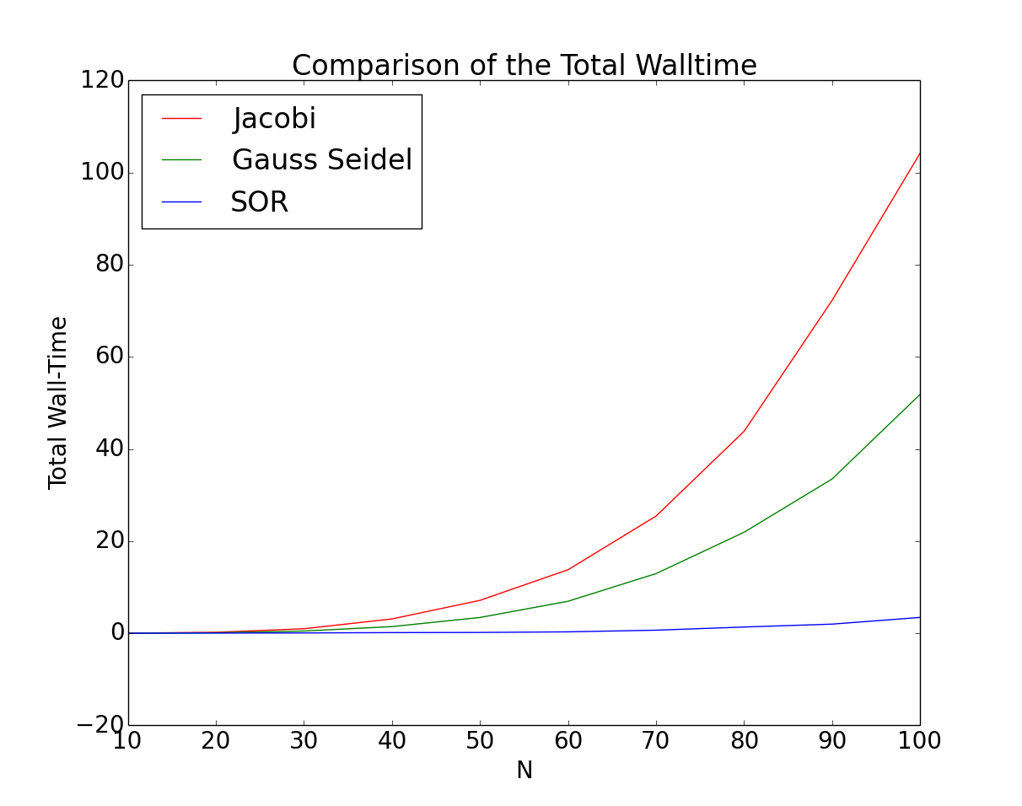

**Figure 3: Total Walltime**

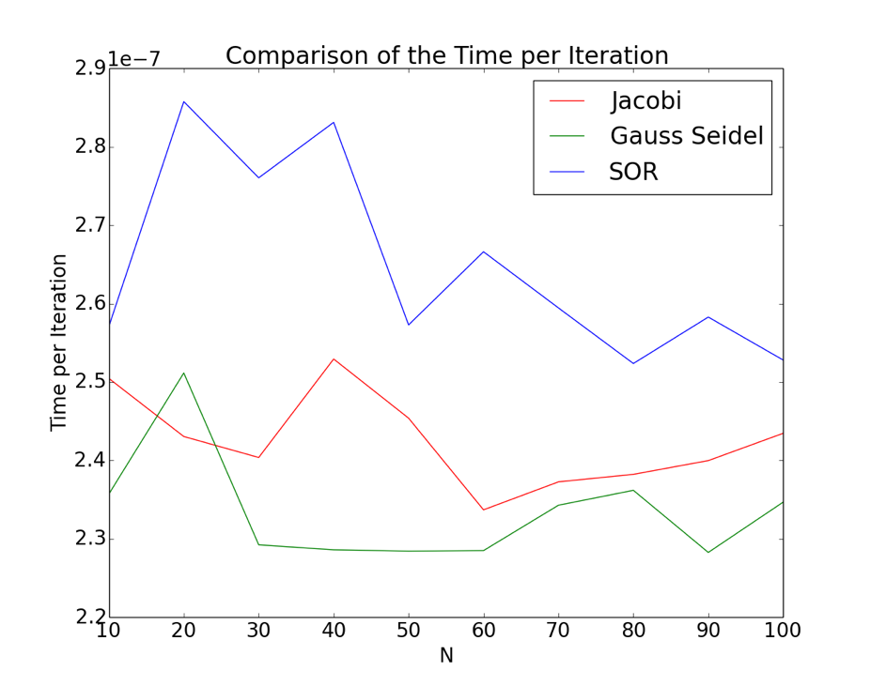

**Figure 4: Time per Iteration**

**Table 1**

|  |  |
| --- | --- |
| Omega (ω) | # of Iterations to Solve for SOR (N=50) |
| 0.1 | 248375000 |
| 0.2 | 4432500 |
| 0.3 | 1730000 |
| 0.4 | 917500 |
| 0.5 | 570000 |
| 0.6 | 387500 |
| 0.7 | 280000 |
| 0.8 | 210000 |
| 0.9 | 167500 |
| 1.0 | 132500 |
| 1.1 | 107500 |
| 1.2 | 90000 |
| 1.3 | 77500 |
| 1.4 | 65000 |
| 1.5 | 55000 |
| 1.6 | 50000 |
| 1.7 | 40000 |
| 1.8 | 37500 |
| 1.9 | 30000 |

Figure 2 shows that the bigger the mesh that is used the more total iterations it will cost. The Jacobi method is costlier the bigger the mesh with the Gauss Seidel method being about half as costly and the SOR method being the least costly. Figure 3 yielded the same results as Figure 2. Figure 4 was swapped with the SOR method having the most time per iteration and the Gauss Seidel method having the least time per iteration. Even though the SOR method has the most time per iteration, it cuts down the total iterations so much that the time per iteration doesn’t even effect the overall result. For Figures 2-4 SOR was ran with an omega of 1.9. Table 1 shows that 1.9 was the best omega for the least amount of iterations.

I would prefer to use the SOR method with an Omega of 1.9 because the amount of total iterations is greatly decreased compared to the other two methods. Also, the size of mesh doesn’t affect the total iterations or the total walltime anywhere near as much as the other two methods.