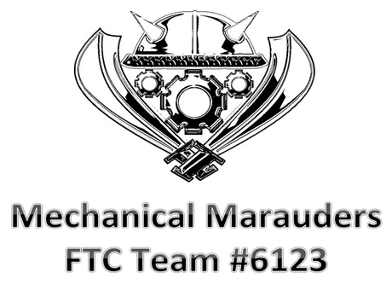

**It is about more than just the robot!**



**Mechanical Marauders**

**Team: 6123 Email: ftc6123@gmail.com**