НАЦІОНАЛЬНИЙ ТЕХНІЧНИЙ УНІВЕРСИТЕТ УКРАЇНИ
“КИЇВСЬКИЙ ПОЛІТЕХНІЧНИЙ ІНСТИТУТ ІМЕНІ ІГОРЯ СІКОРСЬКОГО”
Факультет інформатики та обчислювальної техніки
Кафедра обчислювальної техніки

Лабораторна робота №3
з дисципліни
“Програмування мобільних систем”

Виконав:
студент групи ІО-82
ЗК ІО-8206
Востриков Нікіта

Миколаїв 2021
Варіант = 8206%2 + 1 = 1
Для розробки використовується IDE Android Studio.

Скріншот роботи додатка
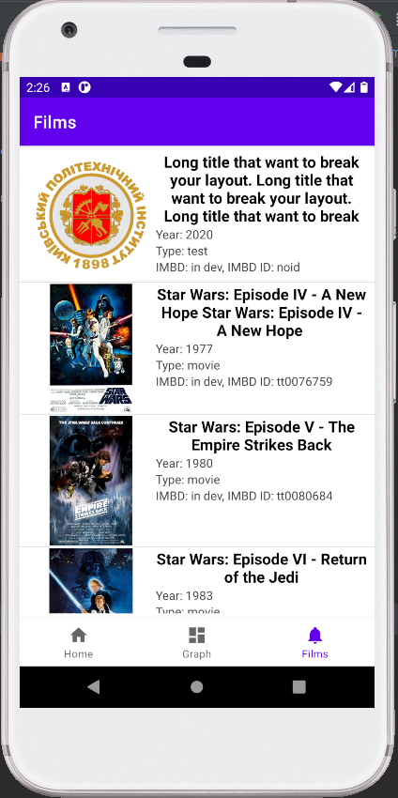
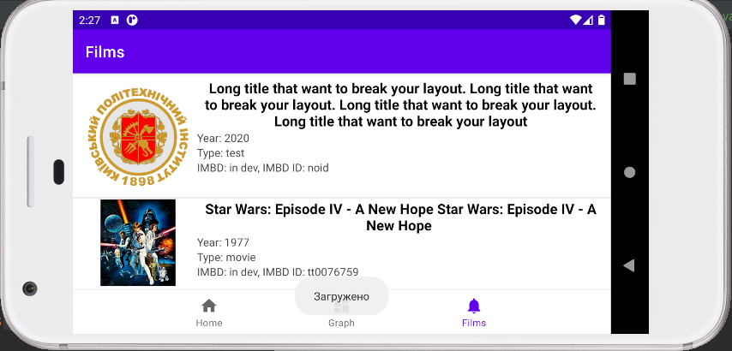

Лістинг коду
MainActivity.java
package ua.kpi.comsys.IO8206;
import android.os.Bundle;
import com.google.android.material.bottomnavigation.BottomNavigationView;
import androidx.appcompat.app.AppCompatActivity;
import androidx.navigation.NavController;
import androidx.navigation.Navigation;
import androidx.navigation.ui.AppBarConfiguration;
import androidx.navigation.ui.NavigationUI;
public class MainActivity extends AppCompatActivity {
@Override
protected void onCreate(Bundle savedInstanceState) {
super.onCreate(savedInstanceState);
setContentView(R.layout.activity_main);
BottomNavigationView navView = findViewById(R.id.nav_view);
// Passing each menu ID as a set of Ids because each
// menu should be considered as top level destinations.
AppBarConfiguration appBarConfiguration = new AppBarConfiguration.Builder(
R.id.navigation_home, R.id.navigation_dashboard, R.id.navigation_notifications)
.build();
NavController navController = Navigation.findNavController(this, R.id.nav_host_fragment);
NavigationUI.setupActionBarWithNavController(this, navController, appBarConfiguration);
NavigationUI.setupWithNavController(navView, navController);
}
}

DashboardFragment.java
package ua.kpi.comsys.IO8206.ui.dashboard;
import android.graphics.Color;
import android.media.audiofx.AudioEffect;
import android.os.Bundle;
import android.view.LayoutInflater;
import android.view.View;
import android.view.ViewGroup;
import androidx.annotation.NonNull;
import androidx.fragment.app.Fragment;
import com.github.mikephil.charting.charts.PieChart;
import com.github.mikephil.charting.components.Description;
import com.github.mikephil.charting.data.PieData;
import com.github.mikephil.charting.data.PieDataSet;
import com.github.mikephil.charting.data.PieEntry;
import com.jjoe64.graphview.GraphView;
import com.jjoe64.graphview.series.DataPoint;
import com.jjoe64.graphview.series.LineGraphSeries;
import java.util.ArrayList;
import java.util.Arrays;
import java.util.List;
import ua.kpi.comsys.IO8206.R;
public class DashboardFragment extends Fragment {
LineGraphSeries<DataPoint> series1;
// private DashboardViewModel dashboardViewModel;
public View onCreateView(@NonNull LayoutInflater inflater, ViewGroup container, Bundle savedInstanceState) {
View root = inflater.inflate(R.layout.fragment_sec_tab, container, false);
int dots = 100;
double min = -5.0, max = 5.0, currentPointX=min, currentPointY, step;
dots -= 1;
DataPoint[] dataPoint = new DataPoint[dots+1];
step = (max-min)/dots;
for (int i = 0; i <= dots; i++) {
currentPointY = currentPointX*currentPointX;
dataPoint[i] = new DataPoint(currentPointX, currentPointY);
currentPointX += step;
}
GraphView graph = (GraphView) root.findViewById(R.id.graph); // график
PieChart pieChart = root.findViewById(R.id.pieChart); // круговая диаграмма
graph.setFocusable(true);
series1 = new LineGraphSeries<>(dataPoint);
System.out.println(Arrays.toString(dataPoint));
graph.addSeries(series1);
graph.getViewport().setMinX(min-1); // установка границ
graph.getViewport().setMaxX(max+1);
graph.getViewport().setMaxY(max*max+5);
graph.getViewport().setXAxisBoundsManual(true);
graph.getViewport().setYAxisBoundsManual(true);
pieChart.setUsePercentValues(true);
Description desc = new Description();
desc.setText("Variant 5");
desc.setTextSize(20f);
List<PieEntry> value = new ArrayList<>();
value.add(new PieEntry(35f, "green"));
value.add(new PieEntry(40f, "yellow"));
value.add(new PieEntry(25f, "red"));
int[] colors = {getResources().getColor(R.color.green), getResources().getColor(R.color.yellow), getResources().getColor(R.color.red)};
PieDataSet pieDataSet = new PieDataSet(value, "Chart");
PieData pieData = new PieData(pieDataSet);
pieChart.setData(pieData);
pieDataSet.setValueTextSize(15f);
pieDataSet.setColors(colors);
pieChart.setDescription(desc);
return root;
}
}

FilmsList.java
package ua.kpi.comsys.IO8206.ui.films;
import android.content.Context;
import android.content.res.Resources;
import android.os.Bundle;
import android.view.LayoutInflater;
import android.view.View;
import android.view.ViewGroup;
import android.widget.ArrayAdapter;
import android.widget.ImageView;
import android.widget.ListView;
import android.widget.TextView;
import android.widget.Toast;
import androidx.annotation.NonNull;
import androidx.annotation.Nullable;
import androidx.fragment.app.Fragment;
import java.util.HashMap;
import java.util.List;
import ua.kpi.comsys.IO8206.Film;
import ua.kpi.comsys.IO8206.JsonHelper;
import ua.kpi.comsys.IO8206.R;
public class FilmsList extends Fragment {
private List<Film> films;
private FilmAdapter adapter;
ListView listView;
@Override
public void onCreate(Bundle savedInstanceState) {
super.onCreate(savedInstanceState);
}
public View onCreateView(@NonNull LayoutInflater inflater,
ViewGroup container, Bundle savedInstanceState) {
View root = inflater.inflate(R.layout.fragment_third_tab, container, false);
listView = root.findViewById(R.id.filmsList);
films = JsonHelper.importFromJSON(getContext()); // берём фильмы из файла
if(films != null){
adapter = new FilmAdapter(getActivity(), R.layout.activity_list, films);
listView.setAdapter(adapter);
Toast.makeText(getContext(), "Загружено", Toast.LENGTH_LONG).show();
}
else{
Toast.makeText(getContext(), "Не удалось открыть данные", Toast.LENGTH_LONG).show();
}
return root;
}
private class FilmAdapter extends ArrayAdapter<Film>{ // свой адаптер
FilmAdapter(Context context, int textViewResourceId, List<Film> objects) {
super(context, textViewResourceId, objects);
}
@NonNull
@Override
public View getView(int position, @Nullable View convertView, @NonNull ViewGroup parent) { // переопределение
LayoutInflater inflater = getLayoutInflater();
View row = inflater.inflate(R.layout.activity_list, parent, false);
TextView title = (TextView) row.findViewById(R.id.filmTitle); // связь данных и ИД слоя
TextView year = (TextView) row.findViewById(R.id.filmYear);
TextView type = (TextView) row.findViewById(R.id.filmType);
TextView rating = (TextView) row.findViewById(R.id.filmRating);
title.setText(handle(films.get(position).getTitle())); // запись всех параметров
year.setText("Year: " + handle(films.get(position).getYear()));
type.setText("Type: " + handle(films.get(position).getType()));
rating.setText("IMBD: in dev, IMBD ID: " + handle(films.get(position).getImdbID()));
ImageView iconImageView = (ImageView) row.findViewById(R.id.poster);
String posterName = films.get(position).getPoster();
int res = getContext().getResources().getIdentifier(posterName.replaceAll(".jpg",
""), "drawable", getContext().getPackageName()); // поиск ИД по имени
if(res!=0) iconImageView.setImageResource(res); // если нет такого ИД
else iconImageView.setImageResource(R.drawable.kpi_logo); // стандартная картинка
return row;
}
public String handle(String str){ // обработчик строки
if(str.equals("")) return "None"; // если не задан любой из параметров
else return str;
}
}
}

Film.java
package ua.kpi.comsys.IO8206;
public class Film {
private String Title, Year, Type, imdbID, Poster;
public Film(String title, String year, String Type, String imdbID, String poster) {
this.Title = title;
this.Year = year;
this.Type = Type;
this.imdbID = imdbID;
this.Poster = poster;
}
public String getTitle() {
return Title;
}
public void setTitle(String title) {
this.Title = title;
}
public String getYear() {
return Year;
}
public void setYear(String year) {
this.Year = year;
}
public String getType() {
return Type;
}
public void setType(String type) {
this.Type = type;
}
public String getImdbID() {
return imdbID;
}
public void setImdbID(String imdbID) {
this.imdbID = imdbID;
}
public String getPoster() {
return Poster;
}
public void setPoster(String poster) {
this.Poster = poster;
}
@Override
public String toString() {
// return "Films{" +
// "title='" + Title + '\'' +
// ", year='" + Year + '\'' +
// ", contentType='" + Type + '\'' +
// ", imdb='" + imdbID + '\'' +
// ", poster='" + Poster + '\'' +
// '}';
return Title + '\n' +
Year + '\n' +
"Type: " + Type;
}
}

JsonHelper.java
package ua.kpi.comsys.IO8206;
import android.content.Context;
import android.content.res.Resources;
import android.view.View;
import android.widget.TextView;
import com.google.gson.Gson;
import java.io.ByteArrayOutputStream;
import java.io.FileInputStream;
import java.io.FileOutputStream;
import java.io.IOException;
import java.io.InputStream;
import java.io.InputStreamReader;
import java.util.List;
public class JsonHelper {
private static final String FILE_NAME = "movieslist.txt";
public static boolean exportToJSON(Context context, List<Film> dataList) { // запись в файл
Gson gson = new Gson();
DataItems dataItems = new DataItems();
dataItems.setSearch(dataList);
String jsonString = gson.toJson(dataItems);
FileOutputStream fileOutputStream = null;
try {
fileOutputStream = context.openFileOutput(FILE_NAME, Context.MODE_PRIVATE);
fileOutputStream.write(jsonString.getBytes());
return true;
} catch (Exception e) {
e.printStackTrace();
} finally {
if (fileOutputStream != null) {
try {
fileOutputStream.close();
} catch (IOException e) {
e.printStackTrace();
}
}
}
return false;
}
public static List<Film> importFromJSON(Context context) {
InputStreamReader streamReader = null;
FileInputStream fileInputStream = null;
try{
Gson gson = new Gson();
DataItems dataItems = gson.fromJson(getStringFromRawFile(context), DataItems.class); // создание объектов из файла
return dataItems.getSearch();
}
catch (Exception ex){
ex.printStackTrace();
}
finally {
if (streamReader != null) {
try {
streamReader.close();
} catch (IOException e) {
e.printStackTrace();
}
}
if (fileInputStream != null) {
try {
fileInputStream.close();
} catch (IOException e) {
e.printStackTrace();
}
}
}
return null;
}
private static class DataItems {
private List<Film> Search;
List<Film> getSearch() {
return Search;
}
void setSearch(List<Film> search) {
this.Search = search;
}
}
private static String getStringFromRawFile(Context context) {
Resources r = context.getResources();
InputStream is = r.openRawResource(R.raw.movieslist);
String myText = null;
try {
myText = convertStreamToString(is);
} catch (IOException e) {
e.printStackTrace();
}
try {
is.close();
} catch (IOException e) {
e.printStackTrace();
}
return myText;
}
static String convertStreamToString(InputStream is) throws IOException {
ByteArrayOutputStream baos = new ByteArrayOutputStream();
int i = is.read();
while( i != -1)
{
baos.write(i);
i = is.read();
}
return baos.toString();
}
}

Висновоки:
Виконано лабораторку роботу №3 за поставленою задачею.
Додаток коректно працює.

