Quadrant Analysis – An Introduction
Background:
Quadrant Analysis analyzes the composition of a power data track produced by an athlete. Power is calculated as the product of force on the pedals and the speed of this motion (cadence). This implies that you can produce the same power output by pressing lightly and spinning quickly, or pressing hard with a low cadence. Both may produce the same power value (measured in watts), but the means to do so is different and the body experiences this differently.
Quadrant Analysis will allow you to analyze this composition by breaking down each point of power and cadence tracks down into the force and speed (cadence) components. You can now analyze the composition of your training. Armed with this new knowledge, you can target specific training areas, and train for a specific type of event.
Quadrant Analysis in Perspective:
Quadrant Analysis provides a valuable view of your performance by giving direct indication on where to focus your training efforts in a way that will effect real performance improvements.
Of course, Quadrant Analysis is a single perspective and should not be used as the ONLY analysis tool, but rather as a part of a suite of analysis tools to understand your current position and optimum focus.
The nature of Quadrant Analysis means that the information is viewed only after the activity is completed, and indications of the required direction are not available while riding. This means that we have to translate our conclusions to tangible objectives that are measurable while riding: Cadence, Power, and Heart Rate.
Data Requirements:
Quadrant Analysis requires:
- Measured Power: Ideally this should be measured using a power meter (iBike, PowerTap, SRM, Quark, or other). Derived measurements (eg GPS2PowerTrack) are likely to compromise the results to some extent. Without a power measurement, Quadrant Analysis isn’t possible. Power is measured in W, Watts.
- Cadence: This needs to be a direct, accurate measurement, typically with a crank magnet. Derived measurements (eg Saris) are acceptable with limited compromise. RPM (Revolutions Per Minute) is used to measure this value.
- Crank length: A fixed parameter applicable to the bike in use: Used to correctly scale the data. This measurement is easy obtained from the bike specifications, or a tape measure. The dimension is in mm from the centre line of the bottom bracket spindle, to the centre line of the pedal.
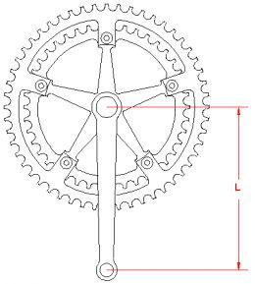
Note: It’s important that Power and Cadence measurements are accurately time synchronized. It’s highly preferred that these track are recorded using a common logging device, however a slight misalignment error should produce acceptable results.

Quadrant Analysis does not require, or benefit from a GPS track, speed, heart rate, heart rate variation, elevation, barometric pressure, environmental factors (wind, temperature, humidity), gear, or other data that might be available.

Producing the Quadrant Analysis:
The activity data is analysed when selecting Quadrant Analysis.
To tune your results, the following entries are required:
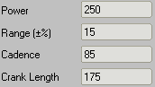
- Power: This setting, like cadence, is tied to the athlete, rather than needing to be set different for each activity. This value is often set to the athlete’s maximum power output over a 1 hour period. A curved blue line will be placed on the chart representing this value.
- Range (±%): Two additional lines (drawn in red) will also be placed on the chart to help you gauge the power lines. The default value for this is ±10%. For example, if Power is set to 250 watts, and range is set to the default value of 10%, then the 2 additional lines will be placed at 275 (+10%) and, 225 (-10%). Range is entered in % (as opposed to decimal notation.)
- Cadence: This should be set to your normal self-selected cadence. This is a value connected to the athlete, rather than being a separate value for each activity. Typical values are 80rpm-100rpm. A vertical line will be placed at this value dividing the analysis chart.
- Crank Length: As described previously. This value is used to calculate the force on the pedals as shown on the y-axis.
A horizontal line is placed on the graph at the intersection of the power line and cadence line.

Interpreting results:
Quadrant Analysis doesn’t tell you what’s right and wrong in your training, but rather shows you the composition of your activity, and it’s up to you to interpret it, and adjust your training accordingly.
Quadrant Analysis plots a point for every few seconds of ride data. Each point:
- Records the Cadence (or pedal speed value) on the X (horizontal) axis.
- Records the Pedal force, in N (Newtons) on the Y (vertical) axis.
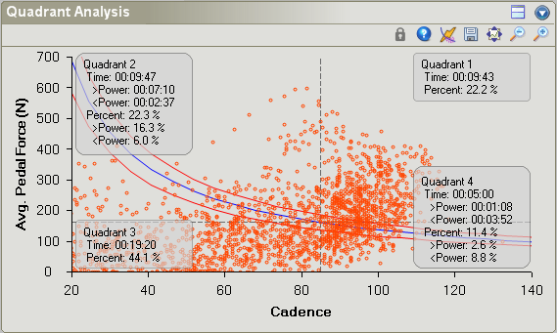
A vertical line is drawn at the entered cadence value (grey dashed line), and the critical power curve (blue line) is plotted. Where the critical power curve crosses the cadence value, a horizontal line is drawn (second grey dashed line). The vertical and horizontal dashed lines make up the 4 quadrants.
The Quadrant Analysis chart is divided into four plot areas (or quadrants), and each point falls in one of the four quadrants as follows:
- Q1: Top Right: This is the high speed, high force zone: This is often seen when sprinting or attacking during a ride. All values in this zone are at above the blue critical power line. It takes a lot of effort to maintain efforts deep in this zone. The combination of force and power will quickly tire body and muscles.
- Q2: Top Left: This is the low speed, high force zone: This is often seen when climbing.
- Q3: Bottom Left: This is the low speed, low force zone: Effectively a resting or recovery zone. This is seen when coasting, or soft-pedaling. This is generally very low intensity and not an effective place to train, however it would be an effective recovery zone.
- Q4: Bottom Right: This is the high speed, low force zone; spinning quick and easy.
Start by getting a feel for what different events look like. Which quadrant are they primarily in? What’s the general shape of the plot? Is it packed tightly or are they spread out all over the place? Once you look through some plots and associate different types of effort with different events, try to identify your weaknesses and see if you can relate those to a specific training aspect.

The results of a Quadrant Analysis plot can be used to target your training for a specific type of event. For instance, go back and look at some past race events to get an idea of what different types of races look like. Once you get an idea of what a Quadrant Analysis plot looks like for a specific type of race effort, you can attempt to mimic that in your training, and hit the areas that will be required for your event.

David C Hall & mechgt v1.1, October 2010

