Student Research Card- Dr. Shambhulinga Aralekallu
1. Basic info
Name: Dr. Shambhulinga Aralekallu
Role: Postdoctoral Fellow (NRF Brain Pool Fellow)
Profile photo: `shambhulinga.jpg`

2. Research summary
Research title: Advanced functional materials for clean energy storage and conversion
Research figure: `shambhulinga-research.png` (an overview illustrating functional materials and their applications in green hydrogen production, rechargeable batteries, fuel cells, and electrochemical water treatment)
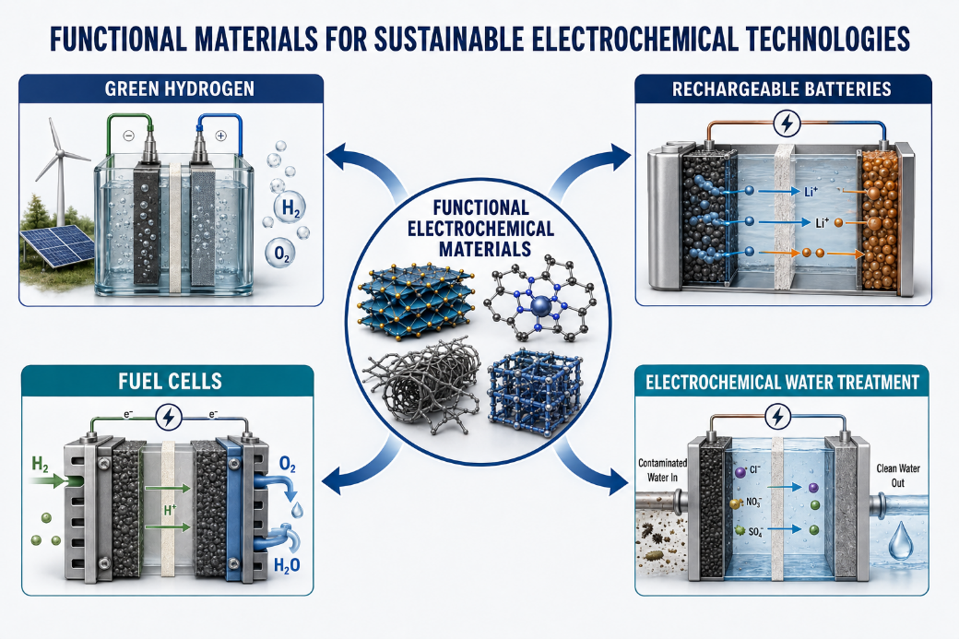
Description: I develop advanced functional materials for electrochemical energy storage and conversion, with applications in rechargeable batteries, fuel cells, green hydrogen production, and electrochemical water treatment. My research combines electrocatalysts and redox-active materials, including transition-metal compounds, metal phthalocyanines, carbon nanomaterials, and Prussian blue analogs, with practical electrode and cell design. I investigate how material composition, structure, and interfaces control electrochemical reactions, charge storage, and ion transport. The overall goal is to create efficient, durable, and sustainable technologies for clean energy and environmental applications.

3. Keywords
- Electrocatalysis
- Green hydrogen
- Rechargeable batteries
- Functional nanomaterials

