Experimental Observations of the Thermal Response of Secondary High Explosives

L. Smilowitz and B.F. Henson

Chemistry Division, Los Alamos National Laboratory, Los Alamos, NM 87545

Work has been ongoing in our group to develop and apply diagnostics for the observation of the dynamic behavior of secondary high explosives subject to a variety of thermal and mechanical boundary conditions. The response of the explosives can range in time scale from slow thermal decomposition or phase changes occurring over hours to super-sonic detonation occurring over hundreds of nanoseconds. Often, we are trying to observe material changes occurring spontaneously and accelerating between these time scales. In order to measure material properties over this range, spanning over ten orders of magnitude in time, we have employed commercial off the shelf, modified, and custom diagnostics. These measurements include temperature, density, light emission, and pressure and cover time scales from slow thermal decomposition and ignition (hours) to detonation (nanoseconds).
In this talk we present a brief description of the suite of diagnostics incorporated and a summary of our state of understanding of the thermal response of secondary high explosives. The experimental observations discussed have all been incorporated into the thermodynamically based theory of secondary high explosives developed by Bryan Henson.
This talk will summarize our current state of understanding of energetic material response including gaps in our knowledge and ties between the slow thermal response and the detonation regimes. A figure representing our overall understanding is shown below with each node representing the onset of a response mechanism with increase in reaction rate of 3 orders of magnitude. The figure presents schematically the driving force of increasing temperature, inducing faster response time, and the resulting pressurization driving the response towards higher reaction violence. Included in the figure are thumbnails representing material responses observed ranging from melting and slow decomposition to high speed (hundreds of m/s) material deflagration and case fragmentation and finally to supersonic detonation propagation.
Case fragmentation is observed dynamically and tied to the burn velocity or deflagration rate of the driving energetic. The overall deflagration can be captured by combining 3 fundamental processes: conductive consumption of solid, convective lighting of solid, and crack propagation. By changing wall strength, we can affect different components of the material burning. Additionally, changing the binder in the energetic material also changes the deflagration rate and case fragmentation. Figure 2 below shows the different response of 2 formulation of the secondary high explosive HMX. The more compliant formulation with a higher volume fraction binder has a slower deflagration and much less case deformation.

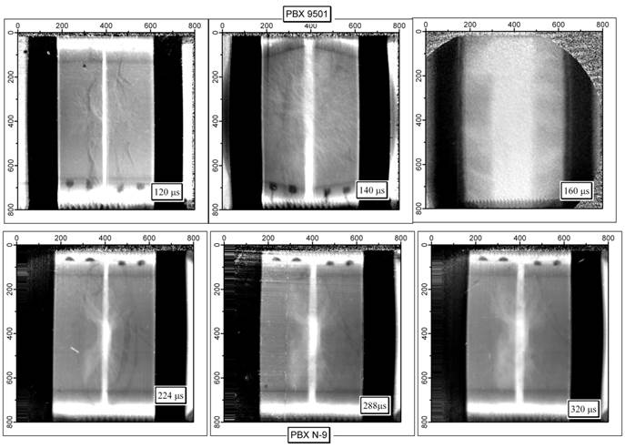

Figure 2: Comparison of response with different binders

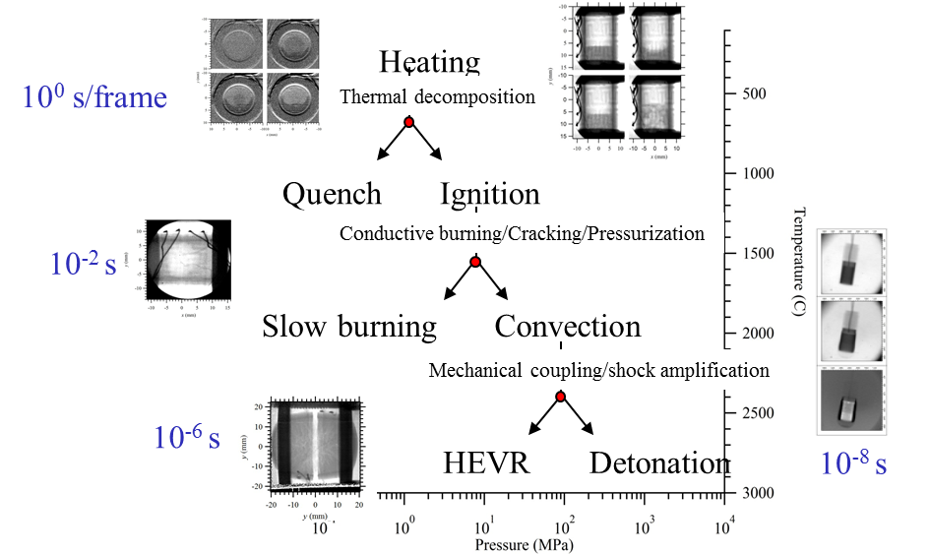

Figure 1: Parsing the dynamic response of energetic materials

