On the advantage of an out-of-plane reinforcement of laminate composites

Zoheir Aboura, Alan T. Martins

Sorbonne Universités Roberval Laboratory UMR CNRS 7337, Compiègne, France

Laminated composite materials are liable to fatal damages under impact load in service conditions, maintenance operations or even in part manufacturing [1, 2]. Such damages are not detectable to the normal eye (the damage being in a surface region or being too small to be visible to the naked eye), which adds to the critical nature of low velocity impact damage [2]. When this type of composite is impacted delamination often occurs, which seriously reduces the load bearing capacity of laminate especially under compressive loads [3]. Indeed, one of the major disadvantages of laminated composites lies in their susceptibility to delamination. The development of weaving and assembly technology made it possible to propose reinforcements in the out-of-plane direction [4, 5], giving rise to a new generation of composite materials called "3D". These reinforcements increase the ability of composites to withstand inter-laminar stresses while increasing mechanical performance in the third direction. We can quote the stitched, interlock, orthogonal composites...
In the present work the tufting process has been used. It is a one-sided stitching process in which the needle pushes high-strength yarn into the fabric, and tufts are held in place when needles are withdrawn by friction resistance imposed through the fabric [5]. In general, for mode I interlaminar loading, through-thickness reinforcement (TTR) stitching increases the delamination resistance by reducing the crack opening displacement, while in mode II loading, it increases the delamination resistance by resisting crack sliding displacement [6].
In manner to evaluate the interest of the TTR, preforms were reinforced with different tufting density (reference, 15x15, 10x10, and 5x5 mm square pattern). In addition, the effect of the tufting angle was studied by using: the transversal tufting and angular tufting 30° to the normal plan of the preform. The stitched preforms were then molded by VARTM.
Thus, the laminates were mechanically tested in low velocity impact (25 J) and higher energy (60J). The damage produced by the impact was quantified by C-Scan technic. The Compression After Impact (CAI) tests were done in order to analyze the mechanical behavior after impact in relationship with stitching parameters. The CAI tests were monitored by multi instrumentation technics using stereo DIC (Direct Image Correlation), AE (Acoustic Emission), and video microscopy observations to evaluate the damage development in the samples and as well local buckling.
Post mortem observations were made in order to evaluate the damage localization according to the stitch parameters. The experimental procedure is summarized on Figure 1.
The results show that the composites reinforced trough-thickness by tufting process have greater out-of-plane resistance compared to unstitched revealed for post-impact test analysis. Also, the CAI tests showed the compressive maximum stress increases with the tufting density. The interest of the TTR will be discussed according to the stitching parameters.
This study highlighted the importance of seams. It therefore raises the question of the integrity of seams during the process of implementation and when the parts are held in service. It is very difficult to assess this integrity by conventional techniques. We then propose an original approach, using seams as vectors of information, in order to evaluate their integrity. This approach will be presented and discussed.
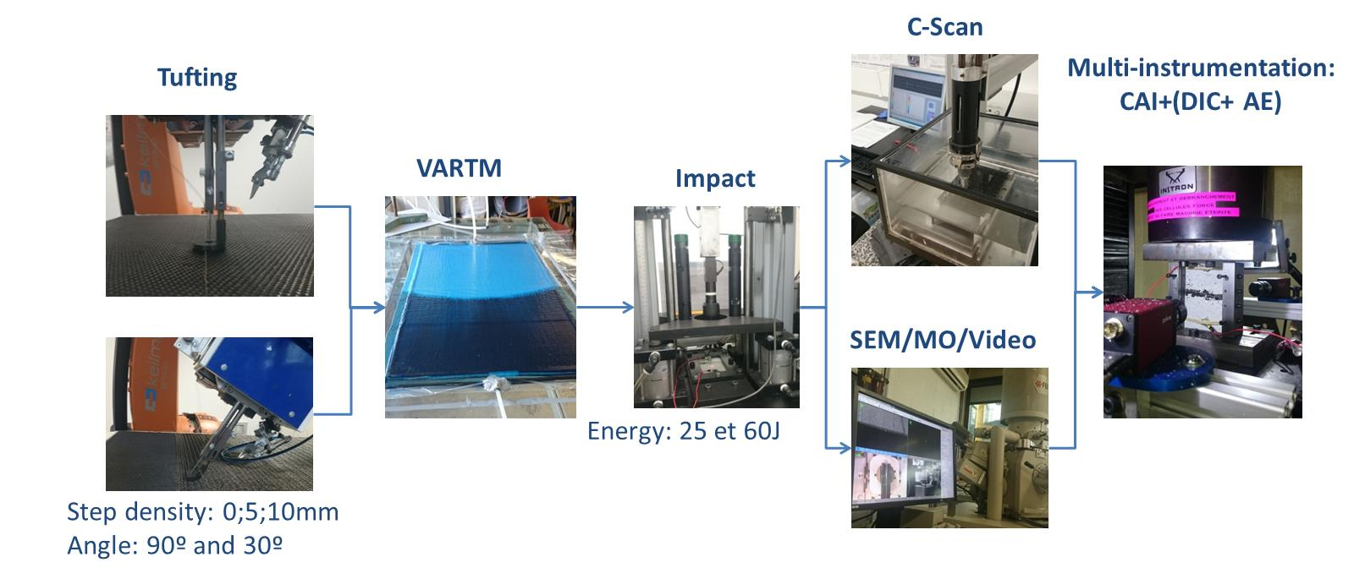
Figure 1: Experimental procedure
REFERENCES
- J. H. Byun, S.W. Song , C.H. Lee, M.K. Um, B.S. Hwang, Impact properties of laminated composites with stitching fibers. Composite structures, 2006. 76(1): p. 21-27.
- M. Hosur, M. Karim, and S. Jeelani, Experimental investigations on the response of stitched/unstitched woven S2-glass/SC15 epoxy composites under single and repeated low velocity impact loading. Composite structures, 2003. 61(1): p. 89-102.
- F . Larsson, Damage tolerance of a stitched carbon/epoxy laminate. Composites part A: applied science and manufacturing, 1997. 28(11): p. 923-934.
- M'membe, B., S. Gannon, M. Yasaee, S.R. Hallett, I.K. Partridge, Mode II delamination resistance of composites reinforced with inclined Z-pins. Materials & Design, 2016.
- A. Mouritz, Fatigue of 3D textile-reinforced composites. Fatigue of Textile Composites, 2015: p. 255.
- K. T. Tan, N., Y. Iwahori., T. Ishikawa, Effect of stitch density and stitch thread thickness on compression after impact strength and response of stitched composites. Composites Science and Technology, 2012. 72(5): p. 587-598.

