Warhead fragmentation: analysis of the localization process

Skander EL MAI
CEA, Gramat, France

The fragmentation of warheads metallic casing (usually made of steel) whilst in use on the theatres of operations is a major matter of concern for the ministries of Defense. A good knowledge of warheads detonation, particularly of their casing natural fragmentation which induces shrapnel generation, is critical for choosing the adequate solutions. Given the current constrained budgetary context, the French MoD intents to develop new low-charge warhead concepts in order to minimize collateral effects. Hence, the CEA-Gramat was given the mission to develop the models and tools capable of predicting the shrapnel generated by these new concepts. The CEA-Gramat has so far followed two modelling pathways: a simplified approach based on Taylor’s [12], Mott’s [8] and Grady’s [2] theories and a purely numerical approach which utilizes perturbations on the dynamic yield stress of the casing. These studies have shown a strong potential for predicting the shrapnel in both cases. However, a thorough analysis of two randomly triggered phenomena is required in order to properly model the fragmentation process: 1) the development of localized strain zones and 2) the ultimate material fracture.
The present work focuses on the development of multiple necks localization based on a novel multi-modes analysis applied to the evolution of the cross-section of a bar in dynamic tension with an initial surface roughness. Numerical simulations of a 128.8 mm-long bar with 1 mm2 cross-section loaded at three different constant velocities (150, 900 and 3000 m/s) are analyzed. In the simulation, the long bar presents a random surface roughness, generating a fluctuation in the initial cross-section. By comparison with the perfect long bar (no surface roughness), Figure 1 shows an enhancement of the localization process as materialized by the rapid decrease of force at a specific time ti associated with the onset of instability. Note that no failure criterion is present in the numerical simulations.
The evolution of the cross-section is also analyzed via Fourier transforms in order to follow the growth of different perturbation modes with time. It is observed that some modes associated with multiple necking have a faster evolution. As introduced by El Maï et al. in [1], this spectral analysis of the cross-section perturbations can provide more information about the time evolution of the distribution of inter-neck distances. The distribution profiles obtained at the different times ti depends on the loading velocity (see Figure 2).
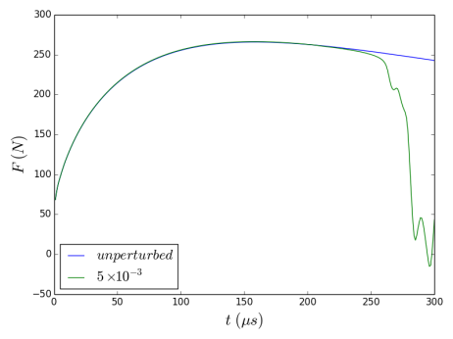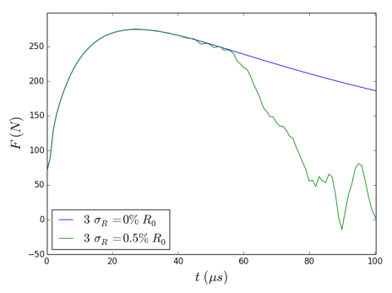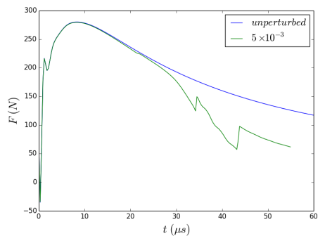
150 m/s
900 m/s
3000 m/s
Figure 1 : Evolution of the traction force in a 128.8 mm-long bar with 1 mm² cross-section loaded at different velocities: 150, 900 and 3000 m/s. An instability time is observed on the perturbed results (green lines) as opposed to the unperturbed evolution (blue lines) at respectively: ~250, ~60 and ~30 µs. The perturbed simulation refers to a long bar with an initial white noise surface roughness defined by the ratio $\frac{3σ_{R}}{R_{0}}=0.5 \%$, where $σ_{R}$ and $R_{0}$ are respectively the variance and the mean radius of the initial cross-section profile.

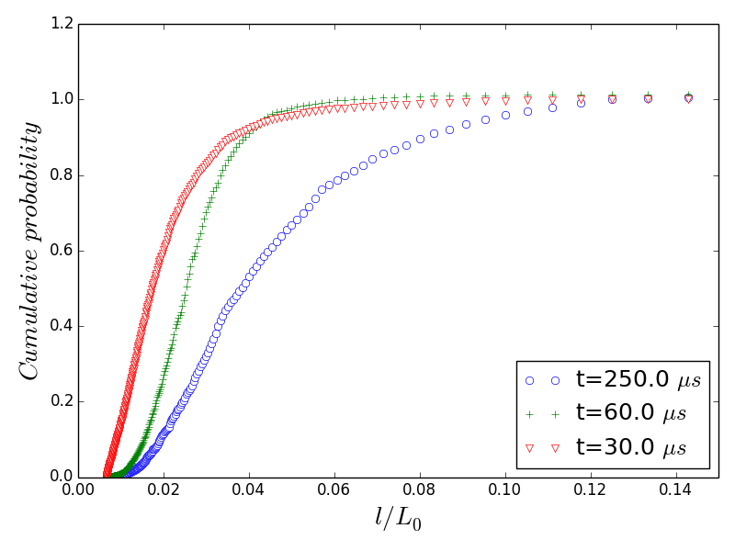
Figure 2 : Inter-neck spacing l cumulative probability distribution profiles obtained for a 2 L₀ = 128.8 mm-long bar with 1 mm² cross-section loaded at velocities of 150, 900 and 3000 m/s. The random surface roughness in all cases is a white noise characterized by $\frac{3σ_{R}}{R_{0}}=0.5 \%$ where $σ_{R}$ and $R_{0}$ are respectively the variance and the mean radius of the initial cross-section profile.

A large number of studies about analytical modeling of the evolution of perturbations are available in the literature. In the work of El Maï et al. [1], the linear stability analysis in [6] is extended to take into account all the perturbation modes so an expression of the cross-section of a bar is obtained during the dynamic extension. Therefore, the approach based on spectral analysis presented previously for the numerical simulations is applicable, thus enabling the time evolution of the pre-neck spacing distribution to be calculated based on this linear stability analysis. The evolution obtained by an initial white noise perturbation on the cross-section is similar to the evolution observed in the numerical simulations: an exponential distribution at the beginning, followed by an intermediate bimodal profile, and finally a Weibull-like distribution at high strains. However, the comparison with the numerical distributions shows some discrepancies in the time evolution. Some improvements in the analytic model of the perturbed cross-section are still necessary.

[1] El Maï S., Mercier S., Petit J., Molinari A. (2014). An extension of the linear stability analysis for the prediction of multiple necking during dynamic extension of round bar. Int. J. Sol. Struct. 51, 3491-3507.
[2] Grady D.E., Kipp M.E. and Benson D.A. (1984). Energy and Statistical Effects in the Dynamic Fragmentation of Metal Rings. Proceedings of the Conference of the Mechanical Properties of High Rates of Strain, Oxford, 1984, Inst. Phys. Conf. Ser. No. 70, 315-320.
[3] Mercier S. and Molinari A. (2003). Predictions of bifurcation and instabilities during dynamic extension. Int. J. Sol. Struc., 40, 1995-2016.
[4] Mott N.F. and Linfoot E.H. (1943). A Theory of Fragmentation. Ministry of Supply, AC3348.
[5] Taylor G.I. (1963) Scientific Papers of G.I. Taylor, Volume III, No. 44, Cambridge University Press.

