# Circadian rhythms

Created by Xinrui Li @20/09/2023.

This repository is for the Circadian rhythms project. The main data analysis process are done by .xlsm files with some auxiliary scripts assistance.

## Script Description

GroupFile.ipynb

This script focuses on grouping target columns from .xlsm file of group1 (plate1) and group2 (plate2) fish.

For sheet **” 6 Cycles”**, columns as below are extracted and horizontally merged with corresponding file. For example, the merging follows the horizontal sequence as group1 WT, group2 WT, group1 A5 and group2 A5.

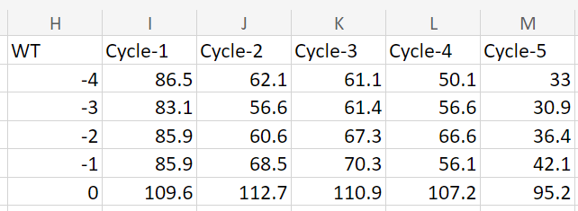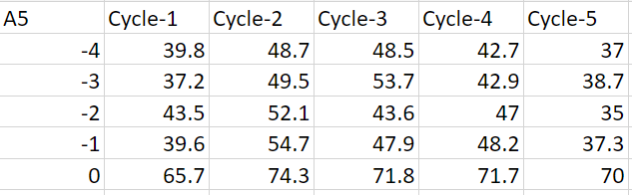

The target columns that need to be merge within each file

Please attention, as the script design, the first group of column names should be start with WT and end with Cycle-5, the second group should be start with A5 and end with Cycle-5. In this sheet, it is not allowed to include another ‘WT’ and ‘A5’ as content.

For sheet **“ GroupCount Data”,** columns as below figures are requested to merge with the other file.

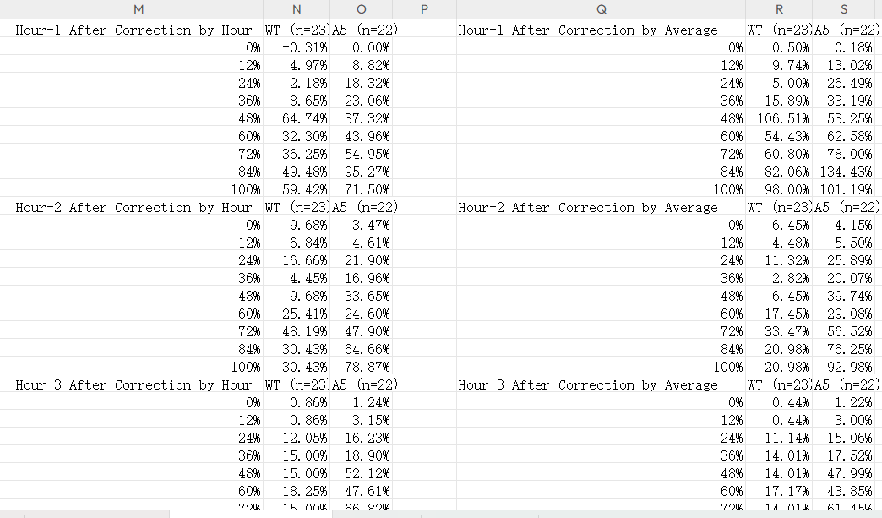

Columns start with names “Hour-1 After Correction by Hour’ and “Hour-1 After Correction by Average” are extracted and merged with the corresponding file. For example, the sequence should be group1 ‘by Hour’, group2 ‘by hour’, froup1 ‘by average’ and group2 ‘by average’.

Please be attention, as script design, the first and fourth column names are fixed to be “Hour-1 After Correction by Hour” and “Hour-1 After Correction by Average”, and the extraction only includes 3 columns (in this case ‘Hour-1 After Correction by Hour’, ‘WT (n=23)’ and ‘A5 (n=22)’)

For sheet ”Sleep Bouts”, the target content of each file are as below.

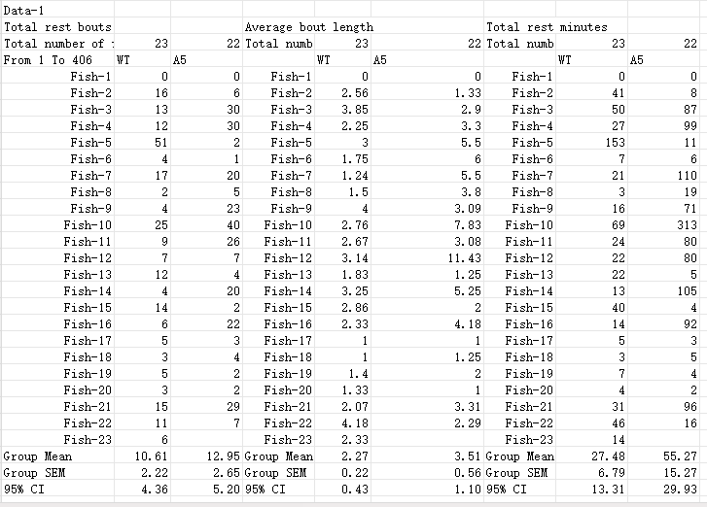

Script searches the first column until the first ’Data-1’ appears, and end the extraction by the second ‘Data-1’ appears.

All un-empty columns and rows are extracted as content to be merged in parallel with the corresponding file.

A new excel file named “groupfile.xlsx’ would be generated to save all the merging contents, as the same sheet separation.