Done by Xinrui Li at 07-09-2023

Programming environment: Python 3.8.17; numpy 1.24.3; matplotlib 3.7.1; pandas 1.5.3; nptdms 1.7.0 channel: conda forge

Instructions of program files

# 1.MakeCSV.py

Firstly, extract useful information from .tdms file and put in new .csv files, which are saved into RawData. Then information of each fish is extracted and saved in FishData. The log file 'Fish_number.txt' is generated for recording fish number and the corresponding. tdms source.

Illustration of running result of MakeCSV.py

# 2.ROIData.py

Focusing on each ROI by pre/middle/post time, dynamic fish information is grouped and calculated, saving in datafolder_ROI.xlsx. It includes 6 sheets which are separated by pre/middle/post time and left/right ROI region.



Illustration of name and sheets of ROI file

Parameters Definition

1). Default pre/middle/post time were set in line 15-16. For example, the default setting indicates pre time is from 0 to 180, stimulus time is from 180 to 1260 and the post time is from 1260 to 1440. If user wants to change the default time, please change the number inside.

2). Default sheet name is set in line 17 as the image shows below, based on stimulus track of fish in left ROI and right ROI.

3) ROI range is set in line 18-20. Default ROI coordinates sequence: top left, bottom left, top right, bottom right.

Meaningful and changeable variables

* **Parameter modification**

If user want to add/delete ROI, please add/delete variables in line 20 and add/delete sheet name in line 17. An example of modification is shown below.

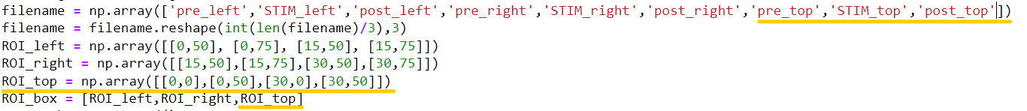

Illustration of adding one ROI field in the code.

Columns Interpretation

TIn and TOut record the time of fish entering and leaving ROI.

MeanVIn and MeanVOut record the mean velocity of fish entering and leaving ROI .

StdVIn and StdVOut record the standard deviation of velocity of fish entering and leaving ROI.

BoundaryCrossings indicates the number of times the fish entering and leaving the ROI area during detection.

ENTRIES = BoundaryCrossings / 2 Mean T per entry = TIn/ENTRIES sanity = TIn + TOut % time in record = TIn / sanity * 100

# 3. User Script.py / User Script.ipynb

This file is directly for user to run the program.

Before running the User Script.py, please make sure the following python modules have been installed:

- npTDMS 1.7.0 (channel: conda forge)

- Pandas 1.5.3

- Matplotlib 3.7.1

- NumPy 1.24.3

For jupyter notebook, please use ‘User Script.ipynb’. For Spyder/PyCharm, please use ‘User Script.py’

Running illustration

* **Data preparation**

Before running, please put the data folder under the same folder as program file.

t1 is .tdms file folder, parallel with program file.

* **Run program**

Open PyCharm, in the top right corner, please change configuration first.

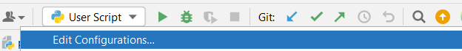

Add a new configuration, set script path to be current ‘user script.py’

Run program and input folder name.

# 4. Sparklines.py

This script helps generate a series of impulse-like figures based on fish crossing ROI boundary. It is divided by stimulus group and control group, x axis is time and y axis is binary value with 0 (not in ROI) and 1 (in ROI).

Illustration of result

# 5. SaveTriggers.py

This script generates information of time distribution for fish in ROI.

Illustration of result

# 6. Other supporting program files

InROI.py helps in ROIData.py.

GetFishTrace.py helps in MakeCVS.py.