Architectural Pattern MVVM (Model-View-ViewModel)

Model–view–viewmodel (MVVM) is a software architectural pattern that facilitates the separation of the development of the graphical user interface (the view) – be it via a markup language or GUI code – from the development of the business logic or back-end logic (the model) so that the view is not dependent on any specific model platform.

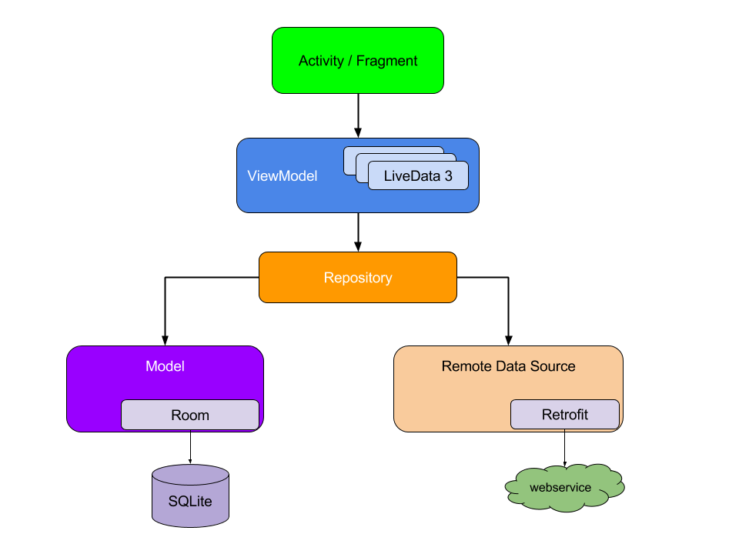

Flowcharts

* SetLanguage

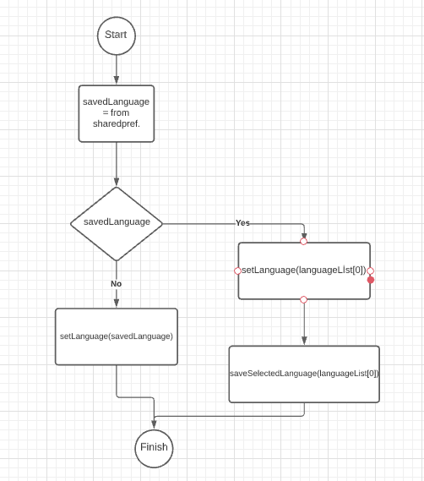

* languageSpinner

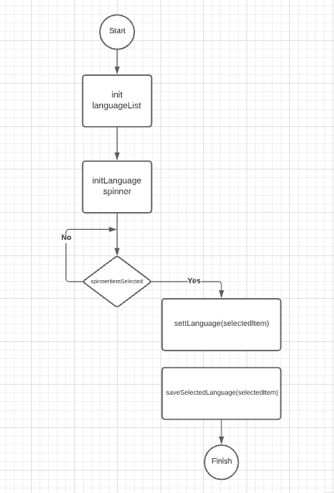

* FindKiwi

