How to use the Data Cleaning Program

Many of the JSON files from an Energy3D workspace may not be valid for JSON processing. This program will assist the data cleaner by immediately fixing many of the JSON errors in a directory.

How do I get started?

To use this program, it is required for the user to implement an external library called **JSON-Simple** into Eclipse. This library allows the program to validate JSON files.

1. **Go to this link:** [**https://code.google.com/archive/p/json-simple/**](https://code.google.com/archive/p/json-simple/) **Scroll down to *Getting Started* and download and save the json-simple.jar.**

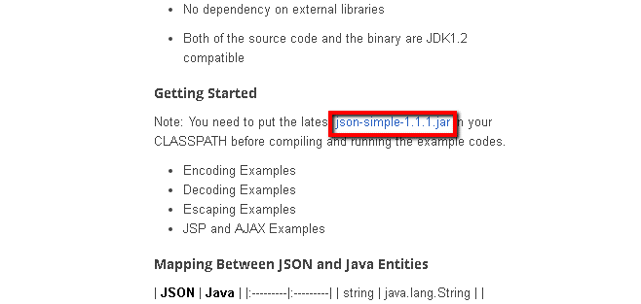

1. **After you’ve downloaded json-simple.jar, open up Eclipse and create a new Java Project (*Other Projects > New > Java Project…*).**

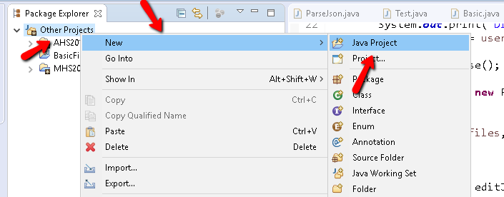

1. **After naming and creating your project, right click your project in the explorer, and click *Build Path* and then *Configure Build Path.***

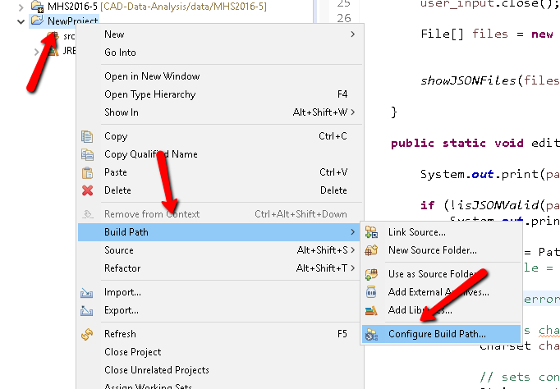

1. **Select the *Libraries* tab, and click on *Add External JARs…*.**

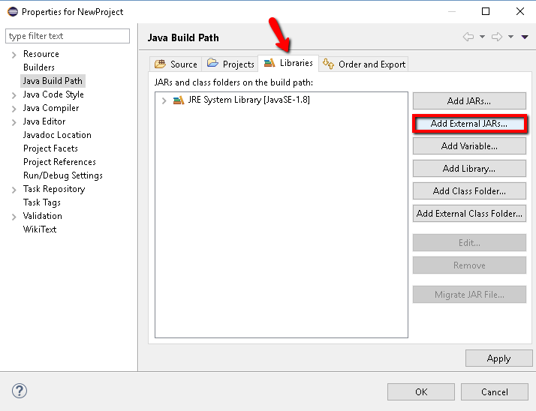

1. **Find your json-simple.jar and open it. Then press apply.**

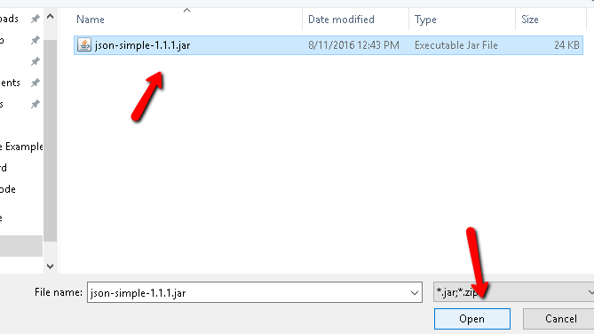

How do I implement the program?

* Copy the program to the clipboard. Paste it into the project by right-clicking the ***src*** ***folder*** and then clicking paste. This should automatically put the program into a new default package.

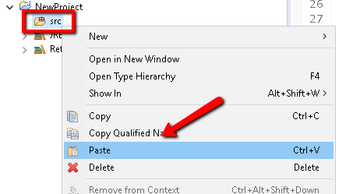

How do I use the program?

1. To open the program, double click the program within the default package (within the src folder) in the explorer. Run the program either by pressing *Ctrl + F11* or by pressing the

Run tab at the top or by pressing the green play button.

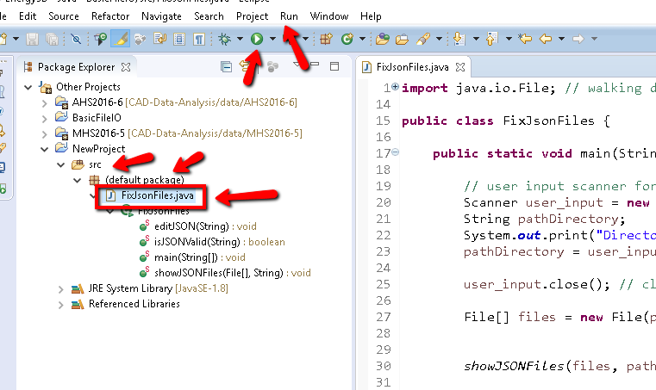

1. The console should come up after you run the program. In the console, type (or paste) in the path of the directory or file that you want to check or edit.

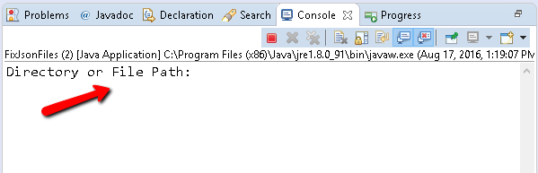

What will the console output?

**Once it finds a JSON file, the console will tell you:**

* The path of the JSON file.
* If the JSON file is valid or not.
* The edits it made to the JSON file.

**Note:** If the directory is quite large, it may take a while (few minutes) for the program to filter through all the non-JSON files to finally get to the JSON files. However, if you run the program for a second time on the same directory, it will cycle through very quickly.

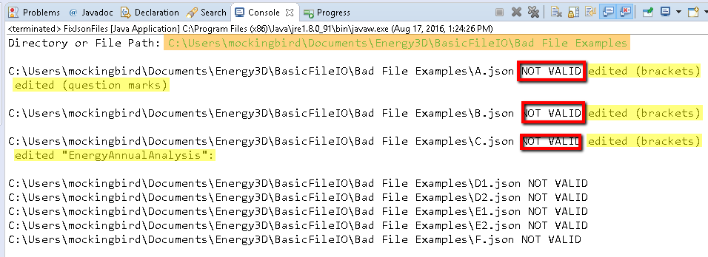Examples:

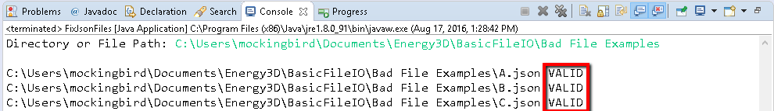 And after running the program for a second time -