**CSY2038**

**Database II**

Table Specifications & Schema

**Group 20:- Module Tutor:-**

Bishnu GC Sangita Satyal

Amir Bhandari

Bikash Yadav

Sudeep Bagale

Arbin Khadka

**Entities**

* provision
* festival
* location
* festival_provision
* location_provision
* festival_nature

**Objects**

* product_type
* product_table_type
* address_type
* addresses
* contact_type
* contact_varray_type
* organizer_type
* organizers

**Schema**

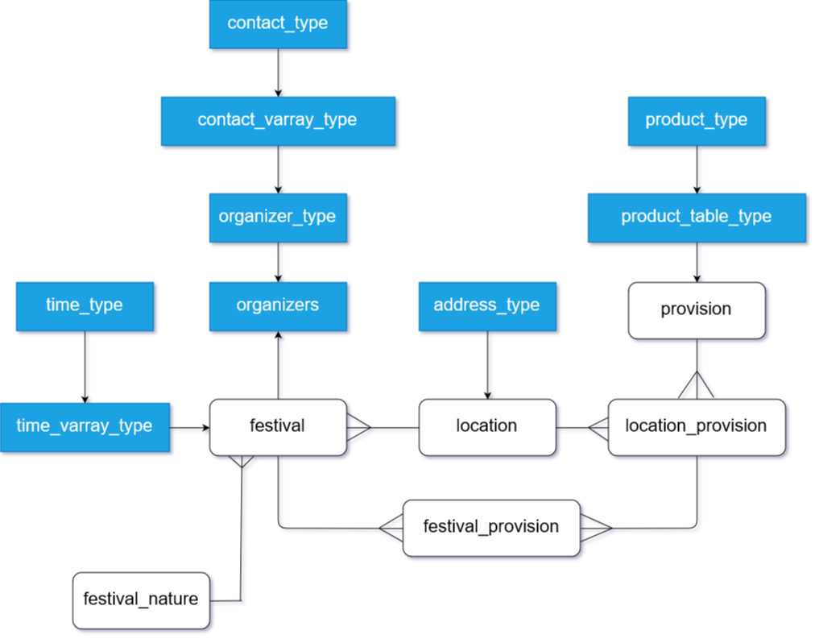

**Table Specifications**

**Objects**

|  |  |  |  |  |  |
| --- | --- | --- | --- | --- | --- |
| **S.N** | **Attribute** | **Type** | **Size** | **Constraints** | **Default** |
| **product_type** | | | | | |
| 1. | product_name | VARCHAR2 | 25 |  |  |
| 2. | cost | NUMBER | 10,2 | CHECKIN (> 0) |  |
| 3. | category | VARCHAR2 | 25 |  |  |
| 4. | quantity | NUMBER | 10 | CHECKIN (> 0) |  |
| 5. | description | VARCHAR2 | 255 |  |  |
| **address_type** | | | | | |
| 1. | street | VARCHAR2 | 30 | UNIQUE |  |
| 2. | city | VARCHAR2 | 25 | CHECK IN (UPPER CASE) |  |
| 3. | country | VARCHAR2 | 25 | CHECK IN (UPPER CASE) |  |
| **contact_type** | | | | | |
| 1. | e-mail | VARCHAR2 | 30 | UNIQUE |  |
| 2. | phone_number | VARCHAR2 | 20 | UNIQUE |  |
| **contact_varray_type** | | | | | |
| 1. | same as contact_type | contact_type | 50 |  |  |
| **organizer_type** | | | | | |
| 1. | organizer_firstname | VARCHAR2 | 25 | CHECK IN (UPPER CASE) |  |
| 2. | organizer_surname | VARCHAR2 | 25 | CHECK IN (UPPER CASE) |  |
| 3. | contact | contact_varray_type |  | NOT NULL |  |
| 4. | gender | CHAR |  |  |  |
| 5. | description | VARCHAR2 | 255 |  |  |
| **time_type** | | | | | |
| 1. | start_date | DATE |  |  |  |
| 2. | end_date | DATE |  |  |  |
| 3. | start_time | VARCHAR2 |  |  |  |
| **time_varray_type** | | | | | |
| 1. | same as time_type | time_type | 40 |  |  |

**Tables**

|  |  |  |  |  |  |
| --- | --- | --- | --- | --- | --- |
| **S.N** | **Attribute** | **Type** | **Size** | **Constraints** | **Default** |
| **provisions** | | | | | |
| **1.** | provision_id | NUMBER | 10 | PK |  |
| **2.** | provision_title | VARCHAR2 | 25 | CHECK IN (UPPER CASE) |  |
| **3.** | product | product_table_type |  |  |  |
| **4.** | supplier | VARCHAR 2 | 25 | CHECK IN (UPPER CASE) |  |
| **festival_natures** | | | | | |
| 1. | festival_nature_id | NUMBER | 10 | PK |  |
| 2. | festival_type | VARCHAR2 | 30 |  |  |
|  |  |  |  |  |  |
| **locations** | | | | | |
| 1. | location_id | NUMBER | 10 | PK |  |
| 2. | address | address_type |  | NOT NULL |  |
|  |  |  |  |  |  |
| **festivals** | | | | | |
| 1. | festival_id | NUMBER | 10 | PK |  |
| 2. | location_id | NUMBER | 10 | FK (NOT NULL) |  |
| 3. | festival_nature_id | NUMBER | 10 | FK(NOT NULL) |  |
| 4. | title | VARCHAR2 | 25 | CHECK IN (UPPER CASE) |  |
| 5. | organizer | REF organizer_type SCOPE organizers |  |  |  |
| 6. | fee | NUMBER | 10,2 |  |  |
| 7. | capacity | NUMBER | 5 | CHECK IN (> 0) |  |
| 8. | total_budget | NUMBER | 10,2 | CHECK IN (> 0) |  |
| 9. | time | time_varray_type | 10,2 |  |  |
| **location_provisions** | | | | | |
| 1. | location_id | NUMBER | 10 | PK, FK |  |
| 2. | provision_id | NUMBER | 10 | PK, FK |  |
|  |  |  |  |  |  |
| **festival_provisions** | | | | | |
| 1. | festival_id | NUMBER | 10 | PK, FK |  |
| 2. | provision_id | NUMBER | 10 | PK, FK |  |
| 3. | location_id | NUMBER | 10 | PK, FK |  |