Project 1 : Deploying multi-tier application
Steps To Solve:
- Launch an EC2 Instance
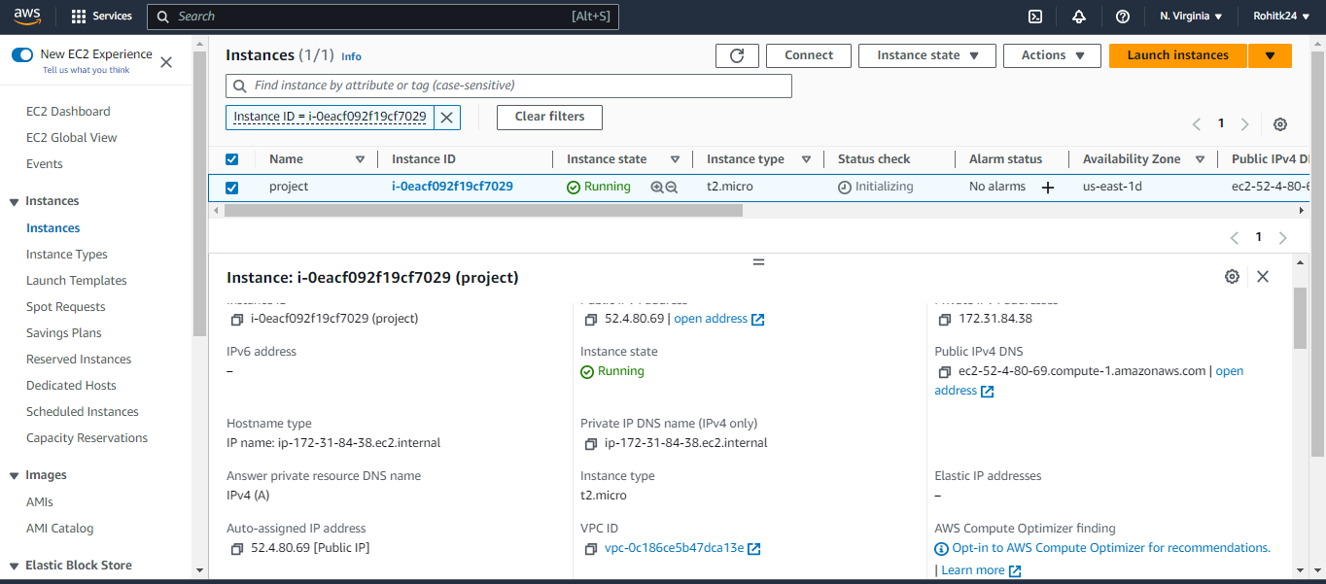
Updaed machine
sudo apt-get update
installed Apache2
sudo apt-get install apache2
installed mysql used below command
sudo add-apt-repository -y ppa:ondrej/php
sudo apt install php5.6 mysql-client php5.6-mysqli
Now everyting is updated on machine.
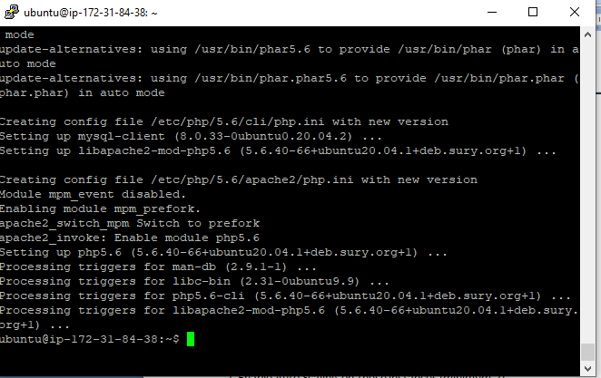
Enable Auto Scaling on these instances (minimum 2)
AMI Created
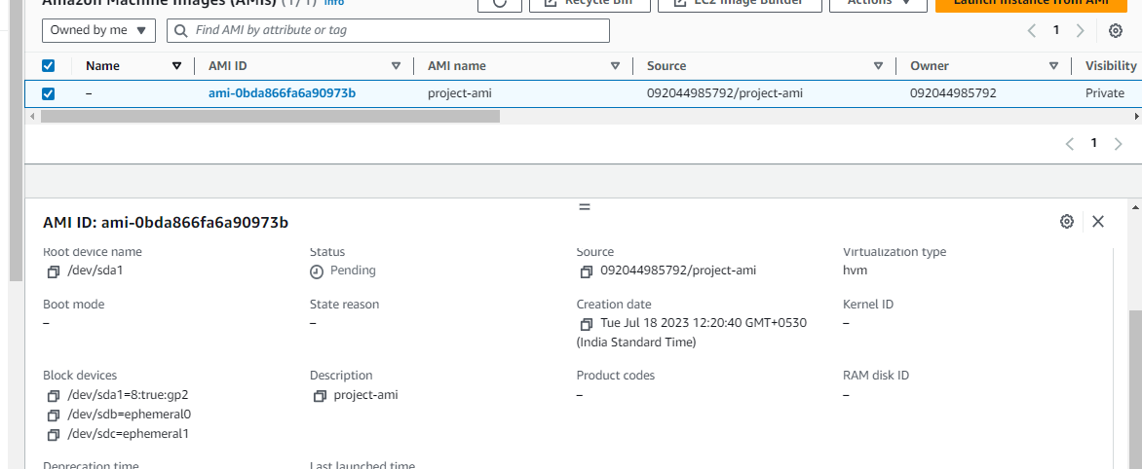
activated its autoscaling and then its classic load balancer which directs the traffic to website directly.

Create an RDS Instance

Created RDS instance.
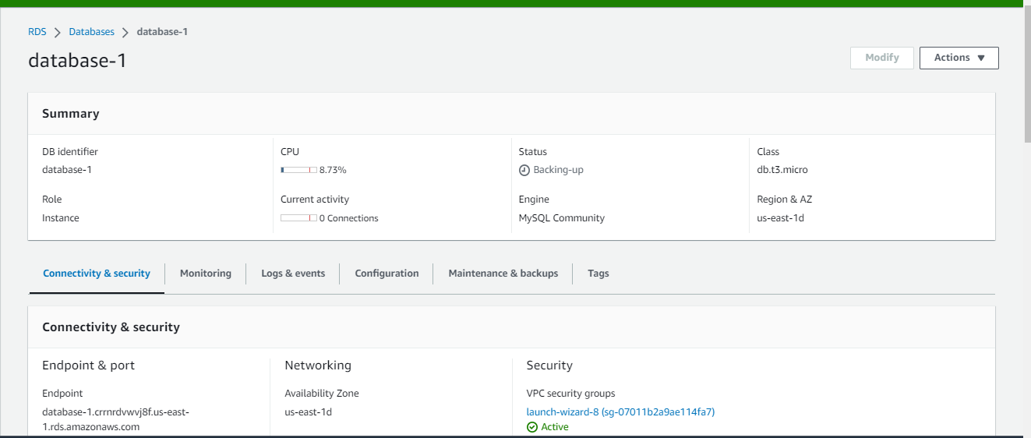
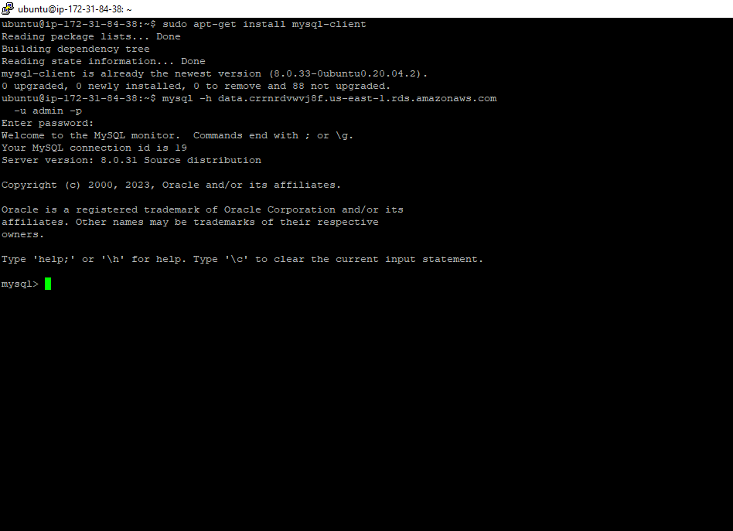

Create Database & Table in RDS instance: a. Database name: intel b. Table name: data c. Database password: intel123
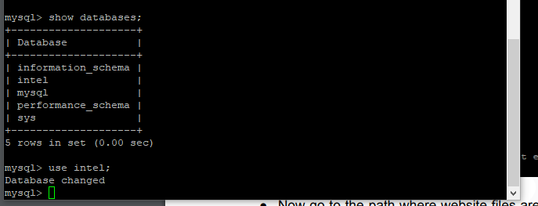
Allow traffic from EC2 to RDS instance
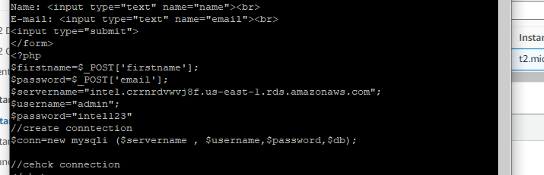
Allow all-traffic to EC2 instance
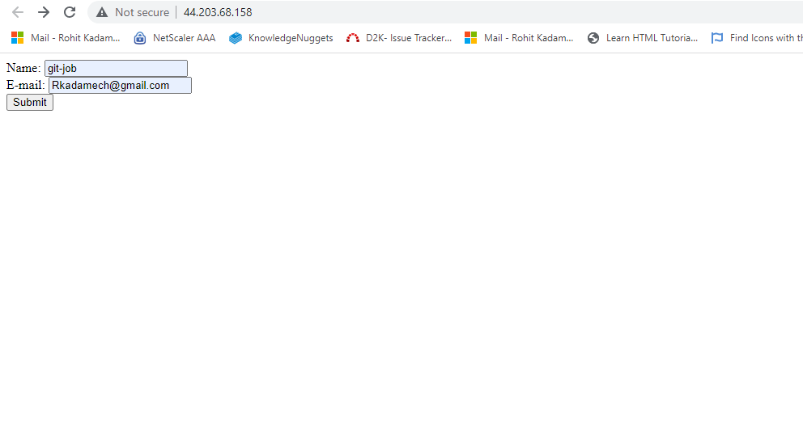
Conclusion: Hence I have understood how to launch multi-tier application

