Project 2 : Host a static website using AWS S3 bucket

Tools Used
1.AWS S3 Bucket
2.AWS Route53

Implementation:
1.Created an s3 bucket with public access
2.Upload the code to the bucket
3.Host it by enabling , “static Wesite Hosting”
4.Give acces to objects that are in the s3 bucket by editing “Bucket Policy”.
5.It will generate a link to access the static website
6.Using Route53 , we can connect it to a specific domain name.

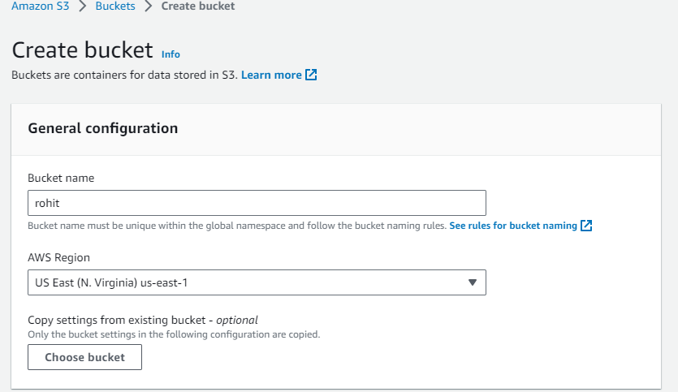
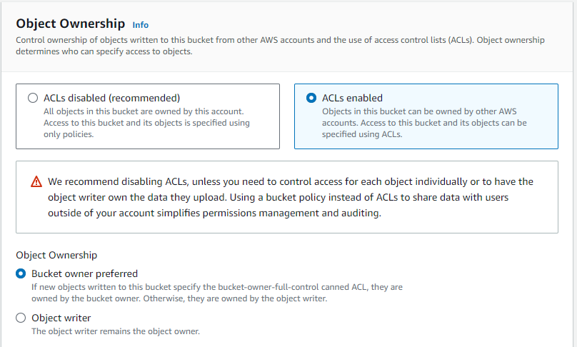
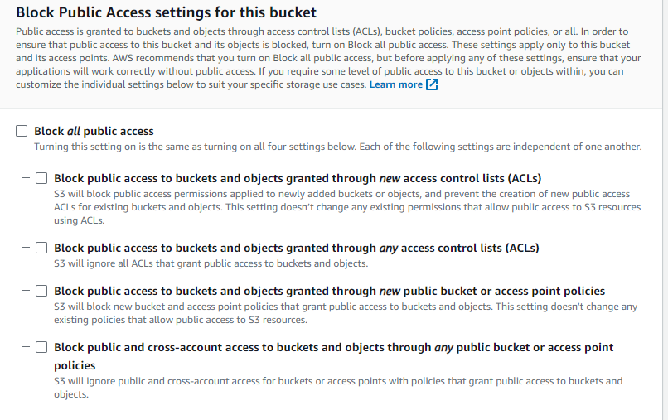
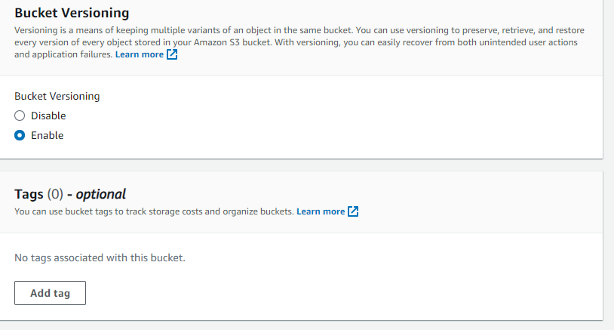
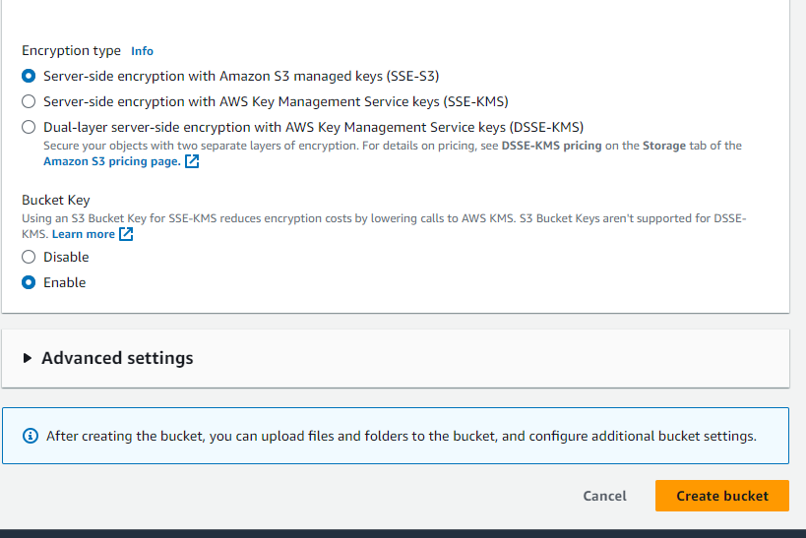
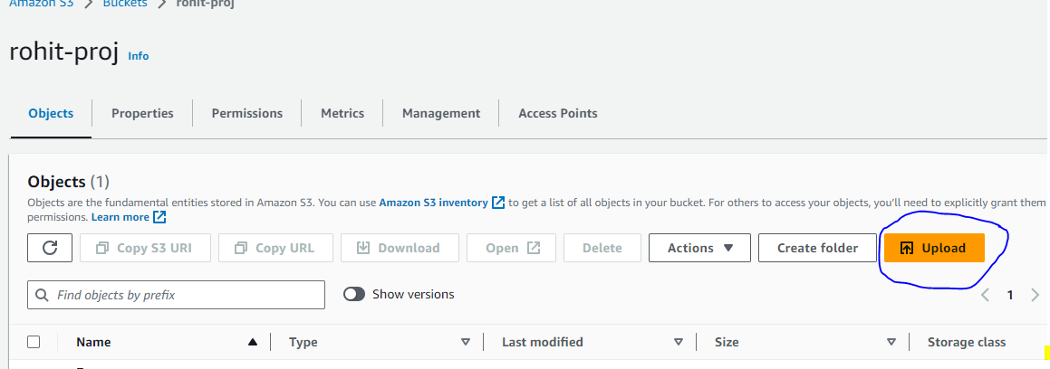

Upload the file using tab upload it will browse your location where your code is located,just click and upload.

After that go to permission and enable the static web site hosting.
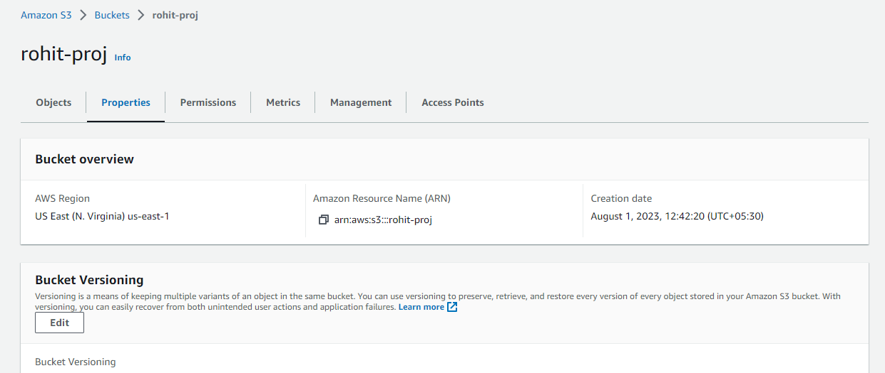
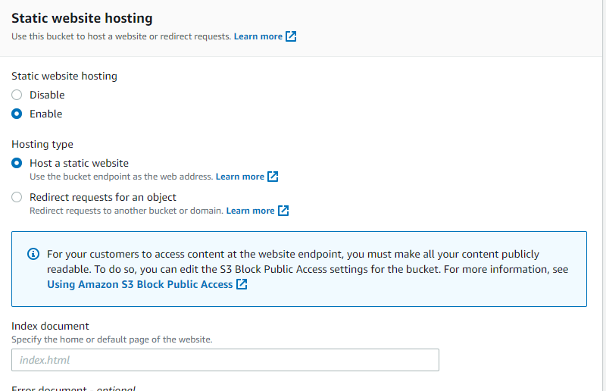


Hope You found this helpful .Do Connect follow for such content.

