Module 5 VPC Case study:
VPC Created for Prod-Env With CIDR Range : 10.10.0.0/16
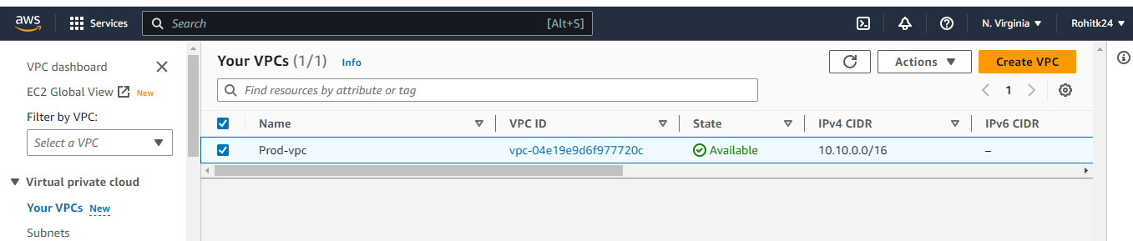

Prod Subnets are created :
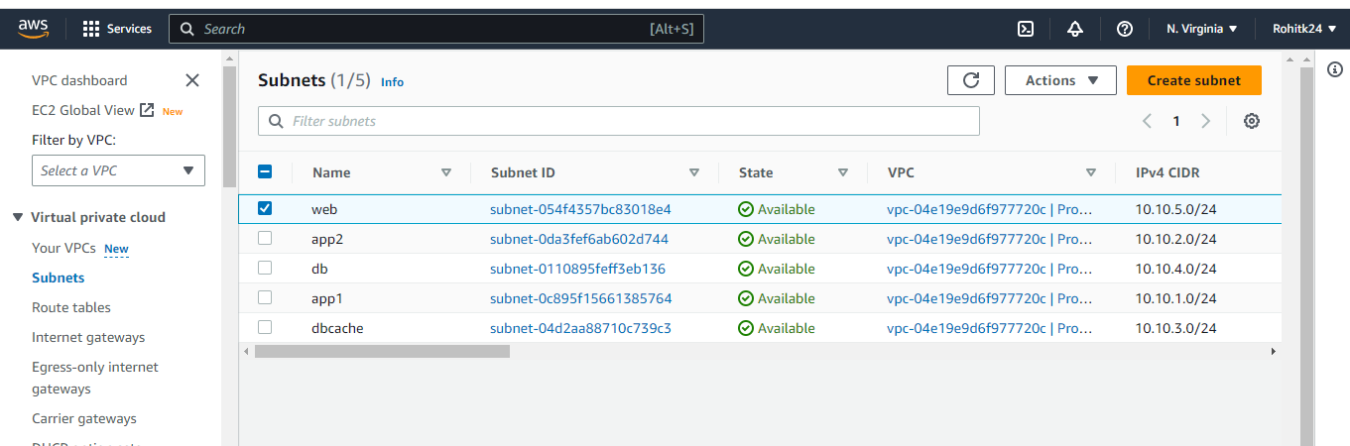

Created Internet Gateway :
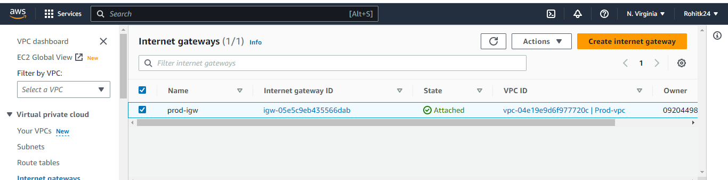

Create NAT-Gateway:
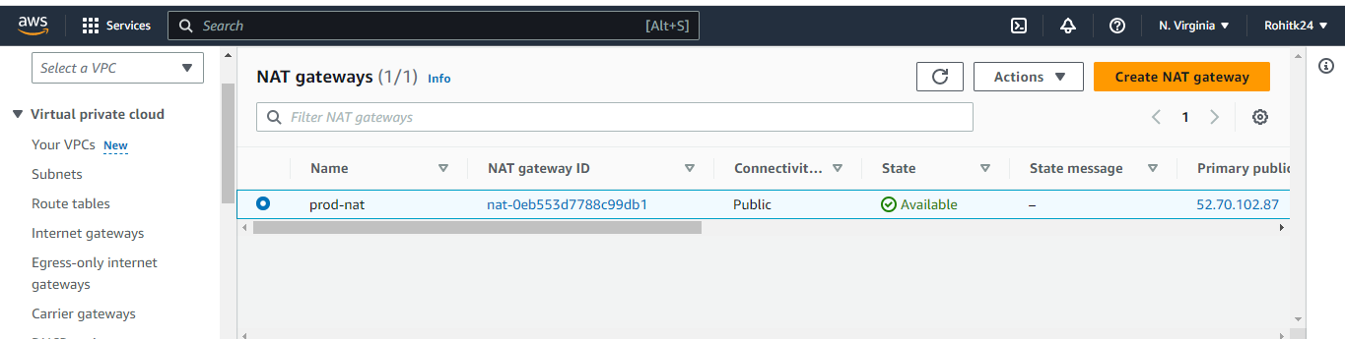

Created Route Table:
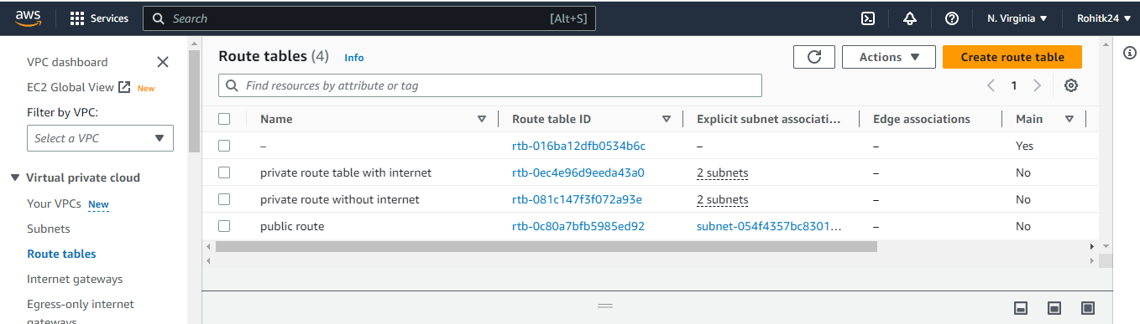

In public route => edit route=> internet gateway selected:
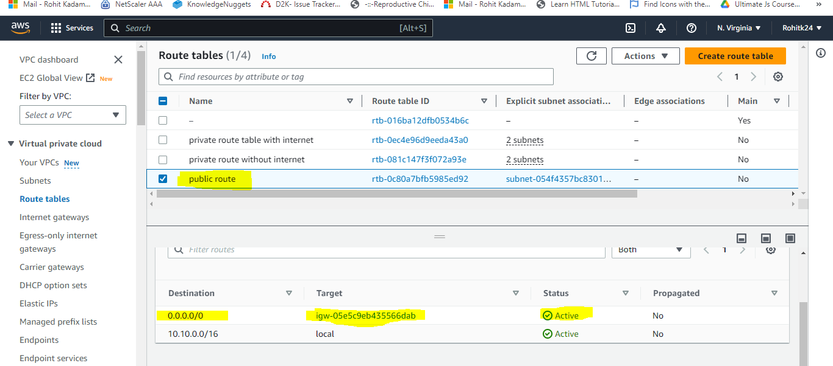
After that edit the subnet association and added the web subnet.
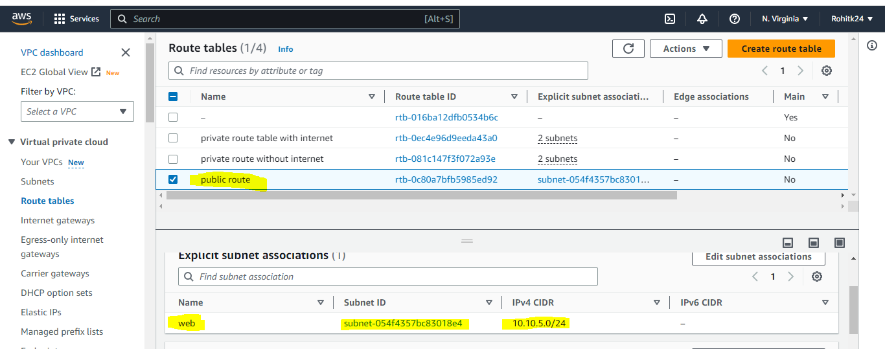

In private route table with internet
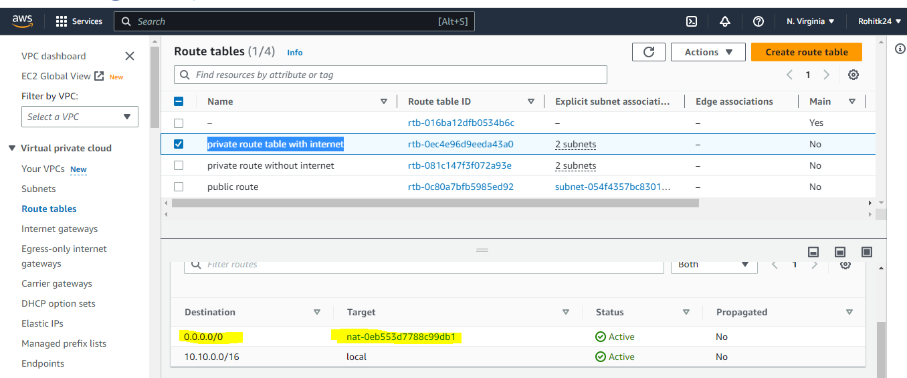

In subnet association added the
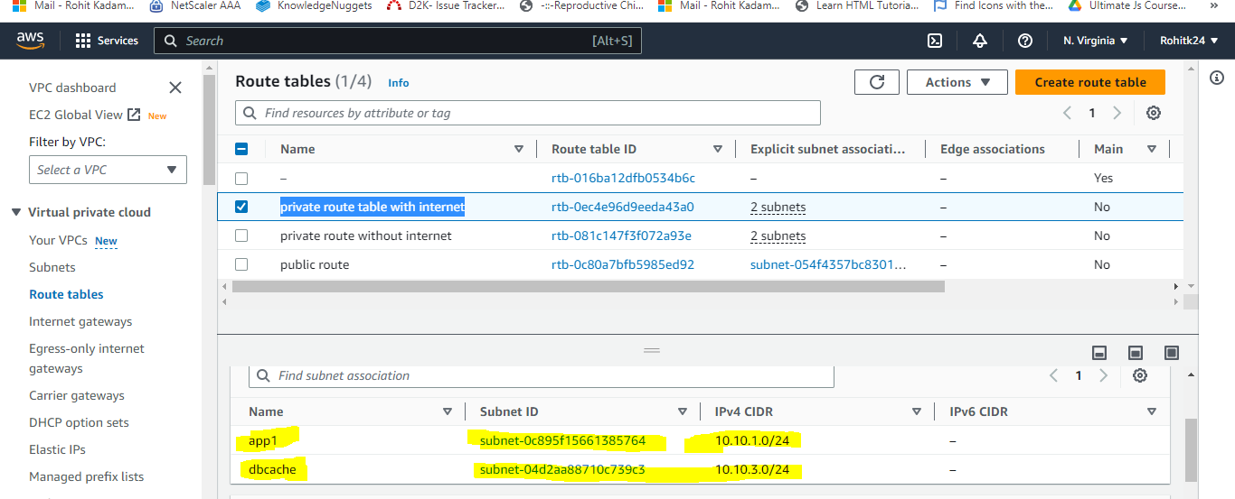
In private route without internet
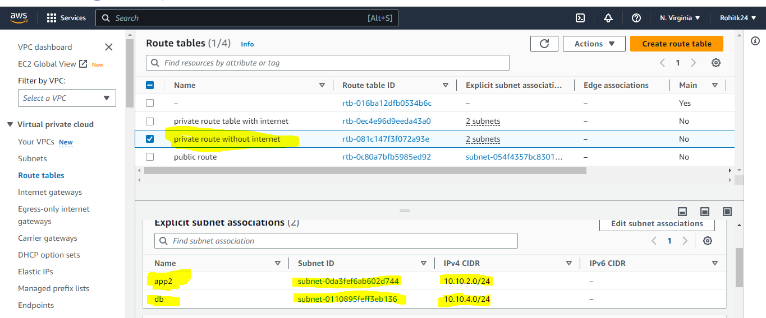

Created the Security Group in North Virginia.
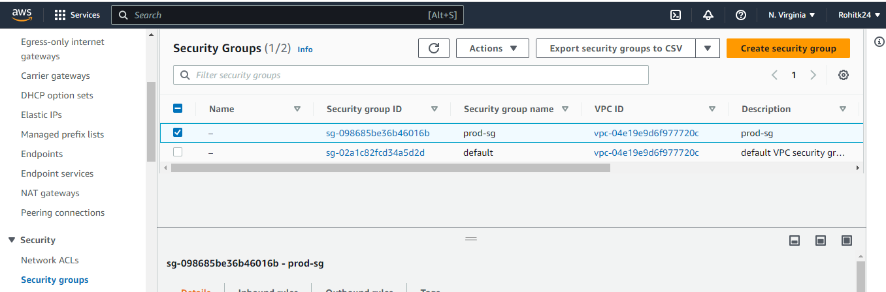
Instance Created :
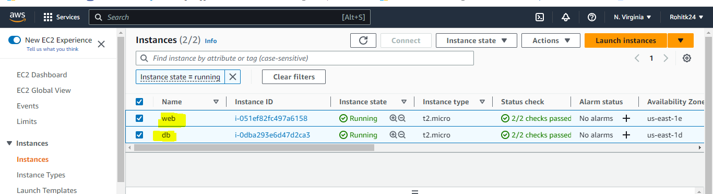
Prod VPC Peering with Oregon region

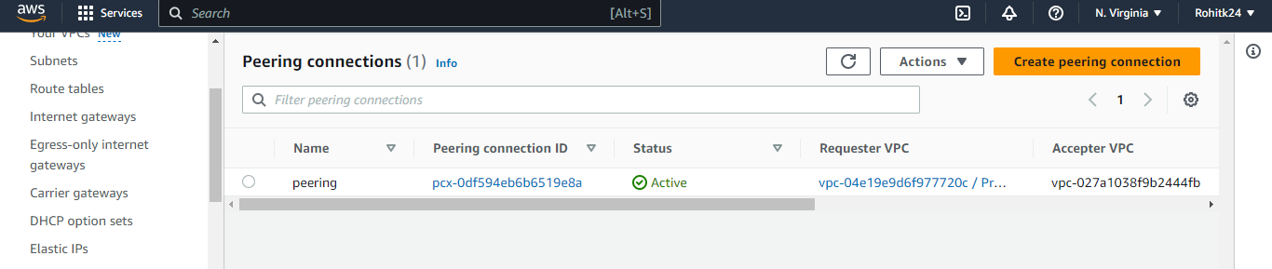

Development Environment
Dev env.
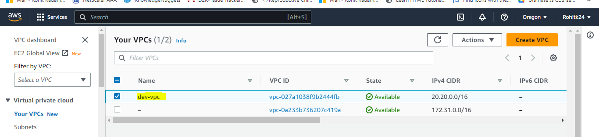
Subnets are created web and db

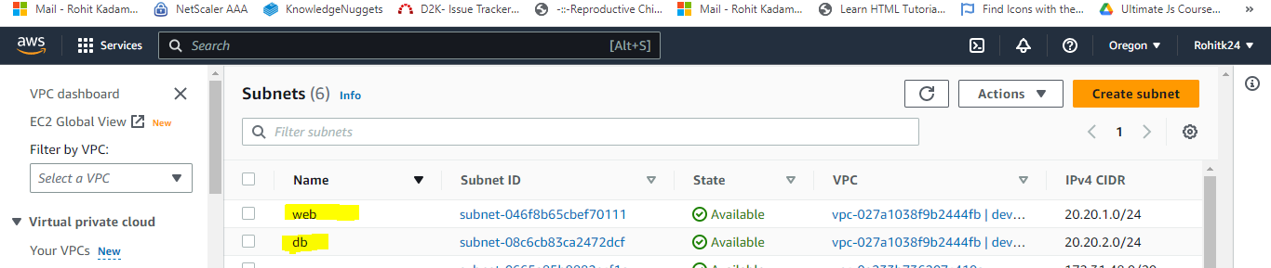
Created Igw and attached to vpc
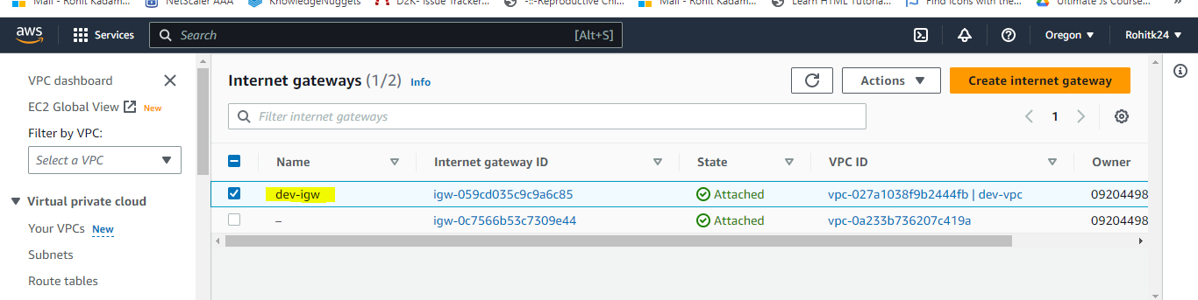

Route Table are created with public route and private route
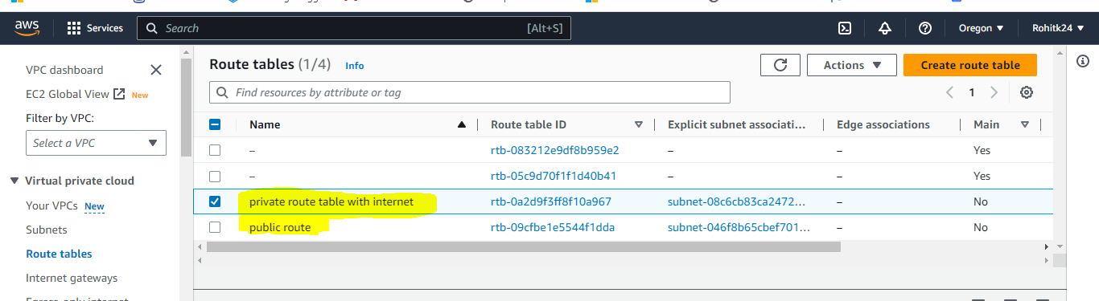
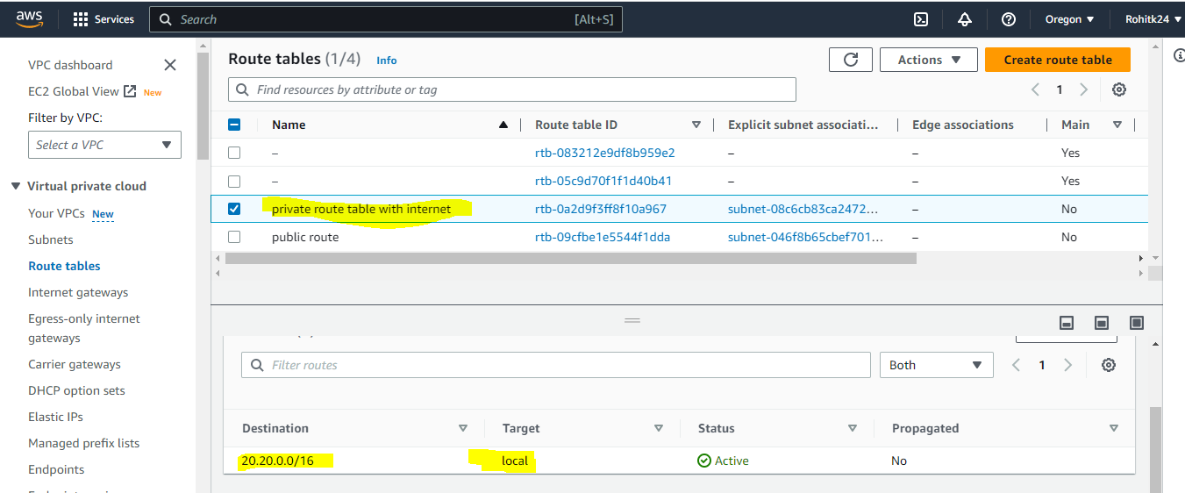
In Private route added the db in subnet association.
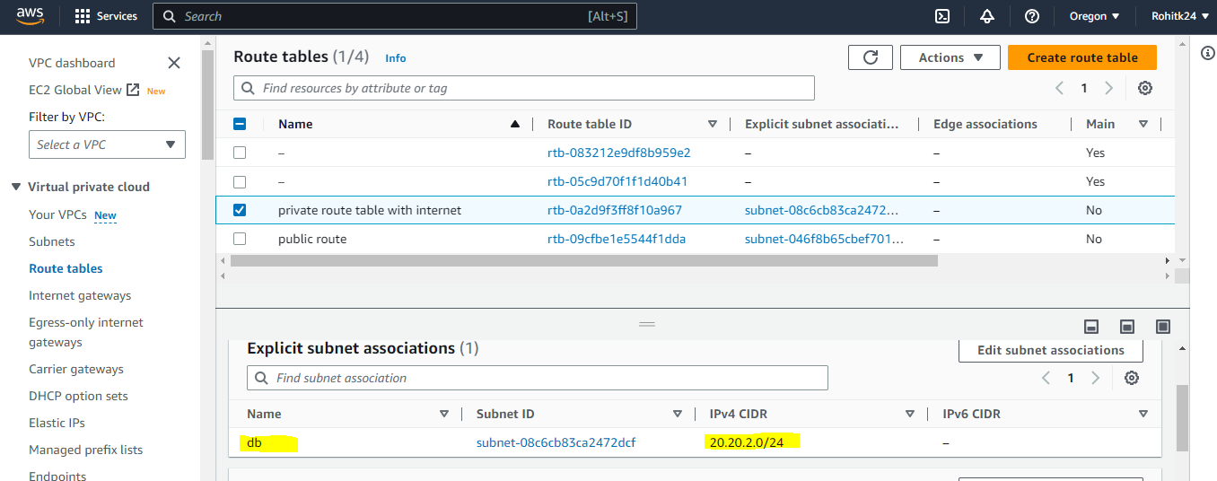

Public Route added igw
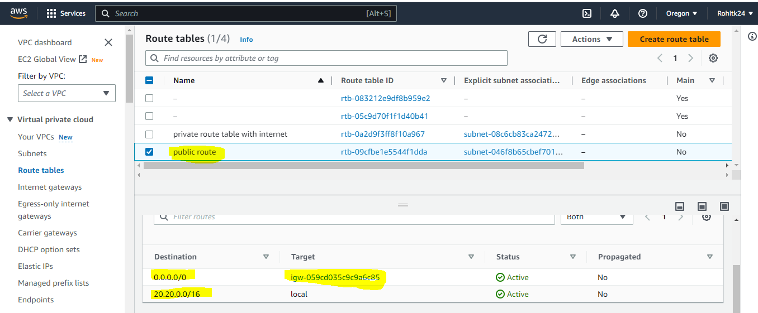
In Public route added the web subnet
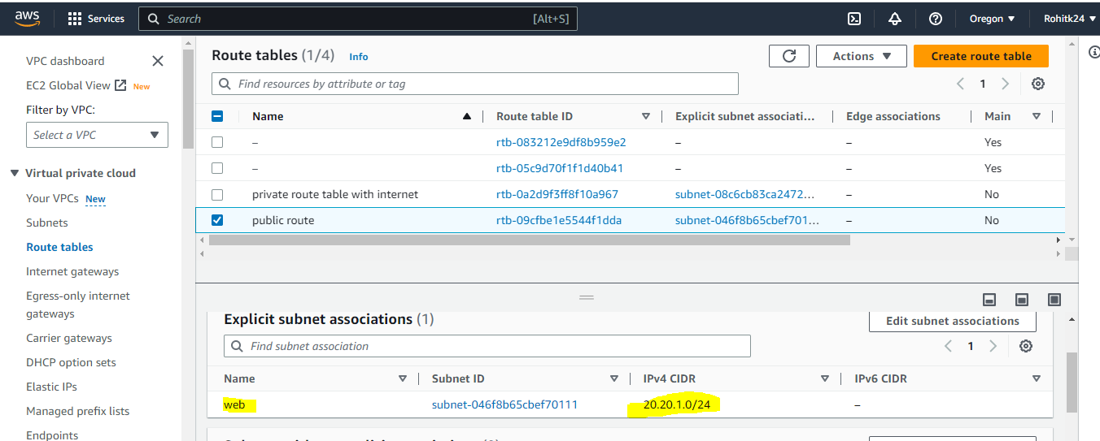

Created the SG:
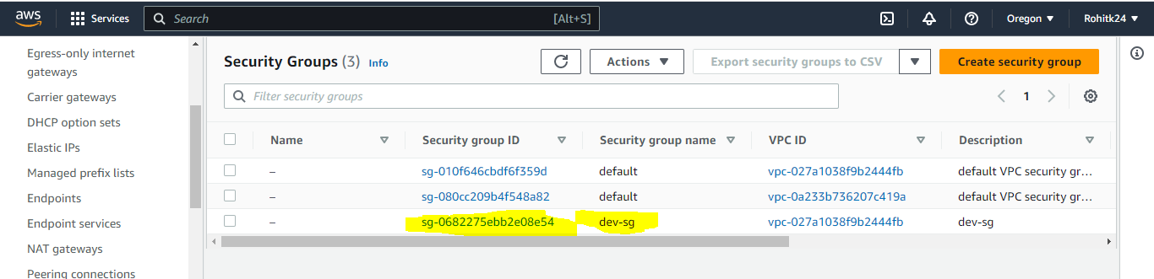
Created the web and db EC2 instance.
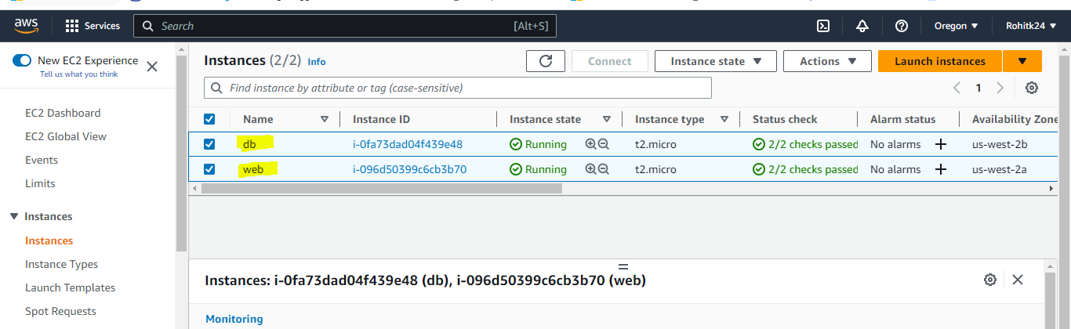

Peering done on N.virginia and Oregon region.
