Activity 1

Iris Dataset Overview
- The dataset contains information about 150 iris flowers (plants).
- Each row (instance) represents one individual iris flower.
- The dataset is divided into 3 species (classes) of iris flowers:
  - Iris setosa
  - Iris versicolor
  - Iris virginica
- Each species contains 50 flower samples, making the dataset balanced.

Features (Independent Variables)
The dataset contains four numerical measurements for each flower:
- Sepal Length (cm) – Length of the sepal.
- Sepal Width (cm) – Width of the sepal.
- Petal Length (cm) – Length of the petal.
- Petal Width (cm) – Width of the petal.
Activity 2
Iris dataset visulization

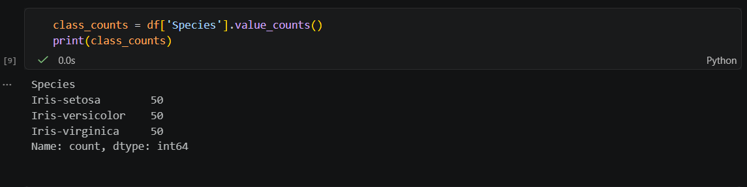

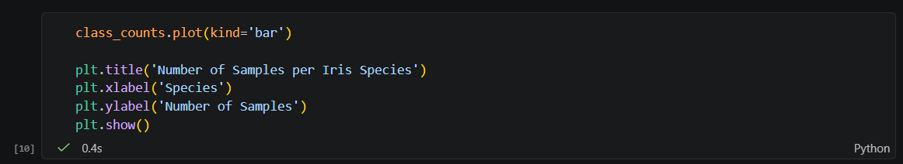

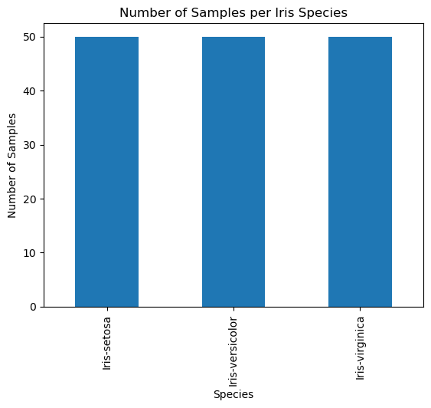

Yes, the classes are balanced.
- Setosa has 50 samples.
- Versicolor has 50 samples.
- Virginica has 50 samples.

Since each class contains the same number of observations, there is no class imbalance.

The Iris dataset contains three flower species: Setosa, Versicolor, and Virginica.
A count of the target variable shows that each species has exactly 50 observations.
The bar chart confirms that all classes have equal representation.
Therefore, the dataset is considered balanced.

