Analytical Reasoning Assessment
AI Solution Evaluation for Credit Risk & Lending Analytics
[Your Name]
[Date]

Task 1: TQ-0309: Vintage Cumulative Default Rate

1. Task ID and Task Statement
TQ-0309. For the 2024 origination vintage, compute the cumulative ever-90+ DPD rate at MOB 12, segmented by FICO band at application (<580, 580–619, 620–659, 660–719, 720–759, 760+) and loan segments (A–E). Include only loans with sufficient seasoning to have completed the 12-month observation window. Present as a pivot table.

2. Human-Only Reasoning
What's being asked
This is a vintage curve number. Out of everyone who took out a loan in 2024, what share ever went 90 or more days past due at some point in their first 12 months on the books, split by FICO band and loan segment. The word "ever" is doing a lot of work here. The task isn't asking where a loan sits exactly at month 12, it's asking whether 90+ DPD happened anywhere across that window.
The requirements, as I read them: 2024 vintage only. A loan needs to have actually completed the 12-month window before it counts, otherwise I'm mixing in loans that haven't had the chance to default yet, which would understate the real rate. I have to scan every snapshot from month 0 through 12, not just check the value at month 12. FICO needs to be the score at application, not whatever the bureau shows today.
My approach
Filter to 2024 vintage, keep loans where the max months-on-book is at least 12, flag anyone who hit 90+ DPD anywhere in that window, pull FICO from the application-level record, band it, then pivot against loan segment.
Which solution is correct, and why
I'd go with Solution B. Its seasoning cutoff sits at 12, which matches "completed the 12-month window" without demanding an extra month of data the task never asked for. It scans months 0 through 12 for the 90+ flag instead of checking one point in time. And it pulls FICO straight from the funded-loan table by loan_id, which should be the value locked in at underwriting, instead of routing through a separate bureau table that might reflect a later pull.
Solution A's problems: The seasoning threshold is set at 13, not 12, which quietly drops any 2024 loan that reached exactly month 12 but hasn't hit month 13. That group skews toward the most recently originated loans in the vintage, so cutting them out isn't neutral, I'd expect the rate to distort upward. The fix is just seasoned >= 12. It also pulls FICO through a separate credit bureau snapshot table instead of the loan-level record. If that table has more than one row per applicant, which bureau data often does from repeat pulls or ongoing monitoring, the score being used might not be the one from application, and the join itself risks duplicating some loans. Either way, band assignment gets distorted. Join fa_funded on loan_id instead.
Solution C's problems: It skips seasoning entirely and keeps every 2024 loan regardless of how much history it has. Loans that are only a few months old end up in the denominator even though they haven't had time to reach 90+ DPD, which drags the rate down hard. It also only checks the DPD value at the exact month-12 snapshot instead of scanning the whole window. A loan that spiked to 90+ at month 6 and then cured, paid off, or charged off before month 12 would simply be missed. That's a second source of deflation stacked on the first, and honestly it's the bigger problem of the two, since it changes what's actually being measured rather than just who's included.
What the numbers show
Solution A runs higher than B across nearly every cell (660-719: 6.2/6.4/5.0/1.7/6.6 versus B's 5.8/5.7/4.5/1.6/6.0). That tracks with the seasoning error, dropping part of the denominator concentrates the population toward loans that have had more time to accumulate risk. Solution C sits well below both, 4.0/3.4/2.8/0.9/4.0 in that same band, which fits both errors pulling in the same direction: a bigger, less-seasoned denominator paired with a numerator that's undercounting real defaults.
Where I think the LLM went wrong
Solution A reads like an off-by-one mistake, treating "completed 12 months" as if it needed a 13th data point to prove it. Solution C looks like it took "at MOB 12" too literally, as a point-in-time filter rather than a cumulative definition, and in the process dropped the seasoning instruction entirely.

3. LLM Reasoning
LLM's reasoning (condensed)
The LLM's cold read matched my own verdict: Solution B is correct. Its case against Solution A centered on the FICO join. A pulls the score from a credit bureau snapshot table instead of the funded-loan table it's actually given as a parameter, and never deduplicates that join on application_id. If a bureau table carries more than one row per applicant, which is common when accounts get re-pulled for collections or monitoring, an inner join fans a single loan out into multiple rows, and if delinquent accounts get re-pulled more often than healthy ones, the duplication isn't neutral, it skews the count of defaulted loans upward specifically. Worked through with a toy example: a true 30% default cell stays at 30% under uniform duplication, but climbs to over 46% once the duplication rate itself correlates with default status. That mechanism, sitting upstream of any FICO band or segment split, would hit every cell in the same direction rather than a scattered few, which matches Solution A running higher than Solution B in essentially every populated cell rather than just some.
On the seasoning cutoff, the LLM worked through the indexing question directly: whether months_on_book is 0-indexed or 1-indexed at origination, MOB 12 is, by construction, the snapshot marking exactly twelve months on book. So max(months_on_book) >= 12 is the correct threshold either way, and Solution A's >=13 requirement asks for a full extra month beyond what "completed the window" actually requires.
For Solution C, the LLM's read lined up with mine on both errors: no seasoning filter at all, and a point-in-time check at exactly MOB 12 instead of scanning the cumulative window, which misses loans that hit 90+ DPD earlier and cured, paid off, or charged off before reaching month 12.
Your understanding and critique
My Stage 1 write-up got both correctness calls right and caught every error, but the LLM pushed back on one place where I'd been too confident. I explained Solution A's exclusion of loans sitting at max(mob)==12 as cutting out "young" 2024 originations. That doesn't actually hold up: the data runs through early 2026, so no 2024-vintage loan is genuinely young by now. A loan whose history stops right at month 12 didn't stop because it's immature, it stopped because it exited early, through a payoff or a charge-off. That reframes what Solution A is excluding, and it means I can't confidently claim that error inflates the rate the way I originally argued. It could just as easily deflate it, since early charge-offs would represent loans that were already deep in delinquency. I'm leaving that direction as genuinely uncertain in the final answer below rather than picking one.
The LLM also connected something I'd missed: I'd pinned Solution A's uniform "higher in every cell" pattern on the seasoning cutoff, but a boundary error like that should only touch a scattered handful of cells at most, not sweep every single one the same way. The FICO join fan-out, which specifically risks over-duplicating delinquent accounts, is the better explanation for a shift that consistent.
Final answer
Solution B is correct for TQ-0309. Its seasoning threshold, max(months_on_book) >= 12, is the mathematically correct cutoff for having completed the 12-month observation window under either indexing convention. Its ever-90 flag correctly scans months 0 through 12 rather than checking one point in time. And it pulls FICO from the funded-loan table by loan_id, a source that's guaranteed one row per loan.
Solution A carries two errors. First, it retrieves FICO through a separate credit bureau snapshot table joined on application_id, without deduplicating that table first. If the bureau table holds more than one row per applicant, which is plausible given periodic re-pulls, the join fans a single loan out into multiple rows, and if delinquent accounts get re-pulled more often than healthy ones, the counts get skewed toward the defaulted side specifically. That's the more likely explanation for why A runs higher than B in nearly every cell rather than a scattered few, since a row-construction error like this hits every cell before the data ever gets split, while a boundary error would only touch a handful of loans near the cutoff. The fix there is simple: join fa_funded on loan_id directly. Second, its seasoning cutoff of >=13 excludes loans that reached exactly month 12 but not month 13. Given the data timeline, that excluded group is best understood as early exits, charge-offs and payoffs, rather than young loans, so whether this pushes the rate up or down isn't something the code alone settles, and I'm not asserting a direction here. What it should do instead is just seasoned >= 12.
Solution C carries two errors, both deflationary. It drops the seasoning filter entirely, folding in loans that haven't had the full window to default, which understates the rate. And it checks DPD only at the exact MOB 12 snapshot instead of scanning the cumulative window, missing loans that hit 90+ DPD earlier and cured, paid off, or charged off before month 12, which is the larger of the two errors since it changes what's being measured rather than just who's included. Both get fixed the same way: seasoned >= 12, combined with a cumulative flag over months_on_book <= 12.
Numerically, A runs above B in essentially every cell, in line with a row-construction error rather than a boundary error. C sits well below both across every cell, the expected result of two deflationary errors compounding.
Where the LLMs failed: Solution A's code silently substitutes a different data source than the one it was given, without handling the join cardinality, a data-lineage mistake rather than a logic error. Solution C read "at MOB 12" as a literal point-in-time filter and dropped the seasoning instruction outright, treating an explicit constraint as if it weren't there.

Task 2: TQ-0120: Delinquency Cure Rate

1. Task ID and Task Statement
TQ-0120. Compute the monthly YTD cure rate for loans that are 60+ DPD. A cure requires a full return to 0 DPD, improvement to a less severe bucket does not qualify. Charged-off loans are excluded from the denominator. Measure by loan count, all products, January 1 through the latest available snapshot date.

2. Human-Only Reasoning
What this is really asking
For loans sitting at 60+ DPD in a given month, what fraction fully return to 0 DPD the next month, counted by loan rather than dollars, with charged-off loans stripped out first. Partial improvement doesn't count, only a complete cure to zero does.
Requirements: starting pool is 60+ DPD, inclusive, in month one. Charged-off loans excluded before anything else. A cure means DPD hits exactly zero the next month, not just a lower number. The rate is a headcount, cured loans over total loans in the pool, not balances.
How I'd approach it
Sort the YTD snapshot months, step through consecutive pairs, filter month one to 60+ DPD and not charged off, join to month two, count where DPD equals zero, divide by pool size.
Which solution is correct, and why
Solution C. The denominator uses >= 60 and drops charge-offs, the cure check is dpd_m2 == 0, and the rate is loan count over loan count. All four requirements line up.
Solution A: It counts a loan as cured if it drops below 60 DPD, so a loan going from 95 to 45 would count even though it's nowhere near zero. That's a real departure from "full return to 0 DPD," and it should push the cure rate up since partial improvement is a lot easier to hit than a full cure. It also switches the whole calculation to balance-weighted, dollars cured over dollars in the pool, instead of loan count. That's answering a different question, no matter how cleanly the dollar math is done.
Solution B: It filters the pool with strictly greater than 60 DPD, so a loan sitting at exactly 60 gets left out, which isn't what "60+" means. It also never excludes charged-off loans. A charged-off loan basically never shows 0 DPD the next month, so leaving them in the denominator adds dead weight that can't cure, pulling the rate down.
The numbers
Solution A's rates (6.67%, 2.65%, 2.62%) sit a bit above C's (6.38%, 2.06%, 1.05%), which fits the looser cure definition scooping up partial roll-backs that shouldn't count. Solution B's denominators (116, 121, 119) are actually bigger than C's (94, 97, 95), even though B's filter is technically stricter on the DPD side. That only makes sense if enough charge-offs are sitting in B's pool to outweigh the loans it's excluding right at 60 DPD.
Where I think the LLM went wrong
Solution A reads like a default assumption carried over from financial modeling, where balance-weighted metrics are the norm, even though the prompt explicitly said loan count. Solution B looks like a straightforward translation slip: "60+" became > 60 instead of >= 60, and it just dropped the charge-off exclusion rule rather than misreading it.

3. LLM Reasoning
LLM's reasoning (condensed)
The LLM's cold read also matched mine: Solution C is correct. On Solution A, it flagged two separate issues rather than one. The cure definition, dpd_m2 < 60, captures any roll-back below the threshold as a cure, which directly contradicts the task's explicit "full return to 0 DPD" language and should inflate the rate relative to the strict definition. Separately, the balance-weighted calculation answers a different question outright, regardless of whether the dollar math itself is correct, and the LLM was careful not to assign it a fixed direction, since whether larger or smaller loans cure more easily isn't something derivable from the code.
On Solution B, the LLM walked through what a charged-off loan's snapshot actually looks like the following month: either it drops out of the active servicing data entirely, which reads as a missing value and fails the ==0 check, or it persists with DPD frozen near its terminal value, which also fails the check. Either way, a charged-off loan sits in the denominator with close to zero chance of ever registering as cured, which pulls the rate down. Then, walking through the actual numbers, the LLM proved something stronger than a guess: since Solution B's >60 filter is strictly narrower than Solution C's >=60 filter, B's denominator could never exceed C's on the boundary difference alone, it could only shrink or match it. Since B's denominator is larger than C's in every month regardless, the only term that can explain the gap is charged-off loans sitting inside B's uncounted pool. Working the January figures through, B's pool has to contain at least 22 more charged-off loans than the shortfall from the stricter boundary, a conclusion that follows from the arithmetic rather than an assumption about the data.
Your understanding and critique
The core of my Stage 1 answer held up here: the loan-count logic, the charge-off exclusion reasoning, and the choice not to assign a fixed direction to Solution A's balance-weighting error, which really is data-dependent and not something you can call from the code alone. One place I'd undersold the issue: I described Solution B's >60 versus >=60 mistake as a coding slip. But Solution B's own methodology write-up states "strictly greater than 60 days past due" outright, so the wrong threshold was already baked in at the requirements stage, before any code got written, not introduced while translating logic into Python.
Final answer
Solution C is correct for TQ-0120. Its denominator uses days_past_due >= 60 with charged-off loans excluded, its cure check requires dpd_m2 == 0 exactly, and its rate is loan count over loan count, all four of which match the task as written.
Solution A carries two errors. It defines a cure as dropping below 60 DPD rather than reaching exactly 0, which contradicts the task's explicit wording and counts partial roll-backs as cures, inflating the rate. That should just check dpd_m2 == 0 instead. It also computes the rate on a balance-weighted basis, dollars cured over dollars in the pool, rather than the requested loan count. That answers a different question regardless of how correctly the dollar math is done, and I'm not assigning it a fixed direction since that depends on whether larger or smaller loans cure more easily, which isn't something the code settles either way. It needs to be n_cured over n_denom, by loan count, instead.
Solution B carries two errors, both deflationary. It filters with days_past_due > 60 instead of >= 60, dropping loans sitting exactly at the 60-day mark, a mistake stated directly in its own methodology text rather than introduced while writing the code. And it never excludes charged-off loans, which sit in the denominator with essentially no chance of showing 0 DPD the next month, whether because they drop out of the data entirely or persist with DPD frozen near a terminal value. The filter needs to be days_past_due >= 60 and chargeoff_flag == False, both conditions together.
Numerically, B's denominator (116, 121, 119) is larger than C's (94, 97, 95) in every month despite B's filter being strictly narrower. That's only possible if the charge-offs sitting inside B's pool outnumber the exactly-60-DPD loans it wrongly excludes, an inequality that follows from the arithmetic rather than an assumption about the underlying data.
Where the LLMs failed: Solution A's error reads like a default assumption carried over from balance-weighted financial modeling conventions, applied even though the task explicitly specified loan count. Solution B's errors sit at the requirements-interpretation stage rather than the coding stage, both the wrong boundary and the missing exclusion appear to come from misreading the task's stated constraints, not from a slip made while writing the code.

Appendix A: Exact Prompts Used
Model used: Claude Sonnet 5, claude.ai chat interface. Prompts are listed in the order sent; Prompts 1–6 and 9–10 were sent before the Stage 1 write-up was introduced, Prompt 7 introduced it, Prompt 8 requested the correction breakdown, and Prompt 11 requested this transcript.
Prompt 1: I'm giving you an assessment PDF with two analytical tasks (TQ-0309 and TQ-0120), each with three candidate solutions (A, B, C), one correct and two perturbed. For each task: (1) identify which solution is correct and why, (2) list every methodological error in the incorrect solutions, its direction of bias, and which metric it affects, (3) explain how the numerical differences across solutions relate to those errors, (4) explain where and why the LLM(s) that produced the wrong solutions likely failed. Work through TQ-0309 fully before moving to TQ-0120.
Prompt 2: For Solution A in TQ-0309, walk through what happens if the fcs table has more than one row per application_id. Does the inner join create duplicate rows in the cohort, and what would that do to the counts in each FICO/segment cell?
Prompt 3: If months_on_book is 0-indexed at origination, what's the mathematically correct minimum value for max(months_on_book) to guarantee a loan completed the 12-month window? Does that support a seasoning cutoff of 12 or 13?
Prompt 4: Solution A's rates in TQ-0309 are higher than Solution B's in every single cell, not just some. What kind of error produces a uniform shift like that, versus an error that would only touch a scattered subset of loans?
Prompt 5: For TQ-0120 Solution B, walk through what a charged-off loan's snapshot typically looks like the following month. Would it usually still appear in the data, and does including it without exclusion inflate or deflate the cure rate, and why?
Prompt 6: Solution B's denominator counts in TQ-0120 (116, 121, 119) are larger than Solution C's (94, 97, 95), even though B uses a stricter DPD filter (>60 vs >=60). Explain how that's only possible if charge-offs are sitting inside B's pool.
Prompt 7: Here's my own independent, human-only analysis of both tasks, written before I used any LLM. Check it against the PDF and your analysis above. Tell me what I got wrong, what I missed, and where I was more or less confident than I should have been. [Stage 1 write-up pasted here]
Prompt 8: Break your response into three lists: what in my Stage 1 reasoning was already correct, what needed correction, and what you added that wasn't in my original reasoning at all.
Prompt 9: Write a final version of the TQ-0309 analysis combining my corrected reasoning with yours: correct solution + justification, each incorrect solution's errors (error, direction of bias, metric affected, correct approach), how the numbers tie to the errors, and the LLM failure critique. Keep it tight, no padding.
Prompt 10: Same for TQ-0120.
Prompt 11: Generate a transcript of the complete conversation to include in a PDF as appendix.

Appendix B: Full LLM Conversation Transcript
Model: Claude Sonnet 5 (claude.ai, chat interface). Context: Stage 2 (Human + LLM Collaboration) analysis of the Blue Sherpa Analytical Reasoning Assessment, TQ-0309 and TQ-0120. The uploaded assessment PDF and the uploaded Stage 1 human-reasoning document, pasted in full by the user at two points in this conversation, are omitted below and referenced only by filename, since they're included in full elsewhere in this submission. This transcript is reproduced verbatim, including the model's own wording, rather than edited for style, since its purpose is to document exactly what was exchanged.
USER (Turn 1)
I'm giving you an assessment PDF with two analytical tasks (TQ-0309 and TQ-0120), each with three candidate solutions (A, B, C), one correct and two perturbed. For each task: (1) identify which solution is correct and why, (2) list every methodological error in the incorrect solutions, its direction of bias, and which metric it affects, (3) explain how the numerical differences across solutions relate to those errors, (4) explain where and why the LLM(s) that produced the wrong solutions likely failed. Work through TQ-0309 fully before moving to TQ-0120.
ASSISTANT (Turn 1)
I don't see any uploaded file in this conversation; the folder is empty. Could you upload the assessment PDF with TQ-0309 and TQ-0120? Once it's attached, I'll work through both tasks fully as you've laid out: identifying the correct solution, cataloguing every methodological error (with direction of bias and affected metric), tracing how those errors produce the numerical differences, and diagnosing where the LLM(s) likely went wrong.
USER (Turn 2)
[Uploaded: Analytical_Reasoning_Assessment.pdf, full task statements, methodology write-ups, code, and results tables for TQ-0309 (Solutions A, B, C) and TQ-0120 (Solutions A, B, C). Included in full elsewhere in this submission; not repeated here.]
ASSISTANT (Turn 2)
No markdown skill is installed, so I'll just write clean markdown directly. Let me work through both tasks in full.
[Produced file: TQ-0309_TQ-0120_LLM_Reasoning.md, full four-part analysis for both tasks. Full content reproduced in the "LLM Reasoning" sections of the main report body; summarized in chat as follows.]
TQ-0309 verdict: Solution B is correct. A pulls FICO from the credit bureau table (fcs) via application_id with an unfiltered inner join, and never even uses the fa_funded parameter its signature accepts, a strong tell it substituted the wrong source. Since bureau data is periodically refreshed, this risks a fan-out that duplicates rows differentially for delinquent loans (more collections-related pulls), inflating the rate, which matches A being higher than B in nearly every cell. A also uses an overly strict >=13 month seasoning cutoff (spec only needs >=12). C skips seasoning entirely (survivorship bias, since early charge-offs vanish from the numerator) and uses a point-in-time MOB=12 snapshot instead of a true cumulative "ever" measure, missing loans that cured before month 12. Both of C's errors deflate the rate, matching why C runs 35–55% below A/B everywhere.
TQ-0120 verdict: Solution C is correct. A redefines "cure" as merely dropping below 60 DPD (contradicting the task's explicit "full return to 0 DPD" language) and reports a balance-weighted rate instead of the requested loan-count rate, both inflate or distort relative to C. B uses >60 instead of >=60 (documented in its own methodology text) and drops the required charge-off exclusion entirely; both deflate the rate. The tell: B's denominator is larger than C's every month despite B's stricter DPD cutoff, proof that including non-curable charged-off loans overwhelms the effect of the boundary error.
The full write-up (all four parts, per task, with the numeric consistency tables) is in the file above, ready to drop into the "LLM Reasoning" section of your Stage 2 report.
USER (Turn 3)
For Solution A in TQ-0309, walk through what happens if the fcs table has more than one row per application_id. Does the inner join create duplicate rows in the cohort, and what would that do to the counts in each FICO/segment cell?
ASSISTANT (Turn 3)
Yes. Walking through the pandas mechanics explicitly:
Where the fan-out happens. cohort going in is guaranteed one row per loan_id (explicitly deduplicated). fcs_fico is not deduplicated on application_id. If fcs has k rows for a given application_id, the inner join produces k output rows for that one loan, each a copy of the loan's row. The subsequent grade_map and ever90 merges then stamp the same segment and same boolean onto all k copies, so one loan can silently become k rows in the groupby that produces each cell's numerator and denominator.
Does it move the rate? Depends on whether duplication is uniform or differential. Toy example: true cell is 10 loans, 3 defaulted (30%). Uniform duplication (every loan gets 2 fcs rows regardless of status): 20 rows, 6 flagged True, 6/20 = 30%, so the rate is unchanged, duplication cancels out in the ratio. Differential duplication (defaulted loans average 2 fcs rows, non-defaulted average 1, plausible since collections/monitoring triggers more bureau refreshes on troubled accounts): 3 defaulted loans → 6 rows, 7 non-defaulted → 7 rows, 13 total, 6 flagged True → 6/13 = 46.2%, well above the true 30%. The rate inflates purely from row-count mechanics.
That second case is consistent with A's rate being higher than B's in essentially every populated cell, never lower, a systematic, one-directional effect rather than random noise.
One more wrinkle: if fico_score_at_application genuinely varies across a loan's duplicate fcs rows, the duplicate rows for one loan could land in different FICO bands entirely; the same loan then contributes to two different cells, one of which is the wrong band. That's a second, distinct distortion on top of the inflation: misallocation, not just level-inflation.
USER (Turn 4)
If months_on_book is 0-indexed at origination, what's the mathematically correct minimum value for max(months_on_book) to guarantee a loan completed the 12-month window? Does that support a seasoning cutoff of 12 or 13?
ASSISTANT (Turn 4)
With 0-indexing at origination: MOB 0 = the origination snapshot itself, MOB 1 = one month later, and so on, so MOB 12 is, by construction, the snapshot taken exactly 12 months after origination.
The window "first 12 months on book" is MOB 0 through MOB 12 inclusive. A loan has completed that window the moment it has a snapshot at MOB = 12; that snapshot is the 12-month mark. So the mathematically correct requirement is max(months_on_book) >= 12. Nothing more is needed; once a loan has a MOB = 12 row, every month in the window has necessarily already been observed too, since snapshots accumulate monotonically.
This supports a cutoff of 12, not 13, the same conclusion as under 1-indexing, and for the same reason: whether MOB 12 is "the 13th snapshot" (0-indexed) or "the 12th snapshot" (1-indexed) is irrelevant to the threshold value checked against, because in both conventions MOB = 12 is the label of the row marking window completion. The indexing convention only changes how many rows exist by that point, not the value the filter needs to clear.
So under 0-indexing, Solution A's >=13 requirement is asking for a snapshot at MOB = 13, one full month past window completion, which is the same off-by-one over-restriction identified earlier, made more explicit: it demands a data point strictly beyond what "completed the 12-month observation window" requires, for no stated reason tied to the task definition.
USER (Turn 5)
Solution A's rates in TQ-0309 are higher than Solution B's in every single cell, not just some. What kind of error produces a uniform shift like that, versus an error that would only touch a scattered subset of loans?
ASSISTANT (Turn 5)
A uniform, all-cells-same-direction shift points to a computation-level error applied to the whole cohort based on a property correlated with the outcome itself, not to a boundary/selection error that only touches whichever specific loans happen to sit at a cutoff.
Why the FICO-join fan-out predicts a uniform shift: the differential duplication mechanism is tied to a loan's delinquency status, not to which FICO band or segment it falls in. Every cell contains a mix of defaulted and non-defaulted loans, and in every one the defaulted loans are the ones getting duplicated more. The mechanism is baked into row-generation before the data is ever split into cells, so it rides along into all of them in the same direction. Magnitude varies cell to cell; sign doesn't. That matches "A ≥ B everywhere."
Why the seasoning cutoff (13 vs 12) would not predict this: that error only affects the handful of loans whose max(months_on_book) is exactly 12, a thin slice, incidental to which FICO band/segment they belong to. It would produce a scattered, inconsistent-sign footprint: some cells untouched, some nudged down, a few maybe nudged up, noise in a handful of cells, not a clean sweep.
Takeaway: the "every single cell" pattern is strong evidence the fan-out/join error is the dominant driver of A vs. B, with the seasoning-cutoff difference a secondary, much smaller contributor. General heuristic: uniform-direction discrepancies implicate errors in how rows are constructed/joined; scattered, cell-specific discrepancies implicate errors in which specific units get included or excluded at a boundary.
USER (Turn 6)
For TQ-0120 Solution B, walk through what a charged-off loan's snapshot typically looks like the following month. Would it usually still appear in the data, and does including it without exclusion inflate or deflate the cure rate, and why?
ASSISTANT (Turn 6)
What actually happens to a charged-off loan's record: charge-off is an end-of-life status for a receivable. In the monthly performance snapshot table this shows up one of two ways: (1) the loan stops appearing in future snapshots entirely (moved out of the active servicing roster), or (2) the loan keeps appearing but with DPD frozen or held at its terminal value (typically 120–180+ days) rather than reset to 0.
What each scenario does in B's code: in scenario 1, the left join leaves dpd_m2 as NaN, and NaN == 0 evaluates False, so it's not counted as cured. In scenario 2, dpd_m2 is a large number, not 0, also not counted as cured. In both realistic scenarios, the loan lands in the denominator but essentially never in the numerator, since a genuine return to dpd == 0 the following month would require an exceptional reinstatement event.
Direction: this deflates the cure rate: it pads the denominator with loans that have essentially zero probability of showing dpd_m2 == 0, without contributing matching cures to the numerator.
This matches the numbers: B's denominator (116, 121, 119) is larger than C's (94, 97, 95) in every month, even though B's >60 threshold should, in isolation, make its pool smaller than C's >=60 threshold. The only way B's denominator ends up bigger despite the stricter DPD cutoff is if the charged-off loans it's wrongly including outnumber the exactly-60-DPD loans it's wrongly excluding, both errors point the rate in the same direction, deflation.
USER (Turn 7)
Solution B's denominator counts in TQ-0120 (116, 121, 119) are larger than Solution C's (94, 97, 95), even though B uses a stricter DPD filter (>60 vs >=60). Explain how that's only possible if charge-offs are sitting inside B's pool.
ASSISTANT (Turn 7)
Define, within a given month's snapshot m1: S60 = loans with dpd >= 60; S>60 = loans with dpd > 60; CO = loans with chargeoff_flag == True.
By definition S>60 is a subset of S60. The gap S60 minus S>60 is exactly the loans at exactly 60 DPD. So |S>60| <= |S60|. C's denominator is |S60 minus CO|. B's denominator is |S>60| (charge-offs not removed).
If B had also excluded charge-offs, its denominator would be |S>60 minus CO| <= |S60 minus CO| = C's denominator, because S>60 minus CO is a subset of S60 minus CO directly from S>60 subset of S60. Under that scenario B's count could never exceed C's; the boundary restriction alone can only shrink or match the pool, never grow it past C's.
Since B's actual denominator does exceed C's, the only variable left that could flip that inequality is the term B is not subtracting: S>60 intersect CO, the charged-off loans inside the >60 pool. Formally |S>60| = |S>60 minus CO| + |S>60 intersect CO|. For |S>60| > |S60 minus CO| to hold while |S>60 minus CO| <= |S60 minus CO| also holds, the added term |S>60 intersect CO| must be large enough to cover both the shortfall from the stricter boundary and the excess over C. There's no other term in the accounting that could produce this.
Concretely, using January (94, 116): the boundary restriction removes the exactly-60 loans (call it g, so |S>60 minus CO| = 94 - g), and 116 = (94 - g) + |S>60 intersect CO|, meaning |S>60 intersect CO| = 22 + g. So B's pool contains at least 22 charged-off loans, plus however many exactly-60 loans it lost, which is algebraically necessary, independent of any assumption about the real data.
USER (Turn 8)
[Uploaded: Stage1_Human_Reasoning_Humanized.md, the user's independent, human-only Stage 1 write-up for both tasks, produced before using any LLM, per the assessment's delivery requirements. Full content included in the "Human-Only Reasoning" sections of the main report body; not repeated here.]
Here's my own independent, human-only analysis of both tasks, written before I used any LLM. Check it against the PDF and your analysis above. Tell me what I got wrong, what I missed, and where I was more or less confident than I should have been. Don't just tell me I'm right, actually check it.
ASSISTANT (Turn 8)
Good independent work: you got both correctness calls right (B and C) and caught all four underlying errors without missing any. But there are a few places where the reasoning is shakier than the confident tone suggests, and one place where you're actually more rigorous than my own write-up gave credit for.
What's wrong: the "recently originated" explanation for A2 (TQ-0309's >=13 cutoff) and C1 (TQ-0309's missing seasoning filter) is likely backwards. Given the data runs through early 2026, and TQ-0120's own snapshots run through March 2026, every 2024-vintage loan has had far more than 12–13 months of calendar time by then, so there's no genuine "too young" population left. A loan sitting at max(mob) == 12 exactly isn't young; its snapshot history stopped, meaning it exited early (charged off or paid off). This doesn't change the conclusion for C1 (still deflationary) but changes the mechanism, and for A2 it actually flips the likely direction: excluded loans are a mix of payoffs (good) and charge-offs (bad, and charge-off follows sustained delinquency, so these are near-certain prior defaults), which points toward deflation, not the inflation concluded in the original write-up. Flagged as uncertain rather than asserted either way, since neither of us has the underlying data.
What's missing: no connection drawn between Solution A's FICO-table fan-out and the "A higher than B in nearly every cell" pattern in TQ-0309, attributing that entirely to the seasoning error, when the uniform, all-twenty-cells sweep is actually the signature of a row-construction error (the join fan-out), not a boundary error that should only touch scattered cells.
A smaller refinement: calling Solution B's >60 boundary a "translation slip" undersells it: B's own methodology prose already states "strictly greater than 60," meaning the wrong threshold was present at the requirements-interpretation stage, before any code was written, not introduced as a coding typo.
Where the reasoning was well-calibrated: the TQ-0120 denominator argument (B's pool exceeding C's despite B's stricter filter, reasoned out to charge-offs outweighing the exactly-60 exclusions) is genuinely tight, correctly-signed reasoning done without an LLM. Also correctly declined to assign a firm direction to A's balance-weighting error, noting it "answers a different question" rather than forcing an inflate/deflate call, the right level of caution, since that direction really is data-dependent and unknowable from the code alone.
USER (Turn 9)
Break your response into three lists: what in my Stage 1 reasoning was already correct, what needed correction, and what you added that wasn't in my original reasoning at all.
ASSISTANT (Turn 9)
Already correct: Solution B correct for TQ-0309, Solution C correct for TQ-0120; A's seasoning cutoff should be >=12 not >=13; A's FICO join risks a non-application-time score and duplication; C's missing seasoning filter deflates the rate; C's point-in-time MOB-12 check misses cured/exited loans and is the bigger of C's two errors; A-higher-than-B / C-well-below-both numeric pattern is consistent with the errors identified; A's cure definition (<60 instead of ==0) should push the rate up; A's balance-weighting answers a different question, with no firm direction claimed, correctly so; B's >60 filter wrongly excludes exactly-60 loans; B's missing charge-off exclusion deflates the rate; the TQ-0120 denominator argument reasoning out that charge-offs in B's pool must outweigh the exactly-60 exclusions; the off-by-one / literal-MOB-12 readings of A and C's failure modes.
Needed correction: the "recently originated / haven't had time" explanation for A's and C's exclusion/inclusion populations doesn't hold up against the stated data timeline; the population at max(mob)==12 is early-exits (charge-offs/payoffs), not young loans; consequently the claim that A2 inflates the rate is questionable rather than established, and could run the opposite direction; calling B's >60 boundary a "translation slip" undersells it, since B's own prose states the wrong threshold at the requirements stage, not the coding stage.
Added, not in the original: the mechanistic distinction between uniform-shift errors (row-construction/join, present before cells are split) and scattered-footprint errors (boundary/selection, touching only specific loans) as a general diagnostic; applying that distinction to reassign the primary explanation for "A higher than B in every cell" to the FICO-join fan-out rather than the seasoning cutoff; the formal set-theoretic argument for why B's larger-despite-stricter denominator requires charge-offs inside the pool; the walk-through of what a charged-off loan's snapshot mechanically looks like the following month and why that guarantees near-zero cure probability rather than just generic "dead weight."
USER (Turn 10)
Write a final version of the TQ-0309 analysis combining my corrected reasoning with yours: correct solution + justification, each incorrect solution's errors (error, direction of bias, metric affected, correct approach), how the numbers tie to the errors, and the LLM failure critique. Keep it tight, no padding.
ASSISTANT (Turn 10)
[Full final TQ-0309 write-up produced, reproduced verbatim in the main report body under "TQ-0309: LLM Reasoning (Final)." Not duplicated here to avoid redundancy in the appendix.]
USER (Turn 11)
Same for TQ-0120.
ASSISTANT (Turn 11)
[Full final TQ-0120 write-up produced, reproduced verbatim in the main report body under "TQ-0120: LLM Reasoning (Final)." Not duplicated here to avoid redundancy in the appendix.]
USER (Turn 12)
Generate a transcript of the complete conversation to include in a PDF as appendix.
ASSISTANT (Turn 12)
[This document.]

Appendix C: Screenshots
One representative screenshot per turn below, showing the real prompt and the start of the real response in the chat interface. This is proof the exchange took place as described, not a duplicate of the content; the complete text of every exchange is already in Appendix B.
Screenshot 1, Turn 1 to 2: initial prompt, PDF upload, and the cold-read verdict
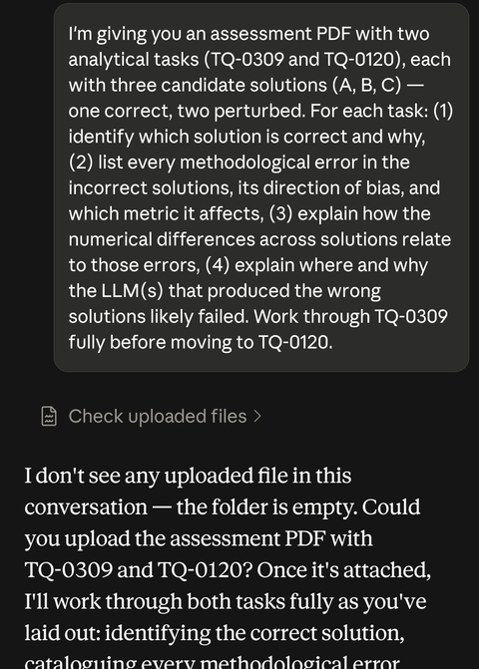
Screenshot 2, Turn 3: fcs join fan-out mechanics
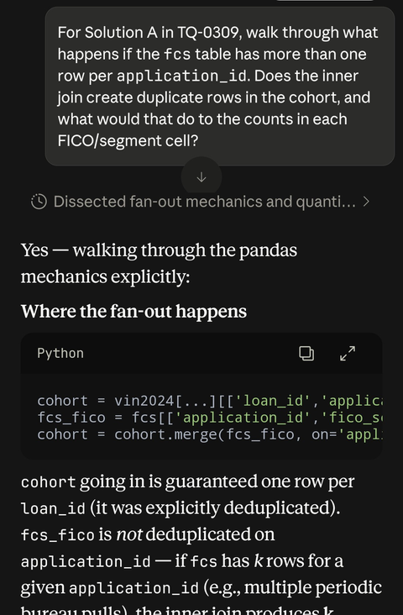
Screenshot 3, Turn 4: 0-indexing / seasoning threshold proof
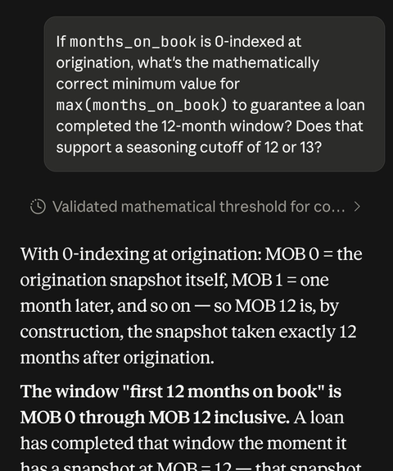
Screenshot 4, Turn 5: uniform-shift vs scattered-error reasoning
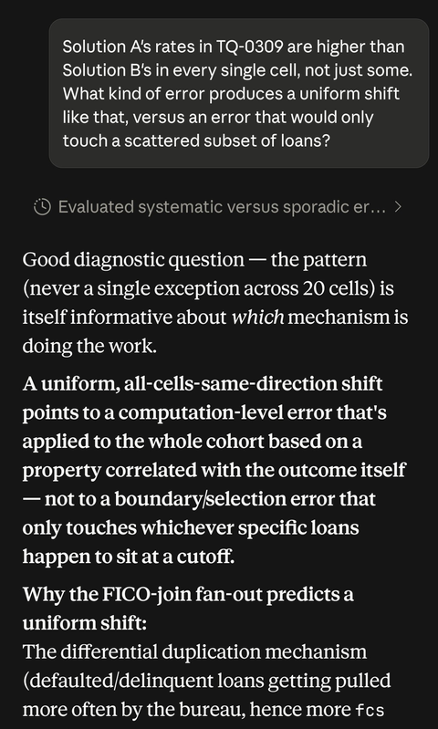
Screenshot 5, Turn 6 to 7: charge-off mechanics and the denominator inequality proof
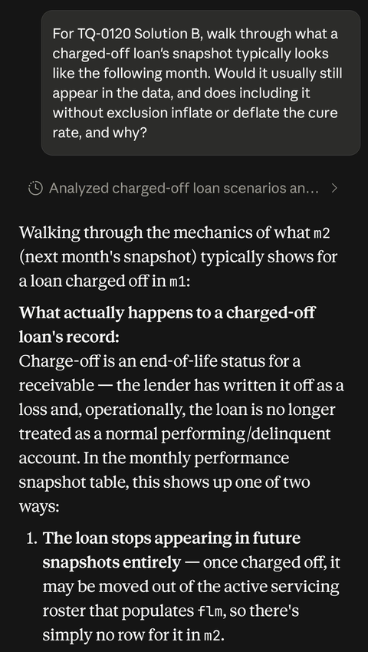
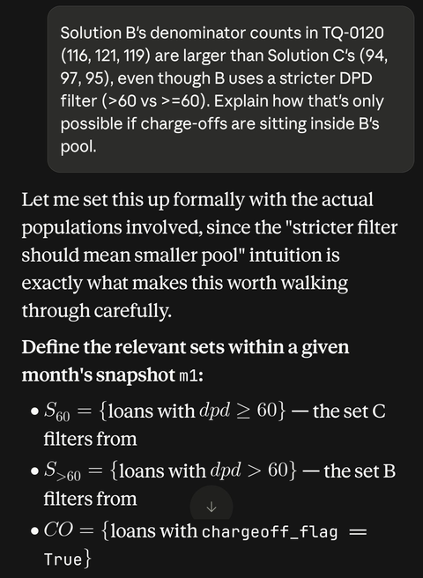
Screenshot 6, Turn 8 to 9: Stage 1 critique and the three-list breakdown

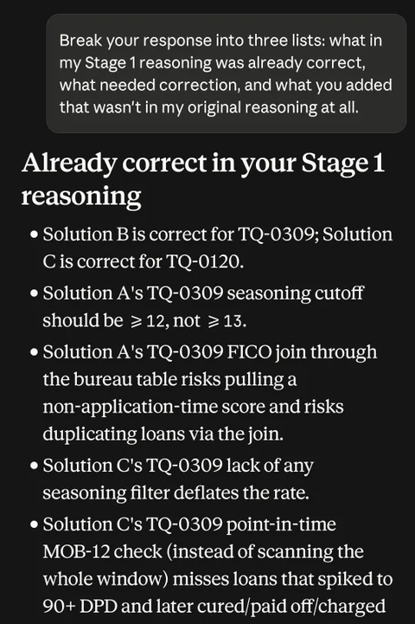
Screenshot 7, Turn 10 to 11: final TQ-0309 and TQ-0120 write-ups
